Supplementary Information for

Using surveillance data for early warning modelling of highly pathogenic avian influenza in Europe reveals a seasonal shift in transmission, 2016-2022
Lene Jung Kjær^{1*}, Michael P. Ward², Anette Ella Boklund¹, Lars Erik Larsen¹, Charlotte Kristiane Hjulsager³, and Carsten Thure Kirkeby¹

¹Department of Veterinary and Animal Sciences, Faculty of Health and Medical Sciences, University of Copenhagen, Denmark
²Faculty of Science, Sydney School of Veterinary Science, University of Sydney, Camden NSW, Australia
³Statens Serum Institut, Copenhagen, Denmark

*Corresponding author:
Email: lenju@sund.ku.dk

Adjacency matrix
We obtained shapefiles of the European countries included in this study from Natural Earth¹ and calculated an adjacency matrix to be used in a spatial weights matrix in the endemic-epidemic time-series model. This adjacency matrix calculated values for pairs of countries dependent on whether they were directly adjacent or whether they were connected through other countries; for example, Denmark and Germany share a border and would get a value of 1, whereas Portugal is connected to France through Spain, so here the value would be 2. Many countries in Europe are divided by waterways, which would automatically give the value zero in the adjacency matrix (for example Denmark and Sweden, and furthermore Iceland and Faroe Islands would stand alone with no adjacencies). Many bird species can easily traverse water separating country borders, and a lot of migrating water birds fly over large distances (for example between Iceland and Faroe Island to Great Britain and mainland Europe²). To account for this in the adjacency matrix, we modified the shape file of Europe to connect countries by adding water as a shape between these countries (Fig. S1). By doing this we connected Denmark to Great Britain, Norway, and Sweden. We also connected Sweden to Germany, the Baltic countries, and Poland, Finland to Estonia and Latvia, and Iceland and Faroe Island to Great Britain, Norway, and Denmark. We furthermore connected Great Britain to mainland Europe and connected Italy to the Balkans. Thus, these specified waterways will in the adjacency matrix act as a connecting country. We based these connections on migratory routes of many of the different migrating swan and goose species in Europe such as whooper swan (Cygnus cygnus), mute swan (Cygnus olor), tundra swan (Cygnus columbianus), barnacle goose (Branta leucopsis), Brent goose (Branta Bernicla), and Canada goose (Branta canadensis)².

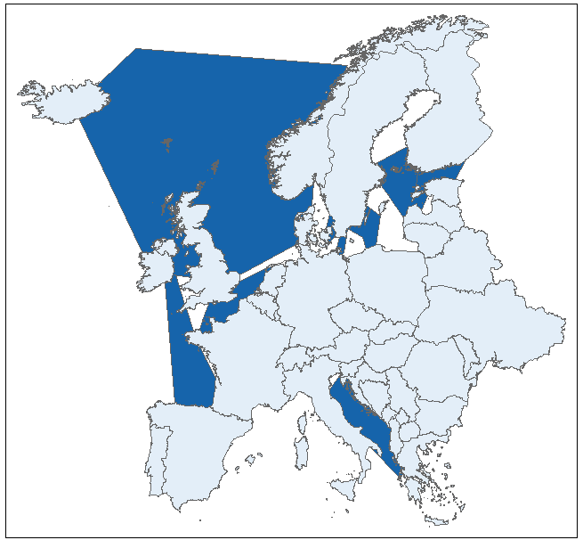
Figure S1. Waterway connections (dark blue) created for the spatial adjacency order of the European countries included in the endemic-epidemic time-series model in this study. The map was created using the package tmap³ in R 4.1.2⁴.
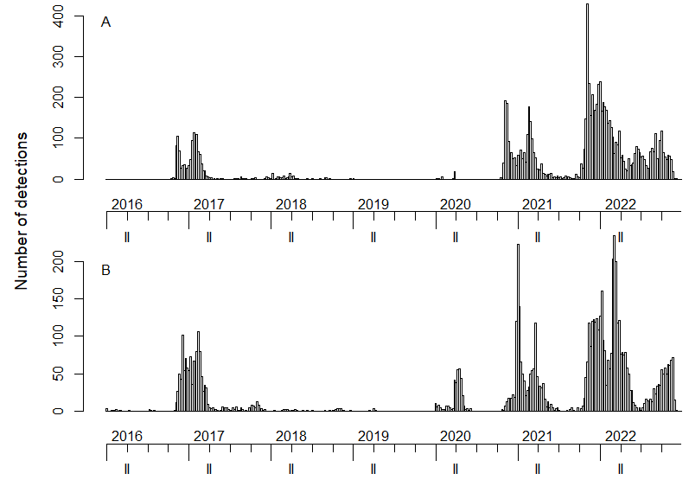

Figure S2. The number of reported highly pathogenic avian influenza (H5 subtype) detections in A) wild birds (N=8,870) and B) domestic birds (N=6,679) summed over 37 European countries (including Faroe Islands) and shown over time, 2016-2022.

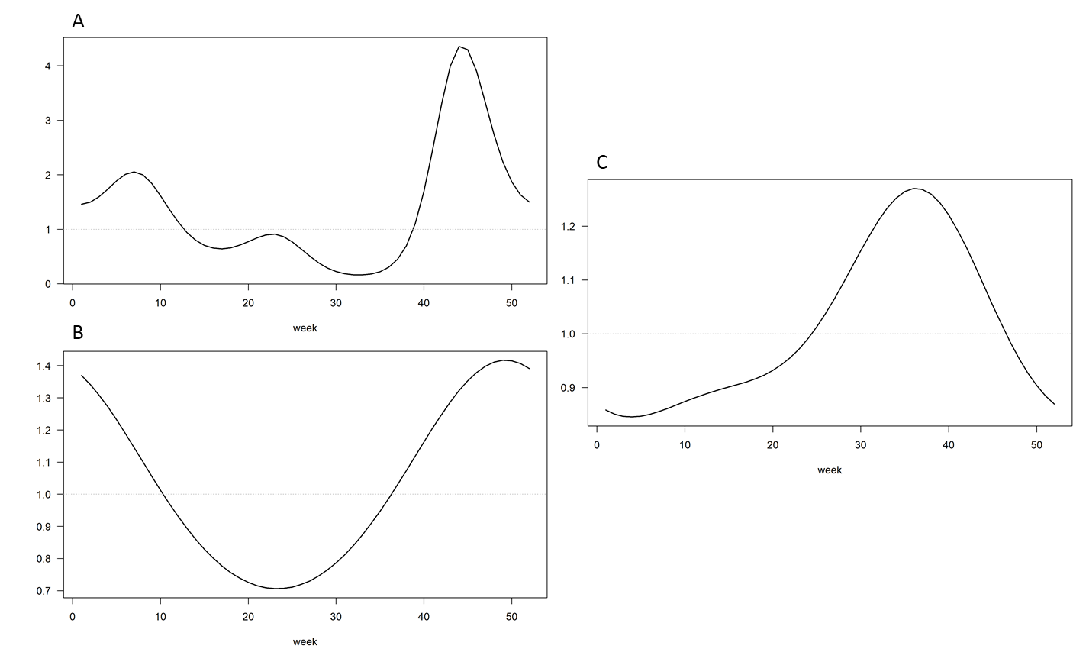

Figure S3. Seasonal waves (frequency ω = 2π/52) included in the final multivariate time-series models for A) the endemic component (3 waves) in the HPAI1621 model, B) the within-country effects in the epidemic component (2 waves) in the HPAI1621 model, and C) the within-country effects in the epidemic component (2 waves) in the HPAI2122 model.
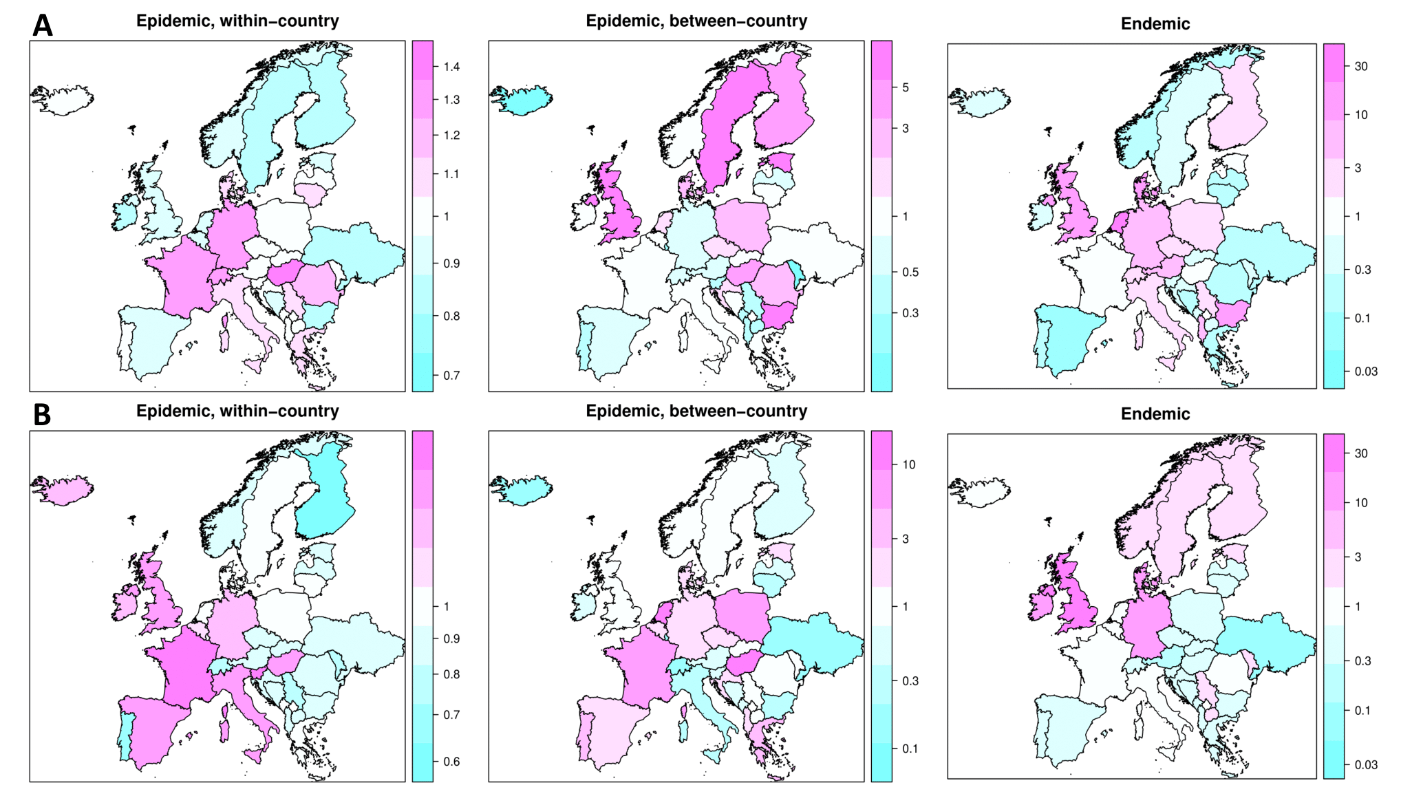

Figure S4. Epidemic (between and within country) and endemic random intercepts (RI) from A) the final HPAI1621 multivariate time-series model and B) the final HPAI2122 multivariate time-series model for all 37 countries. RI < 1 suggest lower number of detections than predicted. The maps were created using the package surveillance^{5,6} in R 4.1.2⁴.

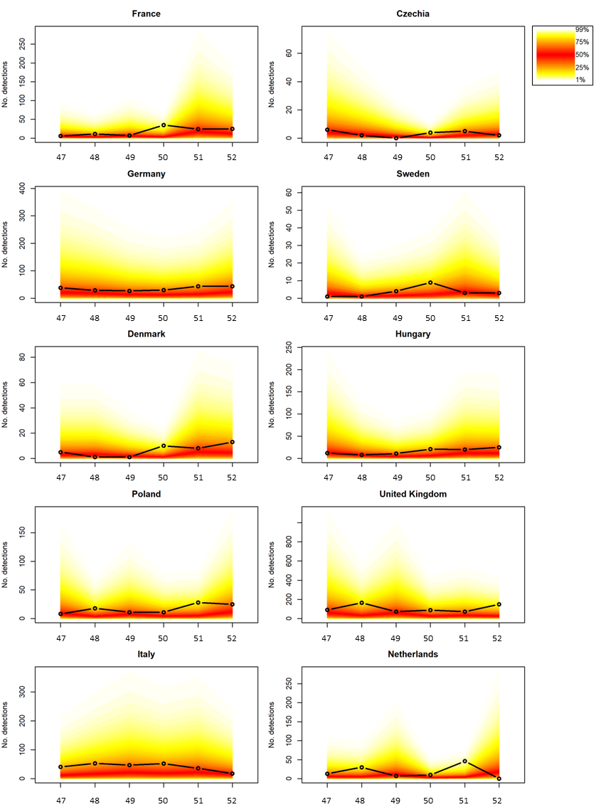

Figure S5. Fan plots of rolling one-week-ahead forecasts during week 47 to week 52 in 2021, produced by the final multivariate HPAI1621 time-series model. The X-axis shows the week number, and the Y-axis show the number of detections. Only countries with > 200 total highly pathogenic avian influenza (H5 subtype) detections are depicted. The fan chart represents the 1% and 99% quantiles of the simulations each week. Actual reported number of detections are depicted with open circles. Note that the scales on the Y-axes are different for some of the graphs.
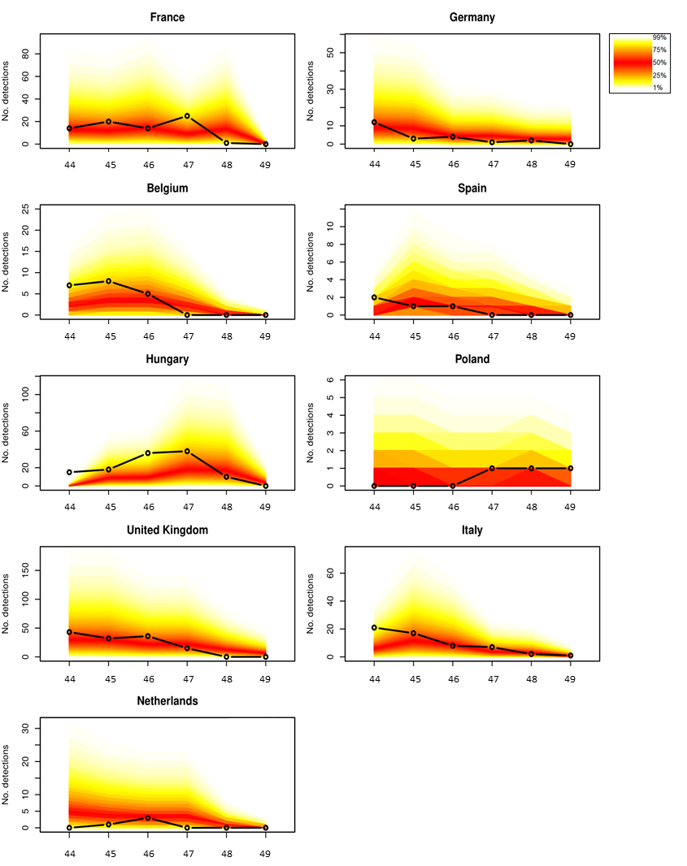

Figure S6. Fan plots of rolling one-week-ahead forecasts during week 44 to week 49 in 2022, produced by the final multivariate HPAI2122 time-series model. The X-axis shows the week number, and the Y-axis show the number of detections. Only countries with > 200 total highly pathogenic avian influenza (H5 subtype) detections are depicted. The fan chart represents the 1% and 99% quantiles of the simulations each week. Actual reported number of detections are depicted with open circles. Note that the scales on the Y-axes are different for some of the graphs.

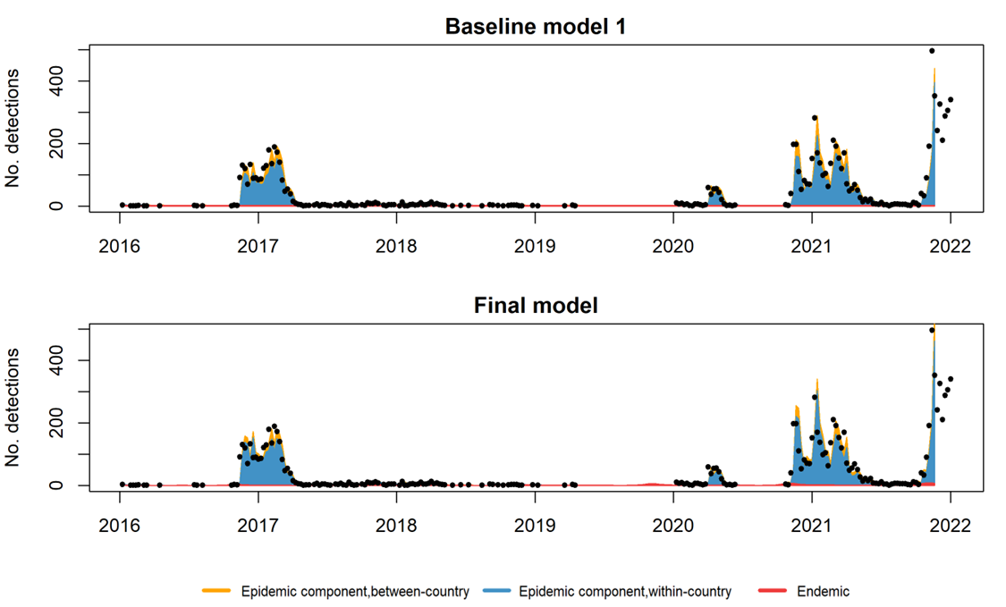

Figure S7. Overall model fit aggregated over all the 37 countries showing the relative contribution of model components for the HPAI1621 baseline model 1 and the HPAI1621 final multivariate time-series model. Dots show the actual counts of reported highly pathogenic avian influenza (H5 subtype) detections in domestic and wild birds. Although actual counts from week 47-52 in 2021 are depicted, they were not part of the training set in the model, and thus are not part of the model fit.
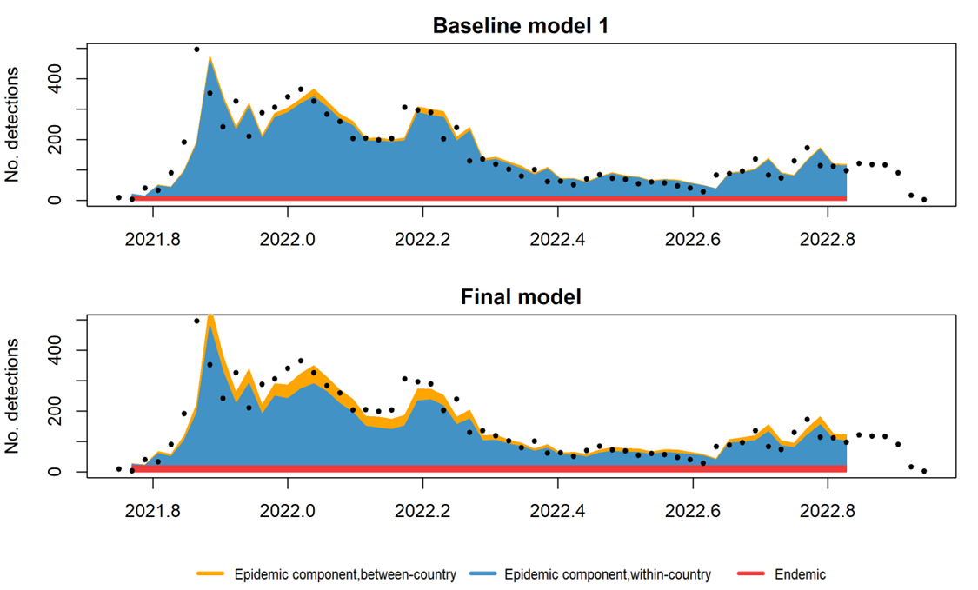
Figure S8. Overall model fit aggregated over all the 37 countries showing the relative contribution of model components for the HPAI2122 baseline model 1 and the final multivariate time-series model. Dots show the actual counts of reported highly pathogenic avian influenza (H5 subtype) detections in domestic and wild birds. Although actual counts from week 44-49 in 2022 are depicted, they were not part of the training set in the model, and thus are not part of the model fit.
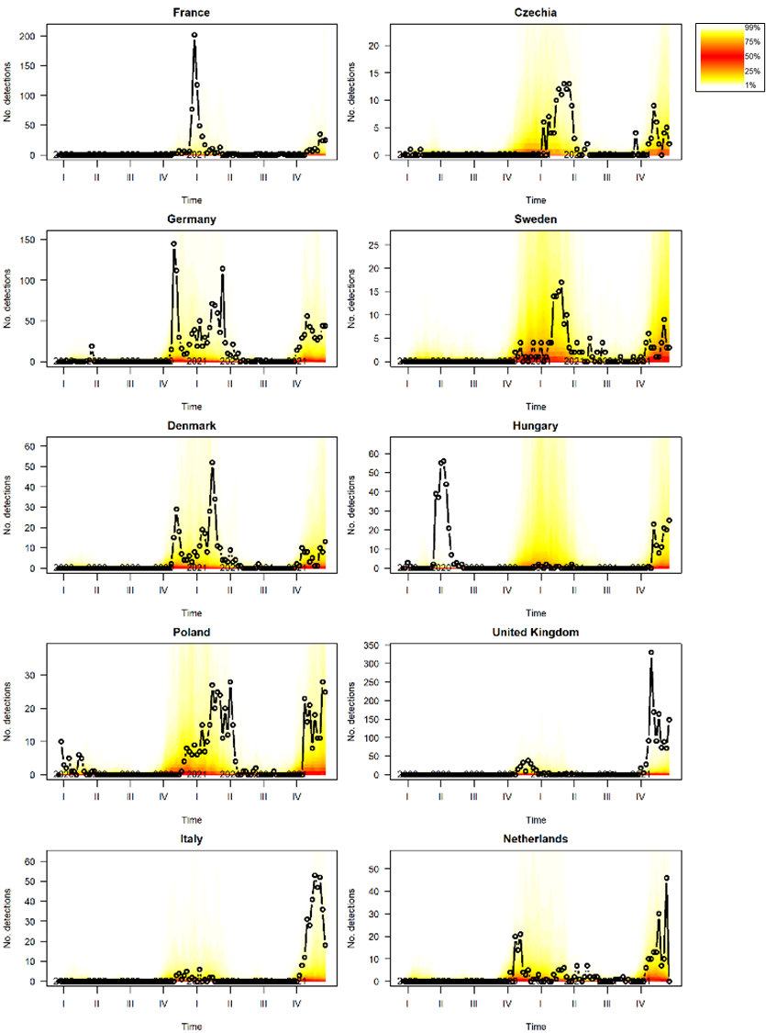
Figure S9. Simulation-based long-term forecast starting from the last week in 2019 (left-hand dot) to week 19 in 2022 using the HPAI1621 model. The plot shows weekly number of HPAI detections for countries with > 200 reported detections. The fan chart represents the 1% and 99% quantiles of the simulations each week. Actual reported number of detections are depicted with open circles. Data from week 47 to week 52 in 2021 were not used to train the model. Note that the scales on the Y-axes are different for some of the graphs.
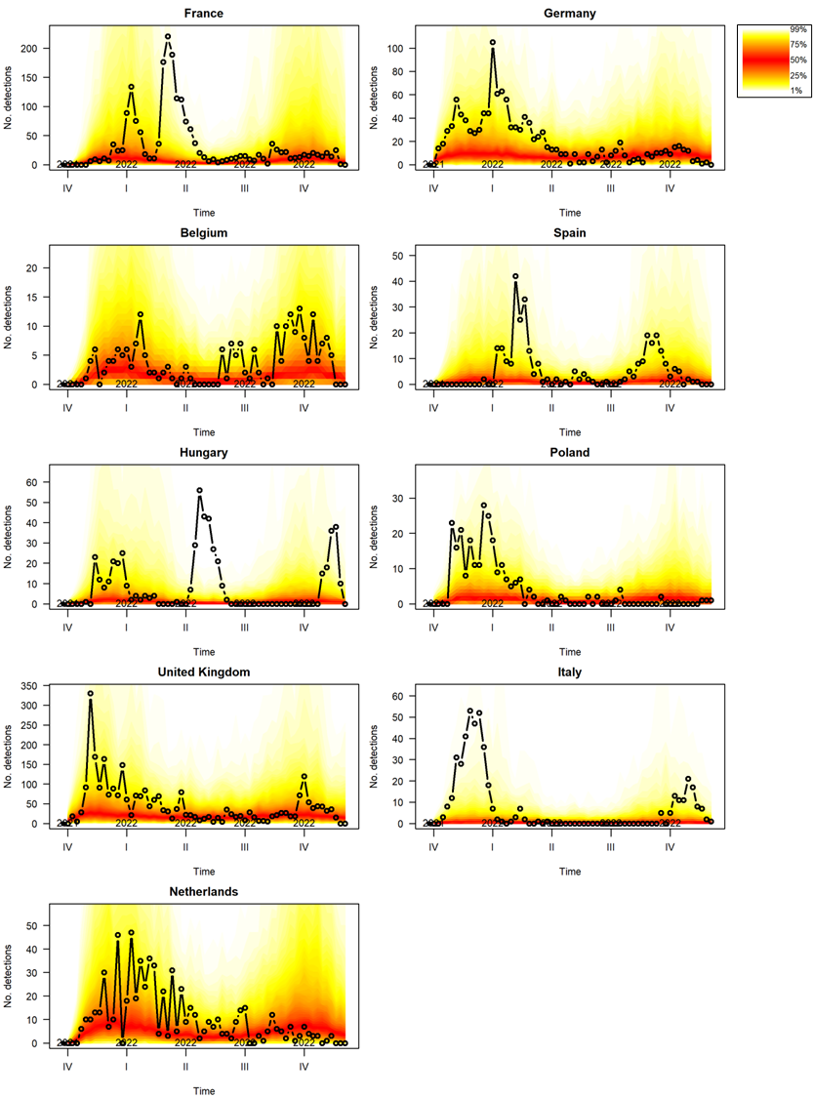
Figure S10. Simulation-based long-term forecast starting from week 39 in 2021 (left-hand dot) to week 49 in 2022 using the HPAI2122 model. The plot shows weekly number of HPAI detections for countries with > 200 reported detections. The fan chart represents the 1% and 99% quantiles of the simulations each week. Actual reported number of detections are depicted with open circles. Data from week 44 to week 49 in 2022 were not used to train the model. Note that the scales on the Y-axes are different for some of the graphs.

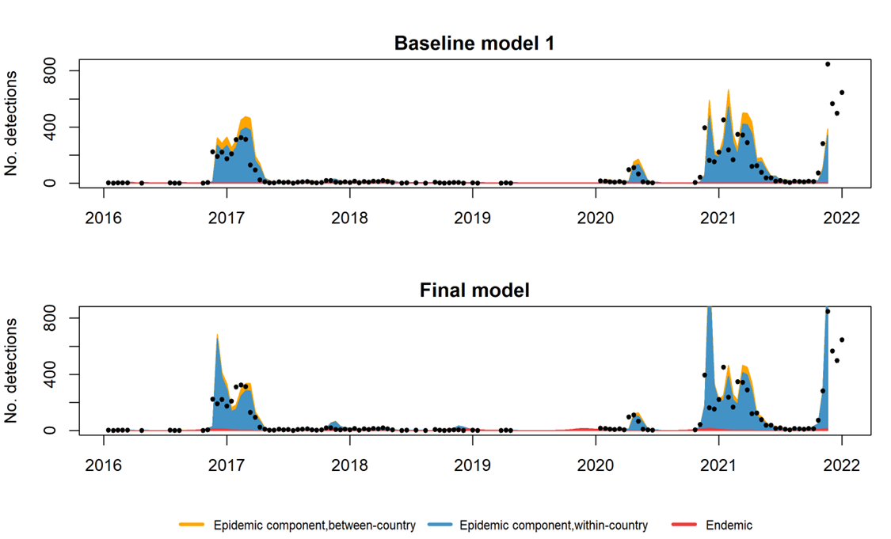

Figure S11. Overall model fit aggregated over all the 37 countries showing the relative contribution of model components for the biweekly aggregated HPAI1621 baseline model 1 and the final multivariate time-series model. Dots show the actual counts of reported highly pathogenic avian influenza (H5 subtype) detections in domestic and wild birds. Although actual counts from the last biweekly detections of 2021 are depicted, they were not part of the training set in the model, and thus are not part of the model fit.

Table S1. HPAI detections and their subtypes reported in the data included in this study, 2016-2022. Number of countries denote the number of countries reporting detected HPAI of the specific subtype.

Subtype | No. detections | No. countries
Subtype not specified | 43 | 1
H5 (N not specified) | 214 | 14
H5N1 | 9476 | 35
H5N2 | 10 | 4
H5N3 | 17 | 6
H5N4 | 17 | 4
H5N5 | 124 | 20
H5N6 | 115 | 10
H5N8 | 5572 | 33
H5N9 | 4 | 1
H7N7 | 3 | 2
Total | 15595

Table S2. HPAI H5 subtype detections for the two datasets 2016-2021 and 2021-2022 (from week 39 in 2021 to week 49 in 2022). Note that the two data sets have overlapping data from week 39-52 in 2021.

 | 2016-2021 | 2021-2022
Subtype | No. detections | No. detections
H5 (N not specified) | 207 | 29
H5N1 | 3061 | 9305
H5N2 | 7 | 3
H5N3 | 17 | 2
H5N4 | 17 | 0
H5N5 | 107 | 17
H5N6 | 115 | 0
H5N8 | 5565 | 20
H5N9 | 4 | 0
Total | 9100 | 9376

Table S3. Performance evaluation comparing baseline multivariate time-series models to models including multiple seasonal waves, area of wetland and length of coastline as covariates as well as offsets, and random effects. RPS is the mean ranked probability score and logS is the mean logarithmic score used in the strictly proper scoring rules scheme. HPAI1621 and HPAI2122 are the datasets containing detections from 2016-2021 and 2021-2022 respectively. Calibration test results of p≥0.05 suggest a well-calibrated model. Seasonal waves and covariates were only included in the within-country effects of the epidemic component, whereas power law was added to the between-country effects in the epidemic component. All models included area of country in relation to area of all countries within the study as an offset in the endemic component. The best calibrated models for logS scores are depicted in bold, whereas the second-best models are depicted in bold italic. * depicts significant differences in permutation test between best and second best model (with no significant differences, the second best model could have been chosen as well).
Model |  | HPAI1621
Endemic | Epidemic, within-country | RPS | Calibration (p-value) |  | logS | Calibration (p-value)
Seasonality (baseline 1 HPAI1621 none|none]
none | none | 4.188 | 0.065 |  | 2.007 | 0.000
one wave | none | 4.055 | 0.153 |  | 1.953 | 0.061
two waves | none | 4.052 | 0.155 |  | 1.955 | 0.066
three waves | none | 4.019 | 0.479 |  | 1.949 | 0.011
none | one wave | 4.125 | 0.172 |  | 2.005 | 0.000
one wave | one wave | 3.997 | 0.065 |  | 1.952 | 0.186
two waves | one wave | 3.992 | 0.067 |  | 1.954 | 0.197
three waves | one wave | 3.959 | 0.250 |  | 1.948 | 0.050
none | two waves | 4.149 | 0.144 |  | 2.005 | 0.000
one wave | two waves | 4.024 | 0.086 |  | 1.952 | 0.152
two waves | two waves | 4.018 | 0.087 |  | 1.954 | 0.164
three waves | two waves | 3.985 | 0.302 |  | 1.948 | 0.040
none | three waves | 4.166 | 0.150 |  | 2.006 | 0.000
one wave | three waves | 4.039 | 0.086 |  | 1.953 | 0.158
two waves | three waves | 4.033 | 0.086 |  | 1.955 | 0.172
three waves | three waves | 3.997 | 0.288 |  | 1.949 | 0.046
Covariates and offsets (baseline 2 HPAI1621: three waves|one wave):
none | none | 3.959* | 0.250 |  | 1.948 | 0.050
offset | none | 3.998 | 0.454 |  | 1.963 | 0.016
covariates | none | 3.956 | 0.217 |  | 1.946 | 0.060
none | offset | 4.034 | 0.421 |  | 1.957 | 0.014
offset | offset | 4.070 | 0.678 |  | 1.972 | 0.004
covariates | offset | 4.031 | 0.372 |  | 1.955 | 0.017
none | covariates | 3.968 | 0.251 |  | 1.949 | 0.056
offset | covariates | 4.008 | 0.452 |  | 1.964 | 0.019
covariates | covariates | 3.964 | 0.218 |  | 1.947 | 0.066
Power law/random effects (baseline 3 HPAI1621: covariates|none)
none |  | 3.956 | 0.217 |  | 1.946 | 0.060
power law |  | 3.920 | 0.005 |  | 1.958 | 0.817
random effects (uncorrelated) |  | 3.629 | 0.052 |  | 1.917 | 0.000
random effects (correlated) |  | 3.643 | 0.039 |  | 1.915 | 0.000
power law + random effects (uncorrelated) |  | 3.543 | 0.217 |  | 1.882 | 0.648
power law + random effects (correlated) |  | 3.549 | 0.223 |  | 1.883 | 0.630
Model |  | HPAI2122
Endemic | Epidemic, within-country | RPS |  | Calibration (p-value) | logS | Calibration (p-value)
Seasonality (baseline 1 HPAI2122 none|none]
none | none | 1.106 |  | 0.631 | 1.125 | 0.340
one wave | none | 1.090 |  | 0.000 | 1.204 | 0.001
two waves | none | 1.100 |  | 0.000 | 1.201 | 0.031
three waves | none | 1.100 |  | 0.001 | 1.195 | 0.061
none | one wave | 1.074 |  | 0.580 | 1.118 | 0.436
one wave | one wave | 1.057 |  | 0.000 | 1.199 | 0.000
two waves | one wave | 1.065 |  | 0.000 | 1.196 | 0.018
three waves | one wave | 1.064 |  | 0.001 | 1.189 | 0.041
none | two waves | 1.069 |  | 0.531 | 1.115 | 0.520
one wave | two waves | 1.054 |  | 0.000 | 1.196 | 0.000
two waves | two waves | 1.063 |  | 0.000 | 1.192 | 0.010
three waves | two waves | 1.061 |  | 0.000 | 1.184 | 0.024
none | three waves | 1.069 |  | 0.531 | 1.115 | 0.519
one wave | three waves | 1.053 |  | 0.000 | 1.197 | 0.000
two waves | three waves | 1.062 |  | 0.000 | 1.193 | 0.012
three waves | three waves | 1.062 |  | 0.001 | 1.184 | 0.028
Covariates and offsets (baseline 2 HPAI2122: none|two waves):
none | none | 1.069 |  | 0.531 | 1.115 | 0.520
offset | none | 1.088 |  | 0.021 | 1.174 | 0.398
covariates | none | 1.056 |  | 0.445 | 1.120 | 0.642
none | offset | 1.159 |  | 0.445 | 1.123 | 0.503
offset | offset | 1.178 |  | 0.013 | 1.183 | 0.378
covariates | offset | 1.143 |  | 0.401 | 1.126 | 0.587
none | covariates | 1.096 |  | 0.477 | 1.117 | 0.538
offset | covariates | 1.112 |  | 0.016 | 1.176 | 0.368
covariates | covariates | 1.084 |  | 0.417 | 1.122 | 0.636
Power law/random effects baseline 3 HPAI2122 none|none):
none |  | 1.069 |  | 0.531 | 1.115 | 0.520
power law |  | 1.042 |  | 0.469 | 1.098 | 0.730
random effects (uncorrelated) |  | 1.031 |  | 0.001 | 1.211 | 0.036
random effects (correlated) |  | 1.031 |  | 0.001 | 1.208 | 0.049
power law + random effects (uncorrelated) |  | 1.028 |  | 0.306 | 1.091 | 0.738
power law + random effects (correlated) |  | 1.029 |  | 0.314 | 1.092 | 0.714

Table S4. Performance evaluation comparing baseline multivariate time-series models of the biweekly aggregated HPAI1621 data set to models including multiple seasonal waves, area of wetland and length of coastline as covariates as well as offsets, and random effects. RPS is the mean ranked probability score and logS is the mean logarithmic score used in the strictly proper scoring rules scheme. Calibration test results of p≥0.05 suggests a well-calibrated model. Seasonal waves and covariates were only included in the within-country effects of the epidemic component, whereas power law was added to the between-country effects in the epidemic component. All models included area of country in relation to area of all countries within the study as an offset in the endemic component. The best calibrated models for logS scores are depicted in bold, whereas the second-best models are depicted in bold italic. There were no significant differences in permutation test between best and second-best models, thus the second-best models could have been chosen as well.

Epidemic | Epidemic, within-country | RPS | Calibration (p-value) | logS | Calibration (p-value)
Seasonality (baseline1: none|none)
none | none | 8.679 | 0.155 | 2.667 | 0.000
one wave | none | 8.321 | 0.594 | 2.575 | 0.006
two waves | none | 8.267 | 0.504 | 2.571 | 0.012
three waves | none | 8.219 | 0.846 | 2.578 | 0.004
none | one wave | 10.384 | 0.294 | 2.679 | 0.000
one wave | one wave | 10.202 | 0.362 | 2.592 | 0.085
two waves | one wave | 10.132 | 0.300 | 2.589 | 0.124
three waves | one wave | 10.040 | 0.569 | 2.596 | 0.062
none | two waves | 10.831 | 0.263 | 2.674 | 0.000
one wave | two waves | 10.700 | 0.397 | 2.588 | 0.079
two waves | two waves | 10.640 | 0.328 | 2.585 | 0.119
three waves | two waves | 10.622 | 0.609 | 2.593 | 0.060
none | three waves | 11.495 | 0.224 | 2.674 | 0.000
one wave | three waves | 11.364 | 0.464 | 2.587 | 0.063
two waves | three waves | 11.258 | 0.387 | 2.584 | 0.095
three waves | three waves | 11.282 | 0.678 | 2.592 | 0.049
Covariates and offsets (baseline 2: two waves|three waves)
none | none | 11.258 | 0.387 | 2.584 | 0.095
offset| none | none | 11.248 | 0.408 | 2.591 | 0.081
covariates | none | 11.436 | 0.240 | 2.572 | 0.165
none | offset | 13.413 | 0.467 | 2.596 | 0.051
offset | offset | 13.548 | 0.484 | 2.604 | 0.047
covariates | offset | 13.733 | 0.294 | 2.584 | 0.097
none | covariates | 10.719 | 0.387 | 2.581 | 0.101
offset | covariates | 10.651 | 0.407 | 2.588 | 0.088
covariates | covariates | 10.832 | 0.238 | 2.568 | 0.172
Power law/random effects (baseline 3: covariates|covariates)
none |  | 10.832 | 0.238 | 2.568 | 0.172
power law |  | 10.688 | 0.029 | 2.589 | 0.889
random effects (uncorrelated) |  | 9.710 | 0.000 | 2.596 | 0.000
random effects (correlated) |  | 10.173 | 0.000 | 2.606 | 0.000
power law + random effects (uncorrelated) |  | 9.676 | 0.857 | 2.522 | 0.603
power law + random effects (correlated) |  | 10.124 | 0.937 | 2.530 | 0.565

Table S5. Coefficient estimates from the final multivariate time-series biweekly aggregated HPAI1621 model with 2 seasonal waves in the endemic component, 3 seasonal waves in the within-country effects of the epidemic component, area of country relative to total area of all countries as offset in the endemic component, covariates length of coastline (km) and area of wetlands (km²) in the endemic component and within-country effects of the epidemic component, spatial weights w_{ji} as a power-law model with distance-decay for the between-country effects of the epidemic component and uncorrelated random intercepts for all components.

Model components/parameters | Coefficient estimate | Std. Error | 2.5% CI | 97.5% CI
Endemic component:
Sine(2πt/52) | 0.359 | 0.072 | 0.218 | 0.500
Cosine(2πt/52) | 2.818 | 0.471 | 1.894 | 3.742
Sine(4πt/52) | 0.555 | 0.088 | 0.382 | 0.728
Cosine(4πt/52) | 1.046 | 0.185 | 0.684 | 1.409
Length of coastline (km) | -0.10 | 0.145 | -0.380 | 0.186
Area of wetland (km²) | 0.172 | 0.313 | -0.442 | 0.785
Random intercept | 0.227 | 0.482 | -0.718 | 1.172
Epidemic component:
Sine(2πt/52) | 0.629 | 0.095 | 0.443 | 0.815
Cosine(2πt/52) | 1.638 | 0.264 | 1.122 | 2.155
Sine(4πt/52) | 0.808 | 0.118 | 0.577 | 1.038
Cosine(4πt/52) | 0.826 | 0.136 | 0.560 | 1.092
Sine(6πt/52) | 1.003 | 0.140 | 0.728 | 1.278
Cosine(6πt/52) | 0.720 | 0.102 | 0.520 | 0.920
Length of coastline (km) | -0.091 | 0.034 | -0.158 | -0.025
Area of wetland (km²) | 0.052 | 0.068 | -0.082 | 0.186
Within-country random intercept | 0.782 | 0.393 | 0.012 | 1.553
Between country random intercept | 0.110 | 0.024 | 0.062 | 0.158
Spatial weights (w_{ji}) | 17.007 | 5.713 | 5.811 | 28.204

References
1. Natural Earth. Admin 0 – Countries - Free vector and raster map data at 1:10m, 1:50m, and 1:110m scales. https://www.naturalearthdata.com/downloads/10m-cultural-vectors/10m-admin-0-countries/ (2021).
2. Spina, F., Baillie, S. R., Bairlein, F., Fiedler, W. & Thorup, K. The Eurasian African Bird Migration Atlas. EURING/CMS https://migrationatlas.org/ (2022).
3. Tennekes, M. tmap: Thematic Maps in R. J. Stat. Softw. 84, 1-39 (2018).
4. R Development Core Team. R: A Language and Environment for Statistical Computing. R Foundation for Statistical Computing http://www.r-project.org Preprint at http://www.r-project.org (2022).
5. Meyer, S., Held, L. & Höhle, M. Spatio-Temporal Analysis of Epidemic Phenomena Using the R Package surveillance. J Stat Softw 77, (2014).
6. Salmon, M., Schumacher, D. & Höhle, M. Monitoring Count Time Series in R: Aberration Detection in Public Health Surveillance. J Stat Softw 70, 1–35 (2016).

