Supplementary Materials

Immunomodulatory Effects of Nanoparticles on Dendritic Cells in a Model of Allergic Contact Dermatitis - importance PD-L2 expression

Angela Wong Lau et al.

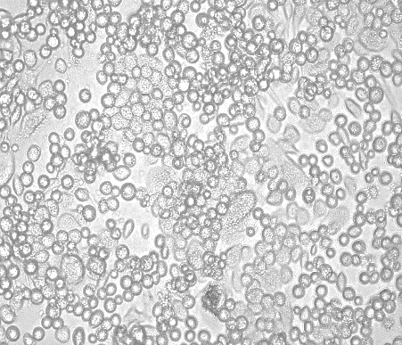
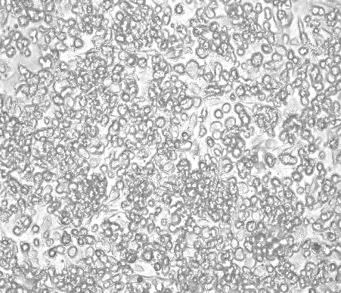
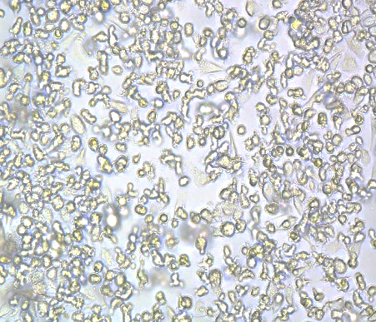
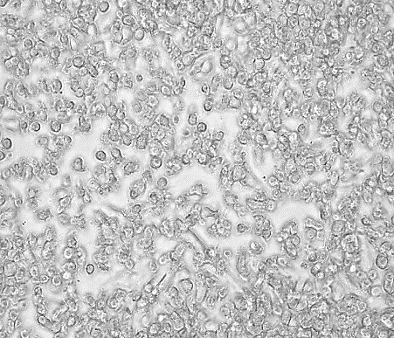
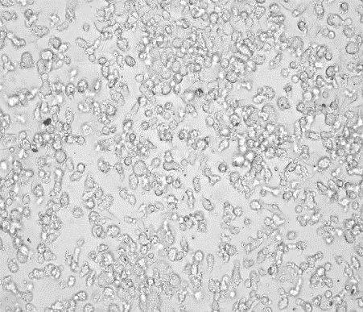
50µm
A
B
C
D
E
50µm
50µm
50µm
50µm

Fig. S1. Bright field images of each treatment after 1 hr exposure, taken in 20x.
(a) untreated immature BMDCs show a heterogeneous populations (adherent and semi-adherent) (b) BMDCs exposed to 0.001 mM DNFB show some semi-adherent cell population becoming round (c) BMDCs exposed to 0.01 mM DNFB show both adherent and semi-adherent cell populations becoming significantly round (d) BMDCs exposed to 0.01 mg/mL SiO₂ NPs show adherent and semi-adherent cell populations keeping its cell morphology (e) BMDCs exposed to 0.005 mg/mL mTiO₂ NPs show adherent and semi-adherent cell populations keeping the dendritic cell morphology.

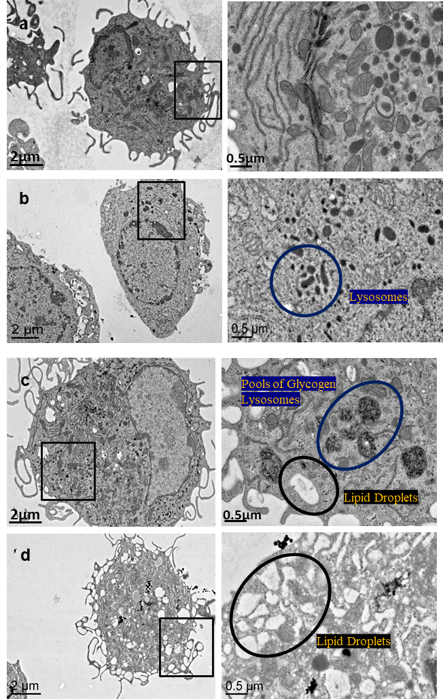

Fig. S2. TEM images of BMDC after 1 hr exposure of each treatment in 2 μm and 0.5 μm scale.
(A) untreated immature BMDCs illustrating the characteristic dendrites (B) BMDCs treated with 0.01 mM DNFB show loss of dendrites (C) BMDCs treated with 0.01 mg/mL SiO₂ NPs retain their dendrites and there is an increased glycogen granules (D) BMDCs treated with 0.005 mg/mL mTiO₂ NPs retain their dendrites and there is an increase in lipid droplets. It is unknown at this time if the rounding of cells (loss of dendricity) is a toxicity response or an activation response of the cells to retract dendrites to migrate out of peripheral tissues to lymph nodes.

Fig. S3. Characterization of mTiO₂ NPs by TEM. BMDCs were culture with mTiO₂ NPs (0.005 mg/ml) for 1 hr. Cells were then prepared for TEM to assess NP uptake. Results show endocytosed mTiO₂ NPs with an average size of 51.6 +/- 12.5 nm. Taking the ratio of the standard deviation to mean particle size the polydispersity is 0.24, which is similar to the PDI of 0.296 that was measured by DLS with the particles suspended in water that had a hydrodynamic ratio of 556.4 nm +/- 33.6 nm¹. Also shown is a TEM image of mTiO₂ suspended in water and dried onto a TEM grid. Results show a tendency to form clusters whereas, they are more dispersed and rounded inside the BMDCs. Mn is highly redox reactive and soluble, hence the biotransformation of mTiO₂ in cells is expected.

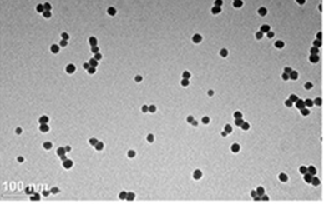

Fig. S4. Characterization of SiO₂ NPs by TEM. BMDCs were culture with DNFB (0.01 mM) plus SiO₂ (0.01 mg/ml) for 1 hr. Cells were then prepared for TEM to assess NP uptake. Results show endocytosed SiO₂ NPs with an average size of 20.6 +/- 3.5 nm. Taking the ratio of the standard deviation to mean particle size, the polydispersity is 0.17, which is slightly lower than the PDI of 0.236 that measured by DLS with the particles suspended in water that had a hydrodynamic ratio of 33.5 nm +/- 3.3 nm². Also shown is a TEM image of SiO₂ NPs suspended in water and dried directly on the TEM grid.

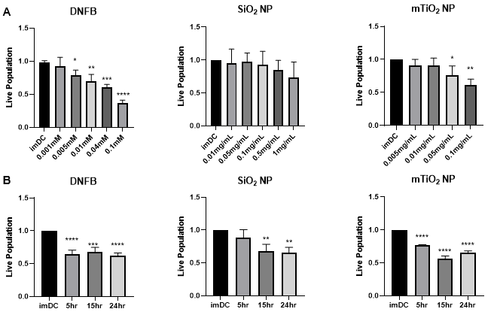

Fig. S5. Effects of DNFB, SiO₂ and mTiO₂ exposure on BMDC cytotoxicity as a function of concentration and time measured with PrestoBlue assay.
BMDCs were harvested on day 8 and treated with DNFB, SiO₂ and mTiO₂ to study cytotoxicity as a function of concentration and time using PrestoBlue. (A) Cell viability as a function of concentration for a 1 hr exposure. (B) Cell viability following exposure to the lowest non-cytotoxic concentrations from (A) and exposed over a period of 5 hr, 15 hr and 24 hr. Results indicate that cytotoxicity of DNFB and mTiO₂ NPs on BMDCs was dose- and time- dependent. Live population was normalized the imDC no treatment control. Ordinary one-way ANOVA was performed and compared to imDC. N=3-5. Mean ± SD. *p < 0.05, **p < 0.01, ***p < 0.001, ****p < 0.0001.

B
A
C

Fig. S6. Supernatants were collected to analyze cytokine production by ELISA for IL-6, TNFα and IL-10 as a function of concentration for 1 hr exposure.
BMDCs were exposed to increasing concentrations of each stressor for 1 hr. (A) DNFB which upregulated IL-10 only at the highest concentration (B) SiO₂ NPs upregulated IL-6 (C) mTiO₂ NPs upregulated IL-6, TNFα and IL-10. Concentration was normalized against % of live cells. Ordinary one-way ANOVA was performed and compared to untreated imDC. N=3-5. Mean ± SD. *p < 0.05, **p < 0.01, ***p < 0.001, ****p < 0.0001.

Fig. S7. Supernatants were collected in order to analyze secreted cytokine production following LPS exposure over time.
BMDCs were exposed to LPS (50 ng/mL) on day 8 and the supernatants were collected to analyze production of IL-6, TNFα and IL-10 by ELISA over time. LPS is a strong, potent stressor that upregulated IL-6, TNFα and IL-10 over time. Ordinary one-way ANOVA was performed and compared to imDC. N=3-5. Mean ± SD. *p < 0.05, **p < 0.01, ***p < 0.001, ****p < 0.0001.

Fig. S8. Intracellular flow cytometry staining of BMDCs at increasing concentrations for 1 hr exposure.
BMDCs were treated with increasing concentrations of DNFB, SiO₂ and mTiO₂ for 1 hr and intracellularly stained for IL-10 and TNFα. SiO₂ NPs upregulated IL-10 at high concentrations without upregulating TNFα while the opposite occurs with mTiO₂ NPs. Ordinary one-way ANOVA was performed and compared to imDC. N=3-5. Mean ± SD. *p < 0.05, **p < 0.01, ***p < 0.001, ****p < 0.0001.

Fig. S9. Intracellular flow cytometry staining of BMDCs over time.
BMDCs were treated to the lowest concentrations of each stressors (0.001 mM DNFB, 0.01 mg/mL Si 20 nm, and 0.005 mg/mL mTiO₂) and intracellularly stained for IL-10 and TNFα. mTiO₂ upregulated TNFa and IL-10 while SiO₂ NPs only upregulated IL-10. Ordinary one-way ANOVA was performed and compared to untreated imDC. N=3-5. Mean ± SD. *p < 0.05.

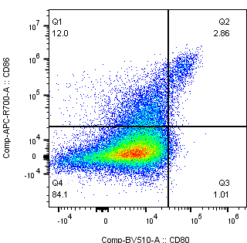
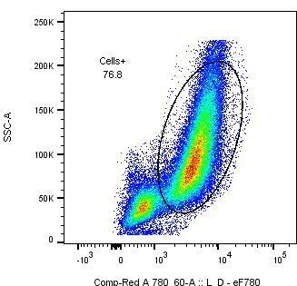
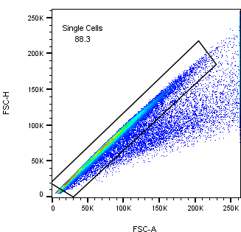
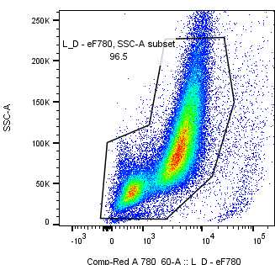
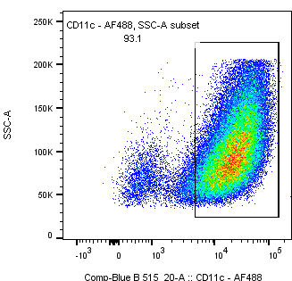
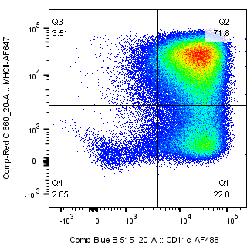
CD86 vs CD80
Cells +
Debris
Single Gating
MHCII vs CD11c
Double Gating
CD11c
CD11c+MHCII+
Single Cells
Dead Cells Exclusion
Live Cells
A
B
C
D
E
F

Fig. S10A. Gating strategy used to differentiate BMDC cell populations performed by FlowJo.
(A) Single cells were gated. (B) Fixable Viability Dye eFluor™ 780 was used to separated live cell population from the dead cell population. (C) The cell population excluding the debris (lower left corner) was selected. (E) Cells were gated under CD11c+MHCII+ (Q2.) which we defined as the BMDC. (F) the BMDC were gated under CD80/CD86 subpopulations split into four quadrants (Q1., Q2., Q3. and Q4.) giving us information about the CD86 and C80 single positive cells, the naive double negative (DN) and activated double positive (DP) subpopulations.

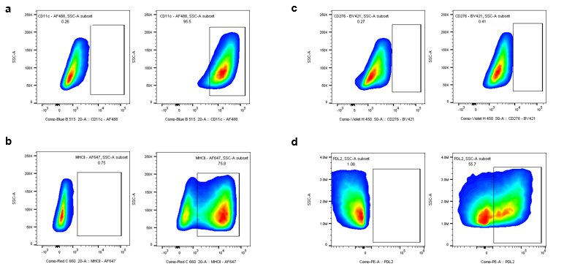

Fig. S10B. Example of FMO controls for untreated imDCs.
BMDCs were cultured in complete media (RPMI) for 8 days. Flow cytometry was done to test for the expression of activation markers. The markers selected for example shown with the FMO controls are: (a) CD11c, (b) MHCII, (c) CD276 and (d) PD-L2

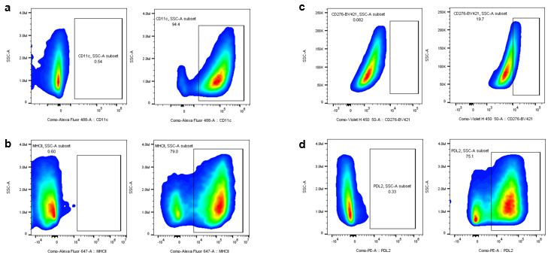

Fig. S10C. Example of FMO controls for BMDC treated with 0.005 mM DNDB for 1 hr. BMDCs were cultured in complete media (RPMI) for 8 days. Then they were cultured for 1 hr with 0.005mM DNFB. Flow cytometry was done to test for the expression of activation markers. The markers selected for example shown with the FMO controls are: (a) CD11c, (b) MHCII, (c) CD276 and (d) PD-L2

Fig. S11. Changes in B7 ligands following exposure of BMDCs to LPS over time for single gating on live cells.
Phenotypic characteristics of BMDCs following LPS (50 ng/mL) exposure over time using single gating (entire live cell population) of B7 co-stimulatory molecules. Exposure of LPS downregulated the expression of CD11c and upregulated the expression of MHCII, CD86, CD80, PD-L1 and no changes in PD-L2 were evident. CD276 increases early (3-6 hr) and decreases >15 hr. Ordinary one-way ANOVA was performed and compared to untreated imDC. N=3-5. Mean ± SD. *p < 0.05, **p < 0.01, ***p < 0.001, ****p < 0.0001.

Fig. S12. Changes in B7 ligand expression on CD11c+MHCII+ BMDCs (double gating) following exposure to LPS over time. Phenotypic characteristics of BMDCs following LPS (50 ng/mL) exposure over time using double gating (CD11c+MHCII+) of B7 co-stimulatory molecules. Exposure of LPS upregulated the expression of CD80, CD86 and PD-L1 with time and no changes in PD-L2 were evident. CD276 increases early (3-6 hr) and decreases >15 hr. These trends are consistent with gating on all cells Fig. S10. Ordinary one-way ANOVA was performed and compared to imDC. N=3-5. Mean ± SD. *p < 0.05, **p < 0.01, ***p < 0.001, ****p < 0.0001.

Fig. S13 Co-stimulatory molecules from the B7 family quantified by flow cytometry under CD80/CD86 single positive subpopulations.
Results for DNFB are colored in blue, SiO₂ in green and mTiO₂ in purple. CD80/CD86 subpopulations were divided and CD276 (B7-H3), PD-L1 (B7-H1) and PD-L2 (B7-DC) were gated under singles positives CD86-CD80+ (Q1.) or CD8+CD80-(Q3.) subpopulations, in order to determine whether their expression varies under the different activation states of BMDCs by using the activation markers CD80/CD86 following single exposures. The lowest non-cytotoxic concentrations of each stressor 0.001 mM DNFB, 0.01 mg/mL SiO₂ NPs and 0.005 mg/mL mTiO₂ NPs were used to treat the cells over 5 hr, 15 hr, and 24 hr. There was a decrease due to upregulation of CD80+ single positive cells on CD80/CD86 subpopulations. There were similarities between DNFB and mTiO₂ on PD-L1 expression where single positives subpopulation increases. On the other hand, SiO₂ NPs showed a downregulation of PD-L1 expression. PD-L2 showed a decrease in the CD86 single positive cells. Expression of CD276 was only upregulated on CD80+ quadrants (Q3.). A two-way ANOVA was performed and compared to imDC. N=3-5. Mean ± SD. *p < 0.05, **p < 0.01, ***p < 0.001, ****p < 0.0001.

A
B
C
D
E
F
G
H

Fig. S14. Cytotoxicity and cytokines for co-exposure of DNFB with SiO₂ or mTiO₂ NPs for 1 hr.
BMDCs were subjected to the co-exposure of the DNFB hapten with the SiO₂ or mTiO₂ NPs after 1 hr. Cell viability, based on flow cytometry, of BMDCs was compared. (A) SiO₂ NPs exhibited cytoprotective effects while (B) mTiO₂ NPs had no effect. Supernatants were then collected in order to analyze cytokine production by ELISA assay for (C-D) IL-6 which showed that addition of mTiO₂ increased its secretion. (E-F) addition of either NPs increased the production of TNFα and (G-H) both NPs had no effect on IL-10 secretion. Ordinary one-way ANOVA was performed and compared to imDC (*) and DNFB (#). Concentration was normalized against % of live cells. N=3-5. Mean ± SD. */#p < 0.05, **/##p < 0.01, ***/###p < 0.001, ****/####p < 0.0001.

Fig. S15 Co-stimulatory molecules from the B7 family quantified by flow cytometry under CD80/CD86 subpopulations following 1 hr co-exposure.
CD80/CD86 subpopulations were divided and CD276 (B7-H3), PD-L1 (B7-H1) and PD-L2 (B7-DC) were gated under double positive (DP) population (Q2.) or double negative (DN) population (Q4.) to determine whether their expression varies under the different activation states of BMDCs using the CD80/CD86 markers following exposure to DNFB alone (0.01 or 0.001 mM) or co-exposure with 0.01 mg/mL SiO₂ or 0.005 mg/mL mTiO₂. Most sticking effects of the NPs occur in the DNFB induced changes in PD-L1 and PD-L2. SiO₂ decrease PD-L1 where as TiO₂ co-exposure increases it in the CD80+CD86+ population. TiO₂ co-exposure decreases PD-L2 expression in the CD80+CD86+ whereas SiO₂ has no effect. A two-way ANOVA was performed and compared to imDC (*) and DNFB (#). N=3-5. Mean ± SD. **/##p < 0.01, ***/###p < 0.001, ****/####p < 0.0001.

Fig. S16. BMDCs profile on Day 8.
Graphic representation of murine BMDCs profile on day 8 with the markers F4/80 (macrophages), CD11b and CD11c (DCs) and MHCII. The graphs show mean ± SD. F4/80 (n=5), CD11b (n=8), CD11c (n=10), MHCI (n=10), CD3 (n=1), CD19 (n=1).

Table S1. Flow panel with its corresponding fluorochrome, concentration, clone number, supplier, and catalog number

Antibody | Concentrations (µg/mL) | Fluorochrome | Clone # | Supplier | Cat #
CD11c | 0.5 | Alexa Fluor 488 | N418 | BioLegend | 117311-BL
CD11b | 0.25 | PE-eFluor™ 610 | M1/70 | Invitrogen | 61-0112-82
MHCII | 0.3 | Alexa Fluor 647 | M5/114.15.2 | BioLegend | 107618-BL
CD86 (B7-2) | 0.5 | APC-R700 | GL1 | BD Biosciences | BDB565479
CD80 (B7-1) | 0.15 | Brilliant Violet 510 | 16-10A1 | BioLegend | BDB740130
CD276 (B7-H3) | 0.08 | Brilliant Violet 421 | MIH32 | BD Biosciences | BDB562634
PD-L1 (B7-H1, CD274) | 0.4 | Brilliant Violet 711 | 10F.9G2 | BioLegend | 10759-272
PD-L2 (B7-DC, CD273) | 0.2 | PE | TY25 | Invitrogen | 12-5986-82
TNFα | 0.1 | PE-Cyanine7 | MP6-XT22 | Invitrogen | 25-7321-82
IL-10 | 0.2 | PerCP-Cyanine5.5 | JES5-16E3 | Invitrogen | 45-7101-82
F4/80 | 0.2 | PE-Cy5 | BM8 | BioLegend | 123112-BL
CD19 | 0.3 | APC Cy7 | SJ25C1 | BD Biosciences | 557791
CD3 | 0.3 | AF700 | SP34-2 | BD Biosciences | 557917
FVD | 0.6 | eFluor 780 |  | Invitrogen | 65-0865-14
FcBlock | 0.5 | Antigen: CD16/32 | 93 | BioLegend | 101320-BL
1 Palmer, B. C. & DeLouise, L. A. Morphology-dependent titanium dioxide nanoparticle-induced keratinocyte toxicity and exacerbation of allergic contact dermatitis. HSOA J Toxicol 4, doi:10.24966/tcr-3735/100019 (2020).
2 Palmer, B. C., Jatana, S., Phelan-Dickinson, S. J. & DeLouise, L. A. Amorphous silicon dioxide nanoparticles modulate immune responses in a model of allergic contact dermatitis. Sci Rep 9, 5085, doi:10.1038/s41598-019-41493-7 (2019).

