SL-scan Identifies Synthetic Lethal Interactions in Cancer using Metabolic Networks

Ehsan Zangene¹, Sayed-Amir Marashi^{2*}, Hesam Montazeri^{1*}

¹ Department of Bioinformatics, Institute of Biochemistry and Biophysics, University of Tehran, Tehran, Iran
² Department of Biotechnology, College of Science, University of Tehran, Tehran, Iran.
* Correspondence to Sayed-Amir Marashi marashi@ut.ac.ir and Hesam Montazeri hesam.montazeri@ut.ac.ir

Supplementary Table S1 This table provides a mapping between the cancer types as defined within the DepMap project and their corresponding counterparts in the TCGA datasets (available as a csv file in the supplementary materials, “Table S1-SL-scan MutSig mapping.csv”).
Supplementary Table S2 presents the total predicted SL pairs using the SL-Scan, number of mutated and wild-type cell liens, t-statistics and their relevant p-value and FDR, and whether the corresponding driver gene is a significantly mutated gene (available as a csv file in the supplementary materials, “Table S2-SL-scan predicted SL pairs and significance analysis.csv”).
Supplementary Table S3 presents number of predicted SL pairs and concordant SL Pairs with CRISPR results for SL-scan, FastSL, gMCS, MCS, and ngMCS methods across various cancer types. To ensure a fair comparison and evaluation of different methods, a set of universally common testable pairs was utilized consistently across all methods (available as a csv file in the supplementary materials, “Table S3-Comparison of SL pair prediction methods with CRISPR analysis.csv”).

Supplementary Table S4. Results of the hypergeometric test for FastSL and CRISPR pairs.
Cancer | Enrichment P-value | #SL pairs  (FastSL) | #SL pairs  (CRISPR) | #overlap | #total
Bile Duct Cancer | 1.00E+00 | 0 | 59 | 0 | 3988
Brain Cancer | 1.00E+00 | 7 | 104 | 0 | 3762
Breast Cancer | 1.00E+00 | 17 | 47 | 0 | 2032
Esophageal Cancer | 1.00E+00 | 1 | 43 | 0 | 2632
Head and Neck Cancer | 1.00E+00 | 0 | 40 | 0 | 3212
Kidney Cancer | 1.00E+00 | 0 | 15 | 0 | 2202
Leukemia | 7.76E-02 | 5 | 322 | 1 | 20090
Lung Cancer | 1.00E+00 | 26 | 370 | 0 | 22618
Myeloma | 1.00E+00 | 0 | 3 | 0 | 970
Neuroblastoma | 1.00E+00 | 0 | 9 | 0 | 1664
Ovarian Cancer | 1.00E+00 | 2 | 271 | 0 | 16260
Pancreatic Cancer | 1.00E+00 | 2 | 20 | 0 | 1376
Skin Cancer | 1.00E+00 | 6 | 337 | 0 | 18102

Supplementary Table S5. Results of the hypergeometric test for MCS and CRISPR pairs.
Cancer | Enrichment P-value | #SL pairs  (MCS) | #SL pairs  (CRISPR) | #overlap | #total
Bile Duct Cancer | 1.00E+00 | 0 | 59 | 0 | 3988
Brain Cancer | 1.00E+00 | 7 | 104 | 0 | 3762
Breast Cancer | 1.00E+00 | 17 | 47 | 0 | 2032
Esophageal Cancer | 1.00E+00 | 1 | 43 | 0 | 2632
Head and Neck Cancer | 1.00E+00 | 0 | 40 | 0 | 3212
Kidney Cancer | 1.00E+00 | 0 | 15 | 0 | 2202
Leukemia | 1.49E-01 | 10 | 322 | 1 | 20090
Lung Cancer | 1.00E+00 | 26 | 370 | 0 | 22618
Myeloma | 1.00E+00 | 0 | 3 | 0 | 970
Neuroblastoma | 1.00E+00 | 0 | 9 | 0 | 1664
Ovarian Cancer | 1.00E+00 | 2 | 271 | 0 | 16260
Pancreatic Cancer | 1.00E+00 | 2 | 20 | 0 | 1376
Skin Cancer | 1.00E+00 | 2 | 337 | 0 | 18102

Supplementary Table S6. Results of the hypergeometric test for gMCS and CRISPR pairs.
Cancer | Enrichment P-value | #SL pairs  (gMCS) | #SL pairs  (CRISPR) | #overlap | #total
Brain Cancer | 1.00E+00 | 20 | 865 | 0 | 41850
Breast Cancer | 1.00E+00 | 21 | 506 | 0 | 26784
Esophageal Cancer | 1.00E+00 | 39 | 192 | 0 | 11718
Head and Neck Cancer | 1.00E+00 | 78 | 223 | 0 | 15066
Kidney Cancer | 1.00E+00 | 12 | 37 | 0 | 6636
Leukemia | 1.00E+00 | 17 | 2929 | 0 | 159030
Lung Cancer | 1.00E+00 | 6 | 4407 | 0 | 249426
Myeloma | 1.00E+00 | 16 | 27 | 0 | 6696
Neuroblastoma | 1.00E+00 | 10 | 33 | 0 | 3348
Ovarian Cancer | 1.00E+00 | 11 | 1363 | 0 | 80352
Pancreatic Cancer | 1.00E+00 | 12 | 150 | 0 | 15066
Skin Cancer | 1.00E+00 | 10 | 1259 | 0 | 68634

Supplementary Table S7. Results of the hypergeometric test for ngMCS and CRISPR pairs.
cancer | Enrichment P-value | #SL pairs  (ngMCS) | #SL pairs (CRISPR) | #overlap | #total
Bile Duct Cancer | 1 | 0 | 59 | 0 | 3988
Brain Cancer | 1 | 0 | 104 | 0 | 3762
Breast Cancer | 1 | 0 | 47 | 0 | 2032
Esophageal Cancer | 1 | 0 | 43 | 0 | 2632
Head and Neck Cancer | 1 | 0 | 40 | 0 | 3212
Kidney Cancer | 1 | 0 | 15 | 0 | 2202
Leukemia | 0.04731938 | 3 | 322 | 1 | 20090
Lung Cancer | 1 | 10 | 370 | 0 | 22618
Myeloma | 1 | 0 | 3 | 0 | 970
Neuroblastoma | 1 | 0 | 9 | 0 | 1664
Ovarian Cancer | 1 | 0 | 271 | 0 | 16260
Pancreatic Cancer | 1 | 0 | 20 | 0 | 1376
Skin Cancer | 1 | 0 | 337 | 0 | 18102

Supplementary Table S8. top KO genes in predicted SL pairs by SL-scan, along with driver genes in different cancer types (available as a csv file in the supplementary materials, “Table S8-SL-scan KO gene frequency and associations with driver genes across cancers.csv”).

Supplementary Table S9. SL-scan and PRISM concordant SL pairs and identified drugs
Cancer | Driver gene | KO gene | Drug | PRISM P-value | SL-scan P-value | SL-scan FDR
Gastric Cancer | KMT2C | DHFR | pralatrexate | 0.003611 | 2.10E-14 | 1.47E-11
Gastric Cancer | KMT2C | DHFR | pyrimethamine | 0.0002918 | 3.66E-33 | 3.32E-30
Gastric Cancer | KMT2C | TYMS | trifluridine | 0.007063 | 1.87E-94 | 3.49E-91
Gastric Cancer | KMT2C | TYMS | capecitabine | 0.04097 | 7.86E-34 | 8.78E-31
Gastric Cancer | KMT2C | TYMS | ftorafur | 0.03399 | 4.67E-55 | 5.80E-52
Lung Cancer | GYS2 | RRM1 | triapine | 2.16E-09 | 6.76E-08 | 0.00002314
Lung Cancer | PDE10A | TYMS | capecitabine | 0.0003572 | 5.86E-15 | 4.61E-12
Lung Cancer | GAD2 | RRM1 | triapine | 2.16E-09 | 6.76E-08 | 0.00002314
Lung Cancer | GUCY1A2 | RRM1 | hydroxyurea | 0.03236 | 6.76E-08 | 0.00002314
Lung Cancer | GUCY1A2 | TYMS | leucovorin | 0.04199 | 5.86E-15 | 4.61E-12
Lung Cancer | PDE1C | RRM1 | hydroxyurea | 0.03394 | 6.76E-08 | 0.00002314
Lung Cancer | ENTPD6 | RRM1 | triapine | 0.004285 | 6.76E-08 | 0.00002314
Skin Cancer | PKM | DHFR | proguanil | 0.02757 | 0.000310328 | 0.02237
Skin Cancer | ALPI | TYMS | nolatrexed | 0.01385 | 0.000310328 | 0.02237

Supplementary Table S10 presents number of predicted SL pairs and concordant SL Pairs with shRNA results for SL-scan, FastSL, gMCS, MCS, and ngMCS methods across various cancer types. To ensure a fair comparison and evaluation of different methods, a set of universally common testable pairs was utilized consistently across all methods (available as a csv file in the supplementary materials, “Table S10-Comparison of SL pair prediction methods with shRNA analysis.csv”)
Supplementary Table S11 presents frequent enriched biological processes after GSEA analysis executed on significant SL-scan predicted SL pairs. General terms such as biological process are excluded from the analysis (available as a csv file in the supplementary materials, “Table S11-SL-scan enriched biological processes.csv”).
Supplementary Data 1 contains FastSL, MCS, and gMCS predicted SL pairs (available as a xlsx file in the supplementary materials, “Data 1 supplementary data1 - FastSL - MCS - gMCS SL pairs.xlsx”).
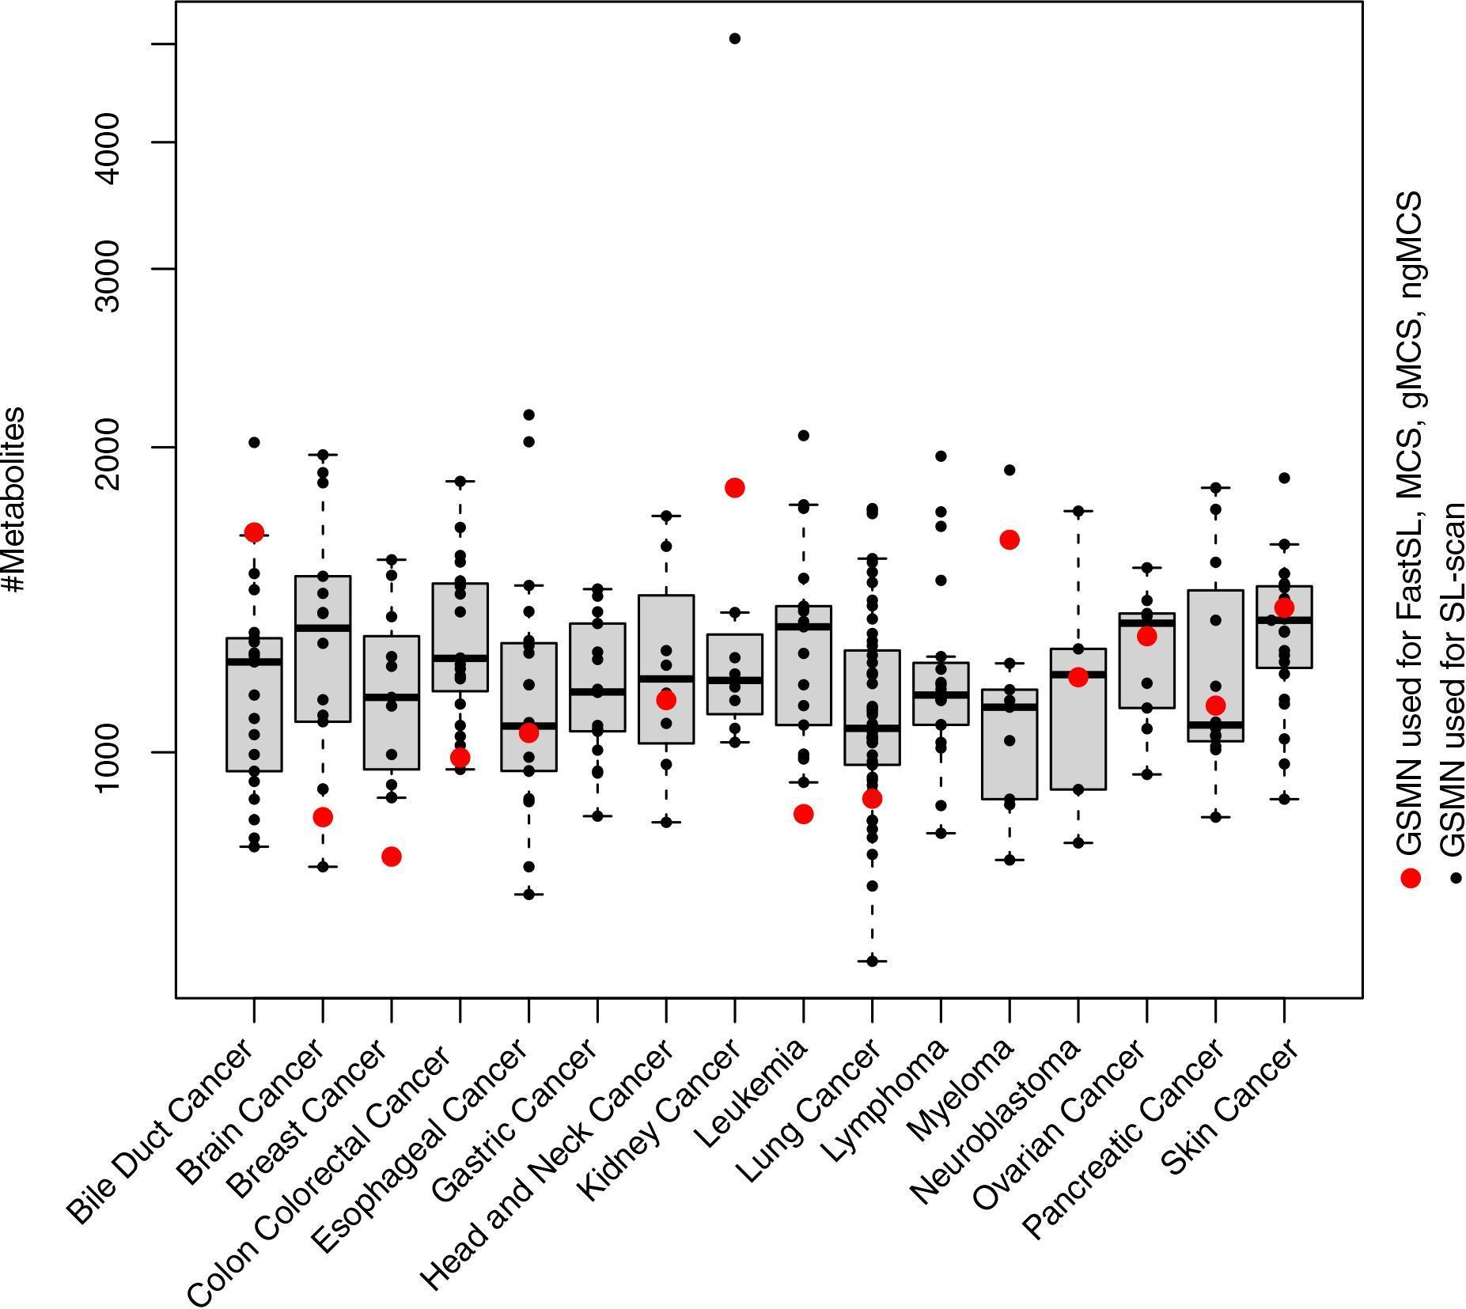
Supplementary Figure S1 the distribution of metabolites of GSMNs in various cancer types. The corresponding values from the SL-scan pipeline are depicted as black dots, while the correspnding values for other SL prediction algorithms are indicated with red dots.

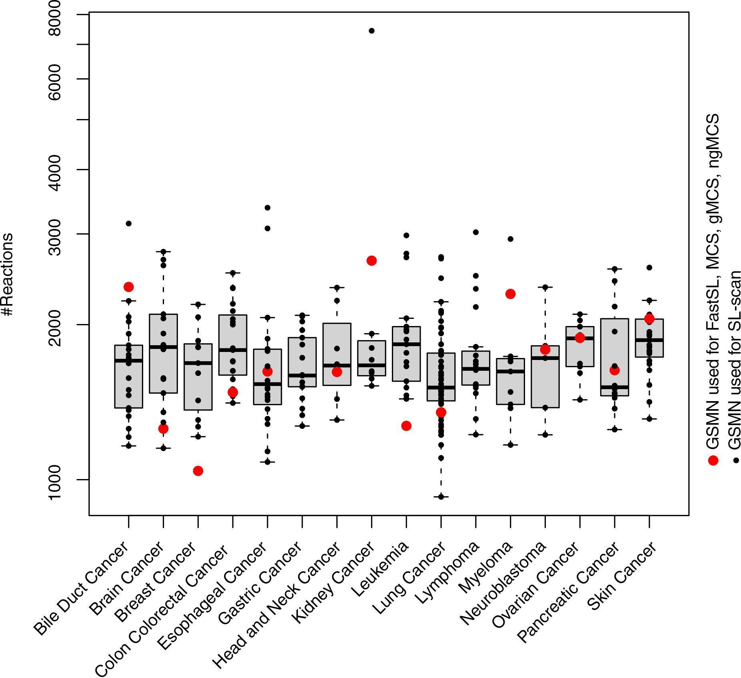
Supplementary Figure S2 the distribution of reactions of GSMNs in various cancer types. The corresponding values from the SL-scan pipeline are depicted as black dots, while the correspnding values for other SL prediction algorithms are indicated with red dots.

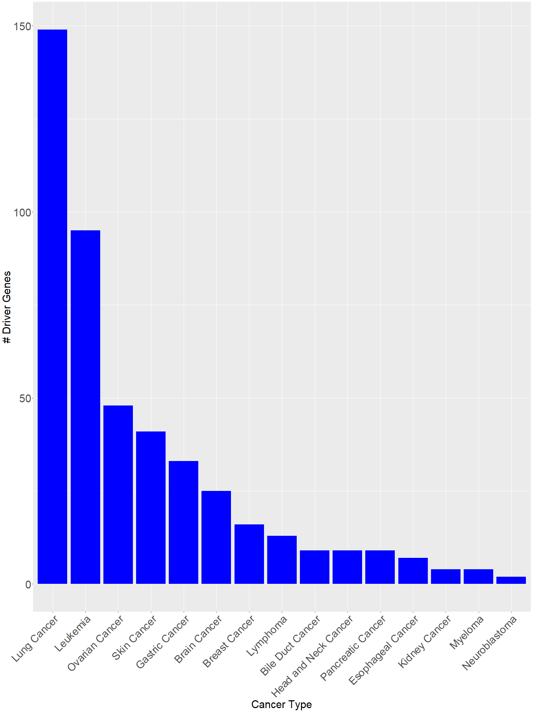
Supplementary Figure S3 number of driver genes across different cancer types.

