Large-band-gap non-Dirac quantum spin Hall states and strong Rashba effect in functionalized thallene films
Xiaojuan Liu¹, Zhijian Li¹, Hairui Bao¹, and Zhongqin Yang^{1,2}*
¹State Key Laboratory of Surface Physics, Key Laboratory of Computational Physical Sciences (MOE) and Department of Physics, Fudan University, Shanghai 200433, China
²Shanghai Qi Zhi Institute, Shanghai 200030, China
*Email: zyang@fudan.edu.cn

TABLE SI. The calculated equilibrium lattice constants (a and c) and atom positions for the Tl₂H and Tl₂H₂ monolayers.
 | Lattice constants  (Å) | Atoms | Position
 | Lattice constants  (Å) | Atoms | x | y | z
Tl₂H | a = 5.24 | Tl₁ | 0.3333 | 0.6667 | 0.5068
 | c = 19.71 | Tl₂ | 0.6667 | 0.3333 | 0.4920
 |  | H | 0.3333 | 0.6667 | 0.6012
Tl₂H₂ | a = 5.28 | Tl₁ | 0.3333 | 0.6667 | 0.5015
 | c = 19.33 | Tl₂ | 0.6667 | 0.3333 | 0.5015
 |  | H₁ | 0.3333 | 0.6667 | 0.5985
 |  | H₂ | 0.6667 | 0.3333 | 0.5985

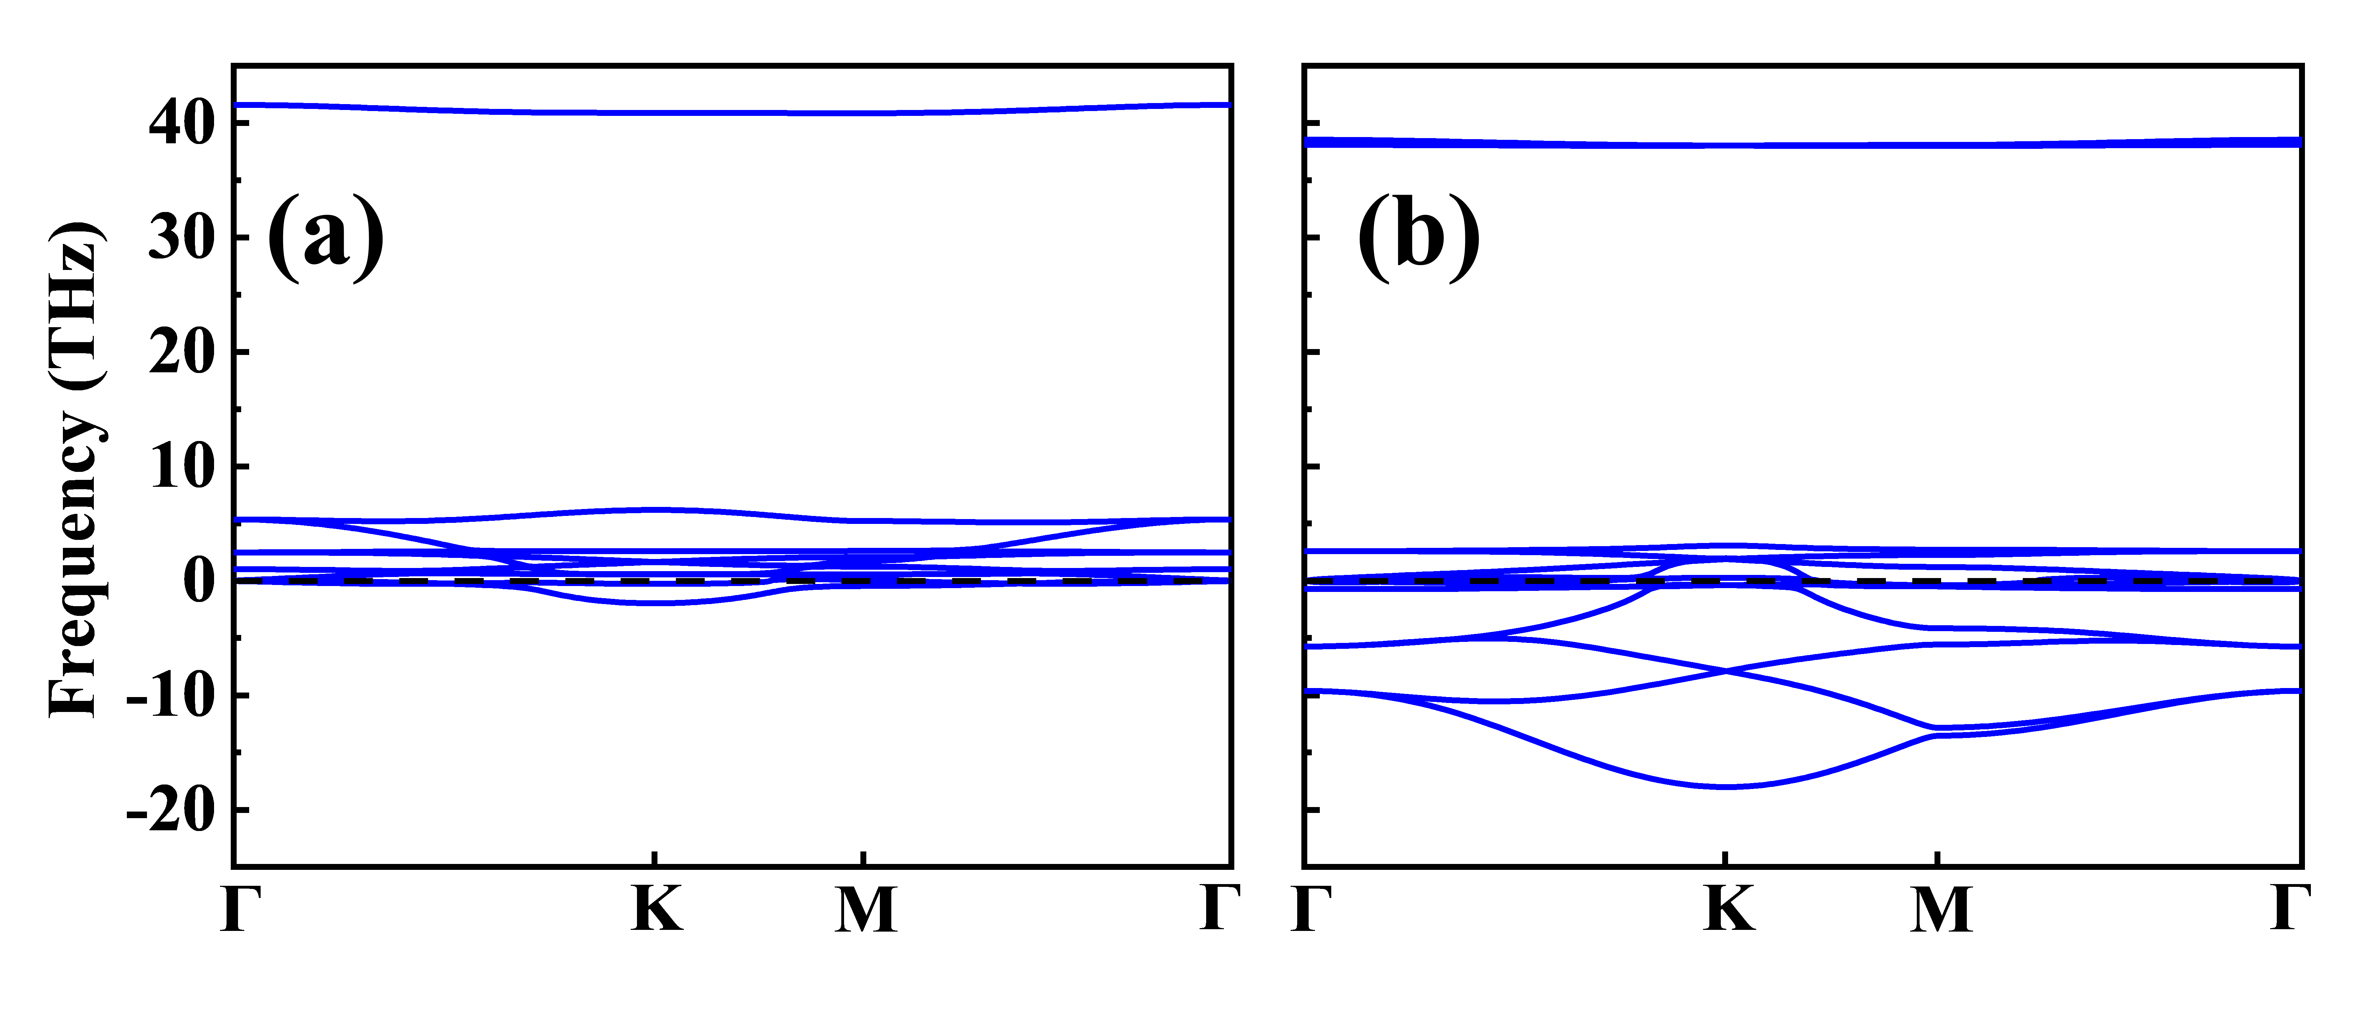
Fig. S1. The calculated phonon spectra of the Tl₂H (a) and Tl₂H₂ (b) monolayers.

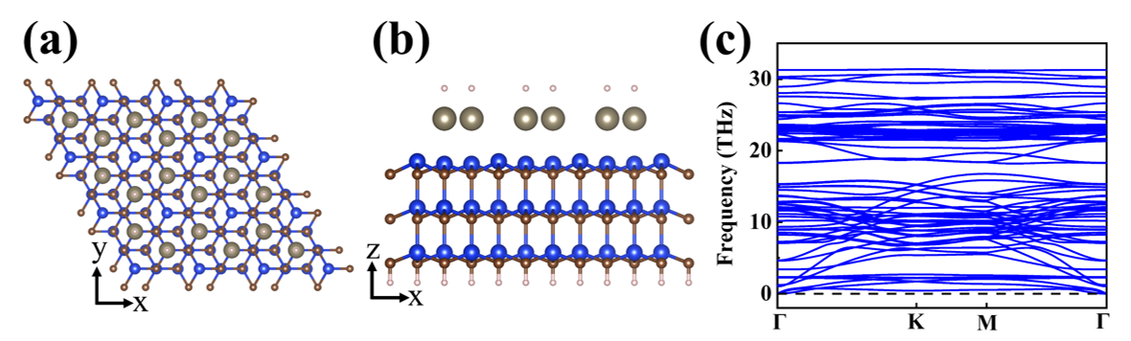
Fig. S2. The top (a) and side (b) views for the Tl₂H₂ monolayer on the SiC substrate. (c) The calculated phonon spectrum of the Tl₂H₂ monolayer on the SiC substrate.

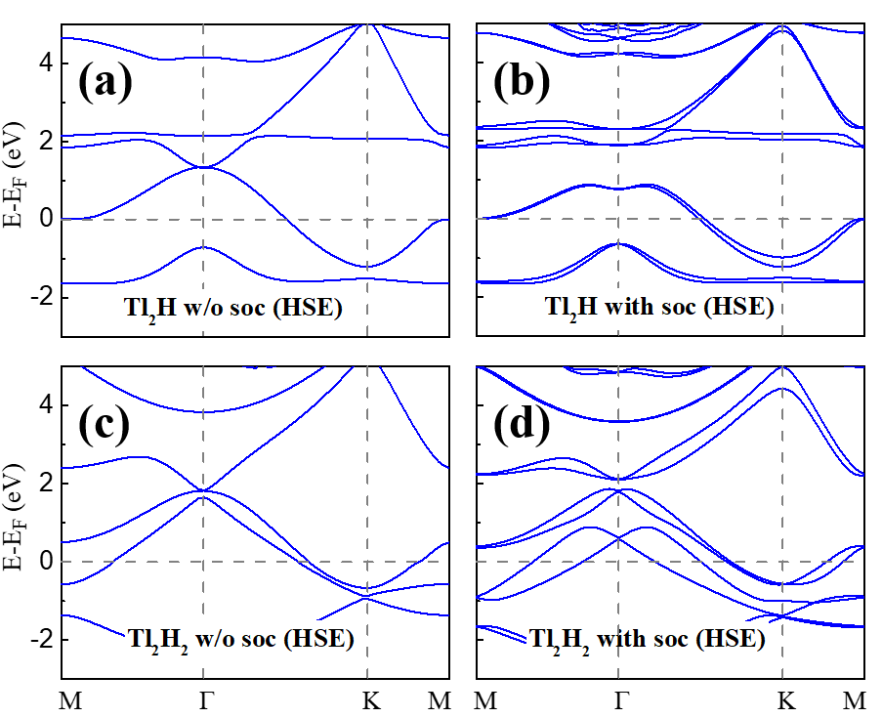
Fig. S3. Band structures obtained with HSE06 functional. (a) and (b) are for the Tl₂H monolayer without and with SOC, respectively. (c) and (d) are for the Tl₂H₂ monolayer without and with SOC, respectively.

Fig. S4. The binding energies as a function of the strain for the monolayer Tl₂H and Tl₂H₂. The red and green colors give the Tl₂H and Tl₂H₂ results, respectively.

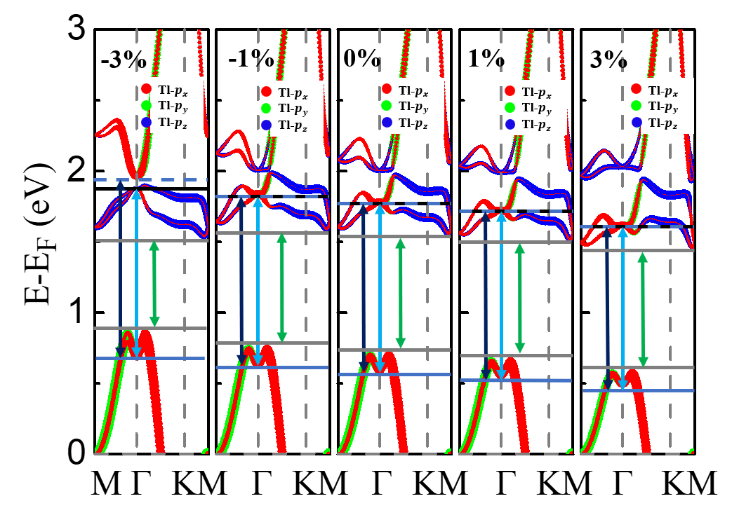
Fig. S5. (Color online) The orbital-projected band structures of the monolayer Tl₂H under different strengths of the biaxial strain. The SOC is considered. The dot size is proportional to the contribution of the corresponding orbitals. The blue arrow represents the direct band gap (△E_{d}) at the Γ point. The black arrow represents the split of p_{x/y} orbitals for SOC. The green arrow represents the global band gap (△E_{g}).

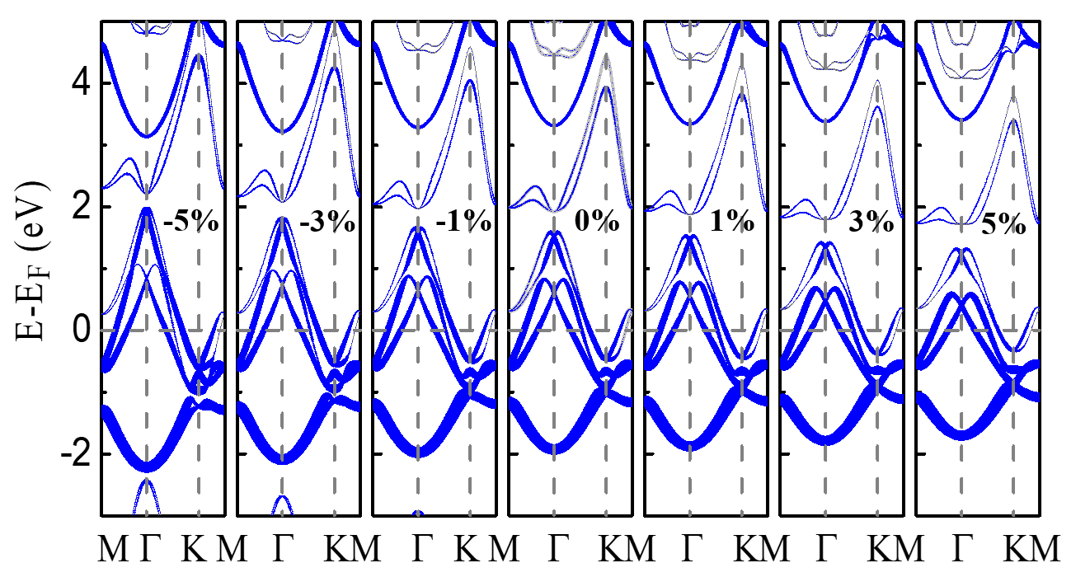
Fig. S6. (Color online) The band structures of the monolayer Tl₂H₂ under different strengths of the biaxial strain. The SOC is considered. The blue dots represent the distribution of p_{z} orbital in the system under the corresponding conditions.

