Table S1. List of indicator species for forest interior, transition zones and pastures (rows) at abrupt and gradual forest edges (columns). The habitat preference of each indicator species is given along with its indicator value (in parentheses). Nomenclature follows MolluscaBase⁵².

 | Abrupt forest edge | Gradual forest edge
Forest | Cochlostoma septemspirale FOREST (0.564)  Discus rotundatus FOREST (0.462)  Helicodonta obvoluta FOREST (0.451)  Acanthinula aculeata FOREST (0.451)  Acicula lineata FOREST (0.391)  Aegopinella nitens FOREST (0.369)  Carychium tridentatum UBIQUITOUS (0.357)  Vitrea subrimata FOREST (0.357)  Aegopinella pura FOREST (0.348)  Cochlodina fimbriata FOREST (0.257)  Orcula dolium FOREST (0.176)  Vitrea crystallina UBIQUITOUS (0.154)  Euconulus fulvus UBIQUITOUS (0.153)  Isognomostoma isognomostomos FOREST (0.084)  Arianta arbustorum UBIQUITOUS (0.069) | Discus rotundatus FOREST (0.458)  Cochlostoma septemspirale FOREST (0.392)  Helicodonta obvoluta FOREST (0.373)  Carychium tridentatum UBIQUITOUS (0.307)  Cochlodina fimbriata FOREST (0.228)  Monachoides incarnatus FOREST (0.214)  Vitrea subrimata FOREST (0.199)  Acicula lineata FOREST (0.141)  Cochlodina laminata FOREST (0.139)
Transition zone | Punctum pygmaeum UBIQUITOUS (0.360)  Merdigera obscura FOREST (0.318)  Abida secale UBIQUITOUS (0.278)  Cochlodina laminata FOREST (0.268)  Helicigona lapicida FOREST (0.170) | Vitrina pellucida OPENLAND (0.341)  Acanthinula aculeata FOREST (0.282)  Merdigera obscura FOREST (0.217)  Aegopinella pura FOREST (0.187)  Arianta arbustorum UBIQUITOUS (0.056)
Pasture | Vertigo pygmaea OPENLAND (0.869)  Vallonia excentrica OPENLAND (0.771)  Helicella itala OPENLAND (0.652)  Vallonia costata OPENLAND (0.649)  Pupilla muscorum OPENLAND (0.462)  Truncatellina cylindrica OPENLAND (0.445)  Vallonia pulchella OPENLAND (0.403)  Cochlicopa lubricella OPENLAND (0.361)  Candidula unifasciata OPENLAND (0.264)  Cecilioides acicula OPENLAND (0.221)  Perpolita hammonis UBIQUITOUS (0.207) | Vertigo pygmaea OPENLAND (0.922)  Vallonia excentrica OPENLAND (0.821)  Vallonia costata OPENLAND (0.667)  Pupilla muscorum OPENLAND (0.648)  Helicella itala OPENLAND (0.578)  Truncatellina cylindrica OPENLAND (0.565)  Vallonia pulchella OPENLAND (0.417)  Cochlicopa lubricella OPENLAND (0.411)  Trochulus hispidus UBIQUITOUS (0.269)  Perpolita hammonis UBIQUITOUS (0.177)  Candidula unifasciata OPENLAND (0.111)  Clausilia rugosa parvula UBIQUITOUS (0.097)

Table S2. Locations of the forest edges examined with elevation, inclination and soil pH of the sites in the Jura Mountains, Switzerland: g = gradual forest edge, a = abrupt forest edge; soil pH represents the average of three soil samples obtained from the pasture, forest edge and forest interior.

Pasture Locality Type of Coordinates Elevation Inclination Soil pH
forest edge N / E (m a.s.l.) (º)
Dittingerweid Dittingen g 47.4462 / 7.4936 520 23.6 6.4
Nenzlingerweid Nenzlingen g 47.4488 / 7.5683 520 19.4 5.3
Hellberg Liesberg g 47.3996 / 7.4075 585 23.7 7.3
Räschberg Liesberg g 47.4129 / 7.4263 700 23.9 7.3
Obere Wengi Matzendorf g 47.3253 / 7.6222 930 27.1 7.0
Haute Abateuse Movelier g 47.4153 / 7.3264 810 23.3 7.2
La Combe Soyhières a 47.4013 / 7.3594 590 33.9 7.3
Liesbergweid Liesberg a 47.4066 / 7.4168 590 22.2 7.0
Chli Weid Bretzwil a 47.3849 / 7.6343 910 20.8 5.5
Lauchweid Langenbruck a 47.3767 / 7.7889 990 30.0 6.8
Ulmet Lauwil a 47.3810 / 7.6539 990 27.1 6.8
Blauenweid Blauen a 47.4583 / 7.5244 670 26.2 7.0
_______________________________________________________________________________________________________

Table S3. Environmental variables [mean (± SE)] assessed in plots in the three habitat types (forest, transition zone and pasture) at both abrupt and gradual forest edges.

 | Abrupt forest edge |  |  | Gradual forest edge
Environmental variables | Forest¹ | Transition  zone² | Pasture¹ | Forest¹ | Transition  zone² | Pasture¹
Open ground (%) | 2.00 (±0.49) | 11.17 (±2.91) | 5.03 (±0.67) | 5.06 (±1.35) | 8.22 (±2.29) | 8.51 (±0.99)
Old grass (%) | 2.88 (±0.87) | 2.89 (±0.93) | 7.42 (±0.80) | 1.07 (±0.26) | 4.58 (±1.95) | 10.5 (±0.98)
Grass (%) | 4.46 (±1.01) | 7.11 (±2.11) | 37.76 (±1.86) | 3.00 (±0.81) | 4.64 (±1.10) | 49.21 (±1.89)
Herbs (%) | 3.77 (±0.36) | 7.61 (±1.52) | 38.46 (±1.98) | 4.71 (±0.63) | 11.28 (±2.52) | 25.99 (±1.82)
Stones (%) | 17.93 (±2.41) | 14.25 (±2.82) | 3.36 (±0.69) | 3.36 (±0.71) | 1.17 (±0.48) | 0.93 (±0.20)
Deadwood (%) | 7.97 (±0.77) | 4.78 (±0.59) | 0.49 (±0.13) | 7.49 (±1.02) | 4.28 (±0.86) | 0.31 (±0.11)
Leaf litter cover (%) | 55.08 (±3.22) | 41.75 (±5.72) | 7.19 (±1.59) | 65.37 (±2.94) | 54.44 (±3.92) | 2.14 (±0.75)
Litter layer (cm) | 3.24 (±0.22) | 2.19 (±0.27) | 0.17 (±0.07) | 3.37 (±0.21) | 2.50 (±0.21) | 0.02 (± 0.01)
Canopy closure (%) | 77.63 (±1.91) | 77.75 (±4.03) | 8.82 (±2.59) | 74.07 (±2.41) | 65.69 (±5.73) | 0.42 (±0.29)

¹ n = 72 plots
² n = 36 plots

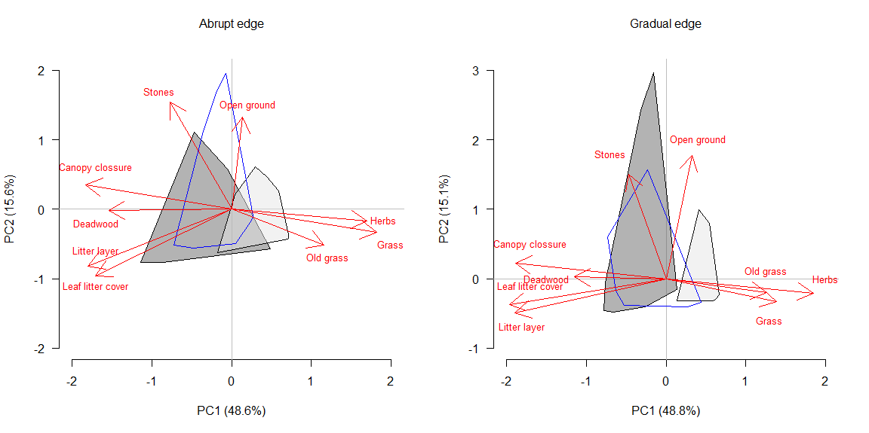
Fig. S1. Principal component analysis (PCA) biplot of quantified plot-level environmental characteristics in the forests, transition zones, and pastures across abrupt (left) and gradual (right) forest edges (red arrows). For clarity, plots are shown only as convex hulls representing forest (dark grey), pasture (light grey) and the transition zone (blue line).

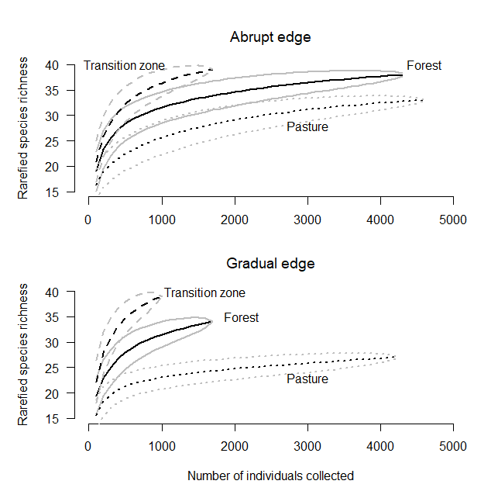
Fig. S2. Individual-based rarefaction curves of snail species richness for forests, transition zones and pastures at both abrupt and gradual forest edges, with 95% confidence intervals.

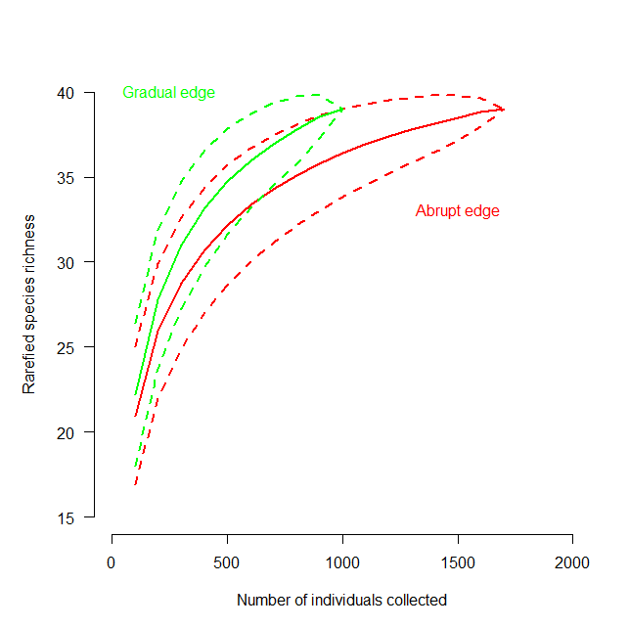Fig. S3. Individual-based rarefaction curves of snail species richness for transition zones at abrupt (red) and gradual (green) forest edges, with 95% confidence intervals.

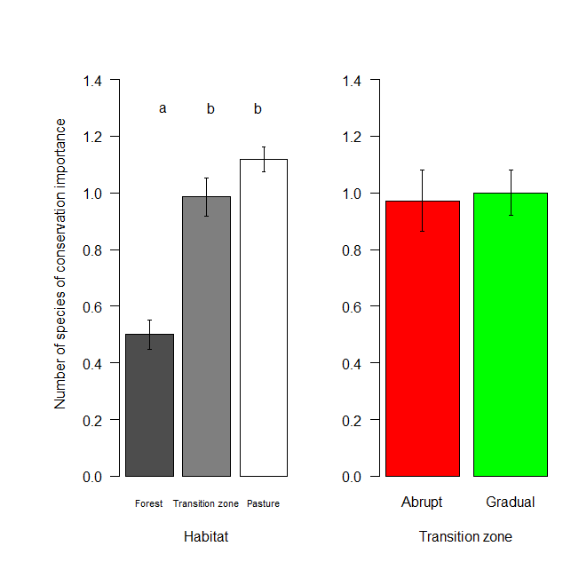
Fig S4. Number of snail species of conservation importance in forests (dark grey), transition zones (light grey), and pastures (white; left), and in the transition zones at gradual and gradual forest edges (right). Bars show mean values (forests, n = 72; transition zone, n = 36; pasture, n = 72) and whiskers standard errors. Different letters indicate significant differences by Tukey test.

