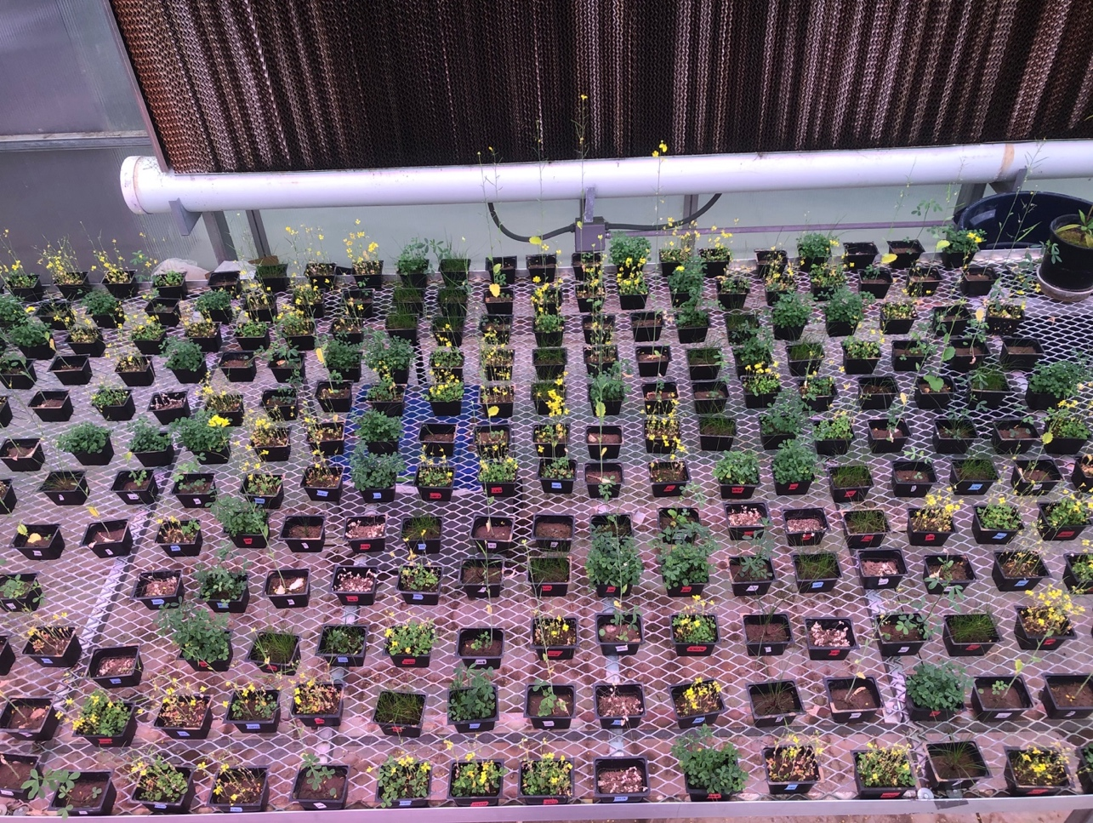
Supplementary Figure S1: Picture of the microcosm experiment

Supplementary Table S1: Experimental set up of the 21 different treatments
 | Monoculture | Polyculture
Low Density | 1. Alfalfa (1 Plant) | 10. Alfalfa (1 Plant) and Brassica (1 Plant)
(1-3 Plants per microcosm) | 2. Brassica (1 Plant) | 11. Alfalfa (1 Plant) and Fescue (1 Plant)
 | 3. Fescue (1 Plant) | 12. Brassica (1 Plant) and Fescue (1 Plant)
 |  | 13. Alfalfa (1 Plant), Brassica (1 Plant), and Fescue (1 Plant)
Medium Density | 4. Alfalfa (24 Plants) | 14. Alfalfa (12 Plants) and Brassica (12 Plants)
(24 Plants per microcosm) | 5. Brassica (24 Plants) | 15. Alfalfa (12 Plants) and Fescue (12 Plants)
 | 6. Fescue (24 Plants) | 16. Brassica (12 Plants) and Fescue (12 Plants)
 |  | 17. Alfalfa (8 Plants), Brassica (8 Plants), and Fescue (8 Plants)
High Density | 7. Alfalfa (48 Plants) | 18. Alfalfa (24 Plants) and Brassica (24 Plants)
(48 Plants per microcosm) | 8. Brassica (48 Plants) | 19. Alfalfa (24 Plants) and Fescue (24 Plants)
 | 9. Fescue (48 Plants) | 20. Brassica (24 Plants) and Fescue (24 Plants)
 |  | 21. Alfalfa (16 Plants), Brassica (16 Plants), and Fescue (16 Plants)

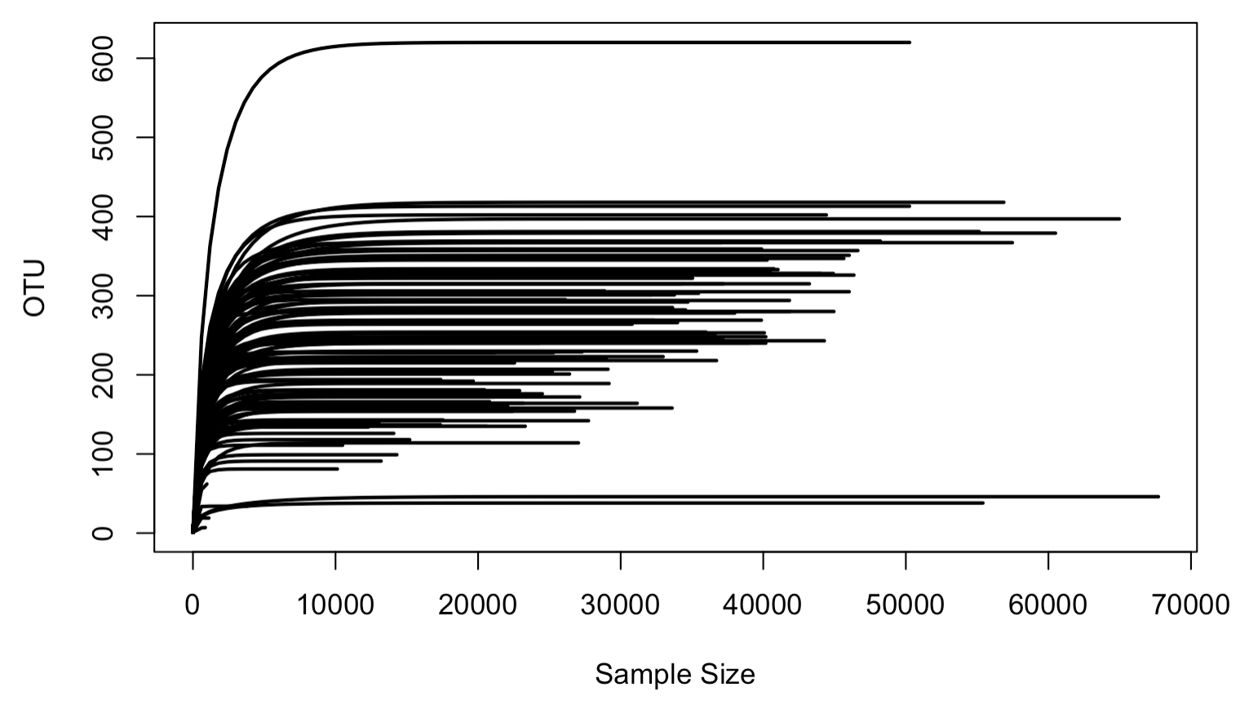
Supplementary Figure S2: Rarefaction Curve for all samples

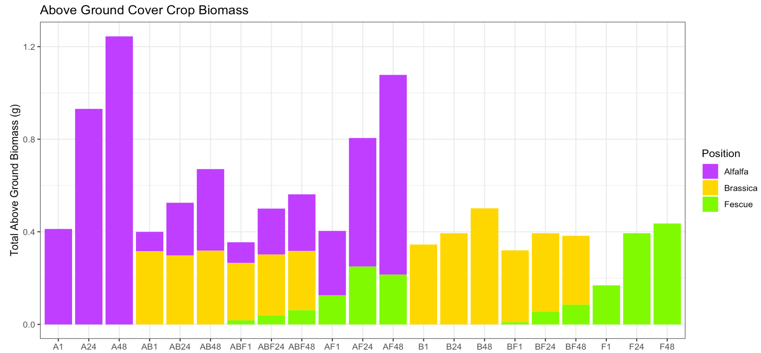
Supplementary Figure S3: Total above ground cover crop biomass stacked by crop (alfalfa: purple, brassica: gold, fescue: lime green).

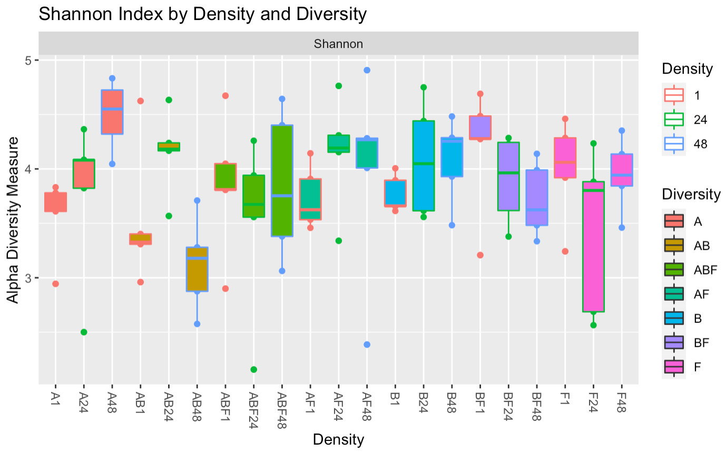
Supplementary Figure S4: Alpha diversity of bacterial microbiomes denoted by increasing densities of monoculture and plant mixtures.
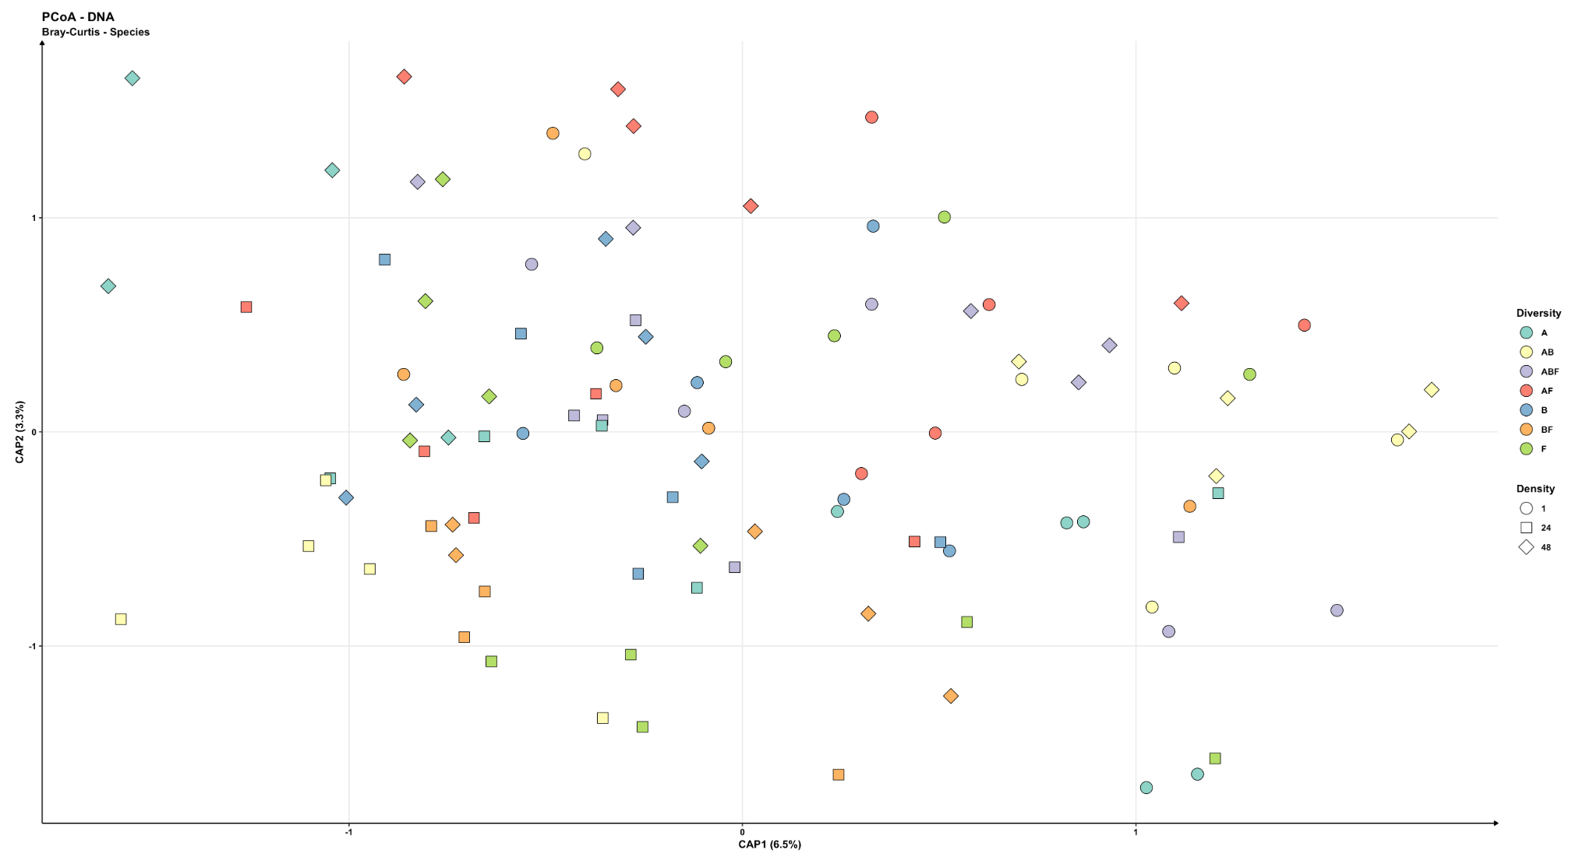
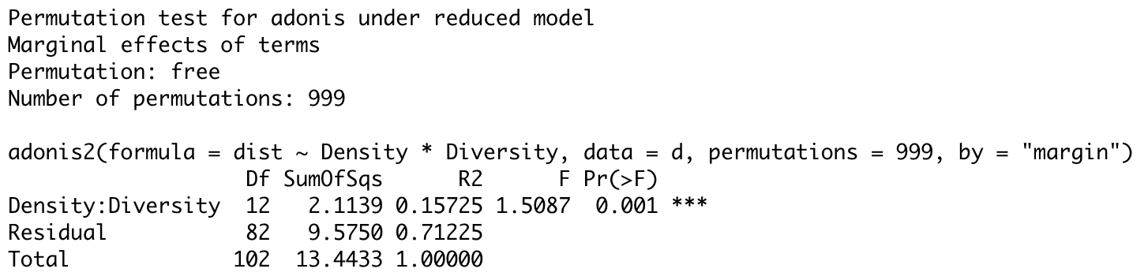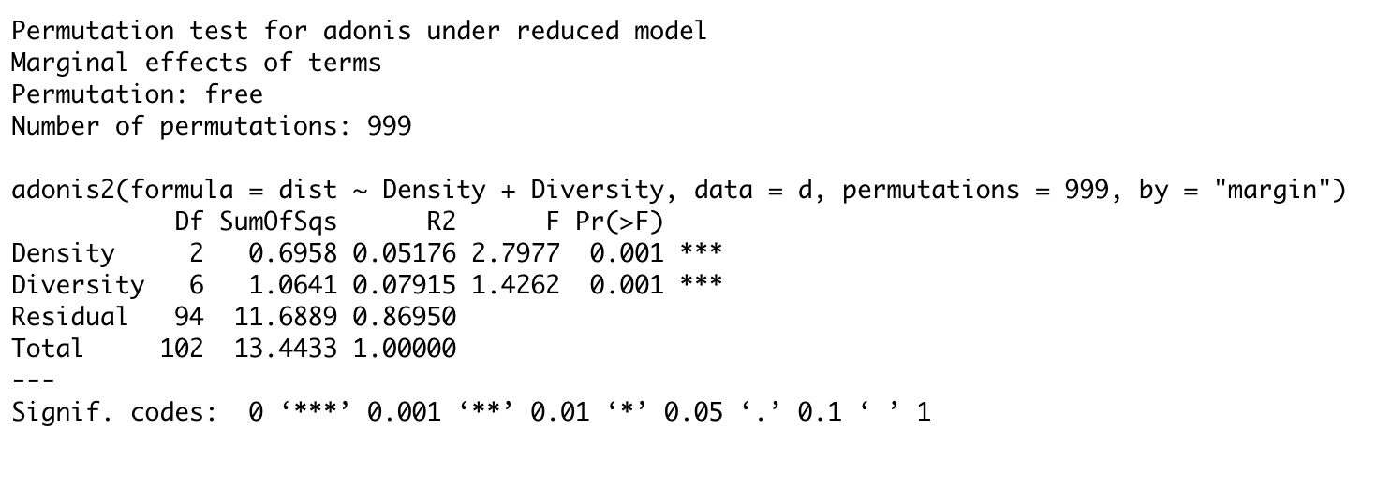
Supplementary Figure S5: PERMANOVA model with all data combined of the interaction between plant diversity and density and the significance of both factors separately on the structure of bacteriomes

Supplementary Table S2: Analysis of Principal Coordinates Summary:
Alfalfa Monocrop
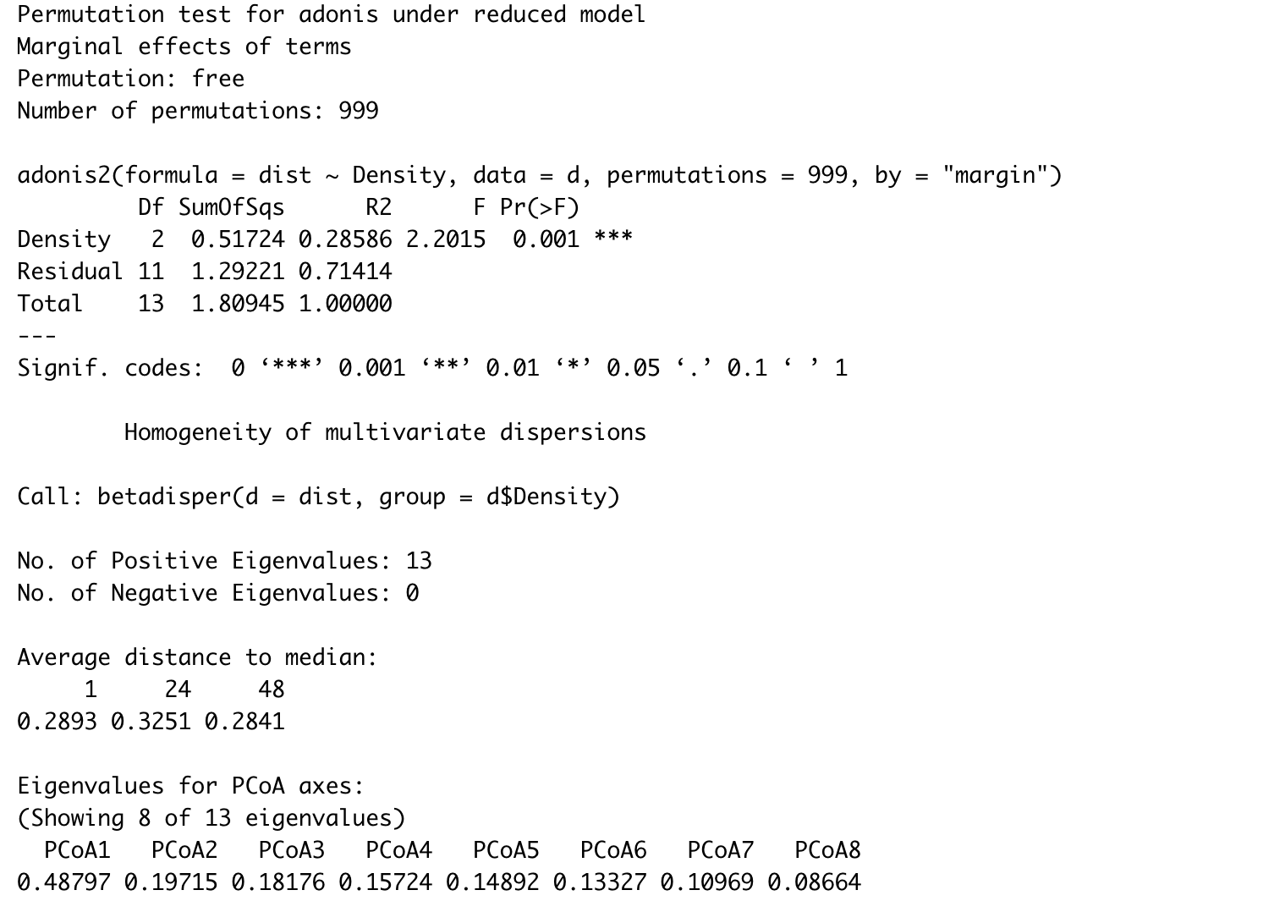

Brassica Monocrop
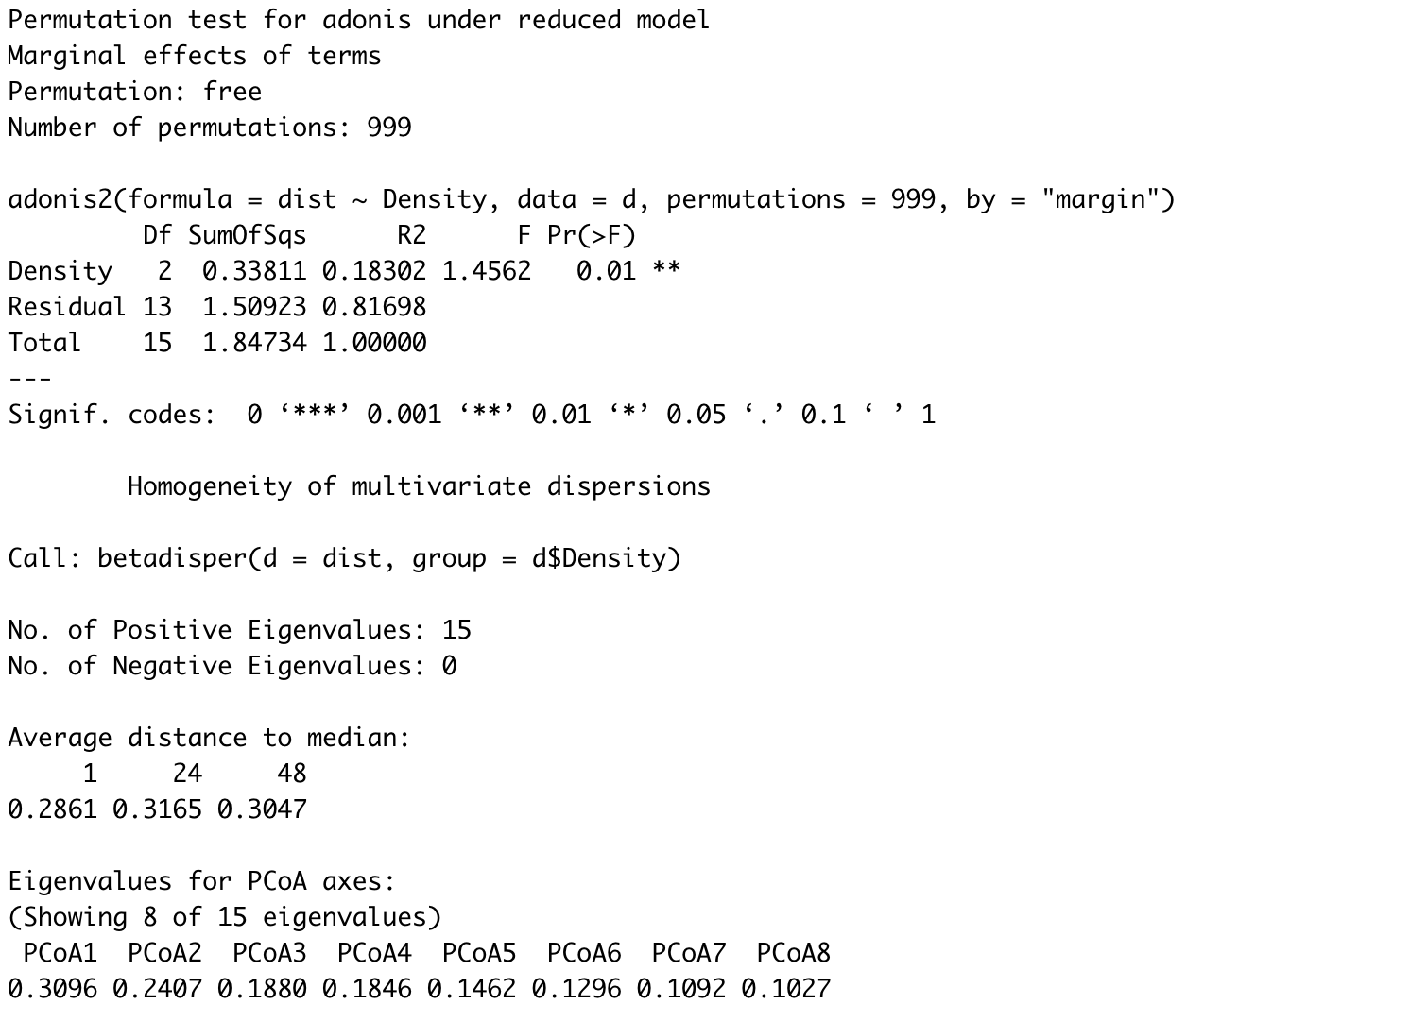
Fescue Monocrop
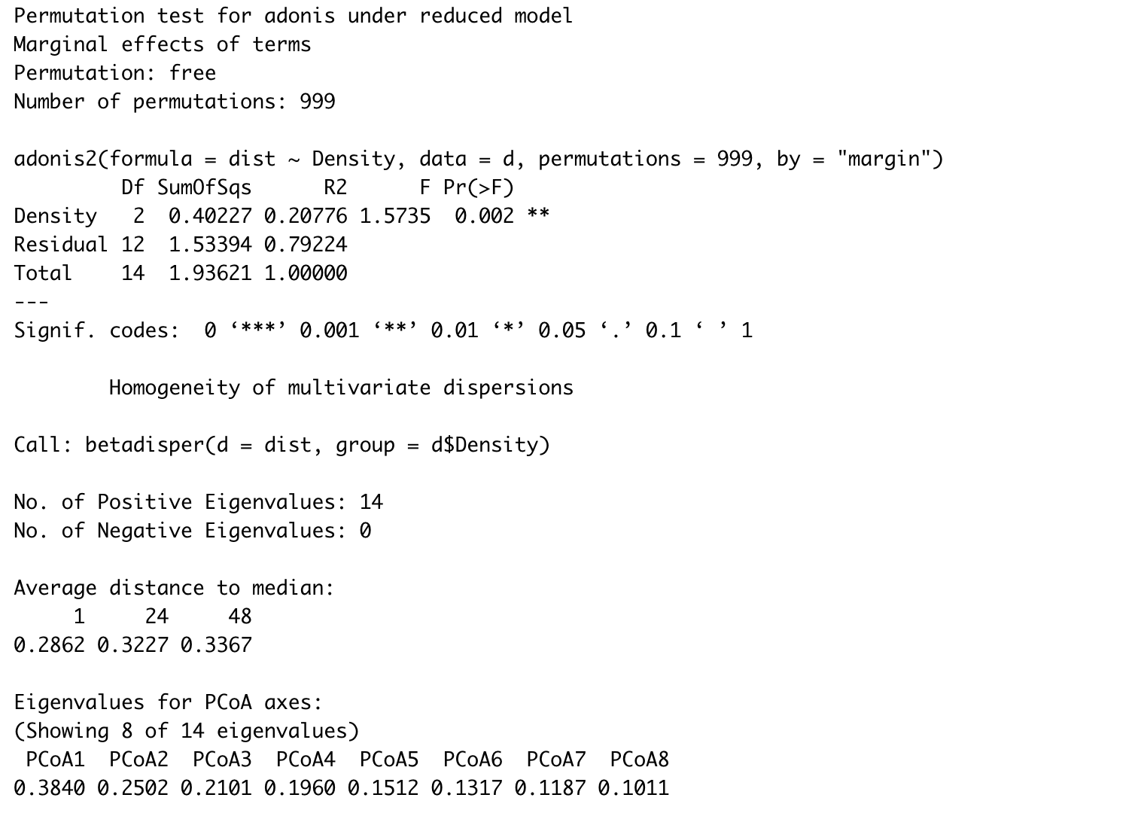

Alfalfa-Brassica Mixture
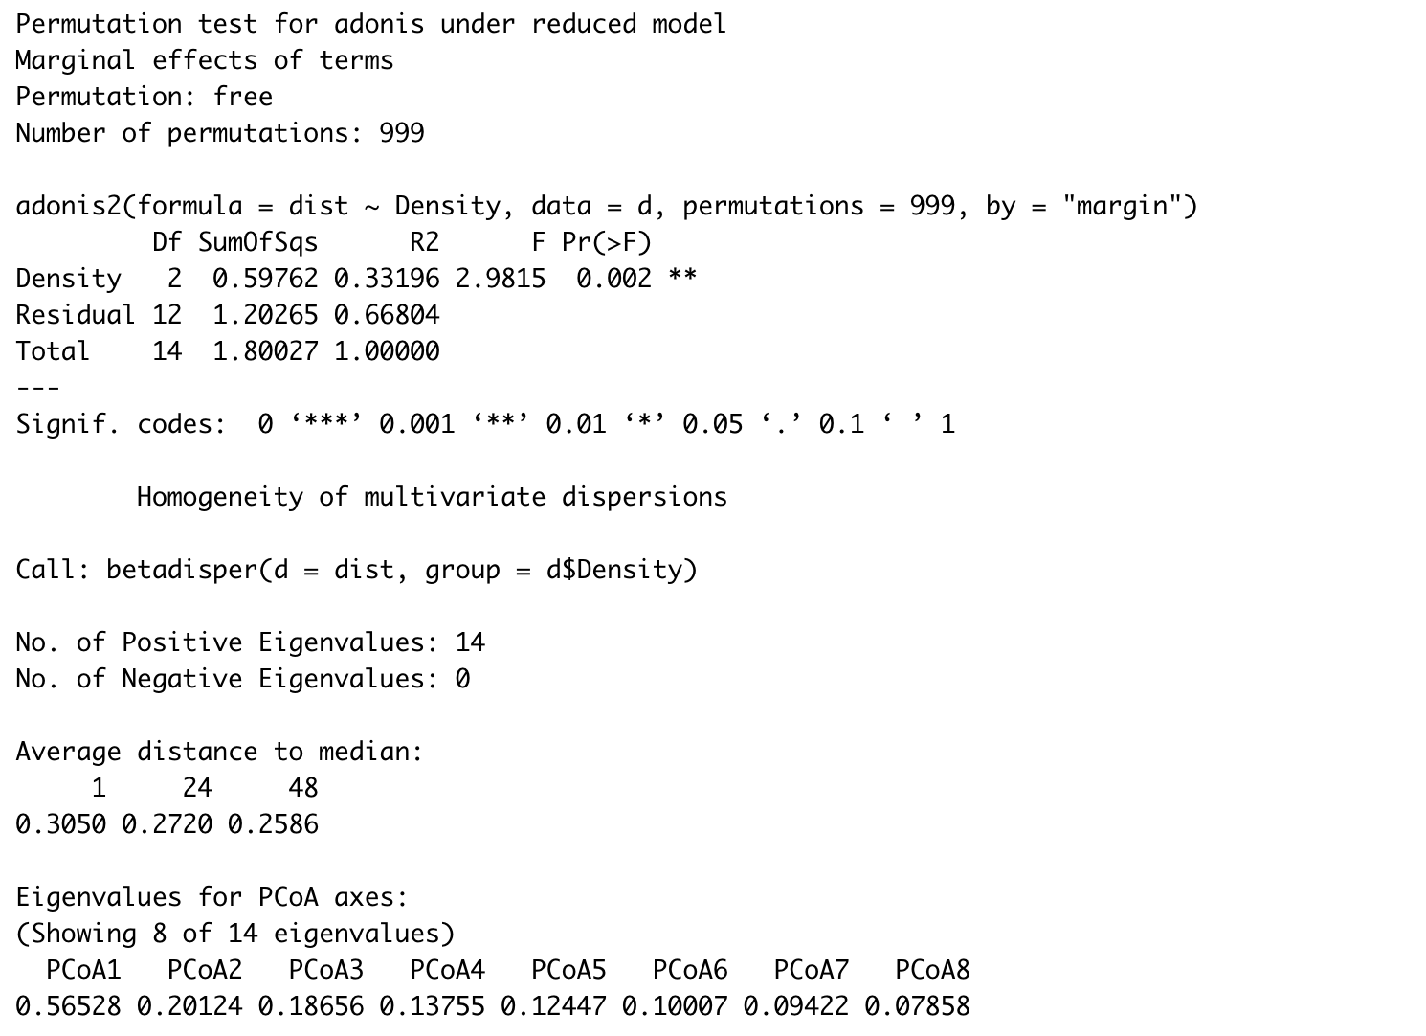
Alfalfa-Fescue Mixture
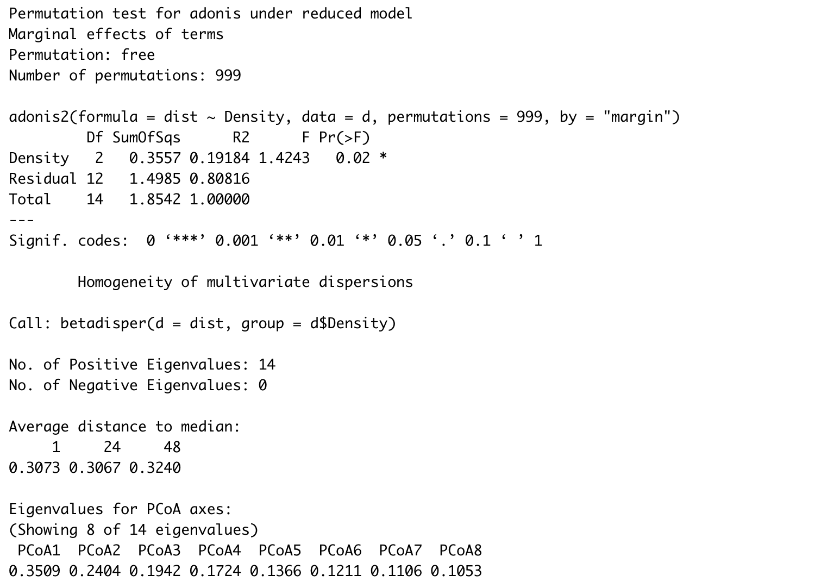
Brassica-Fescue Mixture
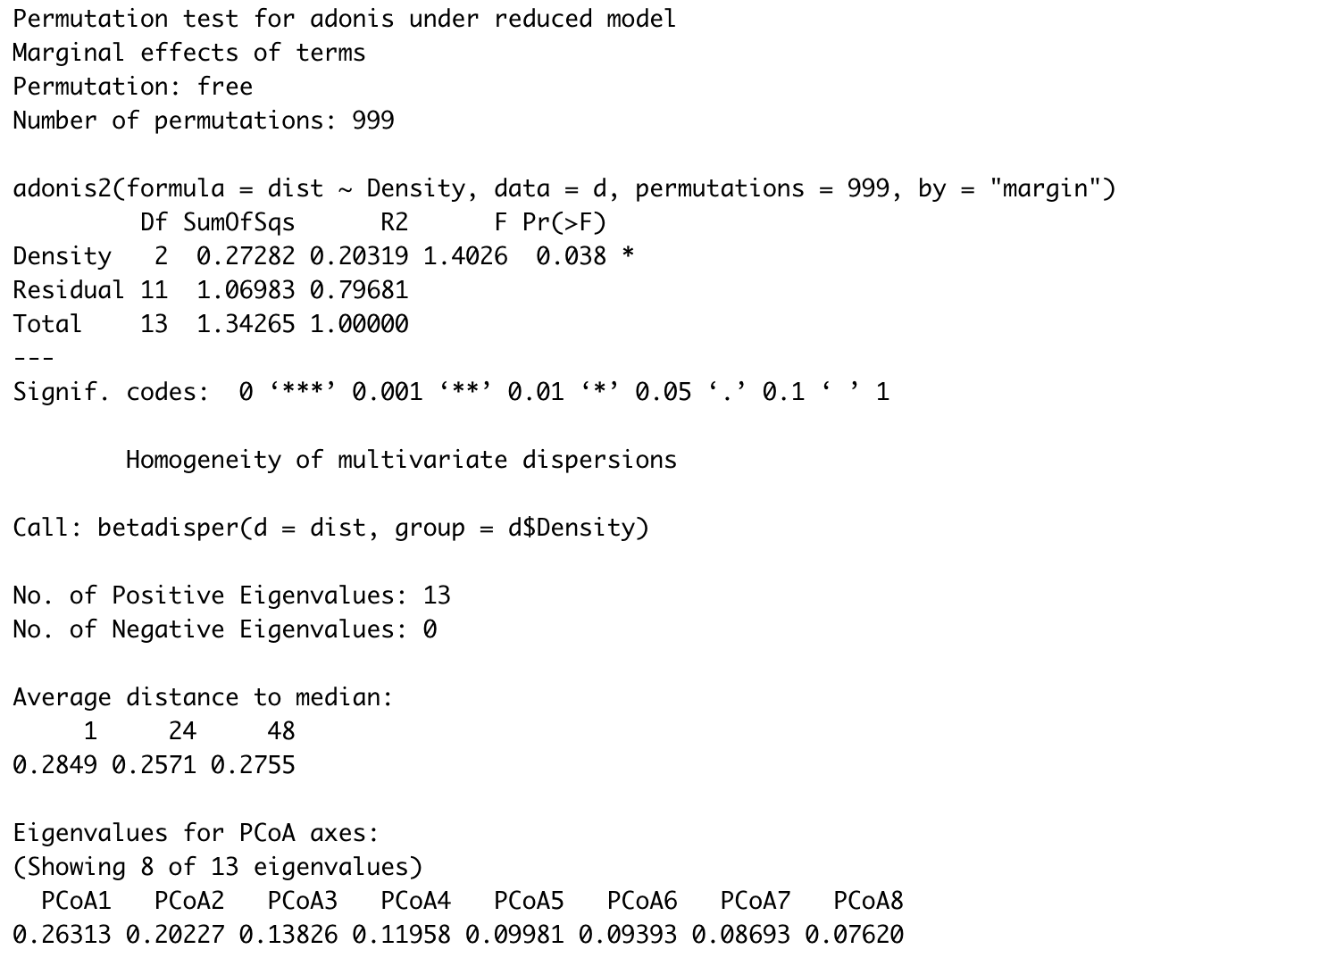
Alfalfa-Brassica-Fescue Mixture
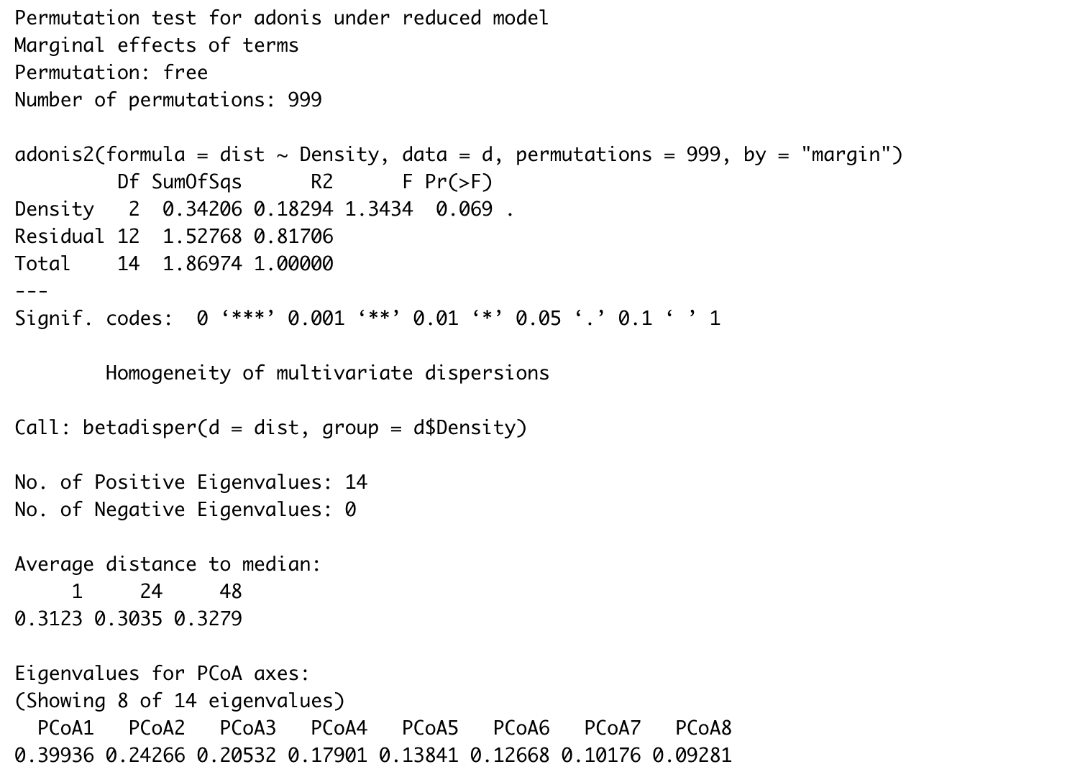

Supplementary Table S3: Aboveground plant biomass per individual plant by treatment
Alfalfa Treatment | Individual Plant weight (g) | Brassica Treatment | Individual Plant weight (g) | Fescue Treatment | Individual Plant weight (g)
Alfalfa 1 | 0.349 | Brassica 1 | 0.344 | Fescue 1 | 0.168
Alfalfa-brassica1 | 0.109 | alfalfa-Brassica 1 | 0.316 | alfalfa-Fescue 1 | 0.125
Alfalfa-fescue 1 | 0.334 | Brassica-fescue 1 | 0.311 | brassica-Fescue 1 | 0.011
Alfalfa-brassica-fescue 1 | 0.097 | alfalfa-Brassica-fescue 1 | 0.249 | alfalfa-brassica-Fescue 1 | 0.016
Alfalfa 24 | 0.037 | Brassica 24 | 0.016 | Fescue 24 | 0.014
Alfalfa-brassica 24 | 0.018 | alfalfa-Brassica 24 | 0.023 | alfalfa-Fescue 24 | 0.018
Alfalfa-fescue 24 | 0.048 | Brassica-fescue 24 | 0.026 | brassica-Fescue 24 | 0.004
Alfalfa-brassica-fescue 24 | 0.022 | alfalfa-Brassica-fescue 24 | 0.028 | alfalfa-brassica-Fescue 24 | 0.004
Alfalfa 48 | 0.031 | Brassica 48 | 0.012 | Fescue 48 | 0.010
Alfalfa-brassica 48 | 0.016 | alfalfa-Brassica 48 | 0.013 | alfalfa-Fescue 48 | 0.010
Alfalfa-fescue 48 | 0.041 | Brassica-fescue 48 | 0.012 | brassica-Fescue 48 | 0.004
Alfalfa-brassica-fescue 48 | 0.016 | alfalfa-Brassica-fescue 48 | 0.013 | alfalfa-brassica-Fescue 48 | 0.004

Supplementary Table S4: Differential abundance results for alfalfa monocrop
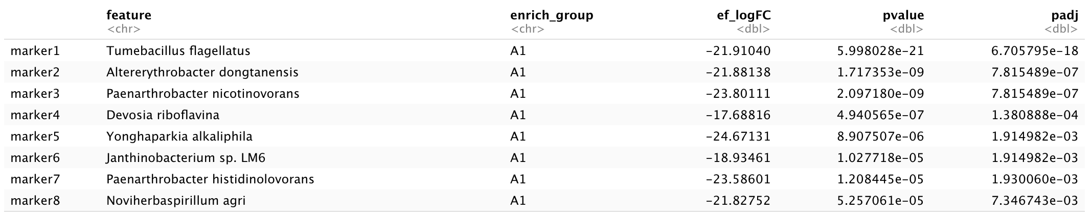
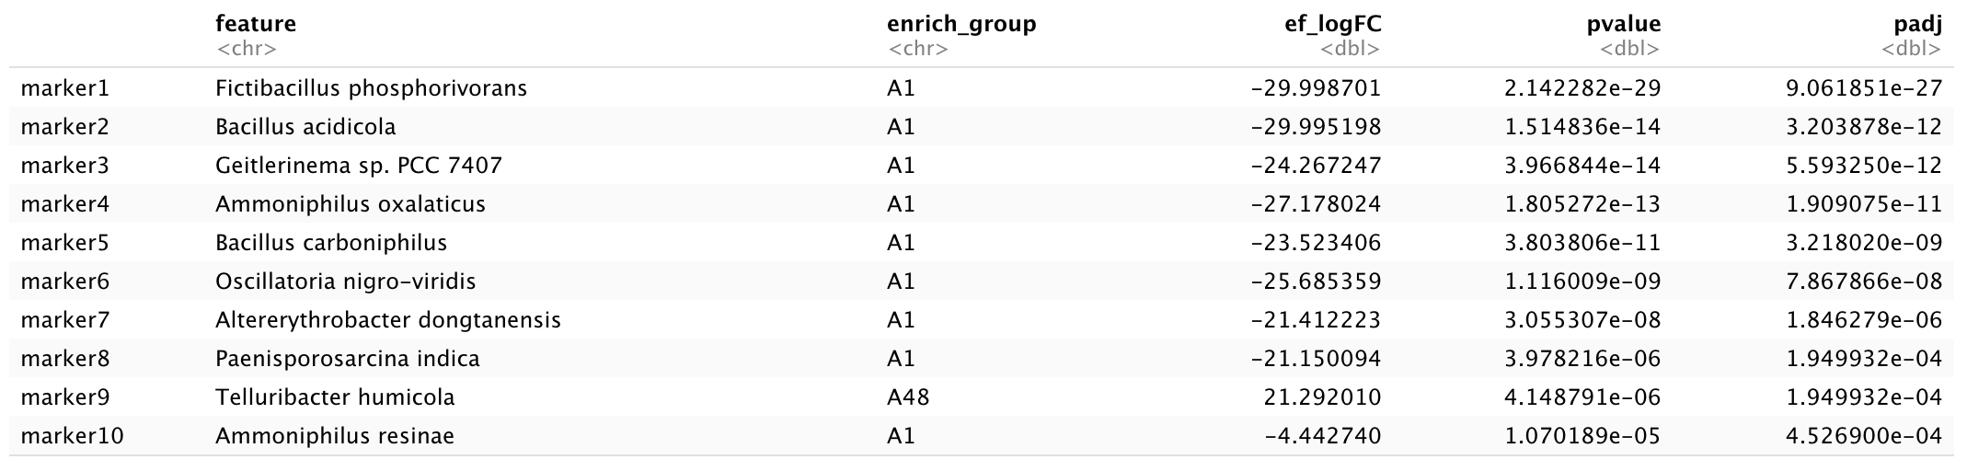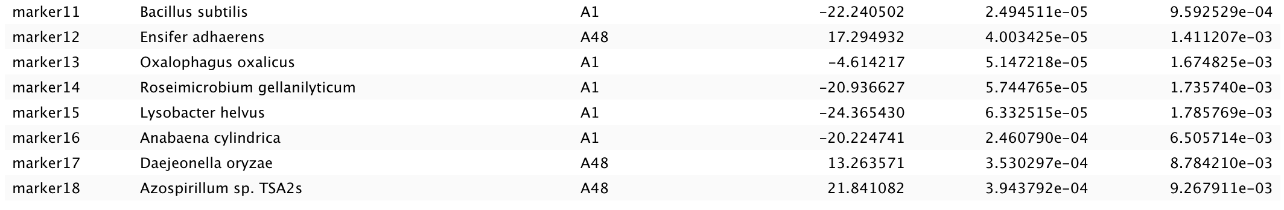
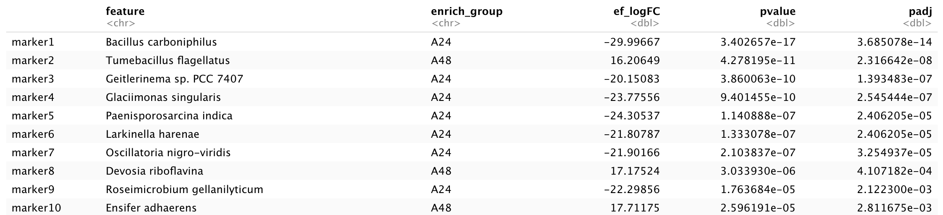

Supplementary Table S5: Differential abundance results for brassica monocrop
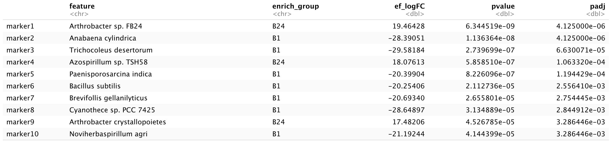

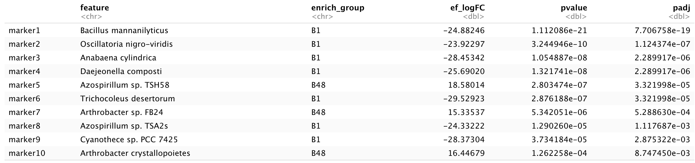

Supplementary Table S6: Differential abundance results for fescue monocrop
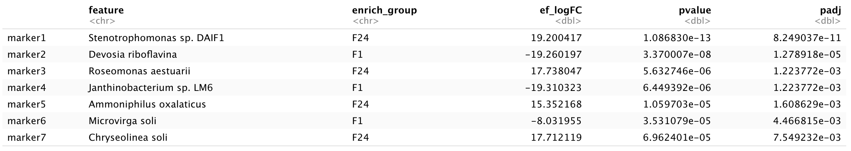
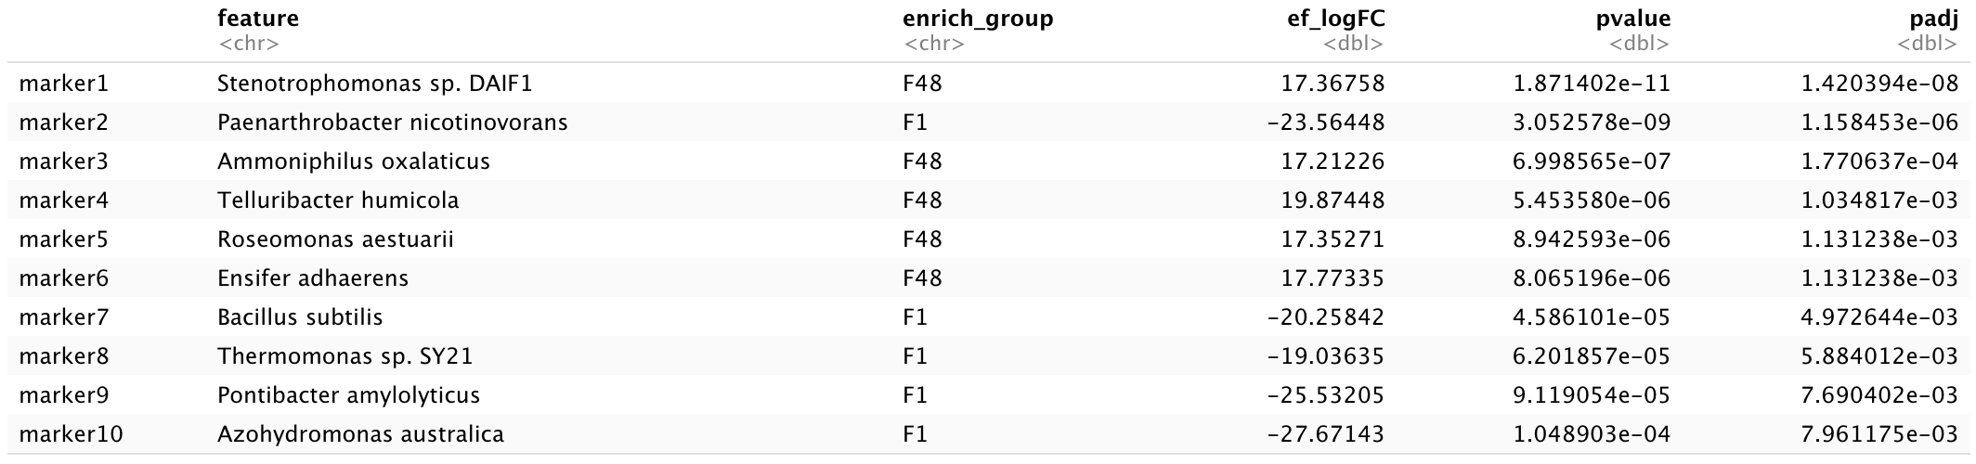
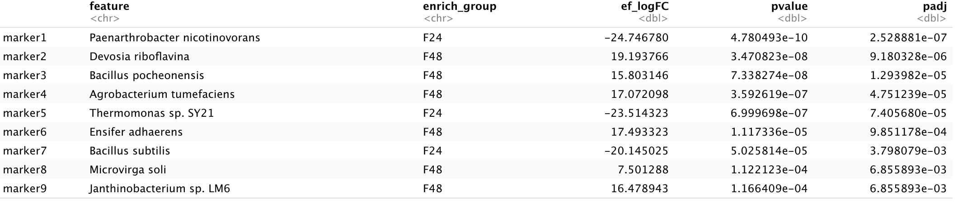

Supplementary Table S7: Differential abundance results for alfalfa-brassica mixture

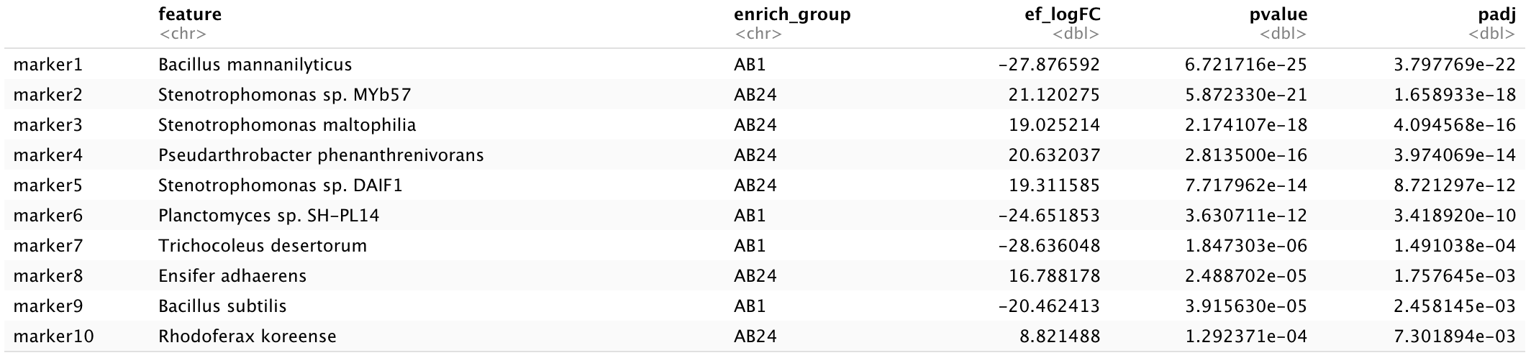
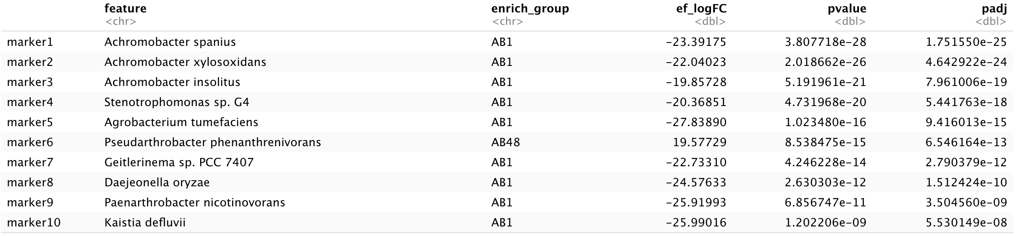
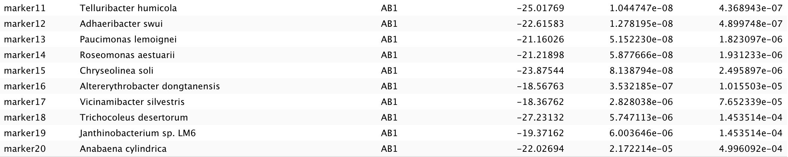
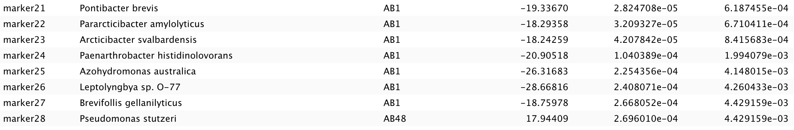
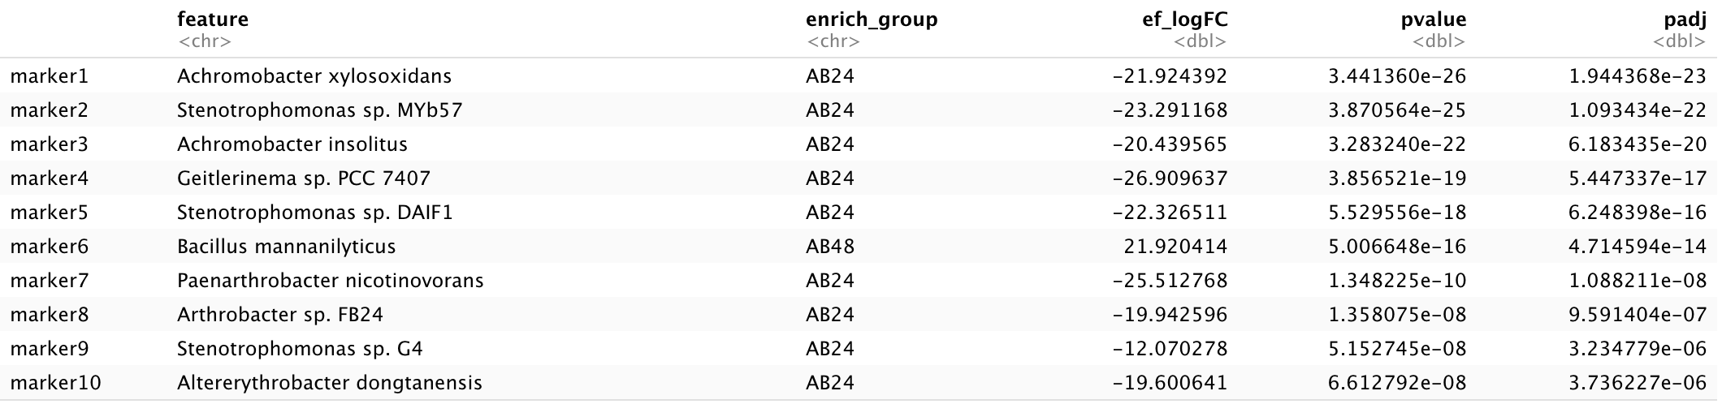
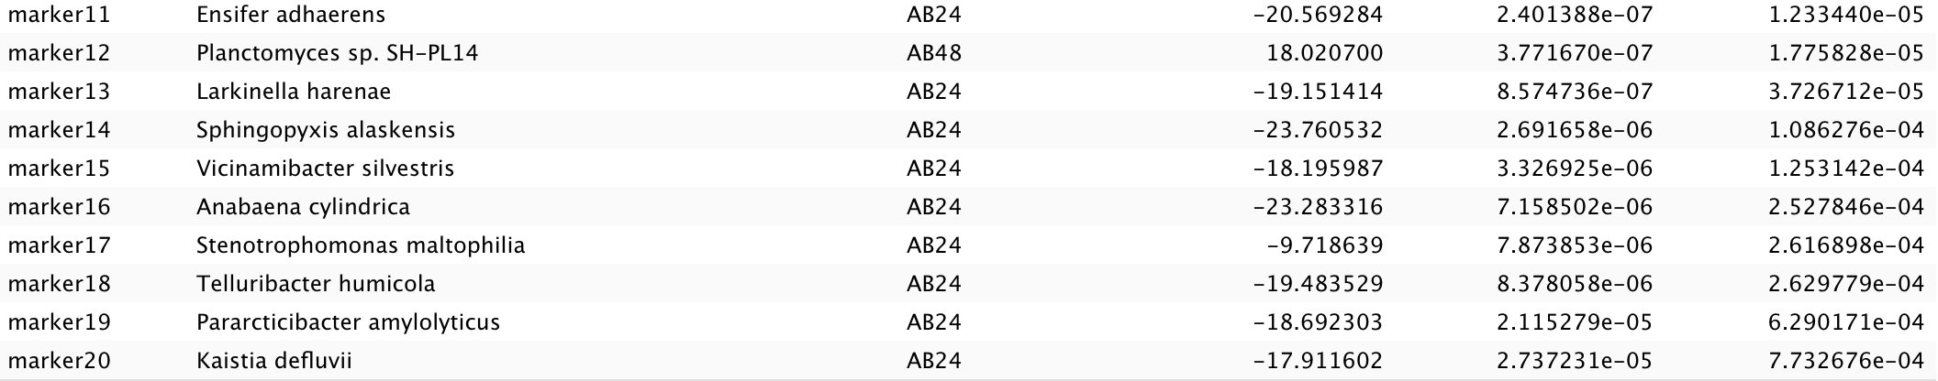
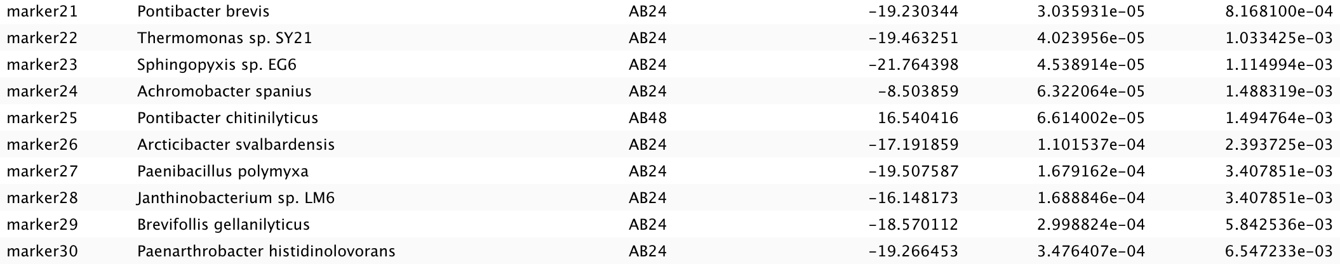

Supplementary Table S8: Differential abundance results for alfalfa-fescue mixture
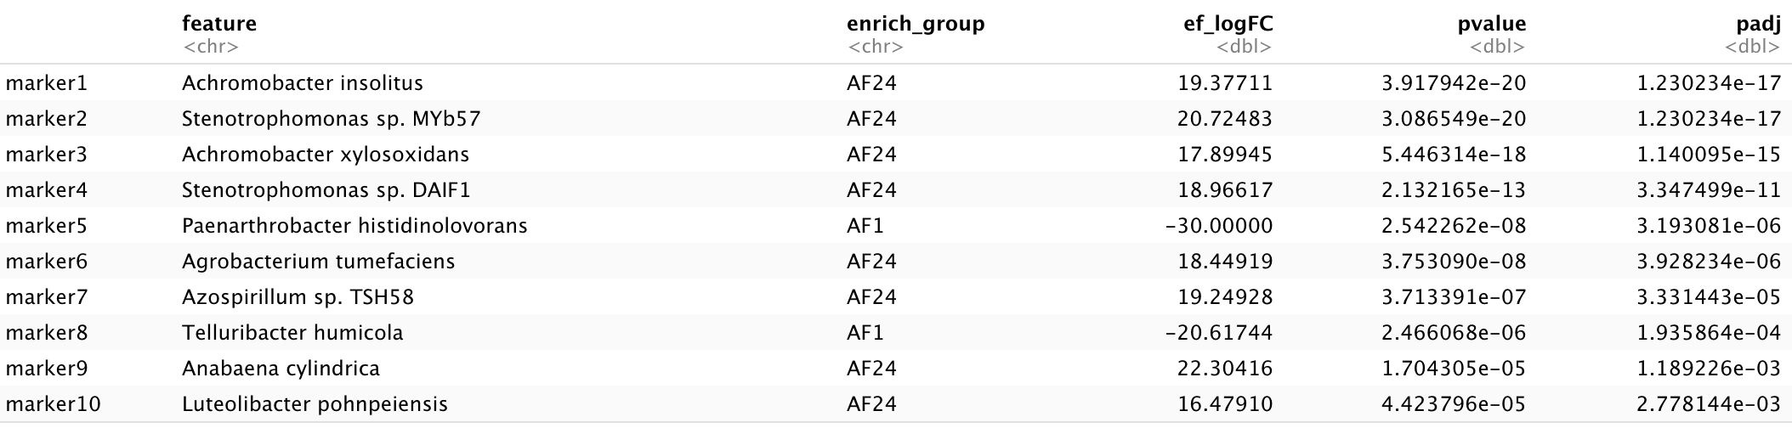
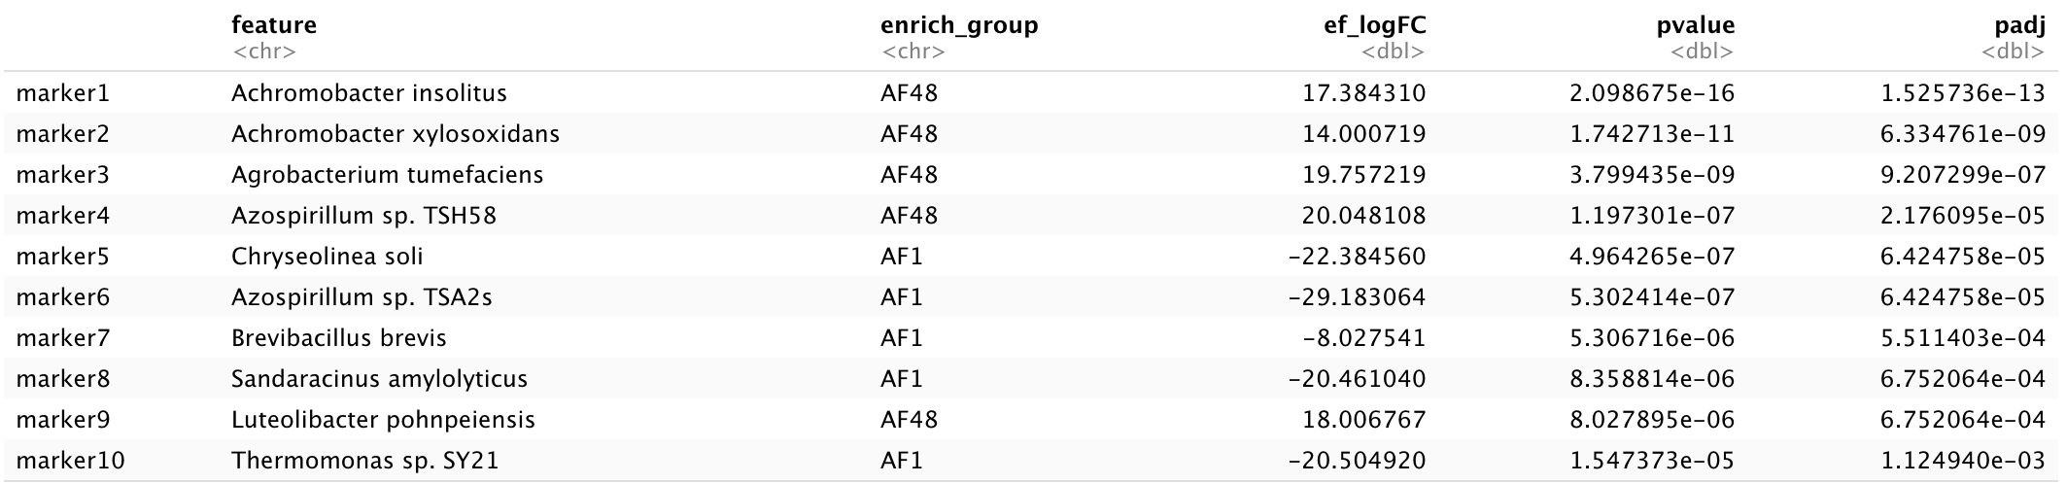
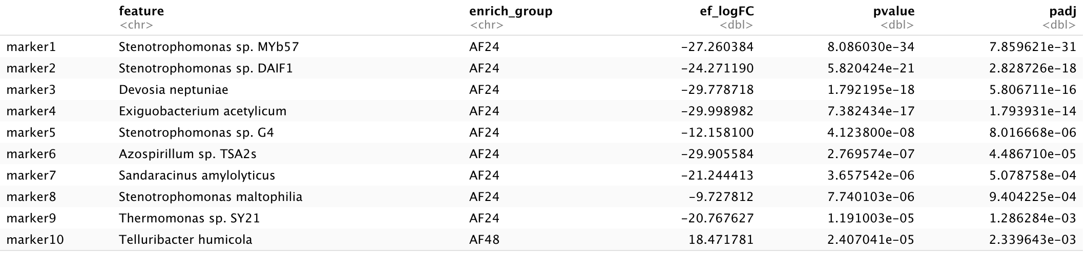
Supplementary Table S9: Differential abundance results for brassica-fescue mixture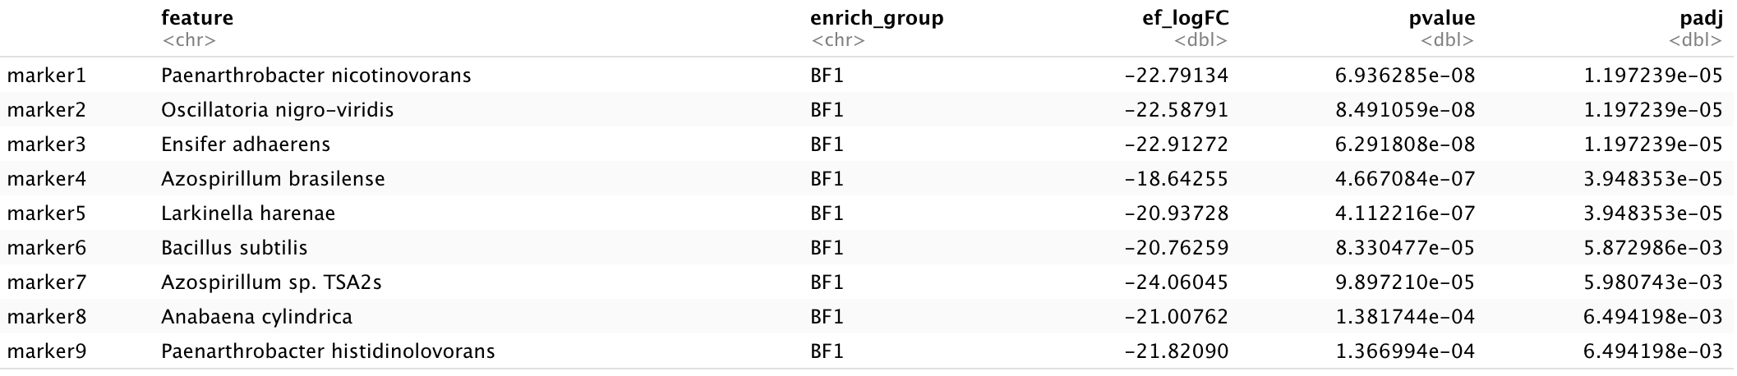
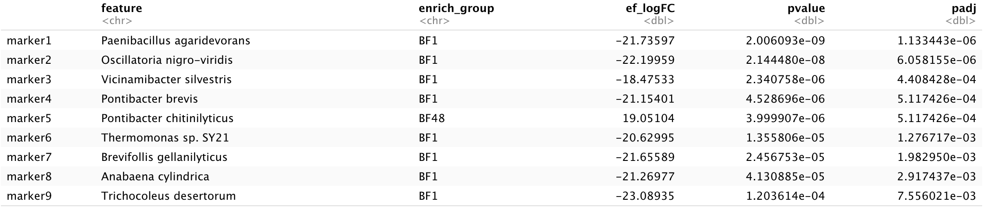
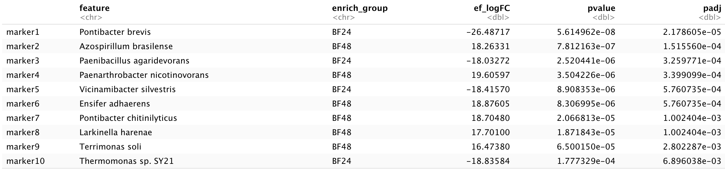
Supplementary Table S10: Differential abundance results for alfalfa-brassica-fescue mixture
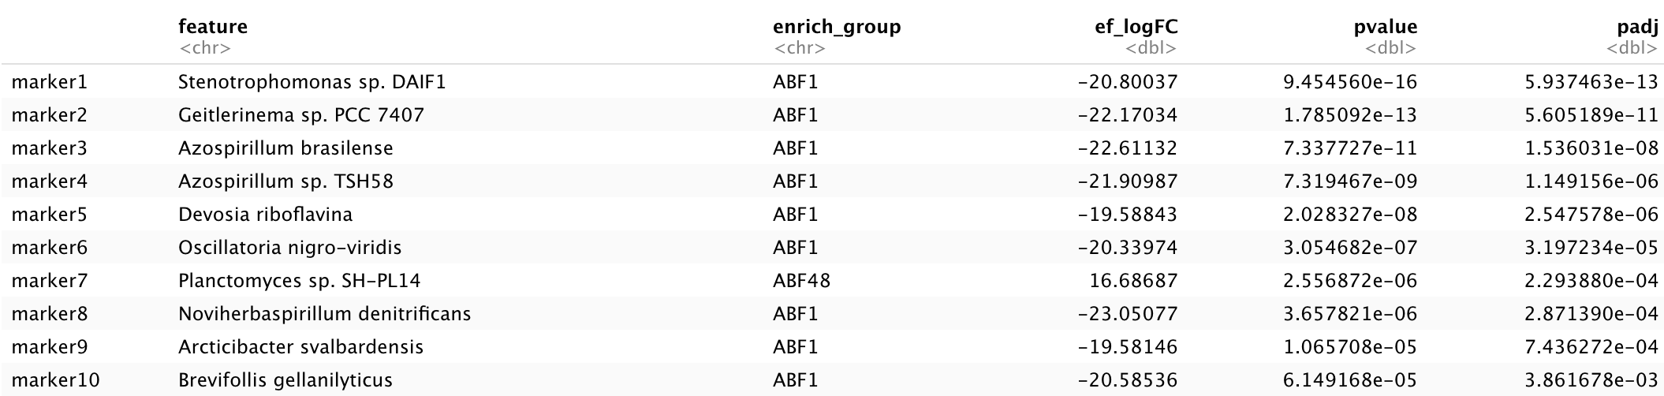
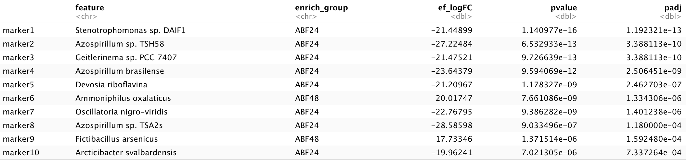
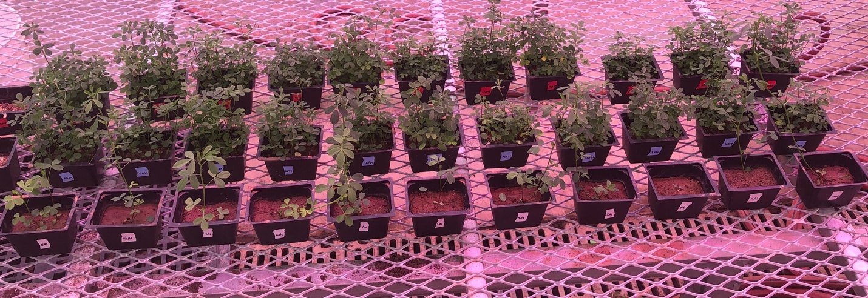
Supplementary Figure S6: Picture of the monocrop of alfalfa at increasing density (bottom row one plant, middle row 24 plants, and top row 48 plants).

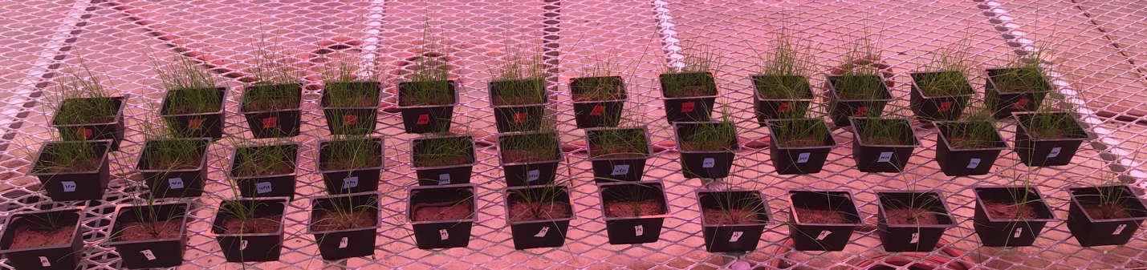
Supplementary Figure S7: Picture of the monocrop of fescue at increasing density (bottom row one plant, middle row 24 plants, and top row 48 plants).
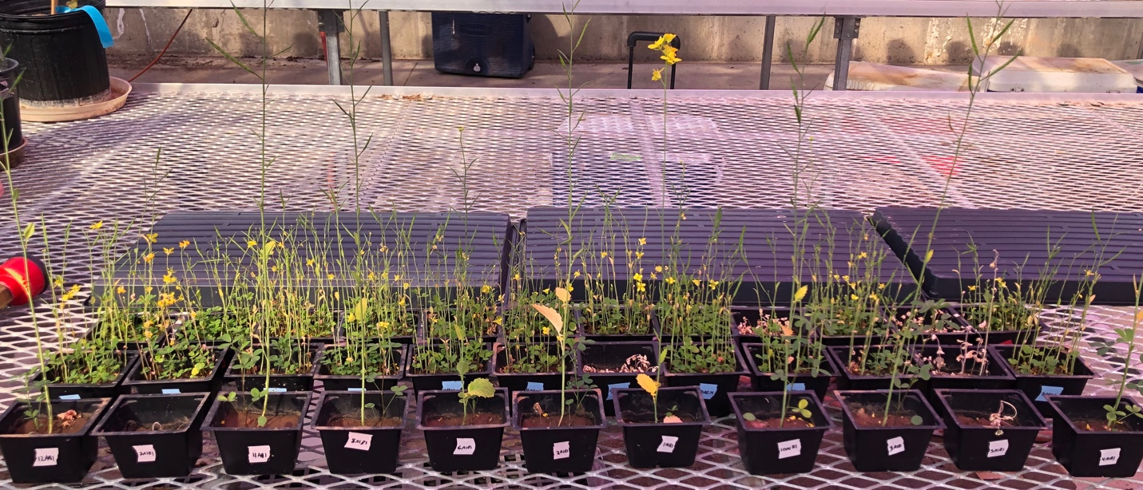
Supplementary figure S8: Supplementary figure 5: Picture of the alfalfa-brassica mixture at increasing density (bottom row one plant, middle row 24 plants, and top row 48 plants).

