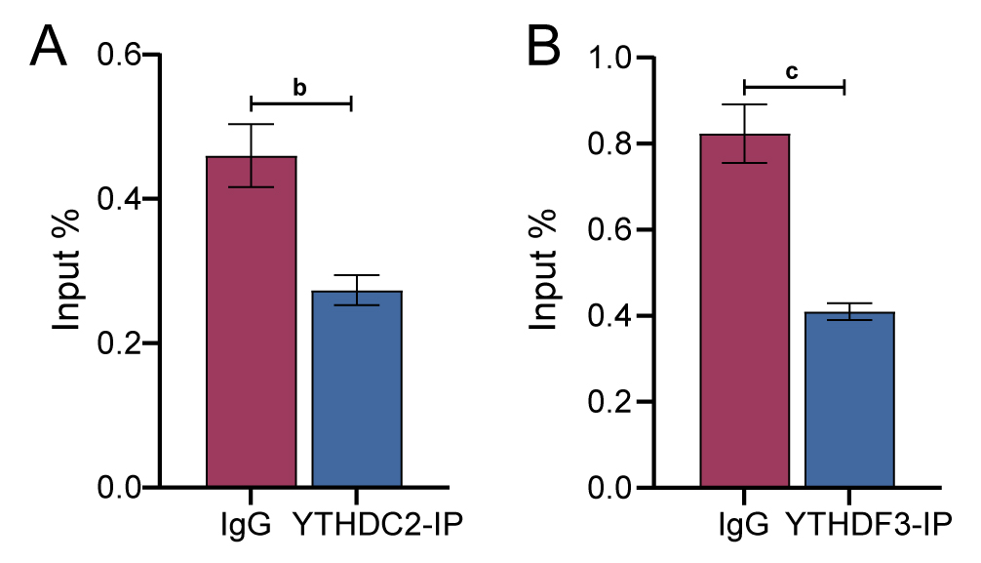
Supplementary Figure S1 The interaction between STAG3 mRNA and m6A “reader” protein (YTHDC2 and YTHDF3) was discovered using the RIP assay. ^{b}P<0.01, ^{c}P<0.001.

