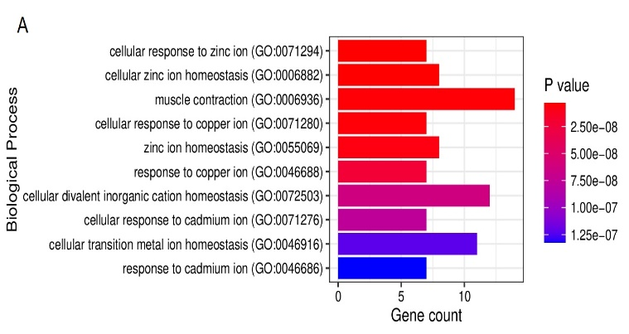
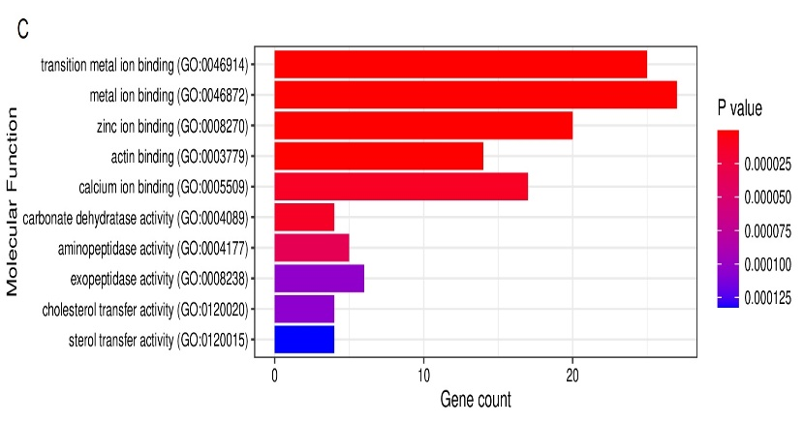
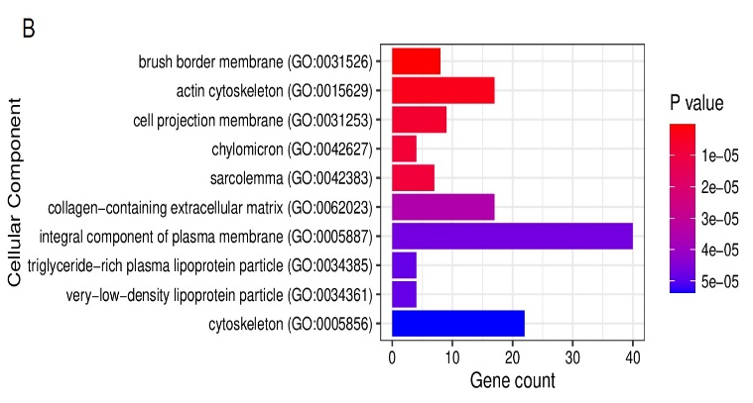
Supplementary Information (Figures)
Figure S1. GO enrichment of downregulated genes. (A) GO enrichment of biological process. (B) GO enrichment of cellular components. (C) GO enrichment of molecular function. The significant enriched GO terms were based on p value < 0.05.

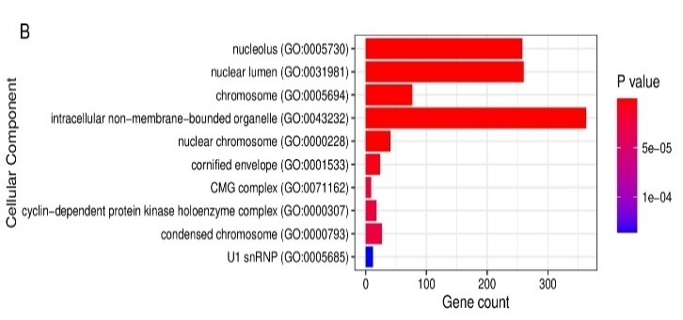
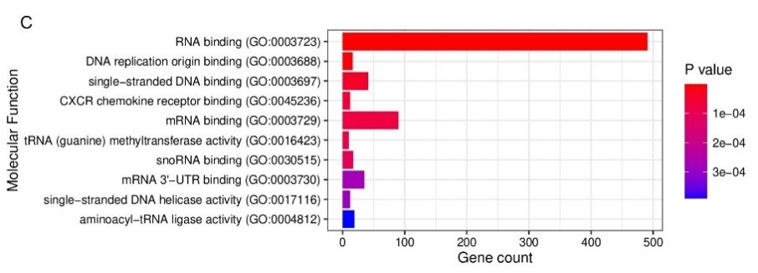
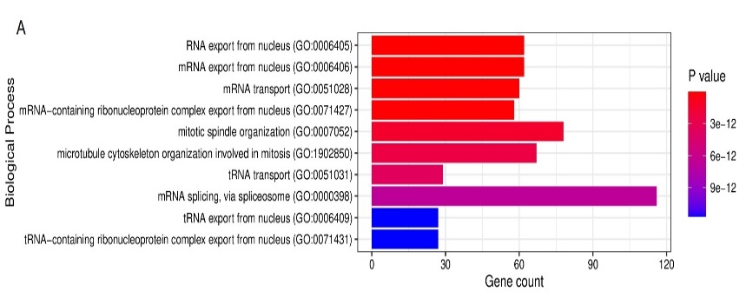

Figure S2. GO enrichment of upregulated genes. (A) GO enrichment of biological process. (B) GO enrichment of cellular components. (C) GO enrichment of molecular function. The significant enriched GO terms were based on p value < 0.05.
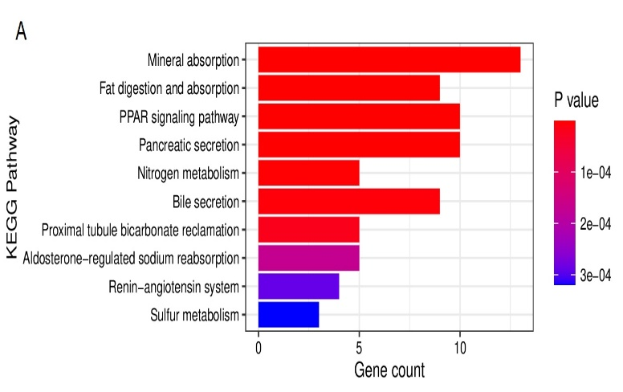
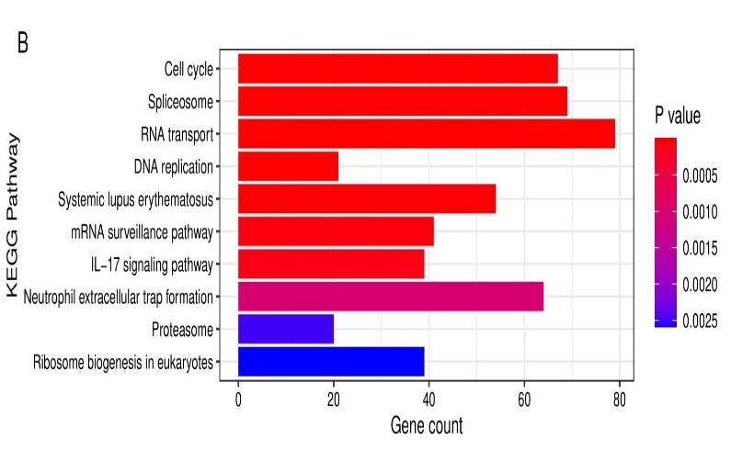

Figure S3. KEGG pathway enrichment analysis. (A) KEGG Pathway enrichment of downregulated genes. (B) KEGG Pathway enrichment of upregulated genes. The significant enriched KEGG pathway were based on p value < 0.05.

