Supplementary material

Title: Feasibility of a novel neurofeedback system - A parallel randomized single-blinded pilot study

Journal name: nature Scientific Reports

Authors: Dávid Horváth^{1, 2, *}, János Négyesi^{1, 2, 3}, Melinda Rácz^{4, 5, 6, 7}, Tamás Győri^{2, 8}, Zsolt Matics², Artyom Puskin⁵, János Csipor⁵, Levente Rácz¹

Affiliations: ¹Department of Kinesiology, Hungarian University of Sports Science, Budapest, Hungary; ²Fit4Race Kft., Budapest, Hungary; ³Department of Medicine and Science in Sports and Exercise, Tohoku University Graduate School of Medicine, Sendai, Japan; ⁴Research Centre for Natural Sciences, Eötvös Loránd Research Network, Budapest, Hungary; ⁵MindRove Kft., Győr, Hungary; ⁶János Szentágothai Doctoral School of Neurosciences, Semmelweis University, Budapest, Hungary; ⁷Selye János Doctoral College for Advanced Studies, Semmelweis University, Budapest, Hungary; ⁸Department of Psychology and Sport Psychology, Hungarian University of Sports Science, Budapest, Hungary

Corresponding author:
Dávid Horváth
e-mail: david.horvath@fit4race.com

Supplementary Figure 1: EEG metrics across the sessions
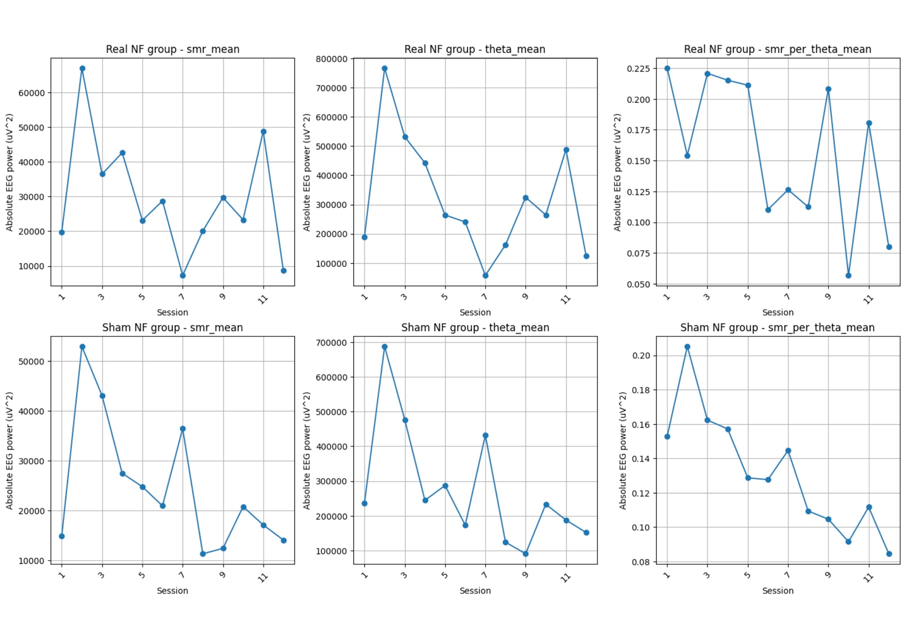

Supplementary Table 1: Supplementary dataset for DSB, TMT, and DT values
Supplementary Table 2: Supplementary dataset for RT, and STROOP Reading values
Supplementary Table 3: Supplementary dataset for STROOP Naming values
Supplementary Table 4: Supplementary dataset for SWITCH values

