a)
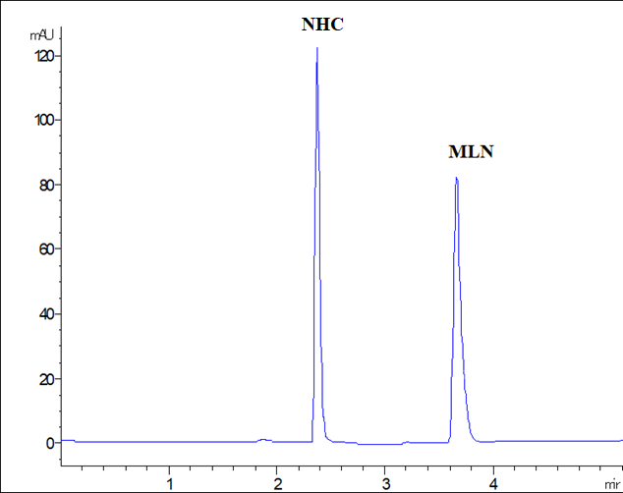
b)
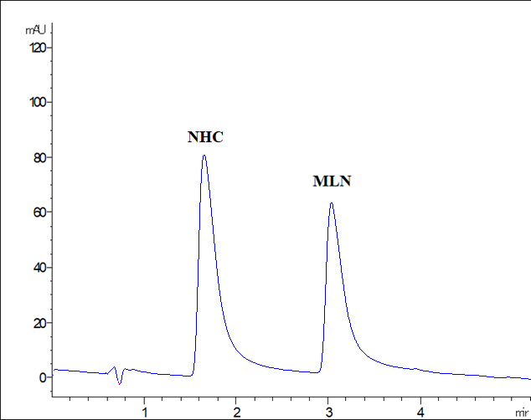
Supplementary Figure 1. HPLC DAD chromatogram of 10 µg/mL MLN and NHC using methanol, a), compared with acetonitrile, b) as organic modifiers.

a)
b)
Supplementary Figure 2. HPLC DAD chromatogram of a prepared solution of MLN capsules, 50 µg/mL MLN, a), and after spiking with a standard MLN (10 µg/mL), b).

