Supplementary Figures:

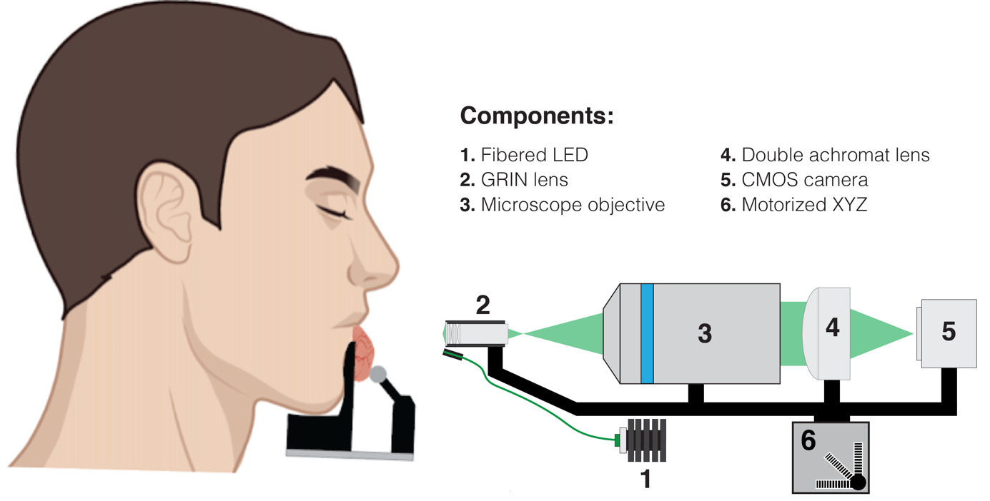Supplementary Figure 1 | An earlier version of the mOBM system for oral mucosa imaging in human subjects uses a microscope objective (Mitutoyo, 378-804-3) that was later replaced with a GRIN lens (Supplementary Figure 2, component #2).

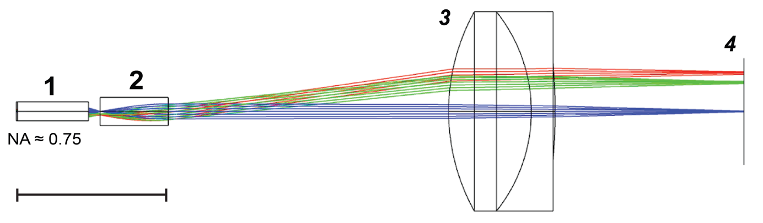
Supplementary Figure 2 | Optical simulation (Zemax) of the imaging pathway of the miniaturized instrument (Fig. 1d). Components: 1. Miniaturized aberration-corrected GRIN lens assembly, NA ≈ 0.75 (in water); 2. Standard GRIN lens, N=0.52; 3. Achromat doublet lens, EFL = 19.1 mm 4. Monochrome CMOS camera.

