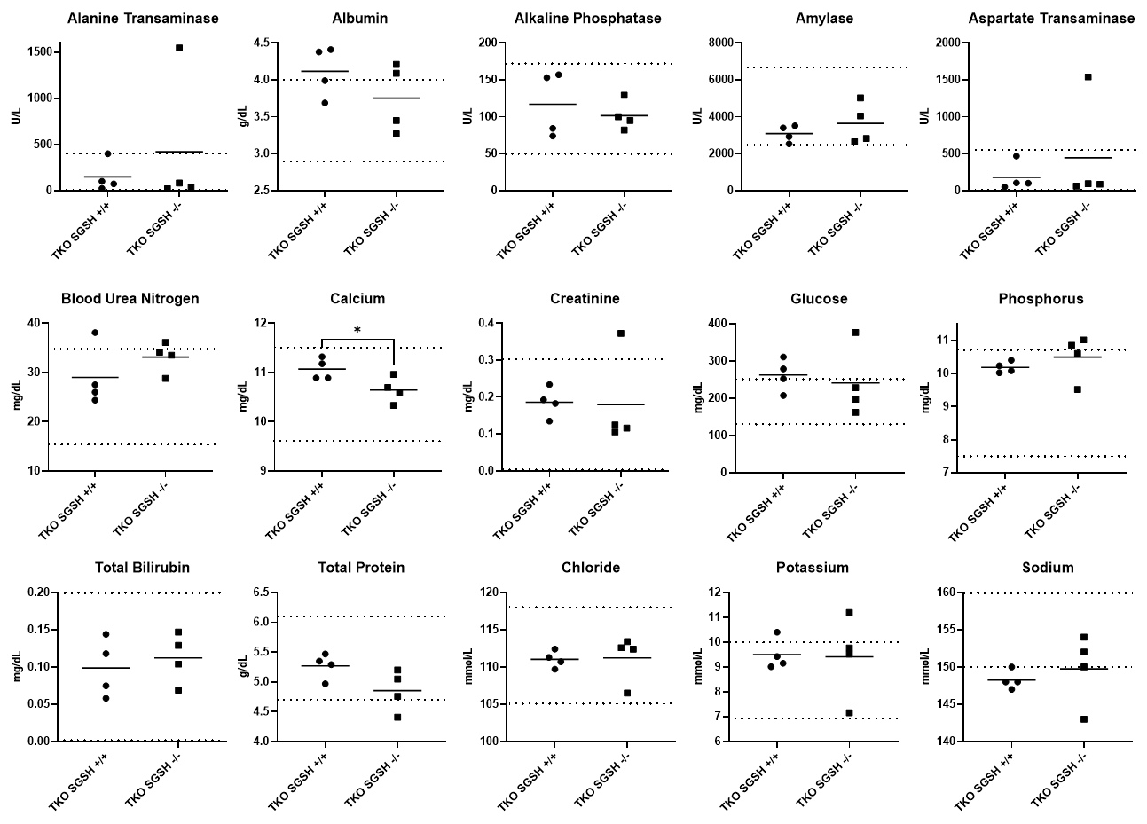
Supplementary Figure 1: Hematological findings in 8-month-old MPSIIIA TKO mice. Dotted lines define the reference range. * p < 0.05

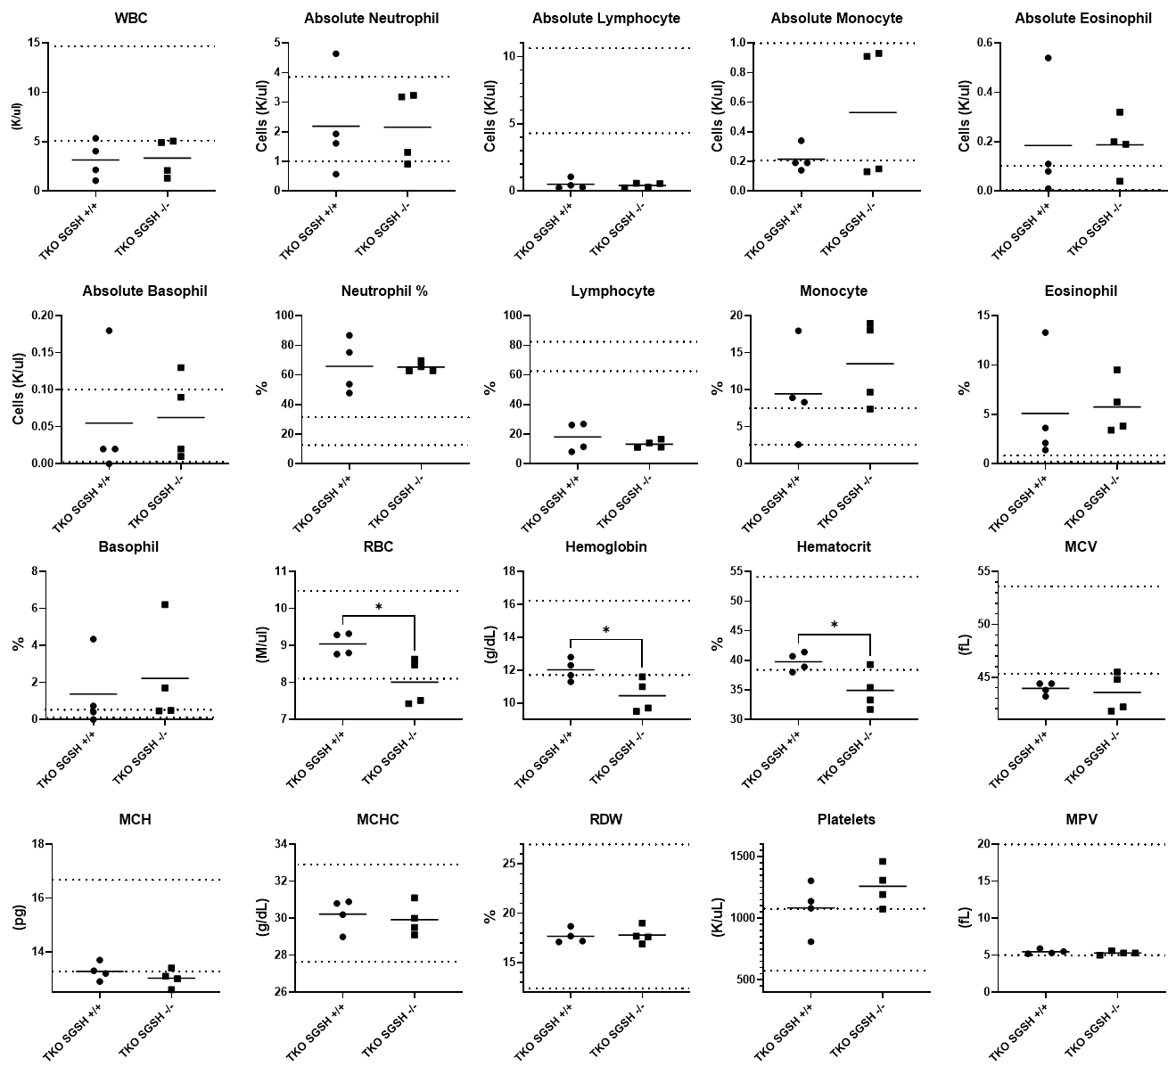
Supplementary Figure 2: Hematological findings in 8-month-old MPSIIIA TKO mice. Dotted lines define the reference range. * p < 0.05

Tissue | Cell type/s affected | Storage product | Distribution
Pituitary gland | Histiocytic/fibroblastic | 2 | Multifocal
Thyroid | Epithelial | 2 | Multifocal
Parathyroid gland | Epithelial | 2 | Multifocal
Pancreas | Epithelial, histiocytic/fibroblastic | 1-2 | Multifocal
Salivary gland, acini, ducts | Epithelial | 2 | Multifocal
Liver | Kupffer cells, hepatocytes | 2-4 | Multifocal
Gallbladder | Epithelial, histiocytic/fibroblastic | 2 | Multifocal to diffuse
Kidney | Epithelial, histiocytic/fibroblastic | 2-3 | Multifocal
Urinary bladder, ureter, urothelium | Epithelial, histiocytic/fibroblastic | 2 | Multifocal
Brain, leptomeninges | Histiocytic/fibroblastic | 1-2 | Multifocal
Adrenals | Histiocytic/fibroblastic | 2 | Multifocal
Heart | Cardiomyocytes | 1-2 | Multifocal
Diaphragm, perimysium | Histiocytic/fibroblastic | 2 | Multifocal
Tongue, interstitium | Histiocytic/fibroblastic | 2 | Multifocal
Spleen, red pulp | Histiocytic/fibroblastic | 2 | Multifocal
Gastrointestinal tract | Histiocytic/fibroblastic | 1-2 | Multifocal
Skin | Histiocytic/fibroblastic | 2-3 | Multifocal
Vagina | Histiocytic/fibroblastic | 2-3 | Multifocal
Uterus | Epithelial, histiocytic/fibroblastic | 2-3 | Multifocal
Ovary | Histiocytic/fibroblastic | 3 | Multifocal
Oviduct | Histiocytic/fibroblastic | 2 | Multifocal
Preputial/clitoral gland | Histiocytic/fibroblastic | 2 | Multifocal
Mammary gland | Epithelial, histiocytic/fibroblastic | 2 | Multifocal
Testes | Epithelial, histiocytic/fibroblastic | 2 | Multifocal
Epididymis | Histiocytic/fibroblastic | 2 | Multifocal
Penis, corpus cavernosum glandis | Histiocytic/fibroblastic | 2 | Multifocal
Seminal vesicles, prostate | Epithelial, histiocytic/fibroblastic | 2 | Multifocal
Lung | Vascular smooth muscle | 1-2 | Multifocal

Supplementary Table 1: Grading reflects the relative number of cells with storage product; 1=mild involvement, 2=moderate involvement, 3=severe involvement. Abbreviations: DCT=distal convoluted tubule, CD=collecting ducts

