External validation of clinical severity scores to guide referral of paediatric acute respiratory infections in resource-limited primary care settings

SUPPLEMENTARY APPENDIX

CONTENTS PAGE
- Supplementary Table 1: Longlisted paediatric severity scores 3
- Supplementary Table 2: Data dictionary for baseline variables
- Supplementary Table 3: Candidate variables for updating severity scores 4
- Supplementary Table 4: Proportion of missing data in candidate predictors 5
- Supplementary Figure 1: Patterns of missing data in candidate predictors 6
- Supplementary Table 5: Characteristics of patients with and without missing data
- Supplementary Table 6: Variables included in imputation model 7
- Supplementary Table 7: Sensitivity analysis I 8
- Supplementary Table 8: Comparison of different methods for handling missing data 9
- Supplementary Table 9: TRIPOD checklist 10
- Supplementary Figure 2: Eligibility of acute illness visits 11
- Supplementary Table 10: Baseline characteristics for patient-level variables 12
- Supplementary Table 11: Relationship between the severity scores and observed outcome proportions 13
- Supplementary Figure 3: Discrimination of the severity scores in each of the multiply imputed datasets 15
- Supplementary Figure 4: Relationships between continuous candidate predictors and the primary outcome 16
- Supplementary Figure 5: Discrimination and calibration of the models in each of the multiply imputed datasets 17
- Supplementary Table 12: Final model equations for the clinical prediction models 18
- Supplementary Table 13: Sensitivity analysis II – performance of severity scores and models 19
- Supplementary Table 14: Sensitivity analysis II – predicted classifications of updated models 20
- Supplementary Table 15: Sensitivity analysis III – performance of severity scores and models 22
- Supplementary Table 16: Sensitivity analysis III – predicted classifications of updated models 23

Supplementary Table 1. Longlisted paediatric severity scores. Grey shaded rows indicate scores excluded at shortlisting stage. FEAST-PET = Fluid Expansion as Supportive Therapy-Paediatric Emergency Triage; ITAT = Inpatient Triage and Treatment; LODS = Lambarene Organ Dysfunction Score; LqSOFA = Liverpool quick Sequential Organ Failure Assessment; mRISC = modified Respiratory Index of Severity in Children; mSIRS = modified Systemic Inflammatory Response Syndrome; PAWS = Paediatric Advanced Warning Score; PEDIA = Paediatric Early Death Index for Africa; PRISM = Paediatric Risk of Mortality-3; PEWS = Paediatric Early Warning System; qPELOD-2 = quick Pediatric Logistic Organ Dysfunction-2; qSOFA = quick Sequential Organ Failure Assessment; qSOFA-L = qSOFA-Lactate; RISC = Respiratory Index of Severity in Children; SIRS = Systemic Inflammatory Response Syndrome.
Score | Constituent variables | Included / Excluded
FEAST-PET¹ | Heart rate, temperature, capillary refill time, respiratory distress, lung crepitations, pulse character, prostration, pallor | Excluded – pulse character and prostration not available in primary dataset
ITAT² | Heart rate, temperature, respiratory rate, oxygen saturation | Excluded – pulse oximetry not feasible for young infants in high-throughput LMIC primary care settings
LqSOFA³ | Heart rate, respiratory rate, capillary refill time, mental status | Included
LODS⁴ | Deep breathing, coma, prostration | Excluded – deep breathing and prostration not available in primary dataset
mRISC⁵ | Chest indrawing, prostration, weight-for-age z-score, dehydration, history of unconsciousness, night sweats, mental status, lab-confirmed malaria | Excluded – prostration, history of unconsciousness, and night sweats not available in primary dataset.
mSIRS⁶ | Heart rate, respiratory rate, temperature | Included
PAWS⁷ | Heart rate, respiratory rate, temperature, capillary refill time, mental status, oxygen saturation, respiratory distress | Excluded – pulse oximetry not feasible for young infants in high-throughput LMIC primary care settings
PEWS⁸ | Heart rate, respiratory rate, systolic blood pressure, capillary refill time, oxygen saturation, supplemental oxygen, respiratory distress | Excluded – supplemental oxygen therapy not relevant for primary care-based score; pulse oximetry not feasible for young infants in high-throughput LMIC primary care settings
PEDIA(s)⁹ | Anaemia, jaundice, respiratory distress, deep breathing, mental status, prostration, seizures, temperature, wasting, kwashiorkor, symptom duration | Excluded – deep breathing, prostration, and seizures not available in primary dataset
PRISM-III¹⁰ | Heart rate, temperature, mental status, systolic blood pressure, glucose, potassium, pCO₂, pH, acidosis, pupillary reflexes | Excluded – large number of laboratory parameters not appropriate for high-throughput LMIC primary care settings and not available in primary dataset
qPELOD-2¹¹ | Heart rate, blood pressure, mental status | Included – blood pressure replaced with capillary refill time; mental status assessed using AVPU instead of GCS
qSOFA¹² | Respiratory rate, systolic blood pressure, mental status | Excluded – LqSOFA selected instead as capillary refill time and heart rate more appropriate for circulatory assessment in primary care
qSOFA-L¹³ | Respiratory rate, systolic blood pressure, mental status, lactate | Excluded – lactate not feasible for high-throughput LMIC primary care settings and not available in primary database
RISC¹⁴ | Oxygen saturation, chest indrawing, wheezing, prostration, weight-for-age z-score | Excluded – pulse oximetry not feasible for young infants in high-throughput LMIC primary care settings; prostration not available in primary dataset
RISC-Malawi¹⁵ | Oxygen saturation, mid-upper arm circumference, sex, wheeze, mental status | Excluded – pulse oximetry not feasible for young infants in high-throughput LMIC primary care settings
SIRS¹⁶ | Heart rate, respiratory rate, temperature, leukocyte count | Excluded – leukocyte count not feasible for high-throughput LMIC primary care settings; mSIRS selected instead

Supplementary Table 2: Data dictionary for baseline variables.

Variable | Description | Type | Notes
study_id | Unique patient identifier | Character
illness_id | Unique illness episode identifier | Character
illness_date | Date of presentation | Date
dob | Date of birth | Date
sex | Sex | Binary
bw | Birthweight | Numeric
gest | Gestational age | Integer
comorbid | Comorbidity | Binary
comorbid_detail | Details of comorbidity | Character
fm_unwell | Family member unwell | Binary
abx_prior | Antibiotics received prior to presentation | Binary
illness_duration | Duration of illness | Integer
fever | Fever | Binary
cough | Cough | Binary
runny_nose | Runny nose | Binary
noisy_breathing | Noisy breathing | Binary
stridor | Stridor | Binary
grunting | Grunting | Binary
head_bobbing | Head bobbing | Binary
nasal_flaring | Nasal flaring | Binary
chest_indrawing | Chest indrawing | Binary
tracheal_tug | Tracheal tug | Binary
creps | Crepitations on auscultation | Binary
wheeze | Wheeze on auscultation | Binary
dehydration | Dehydration | Binary
colour | Skin colour | Categorical | Three levels: normal, abnormal, jaundiced
hr | Heart rate | Integer
rr | Respiratory rate | Integer
temp | Temperature | Numeric
o2_sat | Oxygen saturation | Integer
crt | Capillary refill time | Integer
con_level | Consciousness level | Categorical | Four levels: alert, responsive to voice, responsive to pain, unresponsive
weight | Weight | Numeric
date_weight | Date of weight measurement | Date
length | Length | Integer
date_length | Date of length measurement | Date
muac | Mid-upper arm circumference | Numeric
date_muac | Date of mid-upper arm circumference | Date
hb | Haemoglobin | Numeric
wbc | White cell count | Numeric
neut | Neutrophil count | Numeric
lymph | Lymphocyte count | Numeric
plt | Platelet count | Integer
crp | C-reactive protein | Integer
na | Sodium | Integer
diagnosis_opd | Diagnosis in outpatient department | Character
treatment_opd | Treatment in outpatient department | Character
outcome_opd | Outcome in outpatient department | Categorical | Three levels: admit, home with follow-up, home

Supplementary Table 3. Candidate variables available in primary dataset considered for updating of existing severity scores. White shaded rows indicate variables selected for model updating.

Variables available in primary dataset | Reliability, validity and feasibility considerations for use in LMIC primary care settings
Birthweight | Validity concerns with regards measurement at time of birth. Reliability concerns with regards recall by caregivers at time of presentation.
Chest auscultation | Reliability concerns with regards capacity of limited-skill primary care providers for auscultation. Feasibility concerns with regards maintenance of stethoscopes.
Gestational age | Validity concerns with regards measurement at time of birth. Reliability concerns with regards recall by caregivers at time of presentation.
Nutritional status | Feasibility and reliability concerns with regards accurate measurement of length (length-for-age and weight-for-length). Validity concerns with regards mid-upper arm circumference. Weight-for-age chosen as best compromise between feasibility, reliability and validity to reflect nutritional status.
Respiratory distress | Feasibility and validity concerns with regards inclusion of multiple different measures of respiratory distress. Presence of respiratory distress chosen as binary variable for updating of score.

Supplementary Table 4. Proportion of missing data in candidate predictors.

Variable | Missing data (N; %)
Age | 0
Heart rate | 9 (0.3%)
Respiratory rate | 8 (0.3%)
Axillary temperature | 3 (0.1%)
Capillary refill time | 442 (14.7%)
Mental status | 37 (0.1%)
Weight-for-age z-score | 147 (4.9%)
Respiratory distress | 1 (< 0.01%)

Supplementary Figure 1. Proportion and pattern of missing data in candidate predictors. CRT = capillary refill time; WAZ = weight-for-age z-score.

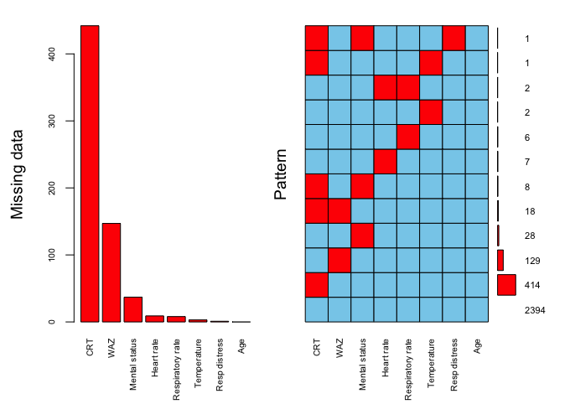
Supplementary Table 5: Characteristics of patients with and without missing data
Characteristic | Overall  N = 3,064  Median (IQR); n / N (%) | Participants with Missing Data
Characteristic | Overall  N = 3,064  Median (IQR); n / N (%) | No  N = 2,326  Median (IQR); n / N (%) | Yes  N = 738  Median (IQR); n / N (%) | p-value¹
Final analysis models (explanatory variables)
Age (months) | 8.1 (3.7, 13.7) | 8.8 (4.3, 14.4) | 5.6 (2.6, 11.1) | < 0.001
Heart rate (bpm) | 134.0 (127.0, 142.0) | 134.0 (126.0, 142.0) | 137.0 (128.0, 145.0) | < 0.01
Respiratory rate (bpm) | 48.0 (42.0, 54.0) | 48.0 (42.0, 56.0) | 48.0 (42.0, 54.0) | 0.40
Axillary temperature (°C) | 36.6 (36.1, 37.5) | 36.7 (36.1, 37.5) | 36.5 (36.0, 37.3) | < 0.01
Not alert | 382 / 3,026 (13%) | 277 / 2,326 (12%) | 105 / 700 (15%) | 0.03
Prolonged capillary refill time | 37 / 2,609 (1.4%) | 29 / 2,326 (1.2%) | 8 / 283 (2.8%) | 0.03
Final analysis models (outcome variables)
Receipt of supplemental oxygen | 104 / 3,010 (3.5%) | 75 / 2,326 (3.2%) | 29 / 684 (4.2%) | 0.20
Final analysis models (updating variables)
Head bobbing | 52 / 3,063 (1.7%) | 35 / 2,326 (1.5%) | 17 / 737 (2.3%) | 0.14
Nasal flaring | 63 / 3,063 (2.1%) | 46 / 2,326 (2.0%) | 17 / 737 (2.3%) | 0.60
Chest indrawing | 503 / 3,063 (16%) | 391 / 2,326 (17%) | 112 / 737 (15%) | 0.30
Tracheal tug | 135 / 3,063 (4.4%) | 105 / 2,326 (4.5%) | 30 / 737 (4.1%) | 0.60
Grunting | 26 / 3,063 (0.8%) | 17 / 2,326 (0.7%) | 9 / 737 (1.2%) | 0.20
Weight-for-age z-score | -0.9 (-1.6, -0.2) | -0.9 (-1.6, -0.2) | -0.8 (-1.6, -0.1) | 0.03
Auxiliary variables
Birthweight (kg) | 2.9 (2.6, 3.2) | 2.9 (2.6, 3.2) | 2.9 (2.6, 3.1) | 0.13
Gestation (weeks) | 39.1 (38.1, 40.0) | 39.2 (38.2, 40.0) | 39.1 (38.1, 39.6) | 0.12
Known comorbidity | 53 / 3,054 (1.7%) | 40 / 2,326 (1.7%) | 13 / 728 (1.8%) | > 0.90
Weight-for-length z-score | 0.0 (-0.8, 0.9) | -0.1 (-0.8, 0.8) | 0.3 (-0.6, 1.1) | < 0.001
Length-for-age z-score | -1.5 (-2.3, -0.7) | -1.5 (-2.3, -0.8) | -1.4 (-2.3, -0.7) | 0.70
Abnormal lung auscultation | 1,466 / 3,003 (49%) | 1,190 / 2,326 (51%) | 276 / 677 (41%) | < 0.001
Dehydration | 131 / 3,057 (4.3%) | 96 / 2,326 (4.1%) | 35 / 731 (4.8%) | 0.40
Receipt of IV fluids | 439 / 3,010 (15%) | 352 / 2,326 (15%) | 87 / 684 (13%) | 0.12
Admitted to clinic | 889 / 3,064 (29%) | 656 / 2,326 (28%) | 233 / 738 (32%) | 0.08
¹Wilcoxon rank sum test; Pearson's Chi-squared test

Supplementary Table 6. Variables included in imputation model. All explanatory and response variables in the final analysis models, along with variables plausibly associated with capillary refill time (CRT; the variable with the highest proportion of missing data) were included in the imputation model.

Variable | Reason
Age | Final analysis models (explanatory variable)
Heart rate | Final analysis models (explanatory variable)
Respiratory rate | Final analysis models (explanatory variable)
Axillary temperature | Final analysis models (explanatory variable)
Capillary refill time | Final analysis models (explanatory variable)
Mental status | Final analysis models (explanatory variable)
Birthweight | Plausibly associated with CRT
Gestational age | Plausibly associated with CRT
Known comorbidity | Plausibly associated with CRT
Weight-for-age z-score | Final analysis models (explanatory variable)
Weight-for-length z-score | Plausibly associated with CRT
Length-for-age z-score | Plausibly associated with CRT
Head bobbing | Final analysis models (explanatory variable)
Nasal flaring | Final analysis models (explanatory variable)
Chest indrawing | Final analysis models (explanatory variable)
Tracheal tug | Final analysis models (explanatory variable)
Grunting | Final analysis models (explanatory variable)
Abnormal lung auscultation | Plausibly associated with CRT
Dehydration | Plausibly associated with CRT
Clinic disposition | Plausibly associated with CRT
Receipt of intravenous fluids | Plausibly associated with CRT
Receipt of supplemental oxygen | Final analysis models (response variable)

Supplementary Table 7. Sensitivity analysis I: impact of not including term for random-effects. Comparison of the discrimination for each of the existing scores in the primary analysis (where missing data are addressed using multiple imputation), a full-case analysis (using pairwise deletion for each of the scores), and two sensitivity analyses restricted to one presentation per child. In the first sensitivity analysis, one presentation is sampled at random per child. Consequently, the number of outcome events in this subgroup are few. In the second sensitivity analysis, in order to maintain a higher number of outcome events, the cohort was divided into children who did meet the primary outcome (received supplemental oxygen) during any ARI presentation and children who never met the primary outcome. One presentation per child was sampled at random from each of these groups; these samples were pooled and the discrimination of each score examined in this cohort.

Score | Primary analysis |  | Full-case analysis |  | Sensitivity analysis 1 |  | Sensitivity analysis 2
Score | Cases / Controls  (Prevalence) | AUC  (95% CI) | Cases / Controls  (Prevalence) | AUC  (95% CI) | Cases / Controls  (Prevalence) | AUC  (95% CI) | Cases / Controls  (Prevalence) | AUC  (95% CI)
LqSOFA | 104 / 2906  (3.5%) | 0.84  (0.79 to 0.89) | 81 / 2444  (3.2%) | 0.84  (0.80 to 0.89) | 19 / 687  (2.7%) | 0.83  (0.74 to 0.93) | 57 / 649  (8.1%) | 0.83  (0.77 to 0.89)
qPELOD | 104 / 2906  (3.5%) | 0.79  (0.74 to 0.84) | 83 / 2448  (3.3%) | 0.79  (0.74 to 0.84) | 19 / 688  (2.7%) | 0.81  (0.71 to 0.92) | 58 / 649  (8.2%) | 0.76  (0.70 to 0.83)
mSIRS | 104 / 2906  (3.5%) | 0.57  (0.51 to 0.63) | 99 / 2893  (3.3%) | 0.56  (0.52 to 0.61) | 15 / 741  (2.0%) | 0.60  (0.48 to 0.71) | 65 / 691  (8.6%) | 0.57  (0.51 to 0.62)

Supplementary Table 8. Discrimination of models when missing data addressed using multiple imputation with chained equations, median imputation grouped by outcome status, and a full case analysis. Dataset for full-case analysis created using pairwise deletion, omitting presentations missing data for any explanatory variable or the response variable (n = 2,523 presentations; 81 outcome events). *Pooled discrimination across multiply imputed datasets reported. †Optimism-adjusted discrimination reported. MICE = multiple imputation with chained equations.

Method to addressing missing data | LqSOFA | mSIRS | qPELOD-2
MICE (95% CI)*† | 0.90 (0.86 to 0.94) | 0.81 (0.76 to 0.86) | 0.84 (0.79 to 0.89)
Median imputation (95% CI) † | 0.89 (0.84 to 0.94) | 0.80 (0.75 to 0.85) | 0.83 (0.78 to 0.88)
Full-case analysis (95% CI) † | 0.89 (0.84 to 0.94) | 0.80 (0.74 to 0.86) | 0.83 (0.77 to 0.89)

Supplementary Table 9. TRIPOD checklist.
Section/Topic | Item |  | Checklist Item | Page
Title and abstract
Title | 1 | D;V | Identify the study as developing and/or validating a multivariable prediction model, the target population, and the outcome to be predicted. | 1
Abstract | 2 | D;V | Provide a summary of objectives, study design, setting, participants, sample size, predictors, outcome, statistical analysis, results, and conclusions. | 3
Introduction
Background and objectives | 3a | D;V | Explain the medical context (including whether diagnostic or prognostic) and rationale for developing or validating the multivariable prediction model, including references to existing models. | 4
Background and objectives | 3b | D;V | Specify the objectives, including whether the study describes the development or validation of the model or both. | 4
Methods
Source of data | 4a | D;V | Describe the study design or source of data (e.g., randomized trial, cohort, or registry data), separately for the development and validation data sets, if applicable. | 5
Source of data | 4b | D;V | Specify the key study dates, including start of accrual; end of accrual; and, if applicable, end of follow-up. | 5
Participants | 5a | D;V | Specify key elements of the study setting (e.g., primary care, secondary care, general population) including number and location of centres. | 5
Participants | 5b | D;V | Describe eligibility criteria for participants. | 5
Participants | 5c | D;V | Give details of treatments received, if relevant. | NA
Outcome | 6a | D;V | Clearly define the outcome that is predicted by the prediction model, including how and when assessed. | 7
Outcome | 6b | D;V | Report any actions to blind assessment of the outcome to be predicted. | 7
Predictors | 7a | D;V | Clearly define all predictors used in developing or validating the multivariable prediction model, including how and when they were measured. | 5-6
Predictors | 7b | D;V | Report any actions to blind assessment of predictors for the outcome and other predictors. | NA
Sample size | 8 | D;V | Explain how the study size was arrived at. | 7
Missing data | 9 | D;V | Describe how missing data were handled (e.g., complete-case analysis, single imputation, multiple imputation) with details of any imputation method. | 7
Statistical analysis methods | 10a | D | Describe how predictors were handled in the analyses. | 7-8
Statistical analysis methods | 10b | D | Specify type of model, all model-building procedures (including any predictor selection), and method for internal validation. | 8
Statistical analysis methods | 10c | V | For validation, describe how the predictions were calculated. | 7
Statistical analysis methods | 10d | D;V | Specify all measures used to assess model performance and, if relevant, to compare multiple models. | 7-8
Statistical analysis methods | 10e | V | Describe any model updating (e.g., recalibration) arising from the validation, if done. | 8
Risk groups | 11 | D;V | Provide details on how risk groups were created, if done. | NA
Development vs. validation | 12 | V | For validation, identify any differences from the development data in setting, eligibility criteria, outcome, and predictors. | Table 1
Results
Participants | 13a | D;V | Describe the flow of participants through the study, including the number of participants with and without the outcome and, if applicable, a summary of the follow-up time. A diagram may be helpful. | 9; S.Fig 1
Participants | 13b | D;V | Describe the characteristics of the participants (basic demographics, clinical features, available predictors), including the number of participants with missing data for predictors and outcome. | 9
Participants | 13c | V | For validation, show a comparison with the development data of the distribution of important variables (demographics, predictors and outcome). | NA
Model development | 14a | D | Specify the number of participants and outcome events in each analysis. | 9
Model development | 14b | D | If done, report the unadjusted association between each candidate predictor and outcome. | NA
Model specification | 15a | D | Present the full prediction model to allow predictions for individuals (i.e., all regression coefficients, and model intercept or baseline survival at a given time point). | S.Table 8
Model specification | 15b | D | Explain how to the use the prediction model. | 10-11
Model performance | 16 | D;V | Report performance measures (with CIs) for the prediction model. | 10
Model-updating | 17 | V | If done, report the results from any model updating (i.e., model specification, model performance). | 10
Discussion
Limitations | 18 | D;V | Discuss any limitations of the study (such as nonrepresentative sample, few events per predictor, missing data). | 13-14
Interpretation | 19a | V | For validation, discuss the results with reference to performance in the development data, and any other validation data. | 12
Interpretation | 19b | D;V | Give an overall interpretation of the results, considering objectives, limitations, results from similar studies, and other relevant evidence. | 12-14
Implications | 20 | D;V | Discuss the potential clinical use of the model and implications for future research. | 13-14
Other information
Supplementary information | 21 | D;V | Provide information about the availability of supplementary resources, such as study protocol, Web calculator, and data sets. | 15
Funding | 22 | D;V | Give the source of funding and the role of the funders for the present study. | 15

Supplementary Figure 2. Eligibility of acute illness visits. ARI = acute respiratory infection.

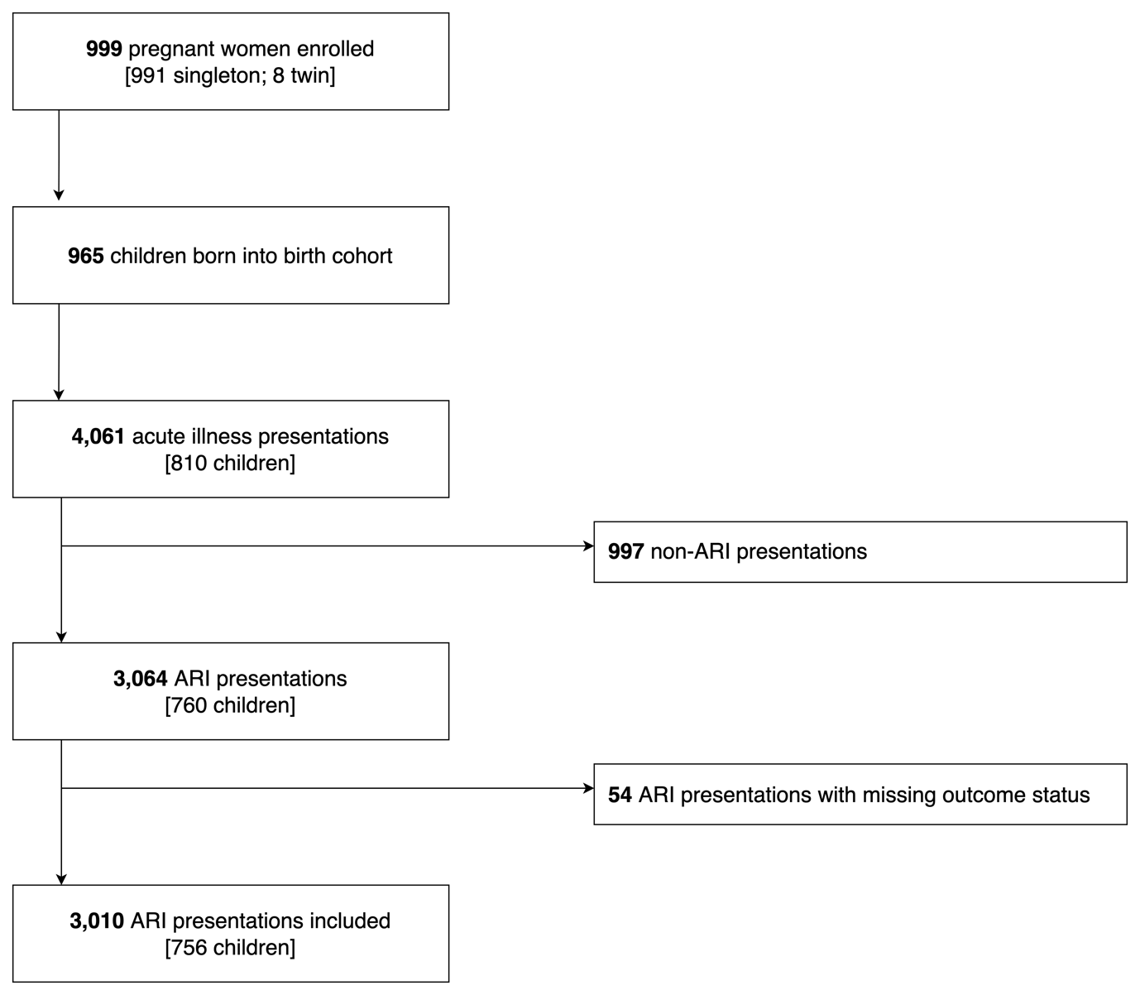

Supplementary Table 10. Baseline characteristics of the cohort for patient-level variables, stratified by outcome status. *Missing data: gestation = 2; birthweight = 4.

Characteristic | Overall  N = 756¹ | Supplemental oxygen
Characteristic | Overall  N = 756¹ | No  N = 735¹ | Yes  N = 21¹ | p-value²
Male sex | 381 / 756 (50%) | 368 / 735 (50%) | 13 / 21 (62%) | 0.30
Gestation (weeks)* | 39.2 (38.2, 40.0) | 39.2 (38.2, 40.0) | 39.1 (38.0, 40.2) | 0.60
Birthweight (kg)* | 2.9 (2.7, 3.2) | 2.9 (2.7, 3.2) | 2.8 (2.4, 3.2) | 0.40
¹Median (IQR); n / N (%)
²Wilcoxon rank sum test; Pearson's Chi-squared test; Fisher's exact test

Supplementary Table 11. Relationship between the severity scores and observed outcome proportions. Scores calculated using full-case analysis: LqSOFA = 2,525 presentations; mSIRS = 2,992 presentations; qPELOD-2 = 2,531 presentations. Bpm = beats per minute; LqSOFA = Liverpool quick Sequential Organ Failure Assessment; mSIRS = modified Systemic Inflammatory Response Syndrome; qPELOD-2 = quick Pediatric Logistic Organ Dysfunction-2.
Characteristic | Overall  N = 3,010¹ | Supplemental oxygen
Characteristic | Overall  N = 3,010¹ | No  N = 2,906¹ | Yes  N = 104¹ | p-value²
LqSOFA
Respiratory rate > 99th centile¹⁷ | 136 / 3,002 (4.5%) | 111 / 2,901 (3.8%) | 25 / 101 (25%) | < 0.001
Heart rate > 99th centile¹⁷ | 7 / 3,001 (0.2%) | 4 / 2,900 (0.1%) | 3 / 101 (3.0%) | 0.001
Not alert | 372 / 2,973 (13%) | 306 / 2,875 (11%) | 66 / 98 (67%) | < 0.001
Capillary refill time > 2 secs | 36 / 2,568 (1.4%) | 27 / 2,476 (1.1%) | 9 / 92 (9.8%) | < 0.001
LqSOFA score
0 | 2,127 / 2,525 (84%) | 2,111 / 2,444 (86%) | 16 / 81 (20%) | < 0.001
1 | 342 / 2,525 (14%) | 296 / 2,444 (12%) | 46 / 81 (57%) | < 0.001
2 | 53 / 2,525 (2.1%) | 35 / 2,444 (1.4%) | 18 / 81 (22%) | < 0.001
3 | 3 / 2,525 (0.1%) | 2 / 2,444 (<0.1%) | 1 / 81 (1.2%) | < 0.001
mSIRS
Axillary temperature > 38°C | 391 / 3,007 (13%) | 370 / 2,903 (13%) | 21 / 104 (20%) | 0.027
Axillary temperature < 35.5°C | 7 / 3,007 (0.2%) | 5 / 2,903 (0.2%) | 2 / 104 (1.9%) | 0.022
Heart rate > 95th centile | 6 / 3,001 (0.2%) | 3 / 2,900 (0.1%) | 3 / 101 (3.0%) | < 0.001
Heart rate < 5th centile | 0 / 3,001 (0%) | 0 / 2,900 (0%) | 0 / 101 (0%) | NA
Respiratory rate > 95th centile | 2,852 / 3,002 (95%) | 2,753 / 2,901 (95%) | 99 / 101 (98%) | 0.20
mSIRS score
0 | 135 / 2,992 (4.5%) | 134 / 2,893 (4.6%) | 1 / 99 (1.0%) | 0.002
1 | 2,475 / 2,992 (83%) | 2,399 / 2,893 (83%) | 76 / 99 (77%) | 0.002
2 | 380 / 2,992 (13%) | 359 / 2,893 (12%) | 21 / 99 (21%) | 0.002
3 | 2 / 2,992 (<0.1%) | 1 / 2,893 (<0.1%) | 1 / 99 (1.0%) | 0.002
qPELOD-2
Heart rate > 195 bpm | 0 / 3,001 (0%) | 0 / 2,900 (0%) | 0 / 101 (0%) | NA
Not alert | 372 / 2,973 (13%) | 306 / 2,875 (11%) | 66 / 98 (67%) | < 0.001
Capillary refill time > 2 secs | 36 / 2,568 (1.4%) | 27 / 2,476 (1.1%) | 9 / 92 (9.8%) | < 0.001
qPELOD-2 score
0 | 2,217 / 2,531 (88%) | 2,190 / 2,448 (89%) | 27 / 83 (33%) | < 0.001
1 | 292 / 2,531 (12%) | 243 / 2,448 (9.9%) | 49 / 83 (59%) | < 0.001
2 | 22 / 2,531 (0.9%) | 15 / 2,448 (0.6%) | 7 / 83 (8.4%) | < 0.001
¹n / N (%)
²Fisher's exact test; Pearson's Chi-squared test

Supplementary Figure 3. Discrimination of the LqSOFA, mSIRS, and qPELOD-2 severity scores in each of the multiply imputed datasets. Overlay plot to illustrate variability in AUCs across multiply imputed datasets. AUC = area under receiver operating characteristic curve; LqSOFA = Liverpool quick Sequential Organ Failure Assessment; mSIRS = modified Systemic Inflammatory Response Syndrome; qPELOD-2 = quick Pediatric Logistic Organ Dysfunction-2.

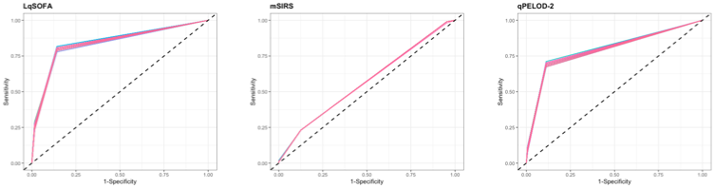
Supplementary Figure 4. Relationships between continuous candidate predictors and the primary outcome. Black line = probability of meeting primary outcome; grey shaded area = 95% confidence interval. Bpm = beats / breaths per minute.
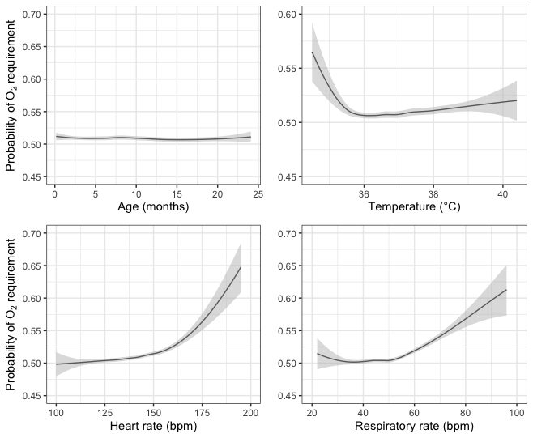

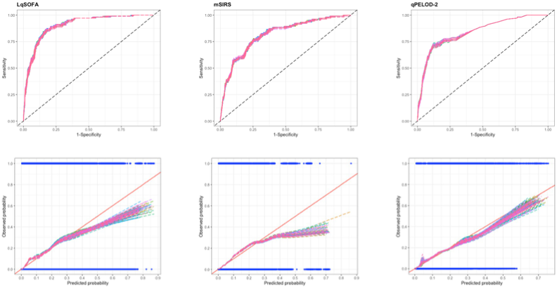
Supplementary Figure 5. Discrimination and calibration of the LqSOFA, mSIRS, and qPELOD-2 models in each of the multiply imputed datasets. Overlay plots to illustrate variability in AUCs (top panel) and calibration plots (bottom panel) across multiply imputed datasets. On calibration plots, solid red line indicates perfect calibration; coloured dashed line indicates calibration slope for each imputed dataset; blue rug plots indicate distribution of predicted risks for participants who did (top) and did not (bottom) meet the primary outcome. AUC = area under the receiver operating characteristic curve; LqSOFA = Liverpool quick Sequential Organ Failure Assessment; mSIRS = modified Systemic Inflammatory Response Syndrome; qPELOD-2 = quick Pediatric Logistic Organ Dysfunction-2.

Supplementary Table 12. Final model equations to illustrate how the clinical prediction models could be used to calculate the predicted probability of supplemental oxygen requirement in children presenting with ARIs in resource-limited primary care settings.
$$\operatorname{Pr}\left(Oxygen requirement\right)=\frac{e^{LP}}{1+e^{LP}}$$
where LP is the linear predictor
The LP should be estimated for each model using the following equations:

Basic models

LqSOFA model
$LP\left(LqSOFA model\right)=-11.097+\left\{\begin{aligned}0 if CRT≤2 \\ 0.999 if CRT>2\end{aligned}+ \right.\left\{\begin{aligned}0 if AVPU= A \\ 2.366 if AVPU< A\end{aligned}+ \right.0.025*age+0.016*hr+0.084*rr$

mSIRS model
$$LP\left(mSIRS model\right)=23.819+\left\{\begin{aligned}-1.0.47*temp if temp<36 \\ 2.930*temp if temp ≥36\end{aligned}+ \right.0.036*age+0.038*hr+0.094*rr$$

qPELOD-2 model
$$LP\left(qPELOD2 model\right)= - 8.783+\left\{\begin{aligned}0 if CRT≤2 \\ 0.966 if CRT>2\end{aligned}+ \right.\left\{\begin{aligned}0 if AVPU= A \\ 2.475 if AVPU< A\end{aligned}+ \right.0.033*hr$$

Updated models

LqSOFA model
$LP\left(LqSOFA model\right)=-8.727+\left\{\begin{aligned}0 if CRT≤2 \\ 0.526 if CRT>2\end{aligned}+ \right.\left\{\begin{aligned}0 if AVPU= A \\ 1.685 if AVPU< A\end{aligned}- \right.0.013*age+0.008*hr+0.035*rr+\left\{\begin{aligned}0 if no respiratory distress \\ 2.722 if respiratory distress\end{aligned}- \right.0.364*WAZ$

mSIRS model
$$LP\left(mSIRS model\right)=25.623+\left\{\begin{aligned}-0.993*temp if temp<36 \\ 3.428*temp if temp ≥36\end{aligned}- \right.0.024*age+0.019*hr+0.036*rr+$$
$\left\{\begin{aligned}0 if no respiratory distress \\ 3.208 if respiratory distress\end{aligned}- \right.0.439*WAZ$

qPELOD-2 model
$$LP\left(qPELOD2 model\right)=-8.112+\left\{\begin{aligned}0 if CRT≤2 \\ 0.558 if CRT>2\end{aligned}+ \right.\left\{\begin{aligned}0 if AVPU= A \\ 1.646 if AVPU< A\end{aligned}+ \right.0.016*hr+$$
$\left\{\begin{aligned}0 if no respiratory distress \\ 3.070 if respiratory distress\end{aligned}- \right.0.325*WAZ$

Note:
$exp$ is the exponential function

Supplementary Table 13. Sensitivity analysis II: performance of the severity scores / clinical prediction models when attendances with SpO₂ < 90% at presentation are excluded. Sensitivity analysis includes 2,949 presentations, 52 of whom met the primary outcome. *Pooled performance measure across multiply imputed datasets reported. †Optimism-adjusted performance measure reported. CI = confidence interval; LqSOFA = Liverpool quick Sequential Organ Failure Assessment; mSIRS = modified Systemic Inflammatory Response Syndrome; qPELOD-2 = quick Pediatric Logistic Organ Dysfunction-2.
 | LqSOFA | mSIRS | qPELOD-2
Severity scores (external validation)
Discrimination (95% CI)* | 0.82 (0.74 to 0.89) | 0.55 (0.47 to 0.63) | 0.78 (0.71 to 0.86)
Prognostic models (internal validation)
Discrimination (95% CI)*† | 0.89 (0.83 to 0.95) | 0.78 (0.70 to 0.85) | 0.83 (0.76 to 0.90)
Calibration slope (95% CI)*† | 0.95 (0.94 to 0.97) | 0.93 0.91 to 0.95) | 0.98 (0.96 to 1.00)
Calibration intercept (95% CI)*† | -0.12 (-0.17 to -0.07) | -0.23 (-0.32 to -0.16) | -0.04 (-0.12 to 0.03)
Prognostic models (updated)
Discrimination (95% CI)† | 0.93 (0.91 to 0.96) | 0.91 (0.87 to 0.93) | 0.93 (0.89 to 0.95)
Calibration slope (95% CI)† | 1.08 (1.01 to 1.17) | 1.05 (1.01 to 1.20) | 1.05 (1.01 to 1.17)
Calibration intercept (95% CI)† | 0.20 (0.03 to 0.49) | 0.14 (0.02 to 0.61) | 0.14 (0.03 to 0.48)

Supplementary Table 14. Sensitivity analysis II: predicted classifications at different referral thresholds using the updated LqSOFA, qPELOD-2, and mSIRS models when attendances with SpO₂ < 90% at presentation are excluded. Sensitivity analysis includes 2,949 presentations, 52 of whom met the primary outcome. A referral threshold of 5% reflects a management strategy whereby any child with a predicted probability of requiring oxygen ≥ 5% is referred. CI = confidence interval; LqSOFA = Liverpool quick Sequential Organ Failure Assessment; mSIRS = modified Systemic Inflammatory Response Syndrome; qPELOD-2 = quick Pediatric Logistic Organ Dysfunction-2.
Model | Sensitivity (95% CI) | Specificity (95% CI) | Negative Predictive Value  (95% CI) | Positive Predictive Value  (95% CI) | Negative Likelihood Ratio  (95% CI) | Positive Likelihood Ratio  (95% CI) | Cases referred  (%) | Cases managed in community (%) | Ratio of Incorrect to Correct referrals | Ratio of Correct to Incorrect cases managed in community
Referral threshold = 1%
LqSOFA | 0.94  (0.86 to 1.00) | 0.80  (0.76 to 0.85) | 1.00  (1.00 to 1.00) | 0.08  (0.06 to 0.10) | 0.07  (0.02 to 0.17) | 4.68  (3.97 to 6.30) | 628  (21.3%) | 2321  (78.7%) | 12 to 1 | 773 to 1
qPELOD-2 | 0.94  (0.86 to 0.98) | 0.78  (0.77 to 0.85) | 1.00  (1.00 to 1.00) | 0.08  (0.06 to 0.10) | 0.08  (0.02 to 0.17) | 4.66  (4.05 to 6.53) | 657  (22.3%) | 2292  (77.7%) | 12 to 1 | 763 to 1
mSIRS | 0.87  (0.78 to 0.94) | 0.80  (0.70 to 0.85) | 1.00  (1.00 to 1.00) | 0.08  (0.05 to 0.10) | 0.16  (0.07 to 0.29) | 4.60  (3.06 to 6.35) | 596  (20.2%) | 2353  (79.8%) | 12 to 1 | 391 to 1
Referral threshold = 5%
LqSOFA | 0.69  (0.47 to 0.83) | 0.94  (0.90 to 0.96) | 0.99  (0.99 to 1.00) | 0.17  (0.12 to 0.23) | 0.33  (0.18 to 0.55) | 11.22  (8.04 to 17.80) | 210  (7.1%) | 2739  (92.9%) | 5 to 1 | 170 to 1
qPELOD-2 | 0.63  (0.44 to 0.79) | 0.94  (0.89 to 0.96) | 0.99  (0.99 to 1.00) | 0.16  (0.11 to 0.23) | 0.39  (0.23 to 0.59) | 10.77  (7.18 to 18.06) | 206  (7.0%) | 2743  (93.0%) | 5 to 1 | 136 to 1
mSIRS | 0.71  (0.51 to 0.84) | 0.90  (0.87 to 0.94) | 0.99  (0.99 to 1.00) | 0.12  (0.09 to 0.15) | 0.32  (0.17 to 0.53) | 7.49  (5.94 to 10.93) | 328  (11.1%) | 2621  (88.9%) | 8 to 1 | 186 to 1
Referral threshold = 10%
LqSOFA | 0.52  (0.34 to 0.68) | 0.96  (0.95 to 0.97) | 0.99  (0.99 to 0.99) | 0.21  (0.15 to 0.27) | 0.50  (0.33 to 0.68) | 14.97  (10.86 to 21.45) | 142  (4.8%) | 2807  (95.2%) | 4 to 1 | 107 to 1
qPELOD-2 | 0.49  (0.32 to 0.63) | 0.97  (0.96 to 0.97) | 0.99  (0.99 to 0.99) | 0.20  (0.15 to 0.27) | 0.52  (0.38 to 0.70) | 14.39  (10.42 to 21.35) | 112  (3.8%) | 2837  (96.2%) | 3 to 1 | 104 to 1
mSIRS | 0.46  (0.25 to 0.64) | 0.96  (0.93 to 0.98) | 0.99  (0.99 to 0.99) | 0.17  (0.12 to 0.22) | 0.56  (0.38 to 0.77) | 11.44  (8.14 to 17.71) | 137  (4.6%) | 2812  (95.4%) | 6 to 1 | 90 to 1
Referral threshold = 20%
LqSOFA | 0.31  (0.10 to 0.52) | 0.98  (0.97 to 1.00) | 0.99  (0.98 to 0.99) | 0.27  (0.17 to 0.37) | 0.70  (0.49 to 0.90) | Inf | 76  (2.6%) | 2873  (97.4%) | 3 to 1 | 84 to 1
qPELOD-2 | 0.32  (0.10 to 0.54) | 0.98  (0.97 to 0.99) | 0.99  (0.98 to 0.99) | 0.28  (0.19 to 0.39) | 0.69  (0.47 to 0.91) | 21.96  (13.93 to 41.68) | 76  (2.6%) | 2873  (97.4%) | 3 to 1 | 84 to 1
mSIRS | 0.18  (0.00 to 0.37( | 0.99  (0.98 to 1.00) | 0.99  (0.98 to 0.99) | 0.30  (0.11 to 0.55) | 0.83  (0.64 to 1.00) | Inf | 39  (1.3%) | 2910  (98.7%) | 3 to 1 | 68 to 1
Referral threshold = 40%
LqSOFA | 0.09  (0.00 to 0.25) | 1.00  (0.99 to 1.00) | 0.98  (0.98 to 0.99) | 0.65  (0.25 to 1.00) | 0.91  (0.76 to 1.00) | Inf | 7  (0.2%) | 2942  (99.8%) | 1 to 1 | 38 to 1
qPELOD-2 | 0.08  (0.00 to 0.27) | 1.00  (0.99 to 1.00) | 0.98  (0.98 to 0.99) | 0.69  (0.33 to 1.00) | 0.92  (0.74 to 1.00) | Inf | 3  (0.1%) | 2946  (99.9%) | 0 to 1 | 59 to 1
mSIRS | 0.04  (0.00 to 0.14) | 1.00  (1.00 to 1.00) | 0.98  (0.98 to 0.99) | 0.70  (0.00 to 1.00) | 0.96  (0.86 to 1.00) | Inf | 3  (0.1%) | 2946  (99.9%) | 0 to 1 | 59 to 1

Supplementary Table 15. Sensitivity analysis III: performance of the severity scores / clinical prediction models when attendances which were sent away from the clinic but required oxygen within the 28 days following presentation are assumed to have met the primary outcome. Sensitivity analysis includes 3,010 presentations, 134 of whom met the primary outcome. *Pooled performance measure across multiply imputed datasets reported. †Optimism-adjusted performance measure reported. CI = confidence interval; LqSOFA = Liverpool quick Sequential Organ Failure Assessment; mSIRS = modified Systemic Inflammatory Response Syndrome; qPELOD-2 = quick Pediatric Logistic Organ Dysfunction-2.
 | LqSOFA | mSIRS | qPELOD-2
Severity scores (external validation)
Discrimination (95% CI)* | 0.75 (0.71 to 0.80) | 0.54 (0.49 to 0.59) | 0.71 (0.66 to 0.76)
Prognostic models (internal validation)
Discrimination (95% CI)*† | 0.82 (0.78 to 0.87) | 0.76 (0.71 to 0.81) | 0.77 (0.72 to 0.82)
Calibration slope (95% CI)*† | 0.98 (0.96 to 0.99) | 0.97 (0.95 to 0.98) | 0.99 (0.98 to 1.00)
Calibration intercept (95% CI)*† | -0.05 (-0.09 to -0.02) | -0.08 (-0.12 to -0.04) | -0.01 (-0.06 to 0.03)
Prognostic models (updated)
Discrimination (95% CI)† | 0.86 (0.82 to 0.89) | 0.85 (0.81 to 0.88) | 0.85 (0.81 to 0.89)
Calibration slope (95% CI)† | 1.03 (1.01 to 1.09) | 1.02 (1.00 to 1.09) | 1.02 (1.01 to 1.09)
Calibration intercept (95% CI)† | 0.07 (0.02 to 0.20) | 0.04 (0.01 to 0.22) | 0.05 (0.03 to 0.20)

Supplementary Table 16. Sensitivity analysis III: predicted classifications at different referral thresholds using the updated LqSOFA, qPELOD-2, and mSIRS models when attendances which were sent away from the clinic but required oxygen within the 28 days following presentation are assumed to have met the primary outcome. Sensitivity analysis includes 3,010 presentations, 134 of whom met the primary outcome. A referral threshold of 5% reflects a management strategy whereby any child with a predicted probability of requiring oxygen ≥ 5% is referred. CI = confidence interval; LqSOFA = Liverpool quick Sequential Organ Failure Assessment; mSIRS = modified Systemic Inflammatory Response Syndrome; qPELOD-2 = quick Pediatric Logistic Organ Dysfunction-2.
Model | Sensitivity (95% CI) | Specificity (95% CI) | Negative Predictive Value  (95% CI) | Positive Predictive Value  (95% CI) | Negative Likelihood Ratio  (95% CI) | Positive Likelihood Ratio  (95% CI) | Cases referred  (%) | Cases managed in community (%) | Ratio of Incorrect to Correct referrals | Ratio of Correct to Incorrect cases managed in community
Referral threshold = 1%
LqSOFA | 0.94  (0.89 to 0.98) | 0.36  (0.14 to 0.57) | 0.99  (0.98 to 1.00) | 0.07  (0.05 to 0.09) | 0.17  (0.07 to 0.36) | 1.52  (1.16 to 2.34) | 1931  (64.2%) | 1079  (35.8%) | 14 to 1 | 153 to 1
qPELOD-2 | 0.95  (0.86 to 0.98) | 0.30  (0.08 to 0.63) | 0.99  (0.97 to 1.00) | 0.06  (0.05 to 0.10) | 0.19  (0.09 to 0.63) | 1.41  (1.08 to 2.72) | 2191  (72.3%) | 819  (27.2%) | 16 to 1 | 163 to 1
mSIRS | 0.95  (0.90 to 0.99) | 0.34  (0.14 to 0.52) | 0.99  (0.98 to 1.00) | 0.06  (0.05 to 0.08) | 0.16  (0.06 to 0.33) | 1.46  (1.14 to 2.09) | 2054  (68.2%) | 956  (31.8%) | 15 to 1 | 136 to 1
Referral threshold = 5%
LqSOFA | 0.74  (0.68 to 0.81) | 0.84  (0.82 to 0.89) | 0.99  (0.98 to 0.99) | 0.19  (0.15 to 0.21) | 0.31  (0.23 to 0.39) | 4.69  (3.92 to 5.71) | 569  (18.9%) | 2441  (81.1%) | 5 to 1 | 65 to 1
qPELOD-2 | 0.75  (0.68 to 0.81) | 0.83  (0.81 to 0.86) | 0.99  (0.98 to 0.99) | 0.17  (0.15 to 0.21) | 0.30  (0.22 to 0.38) | 4.56  (3.77 to 5.53) | 582  (19.3%) | 2428  (80.7%) | 5 to 1 | 70 to 1
mSIRS | 0.75  (0.68 to 0.80) | 0.84  (0.82 to 0.86) | 0.99  (0.98 to 0.99) | 0.18  (0.16 to 0.22) | 0.30  (0.23 to 0.39) | 4.83  (4.10 to 5.64) | 529  (17.6%) | 2481  (82.4%) | 4 to 1 | 68 to 1
Referral threshold = 10%
LqSOFA | 0.65  (0.55 to 0.73) | 0.91  (0.88 to 0.93) | 0.98  (0.98 to 0.99) | 0.25  (0.21 to 0.29) | 0.38  (0.29 to 0.49) | 7.34  (6.00 to 9.32) | 349  (11.6%) | 2661  (88.4%) | 3 to 1 | 56 to 1
qPELOD-2 | 0.65  (0.55 to 0.74) | 0.91  (0.87 to 0.93) | 0.98  (0.98 to 0.99) | 0.24  (0.20 to 0.29) | 0.39  (0.29 to 0.49) | 7.02  (5.45 to 9.36) | 354  (11.8%) | 2656  (88.2%) | 3 to 1 | 54 to 1
mSIRS | 0.64  (0.52 to 0.73) | 0.89  (0.87 to 0.92) | 0.98  (0.98 to 0.99) | 0.22  (0.19 to 0.26) | 0.40  (0.30 to 0.52) | 6.11  (5.03 to 7.42) | 402  (13.4%) | 2608  (86.6%) | 4 to 1 | 53 to 1
Referral threshold = 20%
LqSOFA | 0.48  (0.35 to 0.59) | 0.96  (0.95 to 0.97) | 0.98  (0.97 to 0.98) | 0.37  (0.31 to 0.44) | 0.54  (0.43 to 0.67) | 13.01  (9.55 to 16.90) | 174  (5.8%) | 2836  (94.2%) | 2 to 1 | 39 to 1
qPELOD-2 | 0.46  (0.33 to 0.55) | 0.96  (0.95 to 0.97) | 0.97  (0.97 to 0.98) | 0.37  (0.30 to 0.44) | 0.56  (0.46 to 0.69) | 13.00  (9.93 to 17.94) | 162  (5.4%) | 2848  (94.6%) | 2 to 1 | 38 to 1
mSIRS | 0.41  (0.30 to 0.53) | 0.96  (0.94 to 0.97) | 0.96  (0.94 to 0.97) | 0.30  (0.26 to 0.37) | 0.62  (0.49 to 0.73) | 9.71  (7.42 to 13.84) | 167  (5.5%) | 2843  (94.5%) | 2 to 1 | 34 to 1
Referral threshold = 40%
LqSOFA | 0.19  (0.10 to 0.29) | 0.99  (0.99 to 1.00) | 0.96  (0.96 to 0.97) | 0.53  (0.40 to 0.68) | 0.82  (0.71 to 0.90) | Inf | 49  (1.6%) | 2961  (98.4%) | 1 to 1 | 25 to 1
qPELOD-2 | 0.18  (0.08 to 0.28) | 0.99  (0.99 to 1.00) | 0.96  (0.96 to 0.97) | 0.52  (0.40 to 0.68) | 0.82  (0.73 to 0.93) | Inf | 46  (1.5%) | 2964  (98.5%) | 1 to 1 | 25 to 1
mSIRS | 0.15  (0.06 to 0.26) | 1.00  (0.99 to 1.00) | 0.96  (0.96 to 0.97) | 0.65  (0.48 too 0.98) | 0.85  (0.74 to 0.94) | Inf | 20  (0.7%) | 2990  (99.3%) | 0 to 1 | 25 to 1

REFERENCES

1. George EC, Walker AS, Kiguli S, et al. Predicting mortality in sick African children: the FEAST Paediatric Emergency Triage (PET) Score. BMC Med 2015; 13: 174.
2. Olson D, Davis NL, Milazi R, et al. Development of a severity of illness scoring system (inpatient triage, assessment and treatment) for resource-constrained hospitals in developing countries. Trop Med Int Health 2013; 18(7): 871-8.
3. Romaine S.T, Potter J, Khanijau A, et al. Accuracy of a Modified qSOFA Score for Predicting Critical Care Admission in Febrile Children. Pediatrics 2020; 146(4): e20200782.
4. Helbok R, Kendjo E, Issifou S, et al. The Lambarene Organ Dysfunction Score (LODS) is a simple clinical predictor of fatal malaria in African children. J Infect Dis 2009; 200(12): 1834-41.
5. Emukule GO, McMorrow M, Ulloa C, et al. Predicting mortality among hospitalized children with respiratory illness in Western Kenya, 2009-2012. PLoS One 2014; 9(3): e92968.
6. Beane A, Silva AP, Munasinghe S, et al. Comparison of Quick Sequential Organ Failure Assessment and Modified Systemic Inflammatory Response Syndrome Criteria in a Lower Middle Income Setting. J Acute Med 2017; 7(4): 141-8.
7. Egdell P, Finlay L, Pedley DK. The PAWS score: validation of an early warning scoring system for the initial assessment of children in the emergency department. Emerg Med J 2008; 25(11): 745-9.
8. Parshuram CS, Hutchison J, Middaugh K. Development and initial validation of the Bedside Paediatric Early Warning System score. Crit Care 2009; 13(4): R135.
9. Berkley JA, Ross A, Wangi I, et al. Prognostic indicators of early and late death in children admitted to district hospital in Kenya: cohort study. BMJ 2003; 326(361).
10. Pollack MM, Holubkov R, Funai T, et al. The Pediatric Risk of Mortality Score: Update 2015. Pediatr Crit Care Med 2016; 17(1): 2-9.
11. Leclerc F, Duhamel A, Deken V, Grandbastien B, Leteurtre S, Groupe Francophone de Reanimation et Urgences P. Can the Pediatric Logistic Organ Dysfunction-2 Score on Day 1 Be Used in Clinical Criteria for Sepsis in Children? Pediatr Crit Care Med 2017; 18(8): 758-63.
12. Schlapbach LJ, Straney L, Bellomo R, MacLaren G, Pilcher D. Prognostic accuracy of age-adapted SOFA, SIRS, PELOD-2, and qSOFA for in-hospital mortality among children with suspected infection admitted to the intensive care unit. Intensive Care Med 2018; 44(2): 179-88.
13. van Nassau SC, van Beek RH, Driessen GJ, Hazelzet JA, van Wering HM, Boeddha NP. Translating Sepsis-3 Criteria in Children: Prognostic Accuracy of Age-Adjusted Quick SOFA Score in Children Visiting the Emergency Department With Suspected Bacterial Infection. Front Pediatr 2018; 6: 266.
14. Reed C, Madhi SA, Klugman KP, et al. Development of the Respiratory Index of Severity in Children (RISC) score among young children with respiratory infections in South Africa. PLoS One 2012; 7(1): e27793.
15. Hooli S, Colbourn T, Lufesi N, et al. Predicting Hospitalised Paediatric Pneumonia Mortality Risk: An External Validation of RISC and mRISC, and Local Tool Development (RISC-Malawi) from Malawi. PLoS One 2016; 11(12): e0168126.
16. Goldstein B, Giroir B, Randolph A, International Consensus Conference on Pediatric S. International pediatric sepsis consensus conference: definitions for sepsis and organ dysfunction in pediatrics. Pediatr Crit Care Med 2005; 6(1): 2-8.
17. Bonafide CP, Brady PW, Keren R, Conway PH, Marsolo K, Daymont C. Development of Heart and Respiratory Rate Percentile Curves for Hospitalized Children. Pediatrics 2013; 131(4): e1150-7.

