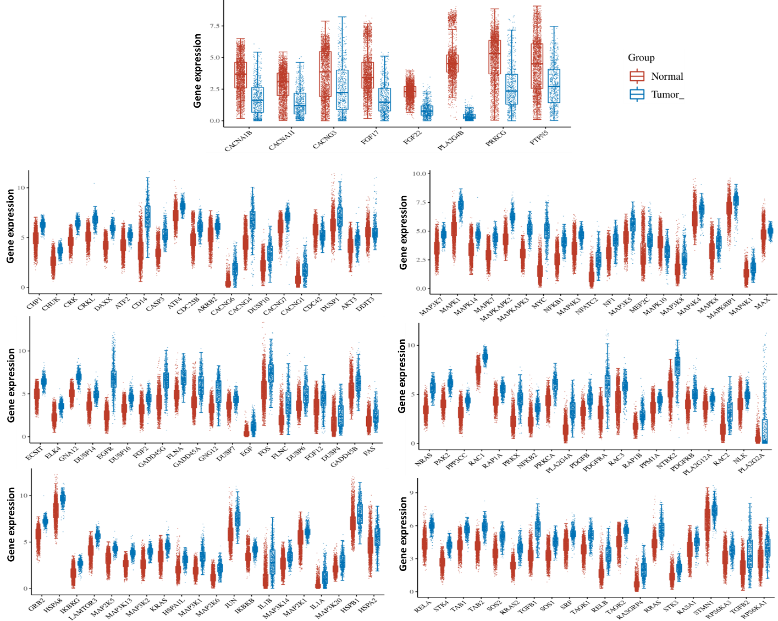
S-Figure 1. Expression of differentially expressed MAPK signaling pathway genes in glioma. The “ggplot2” package was utilized to plot the figures with R software.
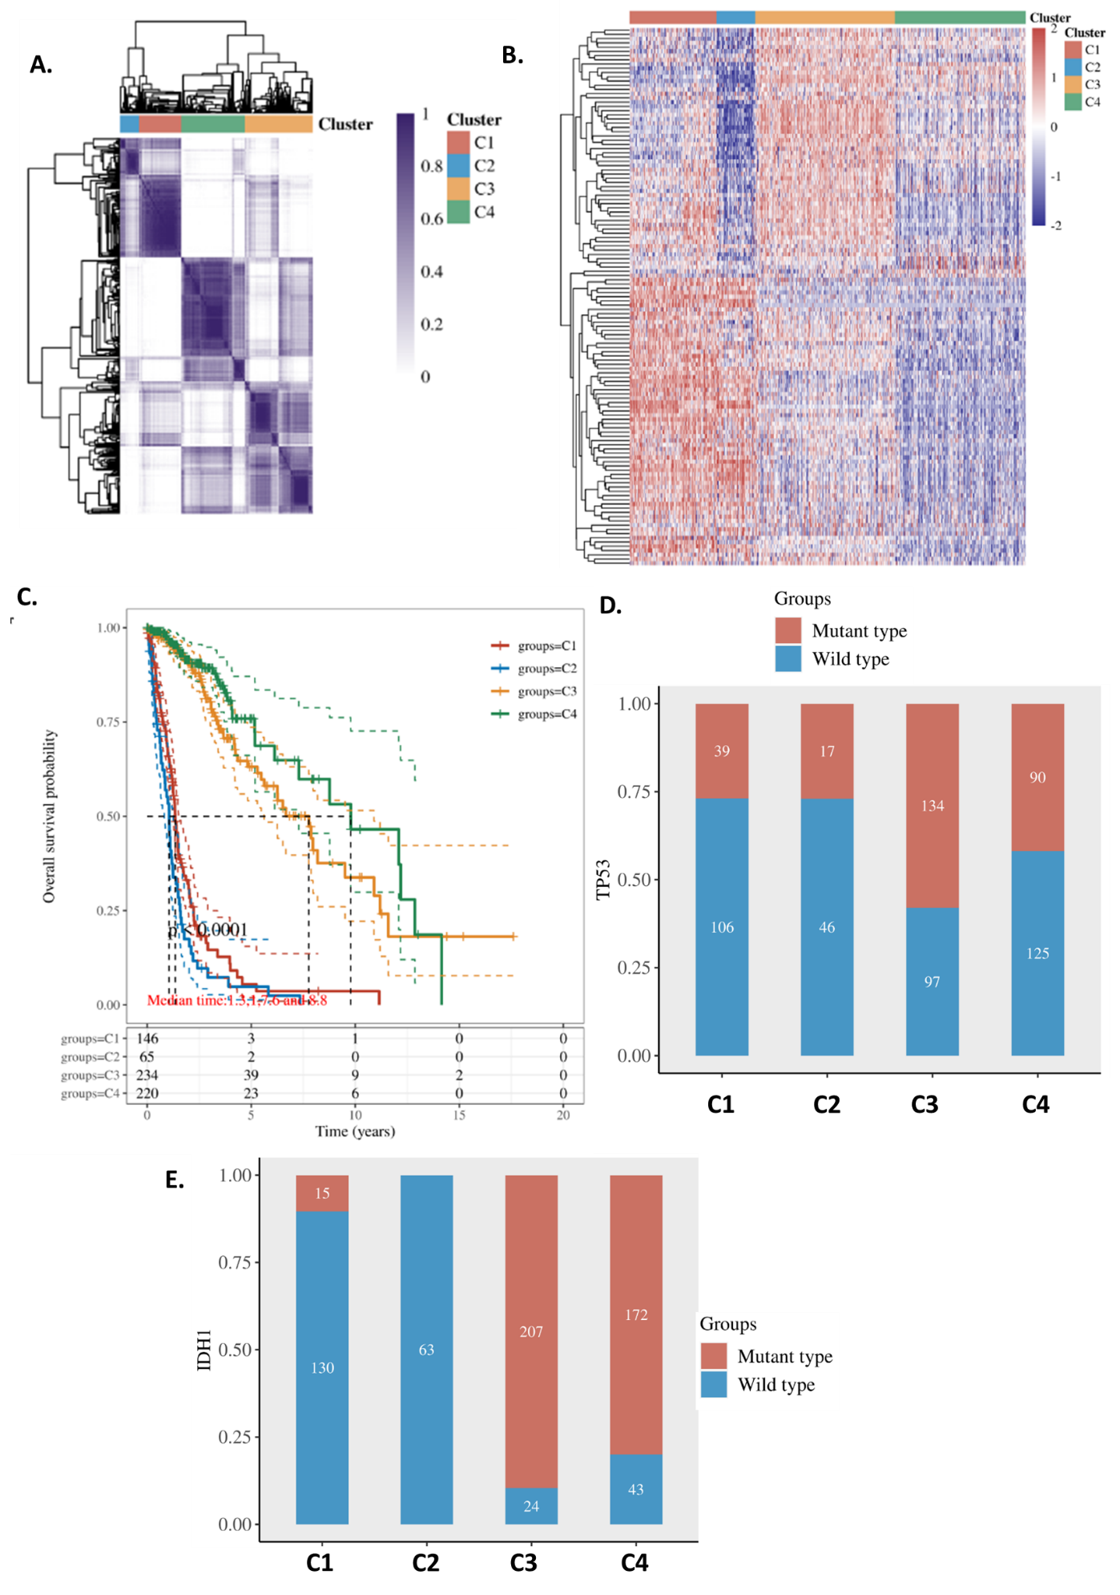
S-Figure 2. Glioma subtype based on the glioma up-regulated MAPK signaling pathway gene set (Clustering to 4 subtypes). A. Consensus matrix and cluster trees of subtypes. B. expression heatmap of subtypes. C. Overall survival of subtypes. D. Subtype difference in TP53 mutation. E. Subtype difference in IDH1 mutation. The “ggplot2” package and “pheatmap” package were utilized to plot the figures with R software.

