Supplementary Information
Supplementary Figure 1:
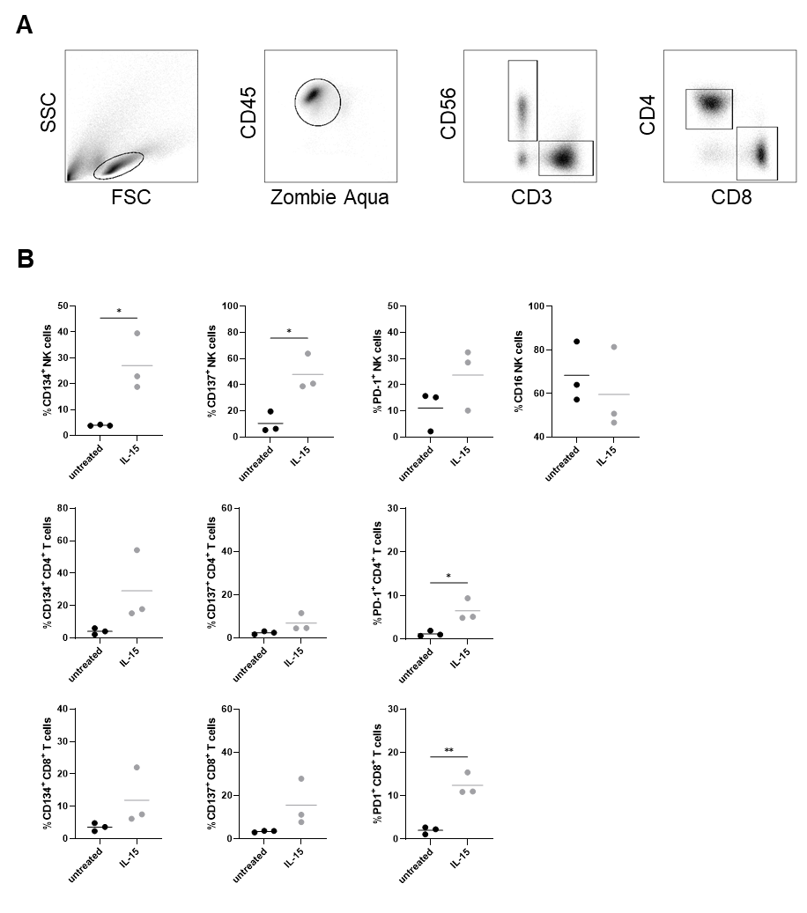
Supplementary Figure 1: IL-15 modulates the immune cell activation. (A) Gating strategy for discrimination of CD3⁻ CD56⁺ NK cells, CD3⁺ CD4⁺ T cells and CD3⁺ CD8⁺ T cells. (B) Expression of activation markers CD134 (left panel), CD137 (middle panel) and PD-1 (right panel) on CD3⁻ CD56⁺ NK cells (upper row), CD3⁺ CD4⁺ T cells (middle row) and CD3⁺ CD8⁺ T cells (lower row), measured in flow cytometry after 48 hours in co-culture.

