SUPPLEMENTARY FIGURES FOR:

Characterization of the microbiome and metabolome in anal gland secretions from domestic cats (Felis catus) using metagenomics and metabolomics

Connie A. Rojas^{1,2*}, Stanley L. Marks³, Eva Borras^{4,5}, Hira Lesea⁶, Mitchell M. McCartney^{4,5,7}, David Coil¹, Cristina E. Davis^{4,5,7}, Jonathan A. Eisen^{1,2}

¹ Genome Center, University of California – Davis, Davis, California, USA
² Department of Evolution and Ecology, University of California – Davis, Davis, California, USA
³ Department of Medicine and Epidemiology, University of California – Davis, School of Veterinary Medicine, Davis, California, USA
⁴ Department of Mechanical and Aerospace Engineering, University of California – Davis, Davis, California, USA
⁵ UC Davis Lung Center, University of California – Davis, Davis, CA, USA.
⁶ Department of Microbiology and Molecular Genetics, University of California – Davis, Davis, California, USA
⁷ VA Northern California Health Care System, Mather, CA, USA

Email the corresponding author with any questions: carojas@ucdavis.edu

List of Figures in this document
Fig S1 - phylogenetic tree built from MAGs
Fig S2 - phylogenetic trees of six MAGs and their closest relatives in the Genome Taxonomy Database (GTDB)
Fig S3 - plots of microbiome composition in the anal gland and in the perianal region

Fig S1. Phylogeny of MAGs constructed with alignments from GTDB, rooted to Fretibacterium, the only member of the phylum Synergistota.
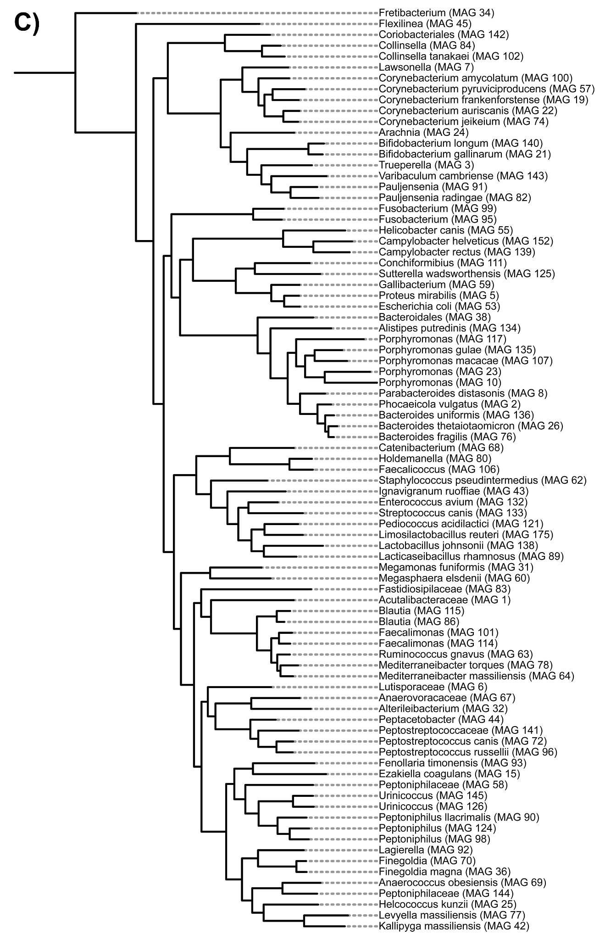
Fig S2. Individual phylogenetic trees of the six most abundant MAGs in the dataset, alongside genomes from the Genome Taxonomy Database (GTDB). Trees show the evolutionary distance of each MAG to the closest genomes in GTDB, release 202. Nodes of MAGs that came from this study have a purple label.

MAG #144 Peptoniphilaceae
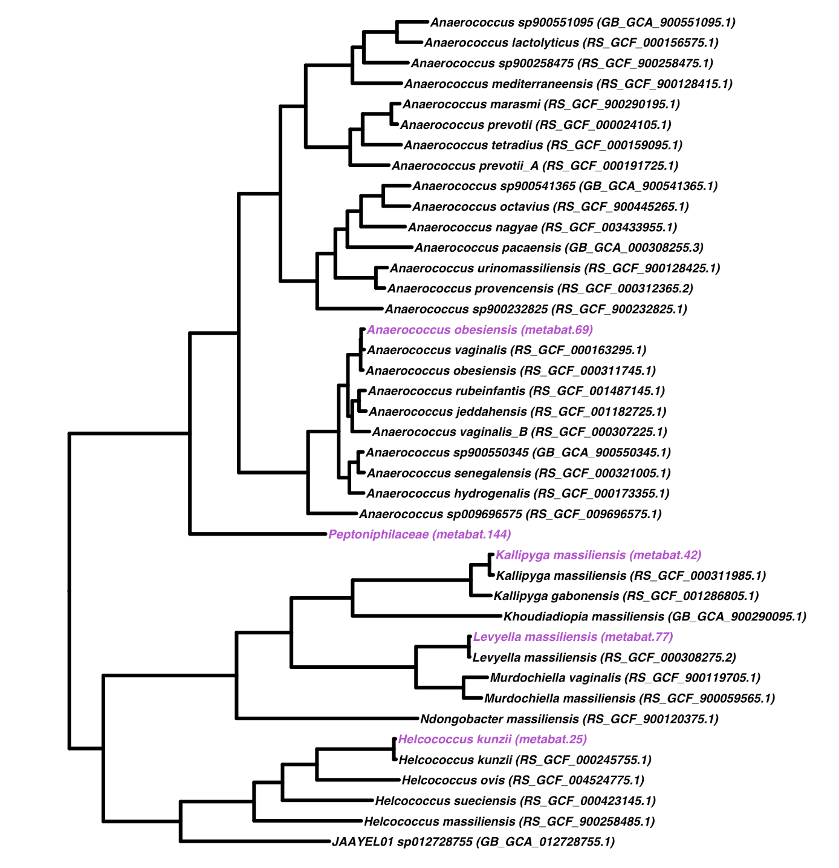

MAG #19 Corynebacterium frankenforstense
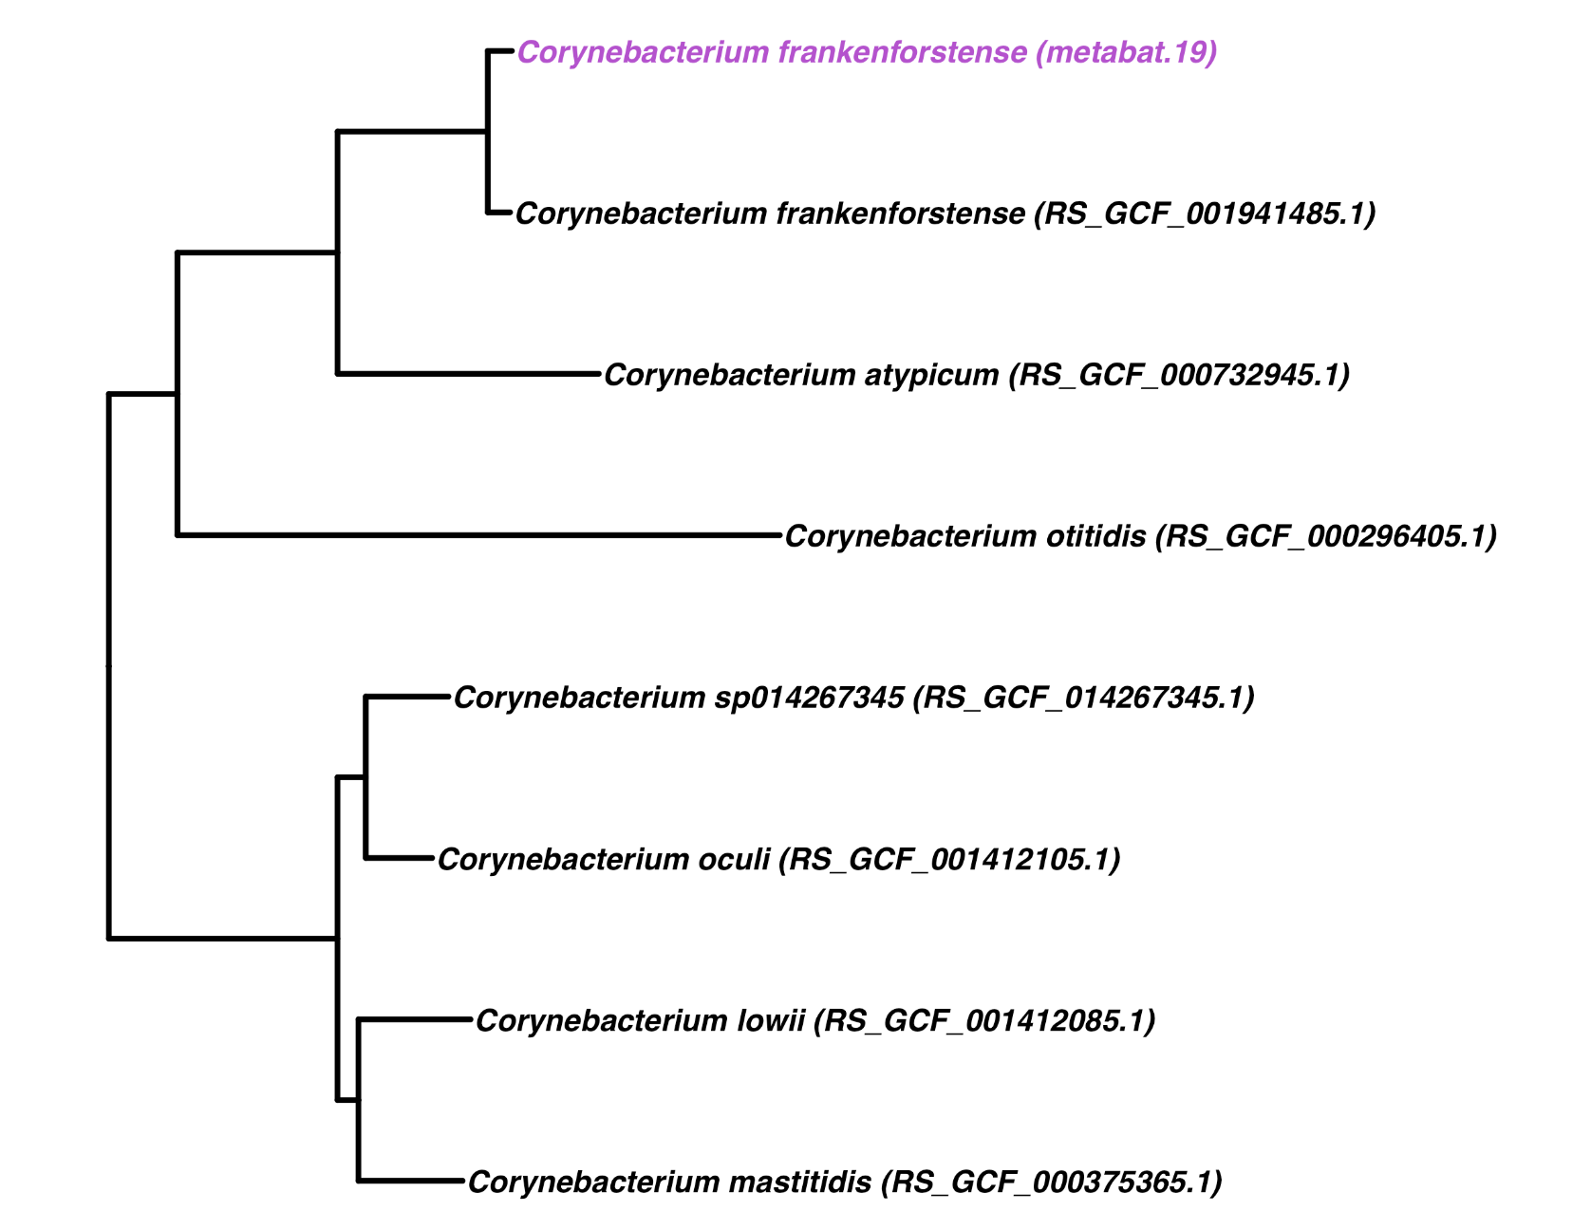

MAG #124 Peptoniphilus
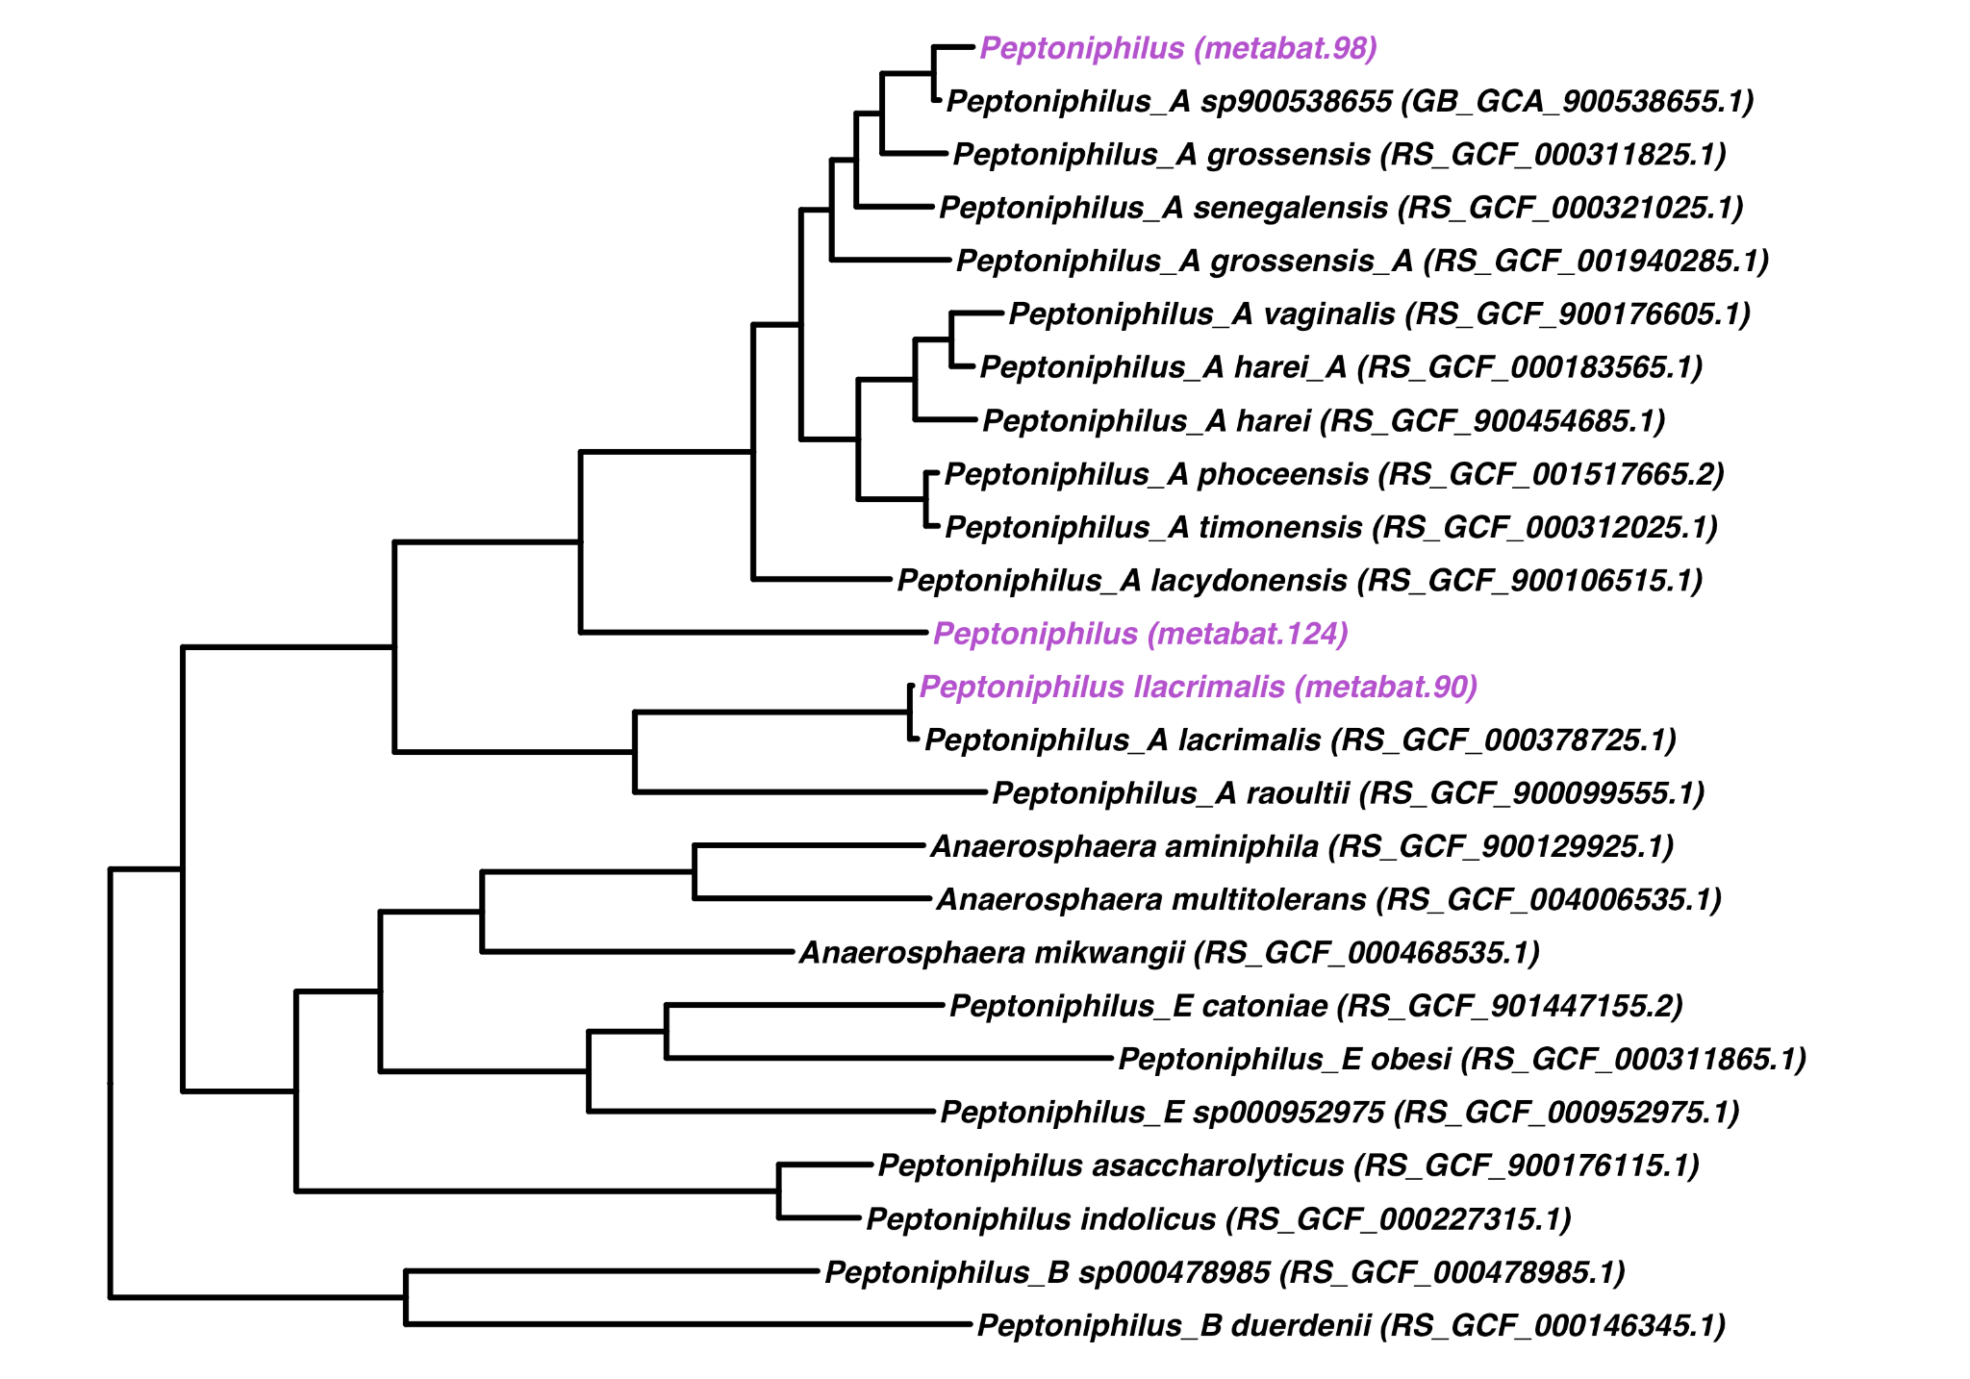

MAG #138 Lactobacillus johnsonii
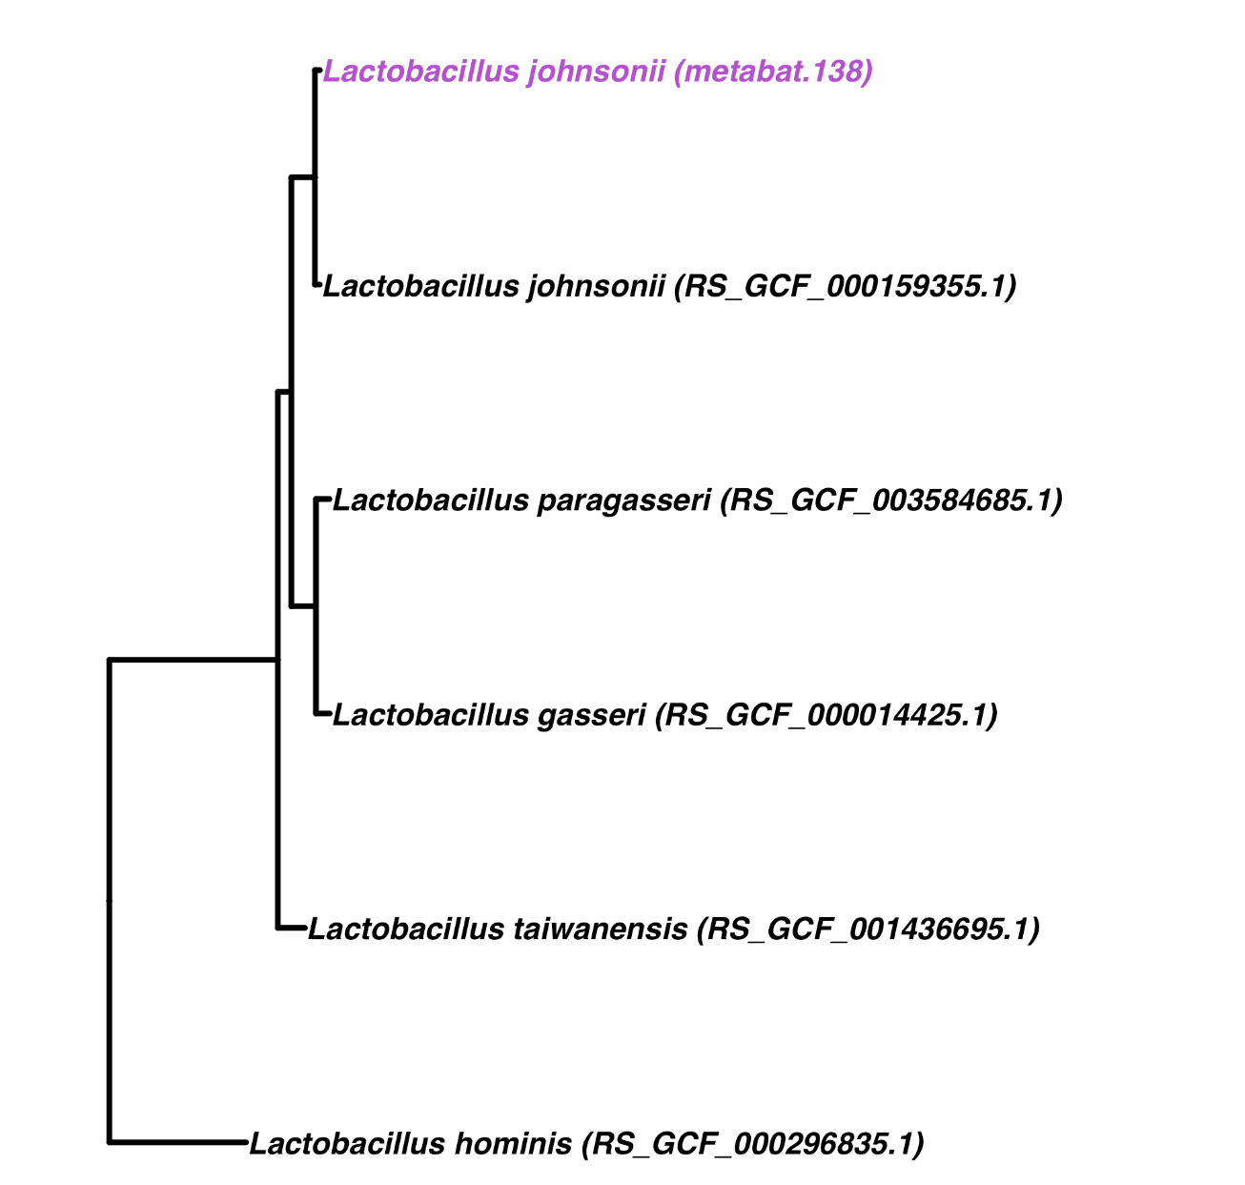

MAG #57 Corynebacterium pyruviciproducens
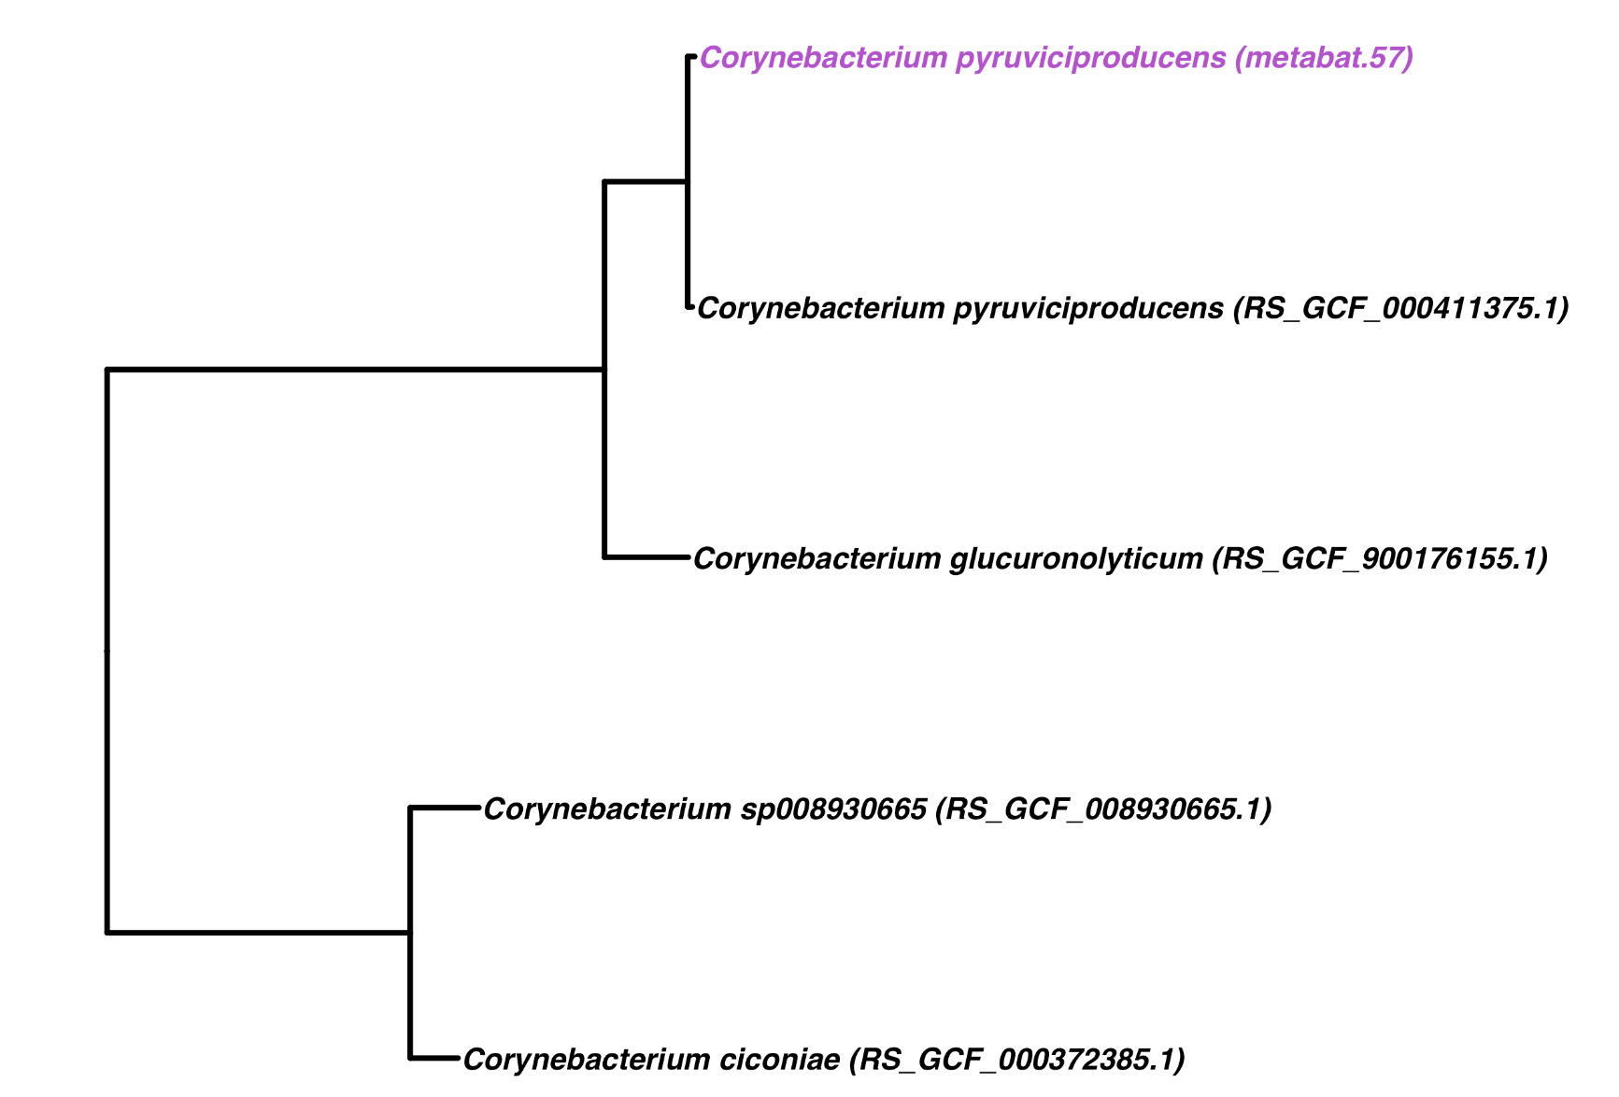
MAG #5 Proteus mirabilis
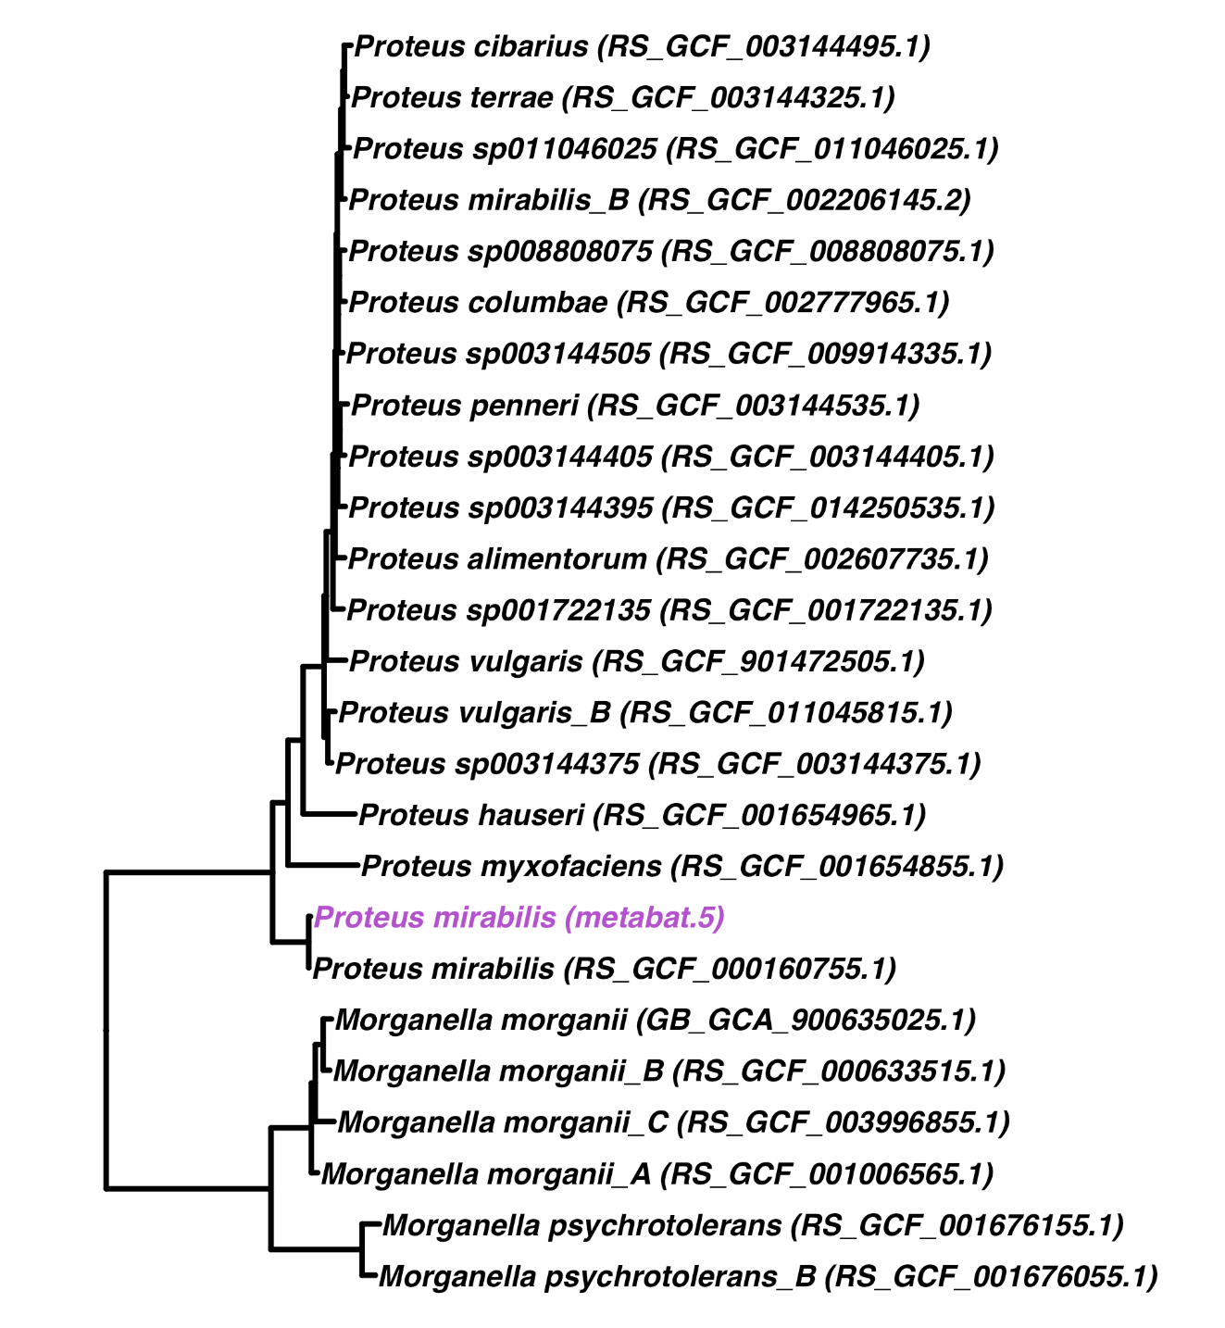

Fig S3. Microbiomes from the anal gland alongside those from the perianal area. Relative abundances of bacterial genera in the anal gland (left) and perianal region (right) for six feline participants, as estimated from shotgun Illumina sequence data using Kraken2/Bracken. (Top panels - this page) Bacterial genera with a mean relative abundance >1.75%. (Bottom panels - next page) Bacterial genera with a mean relative abundance >0.38 but <0.76.

