Supplementary File 1

Supplementary Table S1 – Metadata of the samples. It contains the ID number of the Cow (Cow_ID), SampleID, Barcode Sequence, Site (UH= Uterine Horn, UB= Uterine Body), N° parturition (Number of births that cows had during their lives.), District (O = Olleros) and Breed (BS = Brow Swiss, Cb = Crossbreed).
Cow_ID | SampleID | Barcode_Sequence | Site | N° parturition | Breed | District
10 | C10_S19 | GTTATGACGGAT | UH | 4 | BS | O
12 | C12_S20 | TAGTACTATACT | UH | 1 | BS | O
15 | C15_S21 | GTGAACTGGATT | UH | 7 | Cb | O
17 | C17_S22 | ATAAGGTCGCCT | UH | 6 | Cb | O
18 | C18_S23 | CGTTAGTGACTG | UH | 3 | Cb | O
43 | C43_S28 | TCGCATGGATAC | UH | 1 | Cb | O
45 | C45_S29 | AGTTTAATCTCA | UH | 1 | Cb | O
10 | U10_S4 | TTGTATGACAGG | UB | 4 | BS | O
12 | U12_S6 | ACGAGGAGTCGA | UB | 1 | BS | O
13 | U13_S5 | AACCCTAACTGG | UB | 4 | Cb | O
14 | U14_S7 | CGATCACCACAA | UB | 7 | BS | O
15 | U15_S8 | TGTACGGATAAC | UB | 7 | Cb | O
18 | U18_S9 | GGTTCCATTAGG | UB | 3 | Cb | O
5 | U5_S2 | GATGTCATAGCC | UB | 2 | Cb | O
7 | U7_S3 | GAGGGCGTGATC | UB | 1 | BS | O

Supplementary Table S2 – Alpha Diversity Analysis – Significance test of ANOVA for Shannon and Chao1 indices for Site groups.
ANOVA
Summary (aov. Shannon) | Df | Sum-Sq | Mean-Sq | F-value | Pr(>F) | sig
Site | 1 | 0.115 | 0.1154 | 0.245 | 0.629 | ‘’
Residuals | 13 | 6.114 | 0.4703
Summary (aov. Chao1) | Df | Sum-Sq | Mean-Sq | F-value | Pr(>F)
Site | 1 | 3253 | 3253 | 3.08 | 0.103 | ‘’
Residuals | 13 | 13731 | 1056
Signif. codes: |0 = ‘***’| - |0.001 = ‘**’| - |0.01 = ‘*’| - |0.05 = ‘.’| - |0.1 = ‘’ | - |1|

Supplementary Table S3 - Alpha Diversity Analysis for index Shannon- Tukey’s honest significance test of our ANOVA - Tukey multiple comparisons of means - 95% family-wise confidence level for Site groups.
Shannon
Site | Diff | Lwr | Upr | p | Sig
UB vs UH | -0.1757847 | -0.9425712 | 0.5910019 | 0.6286814 | ‘’
Signif. codes: |0 = ‘***’| - |0.001 = ‘**’| - |0.01 = ‘*’| - |0.05 = ‘.’| - |0.1 = ‘’ | - |1|

Supplementary Table S4 - Analysis of Alpha Diversity for index Chao1- Tukey's honest significance test of our ANOVA - Tukey multiple comparisons of means - 95% family-wise confidence level for Site groups
Chao1
Site | Diff | Lwr | Upr | p | sig
UB vs UH | -29.51786 | -65.85532 | 6.81961 | 0.1027947 | ‘’
Signif. codes: |0 = ‘***’| - |0.001 = ‘**’| - |0.01 = ‘*’| - |0.05 = ‘.’| - |0.1 = ‘’ | - |1|

Supplementary Table S5 - Statistical analysis of beta diversity. Pairwise Permanova, considering the Unweighted Unifrac method in the calculation, and with the Bonferroni correction for comparing Site groups.

Beta Diversity
Site | Df | Sums.Of.Sqs | F.Model | R2 | p-value | sig | p.adjusted | sig
UB vs UH | 1 | 0.06020068 | 0.5489131 | 0.04051344 | 0.666 | ‘’ | 0.666 | ‘’
Signif. codes: |0 = ‘***’| - |0.001 = ‘**’| - |0.01 = ‘*’| - |0.05 = ‘.’| - |0.1 = ‘’ | - |1|

Supplementary Table S6 – Alpha Diversity Analysis – Significance test of ANOVA for Shannon and Chao1 indices using like independent variable the cow that sample were extracted.
ANOVA
Summary (aov. Shannon) | Df | Sum-Sq | Mean-Sq | F-value | Pr(>F) | sig
Cow_ID | 10 | 5.111 | 0.5111 | 1.827 | 0.295 | ‘’
Residuals | 4 | 1.119 | 0.2797
Summary (aov. Chao1) | Df | Sum-Sq | Mean-Sq | F-value | Pr(>F)
Cow_ID | 10 | 12313 | 1231 | 1.054 | 0.524 | ‘’
Residuals | 4 | 4671 | 1168
Signif. codes: |0 = ‘***’| - |0.001 = ‘**’| - |0.01 = ‘*’| - |0.05 = ‘.’| - |0.1 = ‘’ | - |1|

Supplementary Table S7 - Alpha Diversity Analysis for index Shannon- Tukey’s honest significance test of our ANOVA - Tukey multiple comparisons of means - 95% family-wise confidence level for cow groups.
Shannon
Cow | diff | lwr | upr | p adj | Sig
12-10 | 1.4423495 | -1.559561 | 4.44426 | 0.3969885 | "
13-10 | -0.14276948 | -3.819343 | 3.533805 | 0.9999999 | "
14-10 | -0.3874811 | -4.064055 | 3.289093 | 0.9995214 | "
15-10 | 0.44035937 | -2.561551 | 3.442269 | 0.9943668 | "
17-10 | 0.92713613 | -2.749438 | 4.60371 | 0.8890657 | "
18-10 | 0.46082515 | -2.541085 | 3.462735 | 0.9923618 | "
43-10 | 0.75412051 | -2.922453 | 4.430695 | 0.9576229 | "
45-10 | -0.28968646 | -3.96626 | 3.386888 | 0.999959 | "
05-10 | 1.01504545 | -2.661529 | 4.691619 | 0.8421493 | "
07-10 | 1.20172526 | -2.474849 | 4.878299 | 0.7267503 | "
13-12 | -1.58511898 | -5.261693 | 2.091455 | 0.4894269 | "
14-12 | -1.8298306 | -5.506405 | 1.846743 | 0.3684975 | "
15-12 | -1.00199013 | -4.0039 | 1.99992 | 0.7102285 | "
17-12 | -0.51521337 | -4.191787 | 3.161361 | 0.9958917 | "
18-12 | -0.98152435 | -3.983434 | 2.020386 | 0.7264967 | "
43-12 | -0.68822899 | -4.364803 | 2.988345 | 0.974195 | "
45-12 | -1.73203596 | -5.40861 | 1.944538 | 0.4133214 | "
05-12 | -0.42730405 | -4.103878 | 3.24927 | 0.998965 | "
07-12 | -0.24062424 | -3.917198 | 3.43595 | 0.9999922 | "
14-13 | -0.24471162 | -4.490054 | 4.00063 | 0.9999976 | "
15-13 | 0.58312885 | -3.093445 | 4.259703 | 0.990547 | "
17-13 | 1.06990561 | -3.175436 | 5.315248 | 0.8893472 | "
18-13 | 0.60359463 | -3.072979 | 4.280169 | 0.9882227 | "
43-13 | 0.89688999 | -3.348452 | 5.142232 | 0.9507082 | "
45-13 | -0.14691698 | -4.392259 | 4.098425 | 1 | "
01-05 | 1.15781493 | -3.087527 | 5.403157 | 0.8491289 | "
01-07 | 1.34449474 | -2.900847 | 5.589837 | 0.7508348 | "
15-14 | 0.82784047 | -2.848734 | 4.504414 | 0.9327441 | "
17-14 | 1.31461723 | -2.930725 | 5.559959 | 0.7673323 | "
18-14 | 0.84830625 | -2.828268 | 4.52488 | 0.9246601 | "
43-14 | 1.14160161 | -3.10374 | 5.386944 | 0.8569228 | "
45-14 | 0.09779464 | -4.147547 | 4.343137 | 1 | "
01-05 | 1.40252655 | -2.842815 | 5.647869 | 0.7183865 | "
01-07 | 1.58920636 | -2.656136 | 5.834548 | 0.6139952 | "
17-15 | 0.48677676 | -3.189797 | 4.163351 | 0.997257 | "
18-15 | 0.02046578 | -2.981444 | 3.022376 | 1 | "
43-15 | 0.31376115 | -3.362813 | 3.990335 | 0.9999177 | "
45-15 | -0.73004583 | -4.40662 | 2.946528 | 0.9642896 | "
01-05 | 0.57468608 | -3.101888 | 4.25126 | 0.9914003 | "
01-07 | 0.76136589 | -2.915208 | 4.43794 | 0.9554761 | "
18-17 | -0.46631098 | -4.142885 | 3.210263 | 0.9979966 | "
43-17 | -0.17301562 | -4.418358 | 4.072326 | 0.9999999 | "
45-17 | -1.21682259 | -5.462165 | 3.028519 | 0.8195549 | "
01-05 | 0.08790932 | -4.157433 | 4.333251 | 1 | "
01-07 | 0.27458913 | -3.970753 | 4.519931 | 0.999993 | "
43-18 | 0.29329536 | -3.383279 | 3.969869 | 0.9999542 | "
45-18 | -0.75051161 | -4.427086 | 2.926062 | 0.9586679 | "
01-05 | 0.5542203 | -3.122354 | 4.230794 | 0.9932311 | "
01-07 | 0.74090011 | -2.935674 | 4.417474 | 0.9613723 | "
45-43 | -1.04380697 | -5.289149 | 3.201535 | 0.9002289 | "
01-05 | 0.26092493 | -3.984417 | 4.506267 | 0.9999956 | "
01-07 | 0.44760475 | -3.797737 | 4.692947 | 0.9995198 | "
01-05 | 1.30473191 | -2.94061 | 5.550074 | 0.7727469 | "
01-07 | 1.49141172 | -2.75393 | 5.736754 | 0.6683515 | "
07-05 | 0.18667982 | -4.058662 | 4.432022 | 0.9999998 | "

Signif. codes: |0 = ‘***’| - |0.001 = ‘**’| - |0.01 = ‘*’| - |0.05 = ‘.’| - |0.1 = ‘’ | - |1|

Supplementary Table S8 - Analysis of Alpha Diversity for index Chao1- Tukey's honest significance test of our ANOVA - Tukey multiple comparisons of means - 95% family-wise confidence level for cow groups
Chao1
Cow | diff | lwr | upr | p adj | Sig
12-10 | 4.50E+00 | -189.463 | 198.463 | 1 | "
13-10 | -8.00E+00 | -245.5551 | 229.5551 | 1 | "
14-10 | -1.70E+01 | -254.5551 | 220.5551 | 0.9999826 | "
15-10 | 3.90E+01 | -154.963 | 232.963 | 0.9618262 | "
17-10 | -1.50E+01 | -252.5551 | 222.5551 | 0.9999944 | "
18-10 | -8.50E+00 | -202.463 | 185.463 | 0.9999998 | "
43-10 | -9.00E+00 | -246.5551 | 228.5551 | 1 | "
45-10 | -1.70E+01 | -254.5551 | 220.5551 | 0.9999826 | "
05-10 | -1.20E+01 | -249.5551 | 225.5551 | 0.9999993 | "
07-10 | 9.20E+01 | -145.5551 | 329.5551 | 0.5842137 | "
13-12 | -1.25E+01 | -250.0551 | 225.0551 | 0.999999 | "
14-12 | -2.15E+01 | -259.0551 | 216.0551 | 0.9998641 | "
15-12 | 3.45E+01 | -159.463 | 228.463 | 0.9807961 | "
17-12 | -1.95E+01 | -257.0551 | 218.0551 | 0.9999413 | "
18-12 | -1.30E+01 | -206.963 | 180.963 | 0.9999904 | "
43-12 | -1.35E+01 | -251.0551 | 224.0551 | 0.9999979 | "
45-12 | -2.15E+01 | -259.0551 | 216.0551 | 0.9998641 | "
05-12 | -1.65E+01 | -254.0551 | 221.0551 | 0.9999867 | "
07-12 | 8.75E+01 | -150.0551 | 325.0551 | 0.6280298 | "
14-13 | -9.00E+00 | -283.3051 | 265.3051 | 1 | "
15-13 | 4.70E+01 | -190.5551 | 284.5551 | 0.9649774 | "
17-13 | -7.00E+00 | -281.3051 | 267.3051 | 1 | "
18-13 | -5.00E-01 | -238.0551 | 237.0551 | 1 | "
43-13 | -1.00E+00 | -275.3051 | 273.3051 | 1 | "
45-13 | -9.00E+00 | -283.3051 | 265.3051 | 1 | "
01-05 | -4.00E+00 | -278.3051 | 270.3051 | 1 | "
01-07 | 1.00E+02 | -174.3051 | 374.3051 | 0.6369153 | "
15-14 | 5.60E+01 | -181.5551 | 293.5551 | 0.9169751 | "
17-14 | 2.00E+00 | -272.3051 | 276.3051 | 1 | "
18-14 | 8.50E+00 | -229.0551 | 246.0551 | 1 | "
43-14 | 8.00E+00 | -266.3051 | 282.3051 | 1 | "
45-14 | 7.11E-15 | -274.3051 | 274.3051 | 1 | "
01-05 | 5.00E+00 | -269.3051 | 279.3051 | 1 | "
01-07 | 1.09E+02 | -165.3051 | 383.3051 | 0.5614955 | "
17-15 | -5.40E+01 | -291.5551 | 183.5551 | 0.9296819 | "
18-15 | -4.75E+01 | -241.463 | 146.463 | 0.9019126 | "
43-15 | -4.80E+01 | -285.5551 | 189.5551 | 0.9608239 | "
45-15 | -5.60E+01 | -293.5551 | 181.5551 | 0.9169751 | "
01-05 | -5.10E+01 | -288.5551 | 186.5551 | 0.9465846 | "
01-07 | 5.30E+01 | -184.5551 | 290.5551 | 0.9356084 | "
18-17 | 6.50E+00 | -231.0551 | 244.0551 | 1 | "
43-17 | 6.00E+00 | -268.3051 | 280.3051 | 1 | "
45-17 | -2.00E+00 | -276.3051 | 272.3051 | 1 | "
01-05 | 3.00E+00 | -271.3051 | 277.3051 | 1 | "
01-07 | 1.07E+02 | -167.3051 | 381.3051 | 0.5778651 | "
43-18 | -5.00E-01 | -238.0551 | 237.0551 | 1 | "
45-18 | -8.50E+00 | -246.0551 | 229.0551 | 1 | "
01-05 | -3.50E+00 | -241.0551 | 234.0551 | 1 | "
01-07 | 1.01E+02 | -137.0551 | 338.0551 | 0.5060627 | "
45-43 | -8.00E+00 | -282.3051 | 266.3051 | 1 | "
01-05 | -3.00E+00 | -277.3051 | 271.3051 | 1 | "
01-07 | 1.01E+02 | -173.3051 | 375.3051 | 0.6283403 | "
01-05 | 5.00E+00 | -269.3051 | 279.3051 | 1 | "
01-07 | 1.09E+02 | -165.3051 | 383.3051 | 0.5614955 | "
07-05 | 1.04E+02 | -170.3051 | 378.3051 | 0.6028713 | "

Signif. codes: |0 = ‘***’| - |0.001 = ‘**’| - |0.01 = ‘*’| - |0.05 = ‘.’| - |0.1 = ‘’ | - |1|

Supplementary Table S9 - Statistical analysis of beta diversity. Pairwise Adonis, considering the Unweighted Unifrac method in the calculation.

Pairs | Df | SumsOfSqs | F.Model | R2 | p.value | p.adjusted | sig
10 vs 12 | 1 | 0.4504186 | 2.4826515 | 0.5538355 | 0.3333333 | 1
10 vs 15 | 1 | 0.3481032 | 1.1968047 | 0.3743753 | 0.3333333 | 1
10 vs 17 | 1 | 0.3854842 | 1.5878729 | 0.6135823 | 0.3333333 | 1
10 vs 18 | 1 | 0.426473 | 1.9101203 | 0.4885068 | 0.3333333 | 1
10 vs 43 | 1 | 0.3865628 | 1.5923161 | 0.6142446 | 0.3333333 | 1
10 vs 45 | 1 | 0.569925 | 2.3476153 | 0.7012799 | 0.3333333 | 1
10 vs 13 | 1 | 0.3266523 | 1.3455349 | 0.573658 | 0.3333333 | 1
10 vs 14 | 1 | 0.3308125 | 1.3626712 | 0.5767503 | 0.6666667 | 1
10 vs 5 | 1 | 0.2871183 | 1.1826879 | 0.5418493 | 0.6666667 | 1
10 vs 7 | 1 | 0.4140755 | 1.7056454 | 0.6304024 | 0.3333333 | 1
12 vs 15 | 1 | 0.5476393 | 2.386028 | 0.5440066 | 0.3333333 | 1
12 vs 17 | 1 | 0.3111435 | 2.5910233 | 0.7215278 | 0.3333333 | 1
12 vs 18 | 1 | 0.3397044 | 2.0978596 | 0.5119403 | 0.3333333 | 1
12 vs 43 | 1 | 0.3083524 | 2.56778 | 0.7197137 | 0.3333333 | 1
12 vs 45 | 1 | 0.503322 | 4.1913744 | 0.8073728 | 0.3333333 | 1
12 vs 13 | 1 | 0.3099406 | 2.581006 | 0.7207489 | 0.3333333 | 1
12 vs 14 | 1 | 0.3391004 | 2.8238322 | 0.7384823 | 0.3333333 | 1
12 vs 5 | 1 | 0.1773871 | 1.477177 | 0.5963147 | 0.6666667 | 1
12 vs 7 | 1 | 0.498169 | 4.1484635 | 0.8057673 | 0.3333333 | 1
15 vs 17 | 1 | 0.4134102 | 1.2196671 | 0.549482 | 0.3333333 | 1
15 vs 18 | 1 | 0.5186117 | 1.911136 | 0.4886396 | 0.3333333 | 1
15 vs 43 | 1 | 0.4307878 | 1.2709355 | 0.5596528 | 0.3333333 | 1
15 vs 45 | 1 | 0.5339853 | 1.5753949 | 0.61171 | 0.3333333 | 1
15 vs 13 | 1 | 0.3700423 | 1.0917207 | 0.5219247 | 0.6666667 | 1
15 vs 14 | 1 | 0.4144077 | 1.2226102 | 0.5500785 | 0.3333333 | 1
15 vs 5 | 1 | 0.3871759 | 1.1422693 | 0.5332053 | 0.6666667 | 1
15 vs 7 | 1 | 0.302193 | 0.8915476 | 0.4713324 | 0.6666667 | 1
17 vs 18 | 1 | 0.2996428 | 1.4704747 | 0.5952195 | 0.3333333 | 1
17 vs 43 | 1 | 0.2811676 | NA | 1 | NA | NA
17 vs 45 | 1 | 0.4627649 | NA | 1 | NA | NA
17 vs 13 | 1 | 0.2593214 | NA | 1 | NA | NA
17 vs 14 | 1 | 0.158853 | NA | 1 | NA | NA
17 vs 5 | 1 | 0.2830069 | NA | 1 | NA | NA
17 vs 7 | 1 | 0.4467126 | NA | 1 | NA | NA
18 vs 43 | 1 | 0.3982291 | 1.9542793 | 0.661508 | 0.3333333 | 1
18 vs 45 | 1 | 0.5504098 | 2.7010949 | 0.7298097 | 0.3333333 | 1
18 vs 13 | 1 | 0.3953428 | 1.9401149 | 0.6598772 | 0.3333333 | 1
18 vs 14 | 1 | 0.1870019 | 0.9176976 | 0.4785413 | 0.6666667 | 1
18 vs 5 | 1 | 0.3247015 | 1.5934483 | 0.614413 | 0.3333333 | 1
18 vs 7 | 1 | 0.484509 | 2.3776915 | 0.7039398 | 0.3333333 | 1
43 vs 45 | 1 | 0.3846498 | NA | 1 | NA | NA
43 vs 13 | 1 | 0.2534734 | NA | 1 | NA | NA
43 vs 14 | 1 | 0.3020692 | NA | 1 | NA | NA
43 vs 5 | 1 | 0.1902331 | NA | 1 | NA | NA
43 vs 7 | 1 | 0.3907452 | NA | 1 | NA | NA
45 vs 13 | 1 | 0.4892448 | NA | 1 | NA | NA
45 vs 14 | 1 | 0.4156231 | NA | 1 | NA | NA
45 vs 5 | 1 | 0.3789491 | NA | 1 | NA | NA
45 vs 7 | 1 | 0.4589219 | NA | 1 | NA | NA
13 vs 14 | 1 | 0.3060772 | NA | 1 | NA | NA
13 vs 5 | 1 | 0.2612807 | NA | 1 | NA | NA
13 vs 7 | 1 | 0.4227068 | NA | 1 | NA | NA
14 vs 5 | 1 | 0.3047483 | NA | 1 | NA | NA
14 vs 7 | 1 | 0.4410489 | NA | 1 | NA | NA
5 vs 7 | 1 | 0.4059974 | NA | 1 | NA | NA

Signif. codes: |0 = ‘***’| - |0.001 = ‘**’| - |0.01 = ‘*’| - |0.05 = ‘.’| - |0.1 = ‘’ | - |1|
Supplementary Table S10 – Alpha Diversity Analysis – T-test results of differences of Shannon and Chao1 indices grouped by breed.
T-Student (two.sided)
Shannon | Df | t | Pr(>F) | sig
Breed | 13 | 0.45498 | 0.6566 | ‘’
Chao1 | Df | t | Pr(>F) | sig
Breed | 13 | 0.75067 | 0.4662 | ‘’
Signif. codes: |0 = ‘***’| - |0.001 = ‘**’| - |0.01 = ‘*’| - |0.05 = ‘.’| - |0.1 = ‘’ | - |1|

Supplementary figure S1
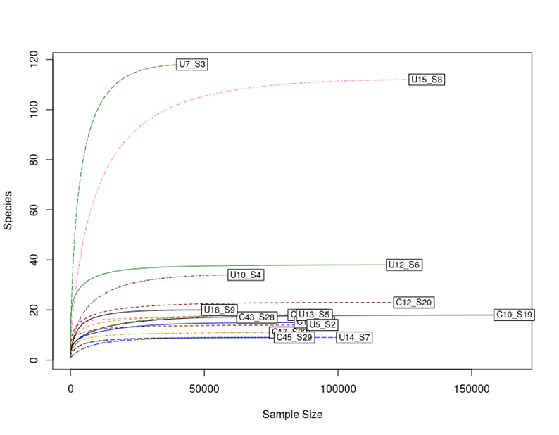
Alpha rarefaction curves. The rarefaction curves of each sample were indicated with different colors and types of lines. The letter C in the name of the samples stands for the samples from the UH group, and the letter U for the samples of the UB group.
Supplementary figure S2
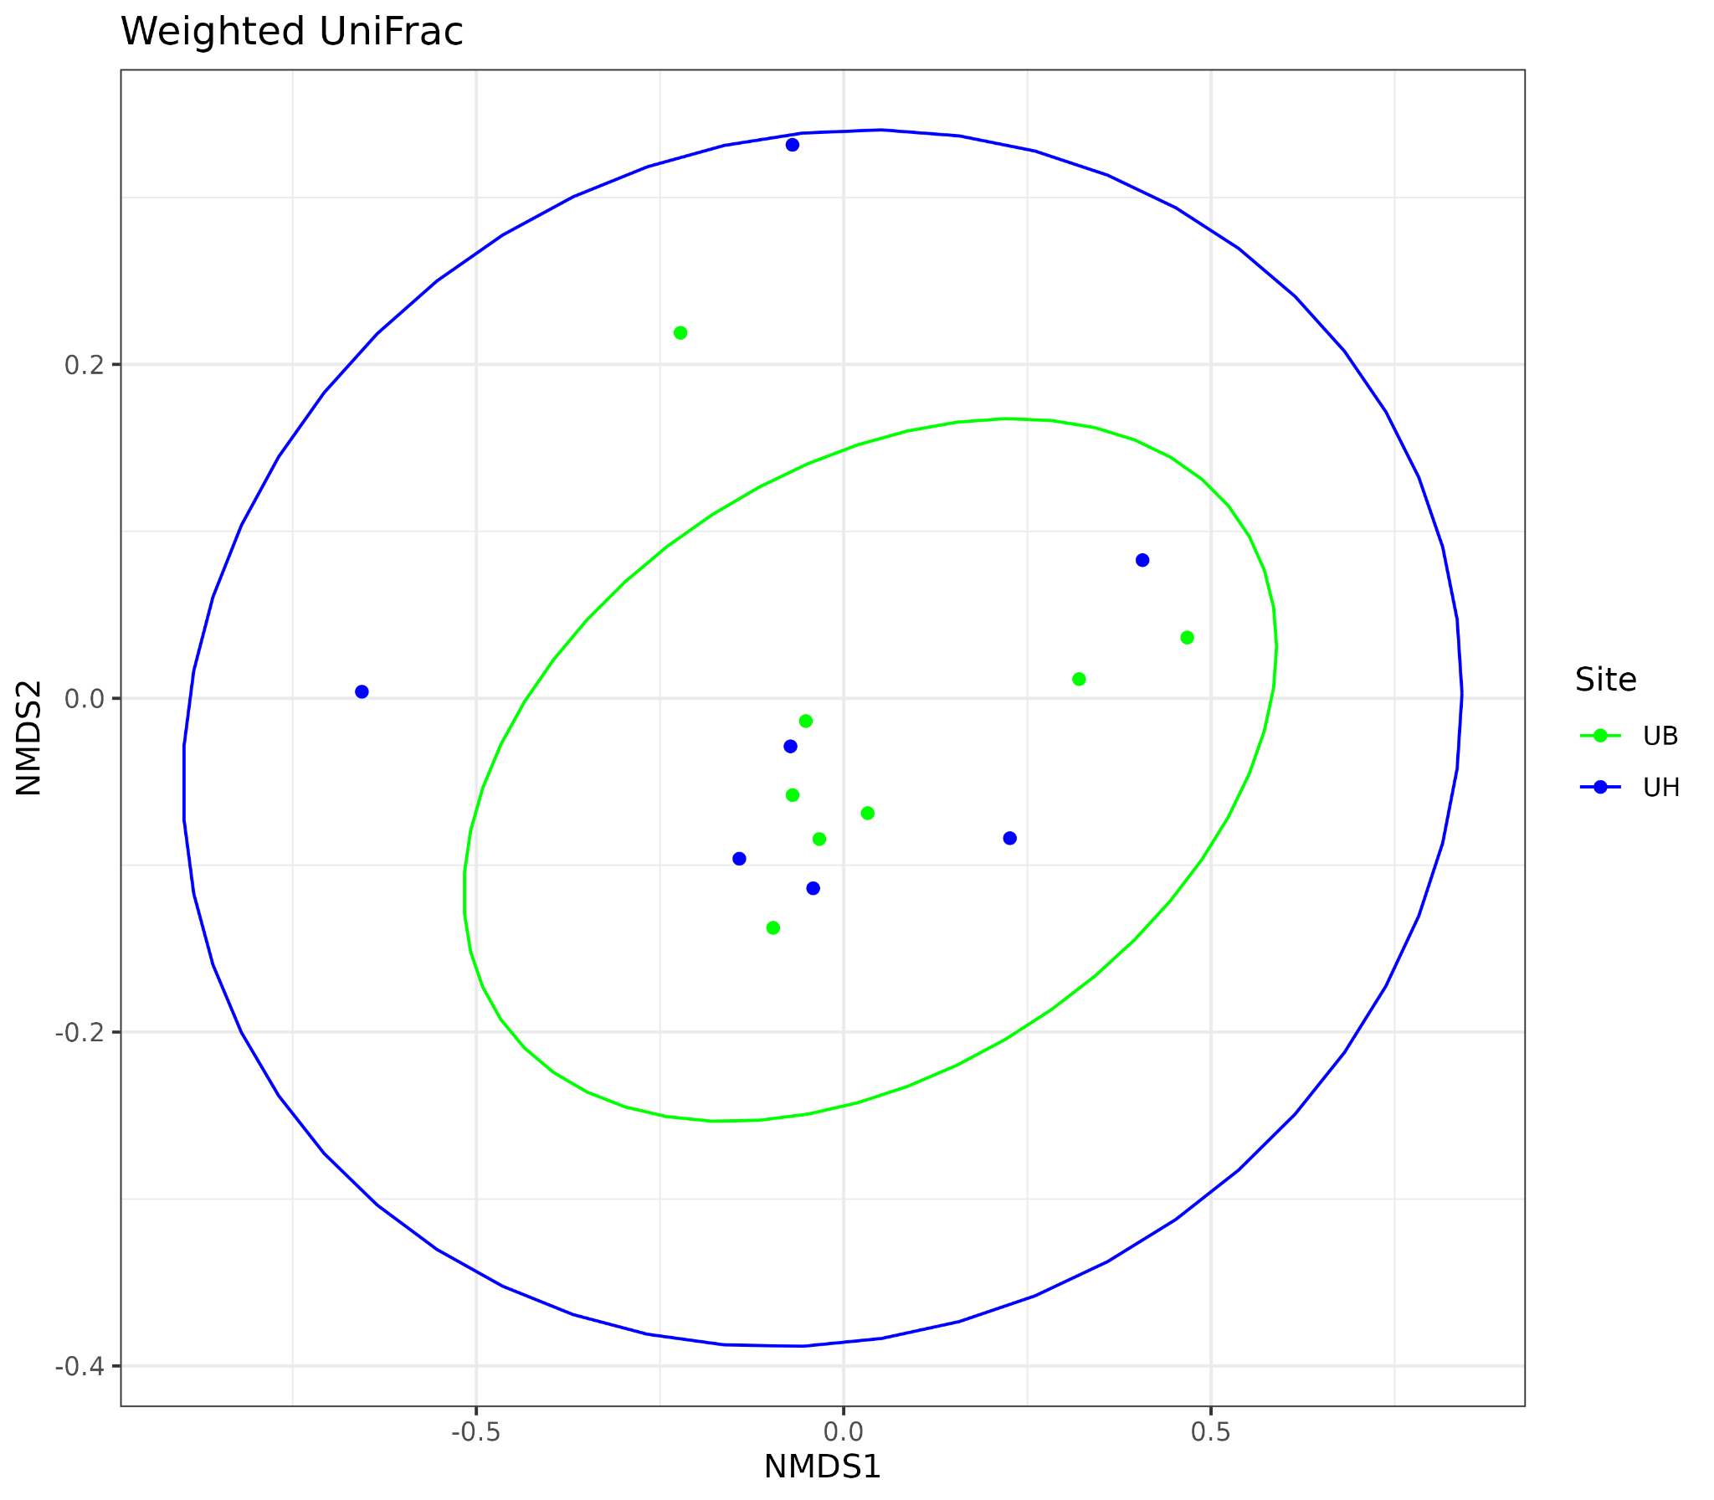
Unifrac weighted distance-based NMDS plot explains the phylogenetic relationship between species for beta diversity concerning site groups. Each color depicts a different group or type of site. The UniFrac weighted distance uses species abundance information and weights the branch length with the difference in abundance.

Supplementary figure S3
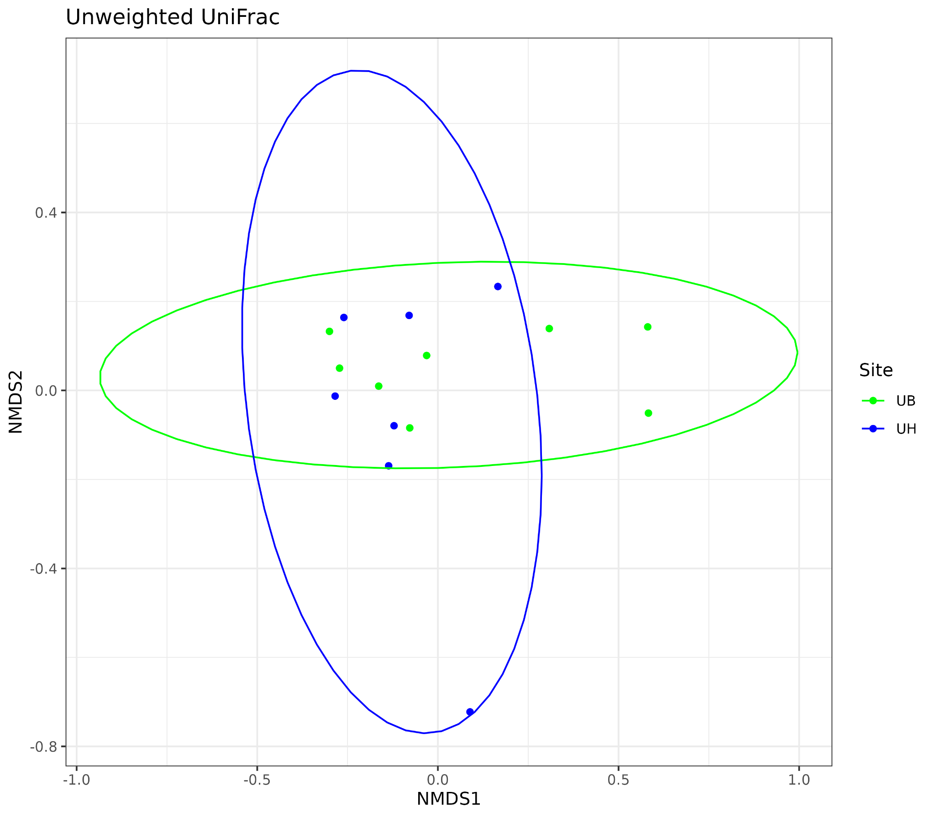
Unifrac unweighted distance-based NMDS plot explains the phylogenetic relationship between species for beta diversity concerning site groups. Each color depicts a different group. The UniFrac unweighted distance considers only the presence and absence of species information and counts the fraction of the length of the single branch for each community.

Supplementary figure S4
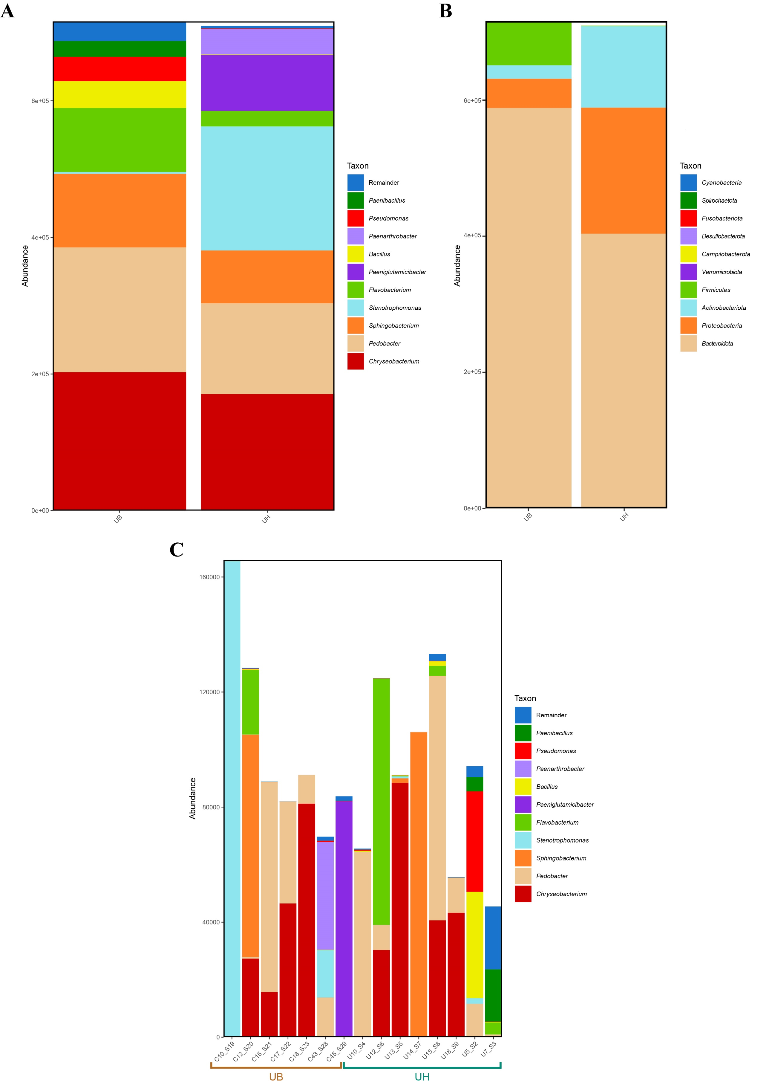
Bacterial microbiota composition in terms of absolute abundance at phylum and genus levels in the groups of sites (UB and UH): (A) Taxonomic composition of the ten main bacterial genera with different abundances among the different types of sites, with each color corresponding to a different genus. (B) Taxonomic composition of the ten main phyla and differentially abundant bacterial taxa, with each color corresponding to a phylum, in the different types of sites. (C) Taxonomic composition of the ten main genera and differentially abundant bacterial taxa, with each color corresponding to a different genus and subdivided by independent samples related to site (UB and UH).

