Engineered CHO cells as a novel AAV production platform for gene therapy delivery
Abdou Nagy^{1*}, Lina Chakrabarti¹, James Kurasawa², Sri Hari Raju Mulagapati³, Paul Devine⁴, Jamy Therres¹, Zhongying Chen⁵, Albert E Schmelzer^{1*}
¹ Cell Culture and Fermentation Sciences, Biopharmaceutical Development, BioPharmaceuticals R&D, AstraZeneca, One MedImmune Way, Gaithersburg, MD 20878, USA.
² Biologics Engineering, R&D, AstraZeneca, One MedImmune Way, Gaithersburg, MD 20878, USA.
³ Analytical Science, Biopharmaceutical Development, Biopharma R&D, AstraZeneca, One MedImmune Way, Gaithersburg, MD 20878, USA.
⁴ Analytical Science, Biopharmaceutical Development, Biopharma R&D, AstraZeneca, Milstein Building, Granta Park, Cambridge, CB216GH, UK.
⁵ Clinical Pharmacology and Safety Sciences, AstraZeneca, One MedImmune Way, Gaithersburg, MD 20878, USA.

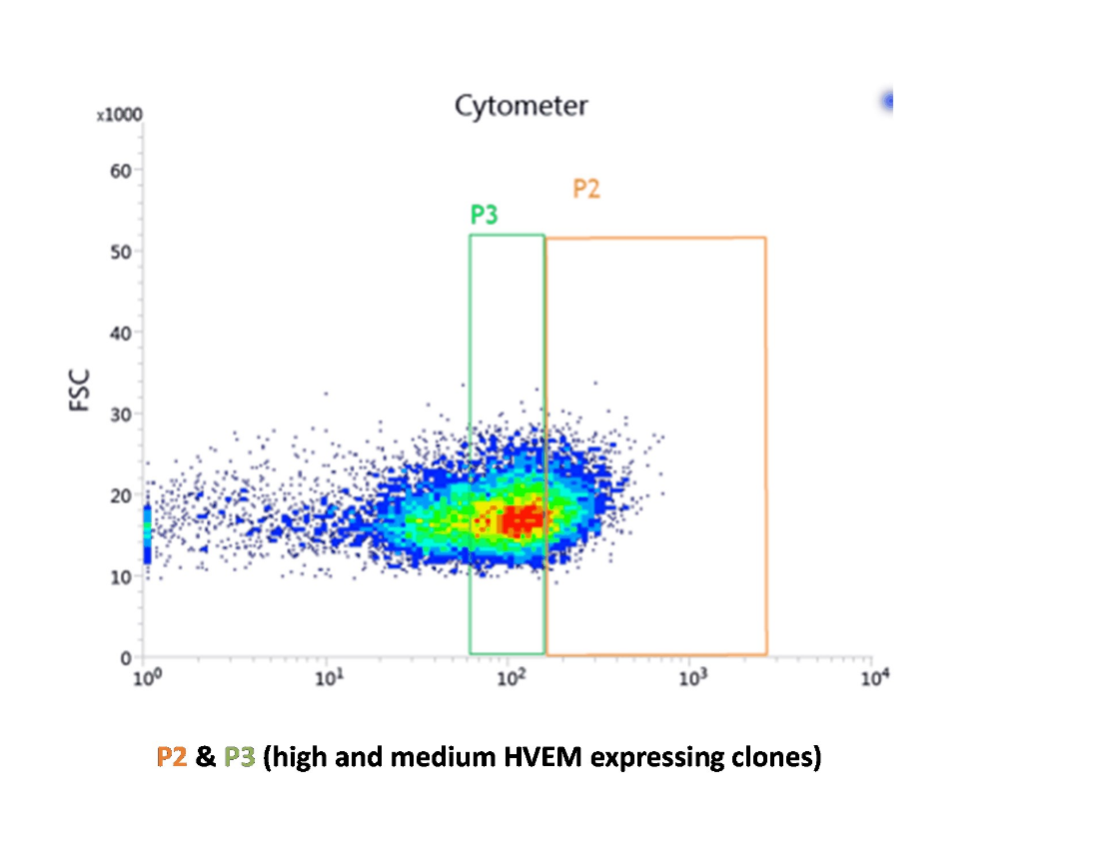Figure S1. Flow cytometry gating strategy. High and medium HVEM-expressing clones were identified and selected for single cell deposition (P2 and P3, respectively).

Figure S2. Temperature switch post rHSV-1 co-infection. (a) Effect of temperature switch on cell viability post co-infection. (b) Effect of temperature switch on rAAV6.2 titers in cell culture medium and cell lysate.

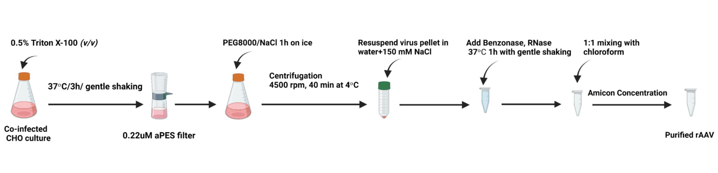

Figure S3. Workflow of the PEG-Chloroform rAAV purification method used for CHO cells. The figure was generated with BioRender.com

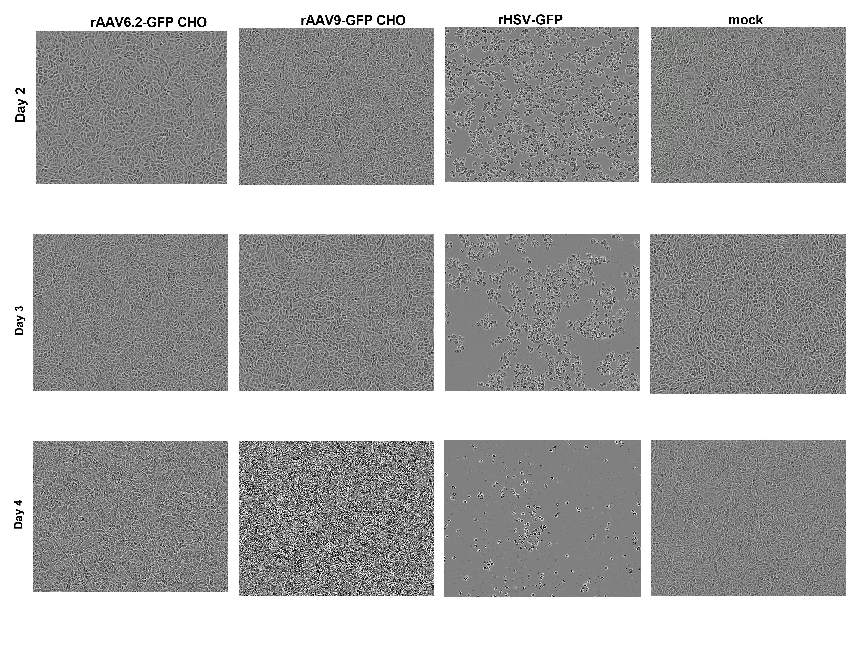
Figure S4. Evaluation of infectious rHSV-1 residues in purified rAAVs on V27 cells. Complementing V27 cells that stably express HSV-1 ICP27 protein were tested for any infectious residues of rHSV-1 vectors used in production of rAAVs in CHO-HV-C1 clone. PBS was used as a mock infection control.

