Appendix
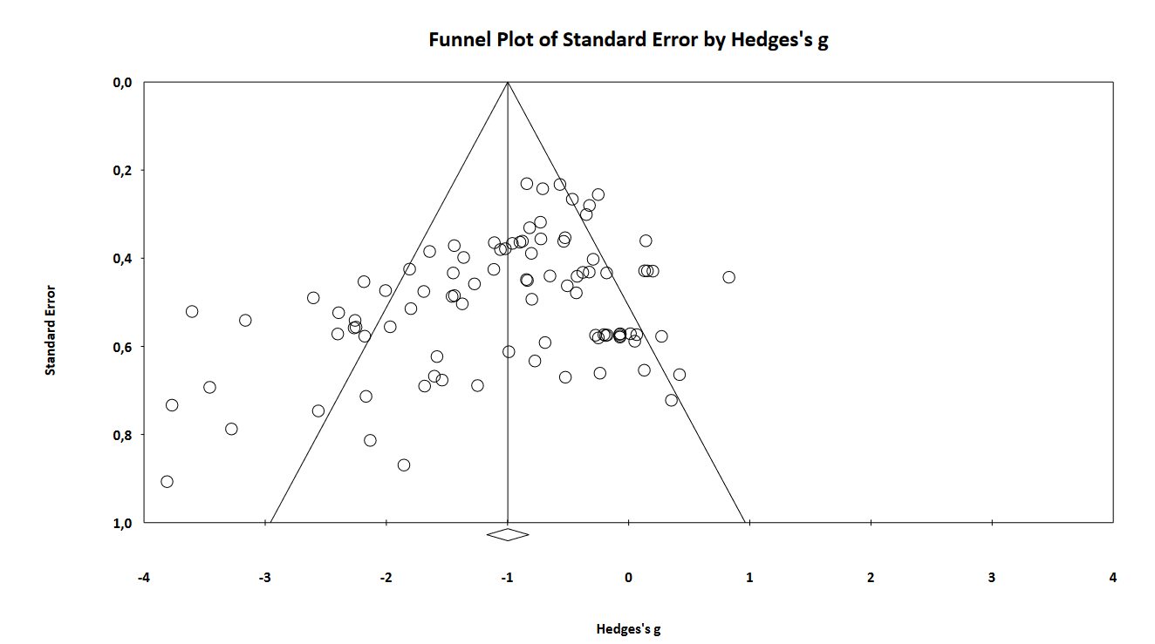
Appendix 1: Funnel plot of effect sizes for force, time and accuracy. Figure was created with CMA.

