Supplementary Material
FIGURE S1
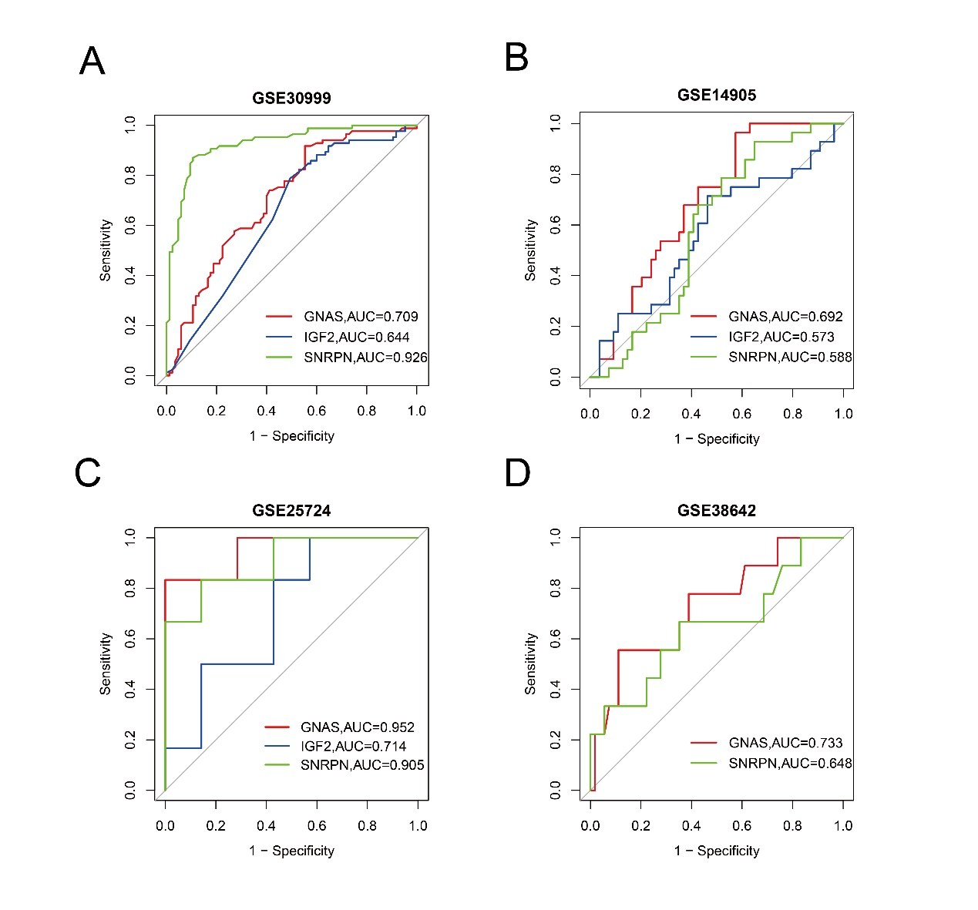

FIGURE S1
The ROC curve of three genes in the (A) GSE30999, (B) GSE14905, (C) GSE25724, (C) GSE38642.

