Supplementary Figures

Title: Superiority of systemic bleomycin to intradermal HOCl for the study of interstitial lung disease
Authors: Arina Morozan†§, Sydney Joy†§, Utako Fujii†, Richard Fraser#, Kevin Watters#, James G. Martin†§&, Inés Colmegna§##*&
Affiliations:
†Meakins Christie Laboratories, McGill University Health Centre and McGill University, Montreal, Quebec, Canada, H4A 3J1
§The Research Institute of the McGill University Health Centre, McGill University, Montreal, Quebec, Canada, H4A 3J1
# Division of Pathology, McGill University Health Centre, Montreal, Quebec, Canada.
## Division of Rheumatology, McGill University Health Centre, McGill University, Montreal, Quebec, Canada.
& Joint senior authors.

Supplementary Figure 1
b
a
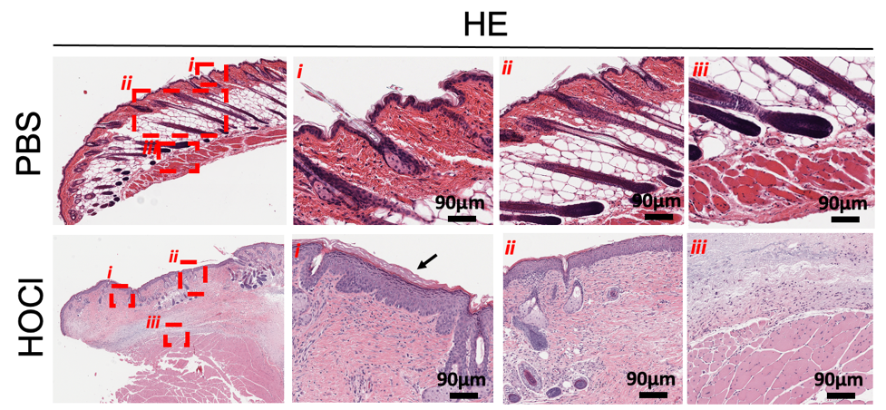
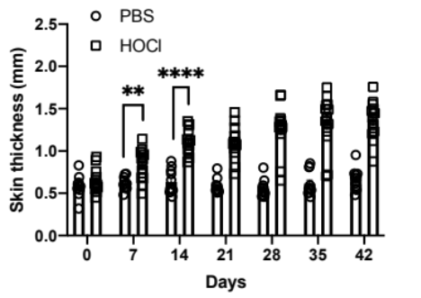

c
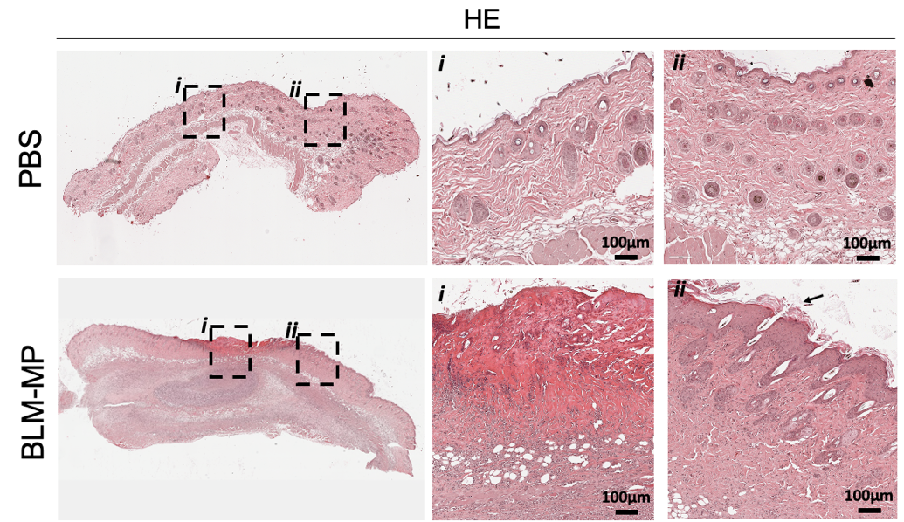

Supplementary Figure 1. Skin fibrosis in HOCl and BLM-MP mice. a. Mice skin thickness increased over the course of 6-weeks of HOCl injections. n = 11-14 mice per group. ** p=7.50 × 10⁻³, **** p< 1.00 × 10⁻⁴. Data are represented as mean ± SEM from 2-3 independent pooled experiments. Data were analyzed using two-way ANOVA. b. Representative skin images of H&E staining of PBS and HOCl-treated mice. Overview and ×20 magnification. Scale bar: 90 μm. H&E sections of HOCl mice show epidermal hyperplasia and hyperkeratosis (HOCl row, black arrow, i); loss of adipose tissue/appendages (ii); and inflammation extending into the superficial muscle layer (iii). c. Representative skin images of H&E staining of PBS and BLM-treated mice. Images show a skin overview (first micrograph in each row) and ×20 magnification. BLM-MP mice show an area of ulceration (panel i), epidermal hyperplasia and hyperkeratosis indicated by the black arrow (BLM-MP row, panel ii).

Supplementary Figure 2
b
a
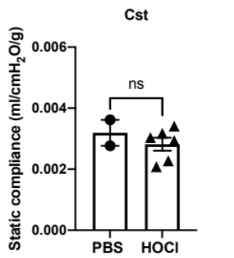
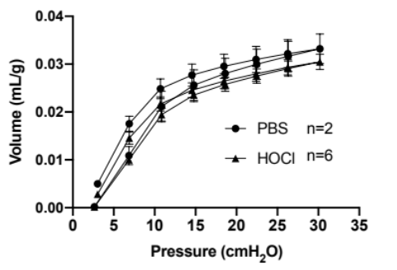

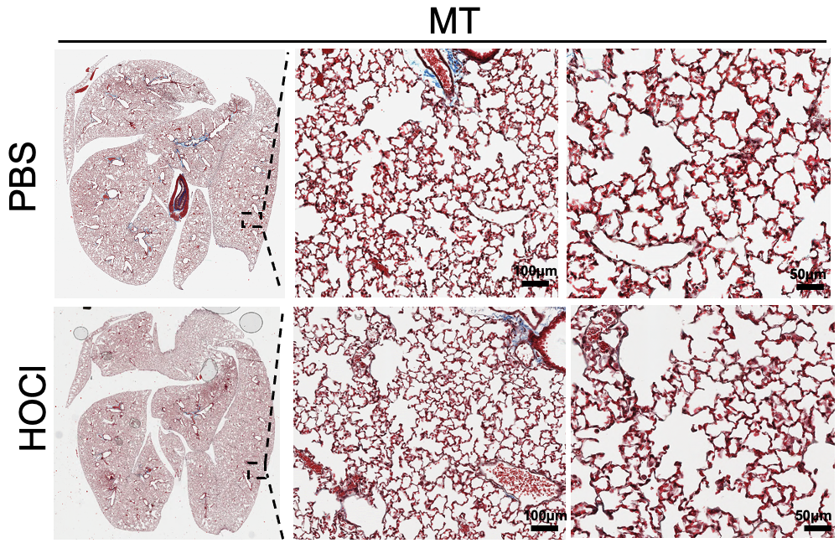
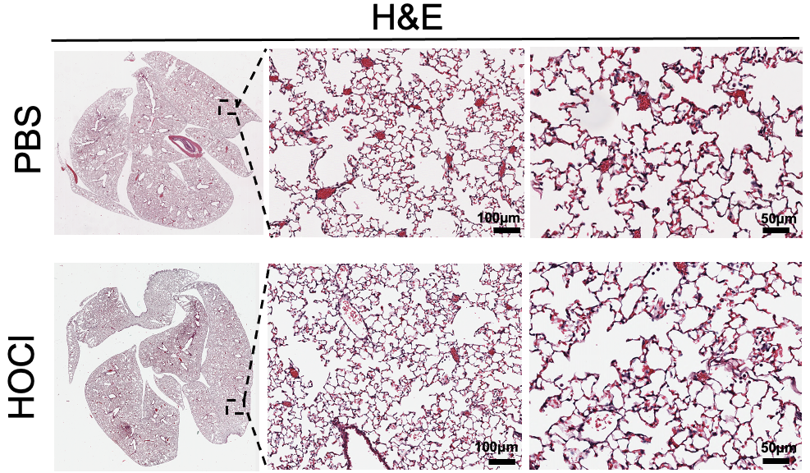
d
c

Supplementary Figure 2. Intradermal HOCl injections (8 weeks) do not impair lung function or induce lung fibrosis. a. Mean pressure-volume (P-V) loops for PBS and HOCl-injected mice. b. Static lung compliance (C_{st}) (n=5-6). c. Micrographs of H&E and (d) MT-stained lung sections. Images show an overview of the lung and ×20 and ×40 magnification (from left to right). Scale bar: 100 μm (×20 magnification) and 50 μm (×40 magnification). Data are represented as mean ± SEM from one experiment. Data were analyzed using Two-way ANOVA (a) and Mann-Whitney U test (b). Abbreviations: ns: not significant.

Supplementary Figure 3
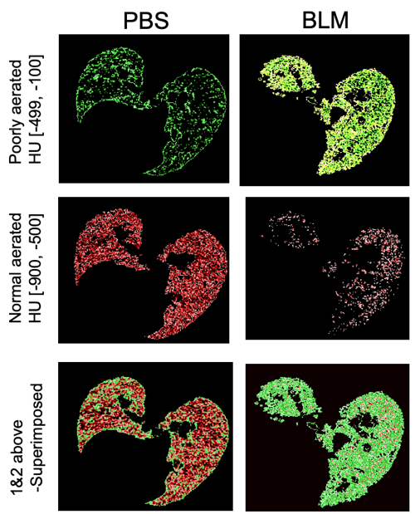
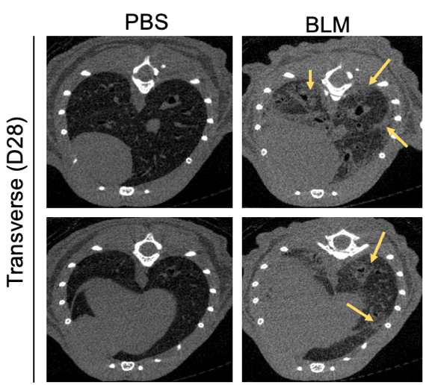
e
a

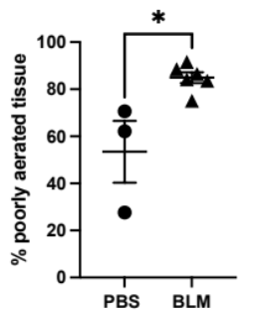
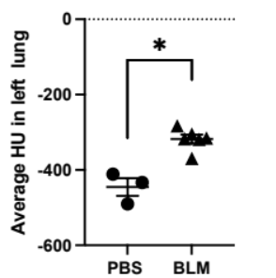
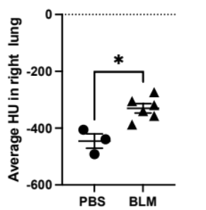
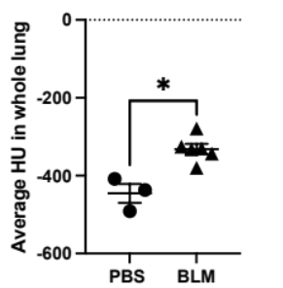
f
d
c
b

Supplementary Figure 3. Osmotic minipump delivery of BLM increases lung density and the percent of poorly aerated tissue. a. Representative micro-CT scans of PBS and BLM animals. Yellow arrows indicate areas of increased lung attenuation. Density of lung parenchyma in whole lung (b), right lung (c) and left lung (d). e. Micro-CT scans of BLM mice evaluated with the image analysis software AMIDE have increase in poorly- aerated tissue. f. Quantification of poorly aerated tissue according to Hounsfield units (HU) range assessed with the MATLAB software. n=3-6 mice per group, graphs show ± SEM. Two tailed t test, * p<0.05

Supplementary Figure 4
Supplementary Figure 4. Representative flow cytometry gating strategy adapted from Pernet et al. 2019.¹³⁸ (1) Eosinophils (SiglecF⁺, CD11b⁺); (2) alveolar macrophages SiglecF⁺, CD11b⁻; (3) neutrophils (SiglecF⁻, CD11b⁺, Ly6G⁺); (4) macrophages (SiglecF⁻,CD11b⁺, Ly6G⁻, F4/80⁺, Ly6C^{+/-}); (5) inflammatory monocytes (SiglecF-, CD11b⁺, Ly6G⁻, F4/80⁻, Ly6C⁺); (6) inflammatory monocyte derived macrophages (SiglecF⁻, CD11b⁺, F4/80⁺, Ly6C⁺); (7) interstitial macrophages (SiglecF⁻, CD11b⁺, F4/80⁺, Ly6C^{low/neg}).

Supplementary Figure 5
b
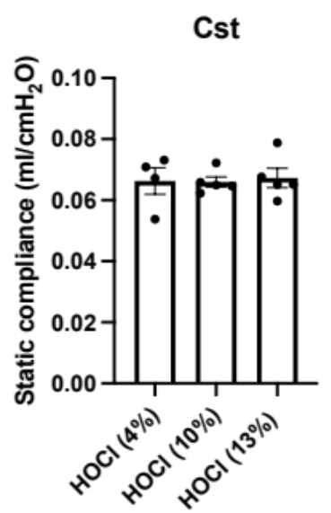
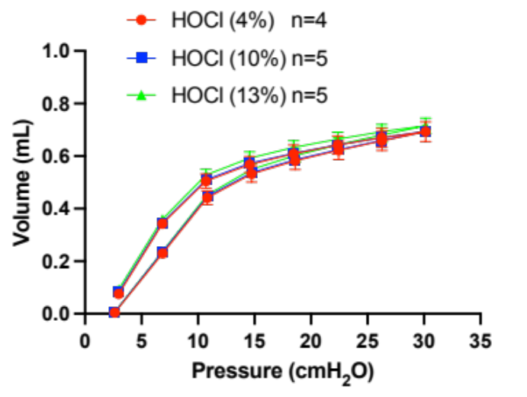
a

Supplementary Figure 5. Different initial concentrations of commercial bleach DO (does) not affect lung compliance. a. Mean pressure-volume (P-V) loops of mice injected with bleach containing initial sodium hypochlorite concentrations of 4%, 10%, and 13% (the final concentration was the same for all the mice, 0.096%). b. Static lung compliance. Data are represented as mean ± SEM from 2 independent pooled experiments. P-V loops and static compliance were analyzed using repeated measures two-way ANOVA and one-way ANOVA, respectively, with Bonferoni post-hoc test.

