Temporal patterns of fucoxanthin in four species of European marine brown macroalgae
Eoghan M. Cunningham^{1,2}, Aaron P. O’Kane³, Lauren Ford⁴, Gary Sheldrake³, Ross N. Cuthbert^{2,5}, Jaimie T.A. Dick^{2,5}, Christine A. Maggs² & Pamela J. Walsh^{1,2}*

Supplementary material

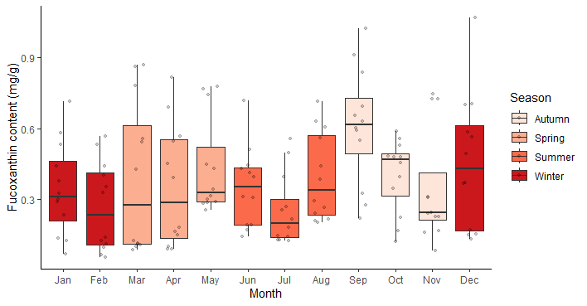
Figure S1: The combined fucoxanthin content of the four macroalgal species (Ascophyllum, nodosum, Fucus serratus, F. vesiculosus, and Saccharina latissima) identified during each month of sample year one. Raw data points include all four species for each month (n = 12 per month)
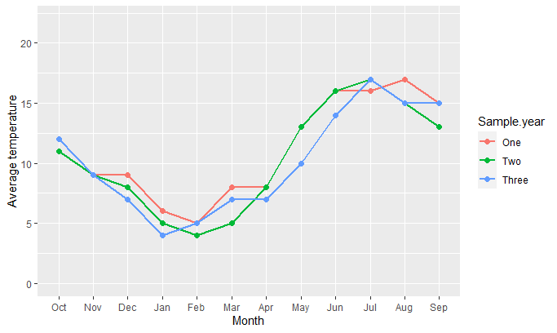
Figure S2: Monthly average temperature (°C) data for each month sampled during sample year one, two, and three. Source: Met Office UK, Bangor, Northern Ireland.
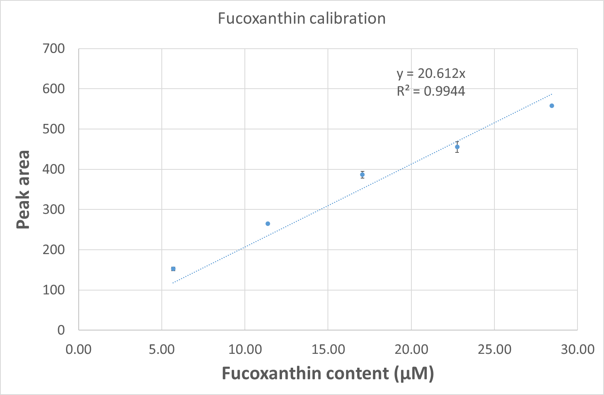

Figure S3: Calibration curve for pure Fucoxanthin (Sigma-Aldrich UK; Product Code: 1001590265; Lot No: #SLBG8952V)

Table S1: Pairwise species differences in fucoxanthin content within each season (Autumn, Spring, Summer, Winter) for each of the four macroalgal species (Ascophyllum, nodosum, Fucus serratus, F. vesiculosus, and Saccharina latissima). Data include Season, Species, Z ratio (Tukey pairwise difference), and P value.
Season | Species | Z ratio | P value
Autumn | A. nodosum - F. serratus | -2.05 | =0.168
Autumn | A. nodosum - F. vesiculosus | -3.76 | =0.001
Autumn | A. nodosum - S. latissima | -0.76 | =0.871
Autumn | F. serratus - F. vesiculosus | -1.70 | =0.319
Autumn | F. serratus – S. latissima | 1.29 | =0.567
Autumn | F. vesiculosus - S. latissima | 3.00 | =0.014
Spring | A. nodosum - F. serratus | -5.29 | <0.001
Spring | A. nodosum - F. vesiculosus | -4.88 | <0.001
Spring | A. nodosum - S. latissima | 1.38 | =0.507
Spring | F. serratus - F. vesiculosus | 0.41 | =0.976
Spring | F. serratus – S. latissima | 6.68 | <0.001
Spring | F. vesiculosus - S. latissima | 6.27 | <0.001
Summer | A. nodosum - F. serratus | -5.02 | <0.001
Summer | A. nodosum - F. vesiculosus | -4.19 | <0.001
Summer | A. nodosum – S. latissima | -2.63 | 0.042
Summer | F. serratus - F. vesiculosus | 0.82 | =0.841
Summer | F. serratus – S. latissima | 2.39 | =0.079
Summer | F. vesiculosus - S. latissima | 1.56 | =0.399
Winter | A. nodosum - F. serratus | -5.88 | <0.001
Winter | A. nodosum - F. vesiculosus | -5.04 | <0.001
Winter | A. nodosum – S. latissima | 0.39 | =0.978
Winter | F. serratus - F. vesiculosus | 0.84 | =0.835
Winter | F. serratus – S. latissima | 6.28 | <0.001
Winter | F. vesiculosus - S. latissima | 5.44 | <0.001

Table S2: Pairwise differences of fucoxanthin content between months within seasons (Autumn, Spring, Summer, Winter) for each of the four macroalgal species (A. nodosum, F. serratus, F. vesiculosus, and S. latissima). Data include Species, Season, Months, Z ratio (Tukey pairwise difference), and P value.
Species | Season | Months | Z ratio | P value
A. nodosum | Autumn | Sep - Oct | -8.74 | <0.001
A. nodosum | Autumn | Oct - Nov | -11.48 | <0.001
A. nodosum | Autumn | Nov - Sep | -2.74 | =0.206
A. nodosum | Spring | Mar - Apr | 6.77 | <0.001
A. nodosum | Spring | Mar - May | -21.92 | <0.001
A. nodosum | Spring | Apr - May | -15.15 | <0.001
A. nodosum | Summer | Jun - Jul | -5.00 | <0.001
A. nodosum | Summer | Jul - Aug | 10.16 | <0.001
A. nodosum | Summer | Aug - Jun | 5.15 | <0.001
A. nodosum | Winter | Dec – Jan | -12.29 | <0.001
A. nodosum | Winter | Jan - Feb | -16.84 | <0.001
A. nodosum | Winter | Feb - Dec | 4.55 | <0.001
F. serratus | Autumn | Sep - Oct | -2.33 | =0.449
F. serratus | Autumn | Oct - Nov | -3.31 | =0.043
F. serratus | Autumn | Nov - Sep | -5.65 | <0.001
F. serratus | Spring | Mar - Apr | 1.13 | =0.993
F. serratus | Spring | Mar - May | -2.75 | =0.201
F. serratus | Spring | May - Apr | -1.62 | =0.902
F. serratus | Summer | Jun - Jul | 2.39 | =0.408
F. serratus | Summer | Jun - Aug | 3.84 | <0.01
F. serratus | Summer | Aug - Jul | 1.45 | =0.953
F. serratus | Winter | Dec – Jan | 0.25 | =1.000
F. serratus | Winter | Jan - Feb | -1.15 | =0.992
F. serratus | Winter | Feb - Dec | 1.41 | =0.960
F. vesiculosus | Autumn | Sep - Oct | -1.97 | =0.711
F. vesiculosus | Autumn | Oct - Nov | 2.03 | =0.668
F. vesiculosus | Autumn | Nov - Sep | 0.06 | =1.000
F. vesiculosus | Spring | Mar - Apr | -2.80 | =0.177
F. vesiculosus | Spring | Mar - May | 6.31 | <0.001
F. vesiculosus | Spring | Apr - May | 3.51 | =0.022
F. vesiculosus | Summer | Jun - Jul | -7.68 | <0.001
F. vesiculosus | Summer | Jul - Aug | 7.59 | <0.001
F. vesiculosus | Summer | Aug - Jun | -0.08 | =1.000
F. vesiculosus | Winter | Dec – Jan | 4.49 | <0.001
F. vesiculosus | Winter | Jan - Feb | -0.34 | =1.000
F. vesiculosus | Winter | Feb - Dec | 4.83 | <0.001
S. latissima | Autumn | Sep - Oct | -10.30 | <0.001
S. latissima | Autumn | Oct - Nov | -1.52 | =0.933
S. latissima | Autumn | Nov - Sep | -11.83 | <0.001
S. latissima | Spring | Mar - Apr | -0.44 | =1.000
S. latissima | Spring | Mar - May | -7.21 | <0.001
S. latissima | Spring | Apr - May | -7.66 | <0.001
S. latissima | Summer | Jun - Jul | -3.27 | =0.048
S. latissima | Summer | Jul - Aug | 0.60 | =1.000
S. latissima | Summer | Aug - Jun | -2.67 | =0.236
S. latissima | Winter | Dec – Jan | 6.94 | <0.001
S. latissima | Winter | Jan - Feb | -1.92 | =0.744
S. latissima | Winter | Feb - Dec | 8.86 | <0.001

