S1: Example of survey filled out by an owner who has one current fetching cat, “Cat”, and lives in a single-person household.

[1] How many cats have you owned that play fetch? (both in the past and any current cats you own)

[2] What is cat number 1's name?

[3] Is cat number 1 a previous cat you had in the past or a cat that currently lives in your household?
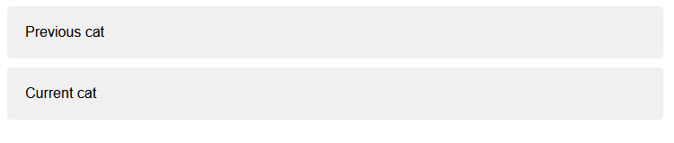

Answer each question as accurately as you can. If you are unsure on any questions, please write 'NA' in the answer box to continue. Please be assured there is no right or wrong answer to any of these questions.
The following questions relate to Cat.
[4] Approximately how long has Cat fetched? If less than a year, please write '0' in the Years answer box.

Years
Months

[5] Did you deliberately train Cat to fetch?
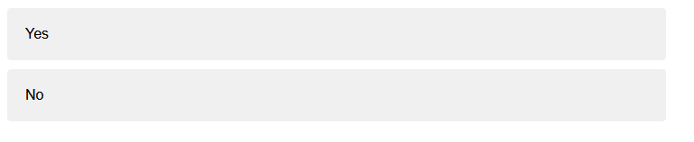

[5a] Please describe in detail how you initially trained this cat.

[5b] Please describe in detail how you first noticed this behaviour.

[6] What objects does Cat fetch? Please list one object per answer box.
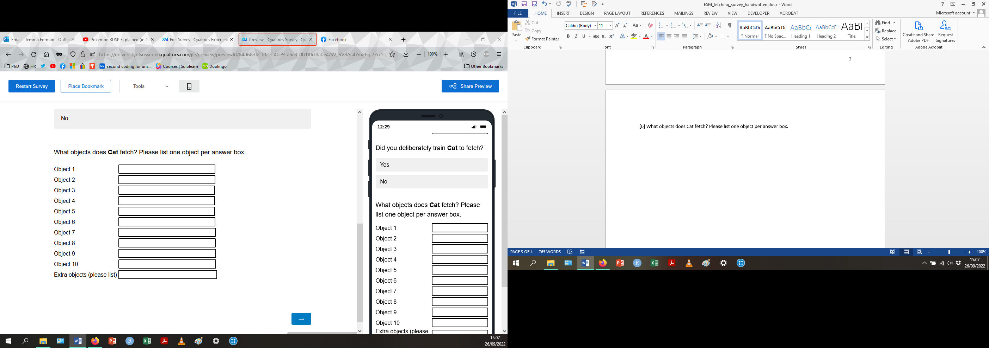

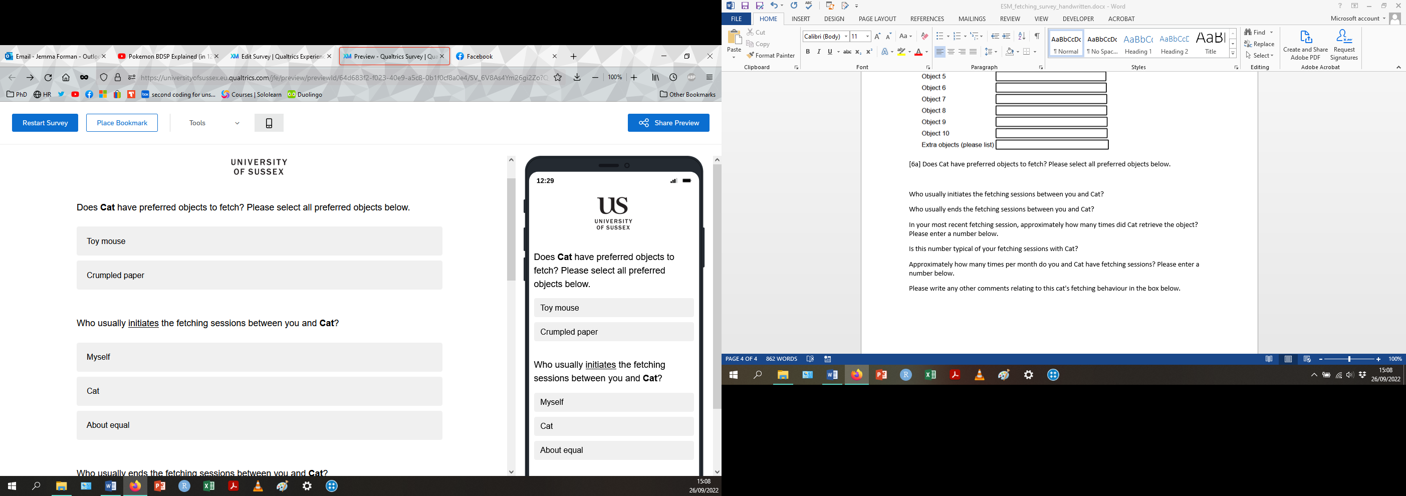
[6a] Does Cat have preferred objects to fetch? Please select all preferred objects below.

[7] Who usually initiates the fetching sessions between you and Cat?

[8] Who usually ends the fetching sessions between you and Cat?

[9] In your most recent fetching session, approximately how many times did Cat retrieve the object?
Please enter a number below.

[10] Is this number typical of your fetching sessions with Cat?
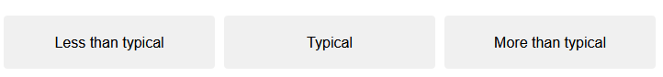

[11] Approximately how many times per month do you and Cat have fetching sessions?
Please enter a number below.

[12] Please write any other comments relating to this cat's fetching behaviour in the box below.

This next set of questions will ask for demographic information about Cat.
[13] How old was Cat at the time you first noticed the fetching behaviour? (years and months)
Years

Months

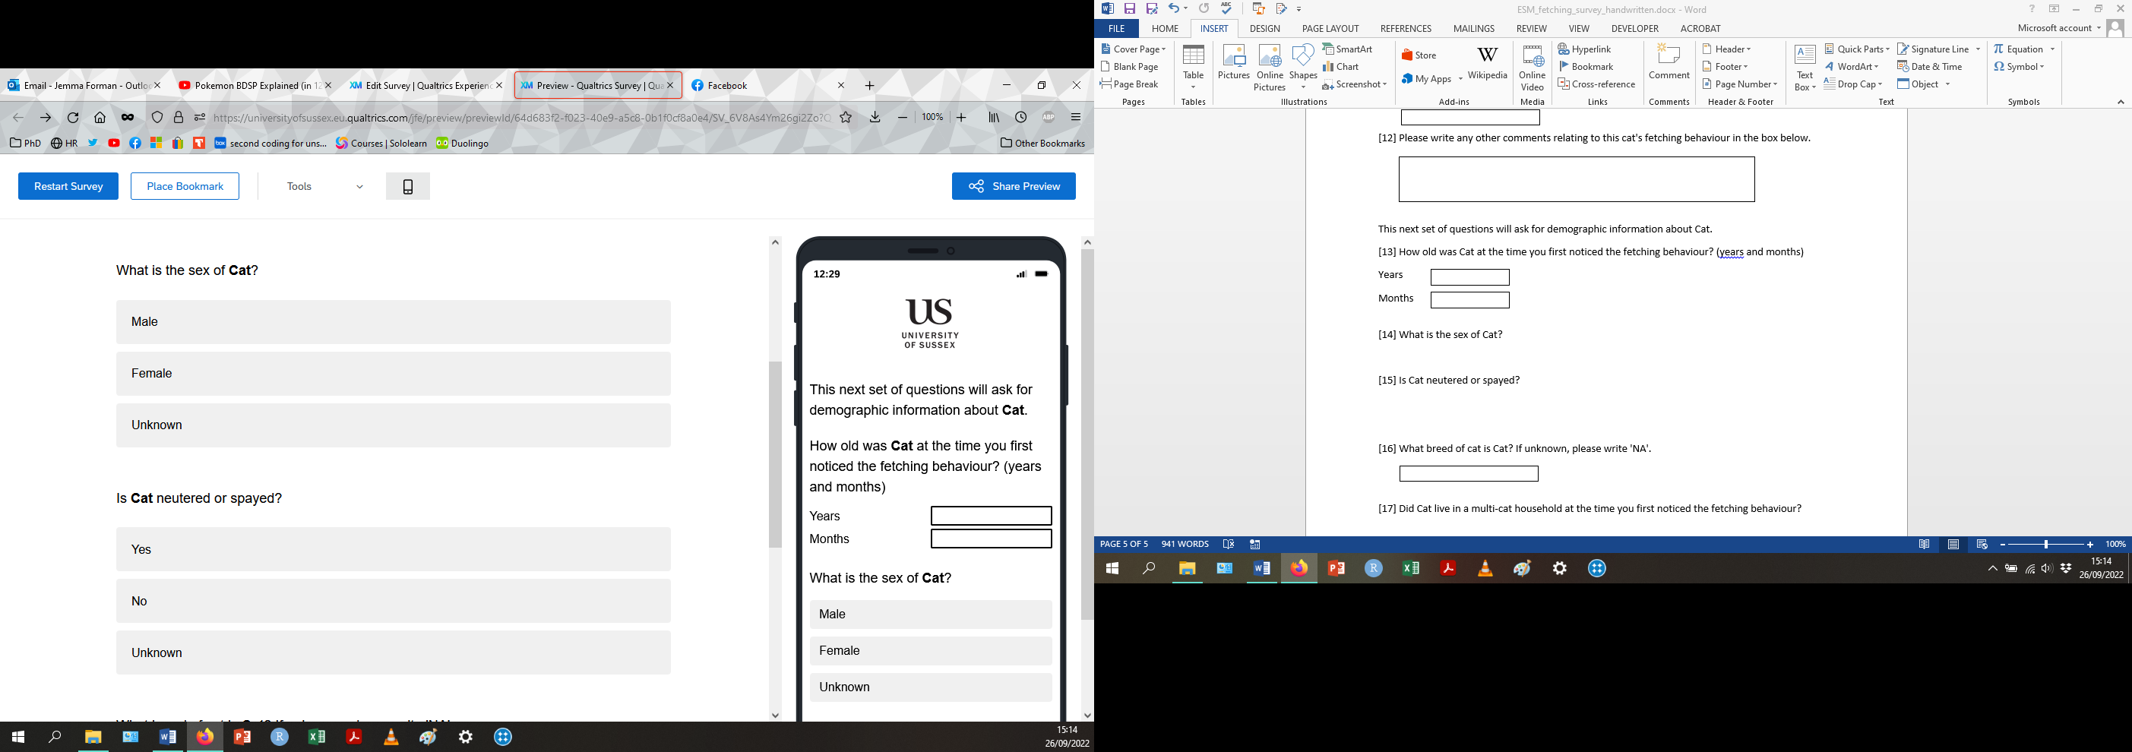
[14] What is the sex of Cat?

[15] Is Cat neutered or spayed?

[16] What breed of cat is Cat? If unknown, please write 'NA'.

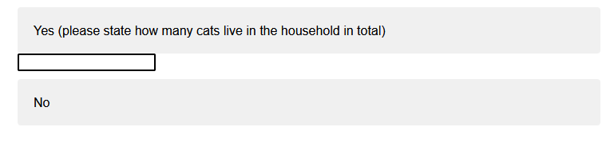
[17] Did Cat live in a multi-cat household at the time you first noticed the fetching behaviour?
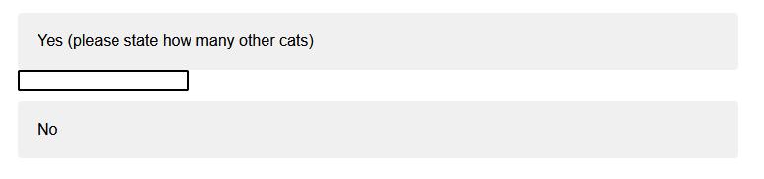
[17a] Did any other cats in this household fetch?

This next set of questions will ask for information about the people and other pet species in Cat's household.
[18] What country do you live in?

[19] How many people live in the household in total? Please enter a number below (including yourself)

This next set of questions will ask for information about yourself and other pet species in your current household.
Person 1 refers to yourself.
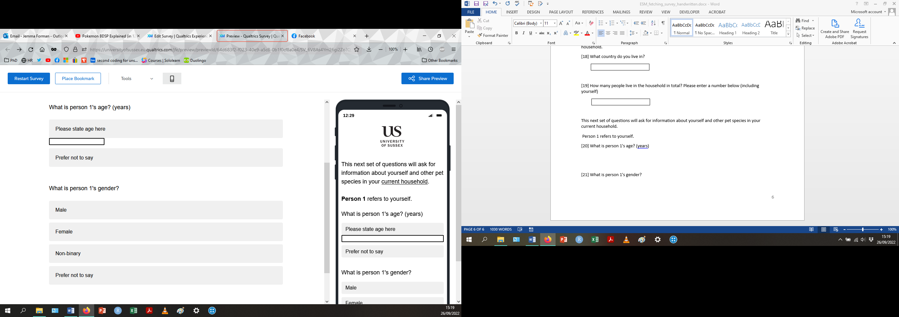
[20] What is person 1's age? (years)

[21] What is person 1's gender?

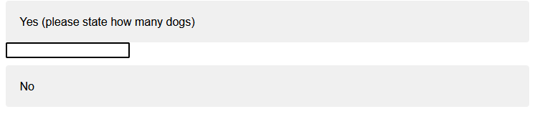
[22] Do you have dogs in your current household?

[22a] Do any of these dogs also fetch?
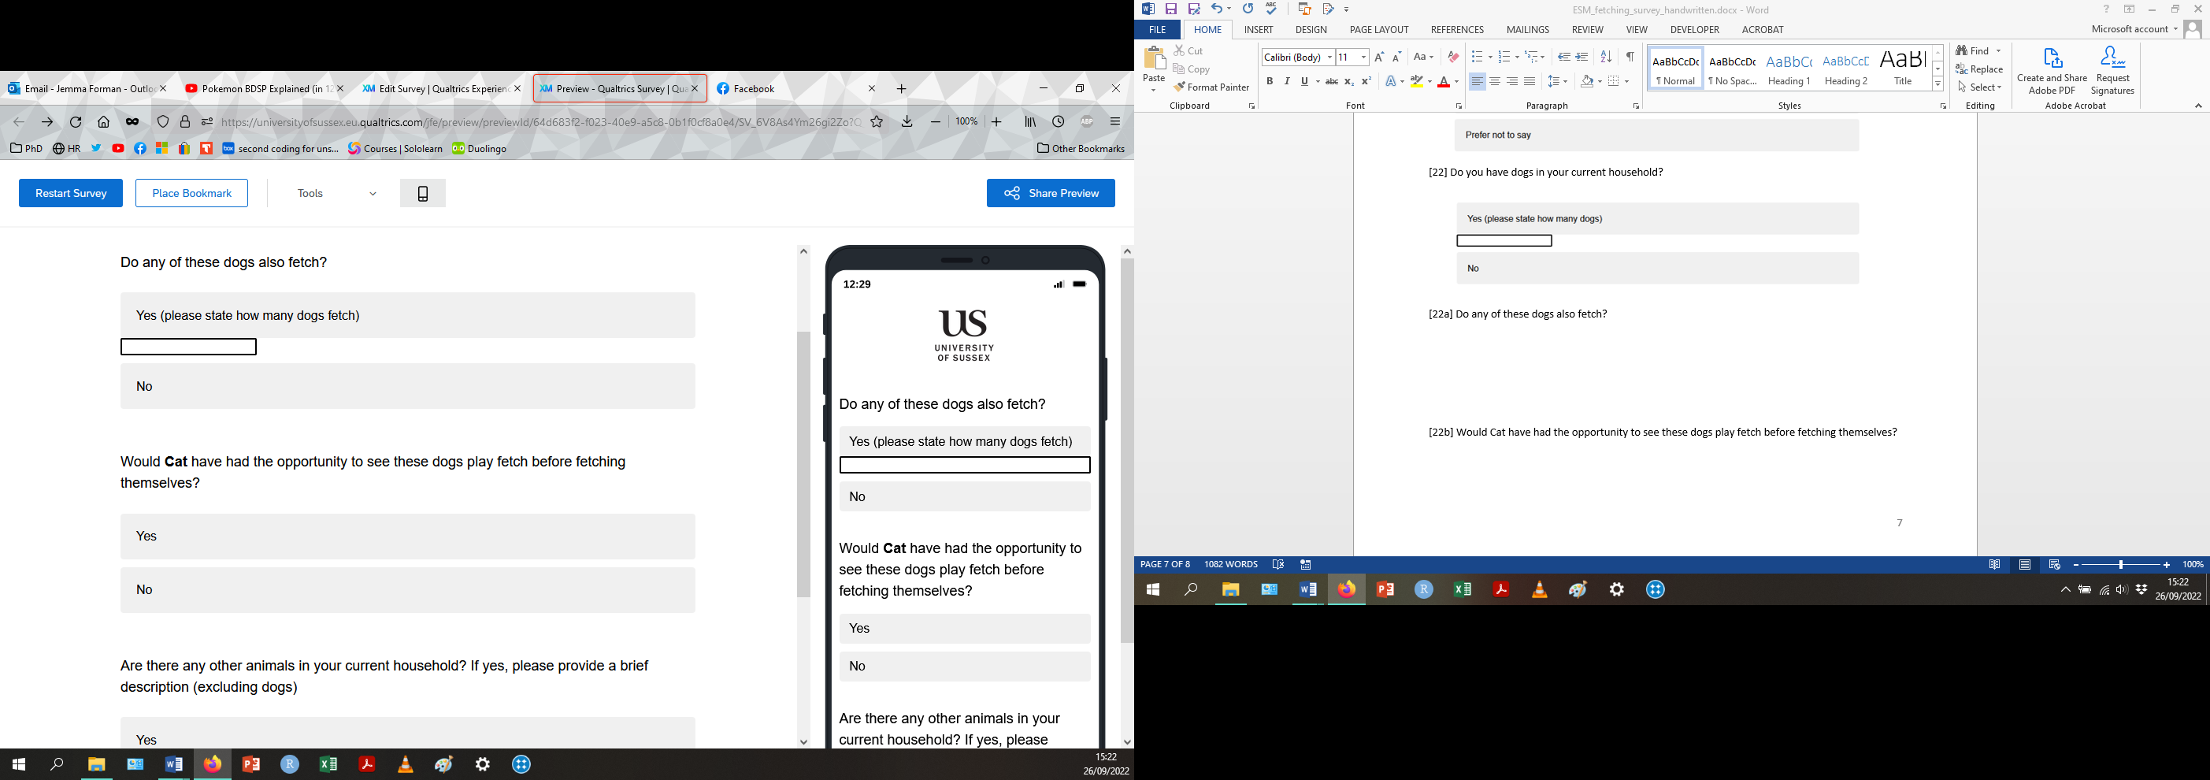

[22b] Would Cat have had the opportunity to see these dogs play fetch before fetching themselves?

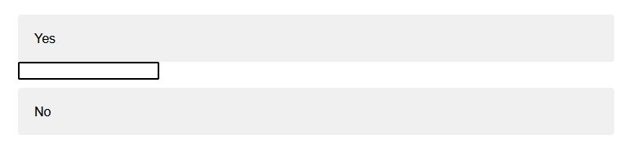
[23] Are there any other animals in your current household? If yes, please provide a brief description (excluding dogs)

Thank you for completing this questionnaire! Your responses have been successfully recorded and your time has been much appreciated.

