Appendix 1.

Figure 4. Aerobic exercise in water versus aerobic exercise on a firm surface, outcome: Muscular strength – Sit to Stand Test

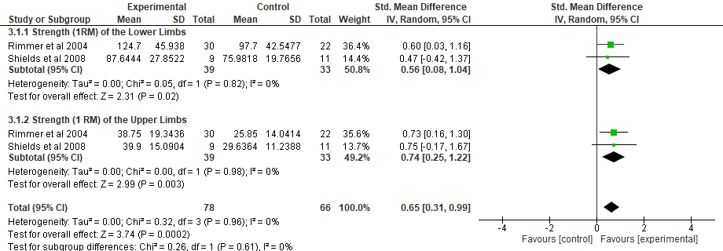
Figure 5. Combined exercise versus progressive resistance exercise, outcome: Strength of the Lower and Upper Limbs – 1RM

Figure 6. Aerobic exercise in water versus aerobic exercise on a firm surface, outcome: Functional Tasks - 6MWD.

Figure 7. Aerobic exercise in water versus aerobic exercise on a firm surface, outcome: Functional Tasks - 8 ft up and go.

