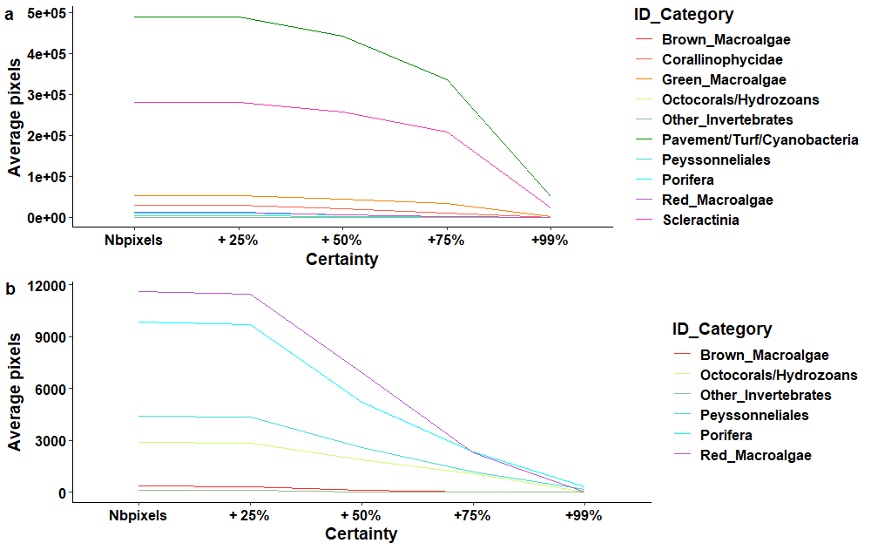
Supplementary Figure S1 Line graphs plotting the average number of identified pixels per broad ID category (y-axis) as certainty level increases (x-axis). (a) Plot including all broad ID categories showing rapid decrease in pixels as certainty increased. (b) Plot with the four largest ID categories (Scleractinia, Pavement/turf/cyanobacteria, Corallinophycidae, Green macroalgae) removed showing the significant decrease or complete loss of less dominant taxa.

