The longitudinal biochemical profiling of TBI in a drop weight model of TBI.
Ali Yilmaz, PhD^{1,2}, Sigal Liraz-Zaltsman ³⁻⁵, Esther Shohami⁴, Juozas Gordevičius⁶, Ieva Kerševičiūtė⁶, Eric Sherman⁷, Ray O. Bahado-Singh², and Stewart Francis Graham, PhD^{1,2*}
1- Metabolomics Department, Beaumont Research Institute, Beaumont Health, Royal Oak, MI 48073, USA.
2- William Beaumont School of Medicine, Oakland University, Rochester, MI 48073, USA
3-Department of Pharmacology, the Institute for Drug Research, The Hebrew University of Jerusalem, Jerusalem, Israel.
4-The Joseph Sagol Neuroscience Center, Sheba Medical Center, Ramat-Gan, Israel.
5-Institute for Health and Medical Professions, Department of Sports Therapy, Ono Academic College, Qiryat Ono, Israel.
6- VUGENE LLC, Grand Rapids, MI, United States.
7- Wayne State University School of Medicine, Detroit, Michigan, USA

*Correspondence: Stewart Francis Graham; Email: stewart.graham@beaumont.edu
; Tel: +1-248-712-4595
Academic Editor: name
Received: date; Accepted: date; Published: date

Supplementary Table 1: Design of the experiment indicating how many animals have been used to access the impact of brain site, sex, time points and disease severity on metabolic profile change associated with traumatic brain injury (TBI).
Samle number | Brain Region | TimePoint | Severity | Gender
1 | Left hemisphere | 7d | Severe | Female
2 | Left hemisphere | 7d | Severe | Female
3 | Left hemisphere | 7d | Severe | Female
4 | Left hemisphere | 7d | Severe | Female
5 | Left hemisphere | 7d | Severe | Female
6 | Left hemisphere | 7d | Severe | Female
7 | Left hemisphere | 7d | Severe | Female
8 | Right hemisphere | 7d | Severe | Female
9 | Right hemisphere | 7d | Severe | Female
10 | Right hemisphere | 7d | Severe | Female
11 | Right hemisphere | 7d | Severe | Female
12 | Right hemisphere | 7d | Severe | Female
13 | Right hemisphere | 7d | Severe | Female
14 | Right hemisphere | 7d | Severe | Female
15 | Left hemisphere | 7d | Severe | Male
16 | Left hemisphere | 7d | Severe | Male
17 | Left hemisphere | 7d | Severe | Male
18 | Left hemisphere | 7d | Severe | Male
19 | Left hemisphere | 7d | Severe | Male
20 | Left hemisphere | 7d | Severe | Male
21 | Right hemisphere | 7d | Severe | Male
22 | Right hemisphere | 7d | Severe | Male
23 | Right hemisphere | 7d | Severe | Male
24 | Right hemisphere | 7d | Severe | Male
25 | Right hemisphere | 7d | Severe | Male
26 | Right hemisphere | 7d | Severe | Male
27 | Left hemisphere | 1d | Severe | Female
28 | Left hemisphere | 1d | Severe | Female
29 | Left hemisphere | 1d | Severe | Female
30 | Left hemisphere | 1d | Severe | Female
31 | Left hemisphere | 1d | Severe | Female
32 | Left hemisphere | 1d | Severe | Female
33 | Right hemisphere | 1d | Severe | Female
34 | Right hemisphere | 1d | Severe | Female
35 | Right hemisphere | 1d | Severe | Female
36 | Right hemisphere | 1d | Severe | Female
37 | Right hemisphere | 1d | Severe | Female
38 | Right hemisphere | 1d | Severe | Female
39 | Left hemisphere | 1d | Severe | Male
40 | Left hemisphere | 1d | Severe | Male
41 | Left hemisphere | 1d | Severe | Male
42 | Left hemisphere | 1d | Severe | Male
43 | Left hemisphere | 1d | Severe | Male
44 | Right hemisphere | 1d | Severe | Male
45 | Right hemisphere | 1d | Severe | Male
46 | Right hemisphere | 1d | Severe | Male
47 | Right hemisphere | 1d | Severe | Male
48 | Right hemisphere | 1d | Severe | Male
49 | Left hemisphere | 7d | Mild | Female
50 | Left hemisphere | 7d | Mild | Female
51 | Left hemisphere | 7d | Mild | Female
52 | Left hemisphere | 7d | Mild | Female
53 | Left hemisphere | 7d | Mild | Female
54 | Left hemisphere | 7d | Mild | Female
55 | Right hemisphere | 7d | Mild | Female
56 | Right hemisphere | 7d | Mild | Female
57 | Right hemisphere | 7d | Mild | Female
58 | Right hemisphere | 7d | Mild | Female
59 | Right hemisphere | 7d | Mild | Female
60 | Right hemisphere | 7d | Mild | Female
61 | Left hemisphere | 7d | Mild | Male
62 | Left hemisphere | 7d | Mild | Male
63 | Left hemisphere | 7d | Mild | Male
64 | Left hemisphere | 7d | Mild | Male
65 | Left hemisphere | 7d | Mild | Male
66 | Left hemisphere | 7d | Mild | Male
67 | Right hemisphere | 7d | Mild | Male
68 | Right hemisphere | 7d | Mild | Male
69 | Right hemisphere | 7d | Mild | Male
70 | Right hemisphere | 7d | Mild | Male
71 | Right hemisphere | 7d | Mild | Male
72 | Right hemisphere | 7d | Mild | Male
73 | Left hemisphere | 1d | Mild | Female
74 | Left hemisphere | 1d | Mild | Female
75 | Left hemisphere | 1d | Mild | Female
76 | Left hemisphere | 1d | Mild | Female
77 | Left hemisphere | 1d | Mild | Female
78 | Left hemisphere | 1d | Mild | Female
79 | Left hemisphere | 1d | Mild | Female
80 | Right hemisphere | 1d | Mild | Female
81 | Right hemisphere | 1d | Mild | Female
82 | Right hemisphere | 1d | Mild | Female
83 | Right hemisphere | 1d | Mild | Female
84 | Right hemisphere | 1d | Mild | Female
85 | Right hemisphere | 1d | Mild | Female
86 | Right hemisphere | 1d | Mild | Male
87 | Left hemisphere | 1d | Mild | Male
88 | Left hemisphere | 1d | Mild | Male
89 | Left hemisphere | 1d | Mild | Male
90 | Left hemisphere | 1d | Mild | Male
91 | Left hemisphere | 1d | Mild | Male
92 | Left hemisphere | 1d | Mild | Male
93 | Right hemisphere | 1d | Mild | Male
94 | Right hemisphere | 1d | Mild | Male
95 | Right hemisphere | 1d | Mild | Male
96 | Right hemisphere | 1d | Mild | Male
97 | Right hemisphere | 1d | Mild | Male
98 | Right hemisphere | 1d | Mild | Male
99 | Right hemisphere | None | Control | Male
100 | Right hemisphere | None | Control | Male
101 | Right hemisphere | None | Control | Male
102 | Right hemisphere | None | Control | Male
103 | Right hemisphere | None | Control | Male
104 | Left hemisphere | None | Control | Male
105 | Left hemisphere | None | Control | Male
106 | Left hemisphere | None | Control | Male
107 | Left hemisphere | None | Control | Male
108 | Left hemisphere | None | Control | Male
109 | Right hemisphere | None | Control | Female
110 | Right hemisphere | None | Control | Female
111 | Right hemisphere | None | Control | Female
112 | Right hemisphere | None | Control | Female
113 | Right hemisphere | None | Control | Female
114 | Left hemisphere | None | Control | Female
115 | Left hemisphere | None | Control | Female
116 | Left hemisphere | None | Control | Female
117 | Left hemisphere | None | Control | Female
118 | Left hemisphere | None | Control | Female

Supplementary Table 2: The calculated the correlation of fold change between the left and right hemispheres and corresponding significance for each pairwise comparison.

Comparison | Pearson correlation | statistic | p.values | Lower confidence intervall | Higher confidence intervall
Mild TBI 1d vs. Control | 0.9257 | 19.88 | 2e-16 | 0.88 | 0.95
Mild TBI 7d vs. Control | 0.9568 | 26.73 | 2e-16 | 0.93 | 0.97
Severe TBI 1d vs. Control | 0.7267 | 8.60 | 2e-16 | 0.59 | 0.82
Severe TBI 7d vs. Control | 0.8728 | 14.53 | 2e-16 | 0.80 | 0.92
Mild TBI (all) vs. Control | 0.9576 | 27.02 | 2e-16 | 0.93 | 0.97
Severe TBI (all) vs. Control | 0.8448 | 12.83 | 2e-16 | 0.76 | 0.90

Supplementary Table 3: The results of linear model comparing metabolic profile differences between all Mild TBI (24 hours and 7days) with controls.
Metabolites | logFC | AveExpr | P.Value | adj.P.Val | B
Valine | -0.8086152 | 5.01563969 | 1.05E-31 | 6.94E-30 | 61.52503
Leucine | -1.0767622 | 4.85165998 | 2.38E-26 | 7.84E-25 | 49.19875
Tyrosine | -0.5641349 | 4.39424205 | 5.43E-24 | 1.19E-22 | 43.77049
Inosine | 0.79830781 | 6.91219303 | 2.58E-23 | 4.25E-22 | 42.21503
Histidine | 1.42073622 | 5.53765732 | 6.11E-20 | 8.07E-19 | 34.45414
Sn-Glycero-3-phosphocholine | 1.15315041 | 5.70635968 | 5.03E-19 | 4.8E-18 | 32.35018
Adenine | 1.17178312 | 7.79664914 | 5.09E-19 | 4.8E-18 | 32.3396
Choline | -0.6194173 | 6.02149574 | 1.98E-17 | 1.64E-16 | 28.68618
ATP | 0.87533906 | 3.37403277 | 6.78E-17 | 4.97E-16 | 27.46196
ADP | 0.43231814 | 3.3774816 | 1.26E-15 | 8.34E-15 | 24.54949
3-Hydroxyisobutyrate | -0.4154287 | 2.90047377 | 1.99E-15 | 1.19E-14 | 24.09692
Anserine | -0.4884409 | 4.95469821 | 5E-14 | 2.75E-13 | 20.89074
Fumarate | 0.51774877 | 5.7854433 | 2.9E-13 | 1.47E-12 | 19.1462
2-Hydroxyisovalerate | -0.4490694 | 3.52794025 | 2.59E-12 | 1.15E-11 | 16.97218
Isoleucine | -0.3651277 | 4.23208092 | 2.62E-12 | 1.15E-11 | 16.96194
4-Aminobutyrate | -0.4391623 | 7.87200503 | 8.9E-12 | 3.67E-11 | 15.74961
Phenylalanine | -0.5286144 | 4.28833214 | 1.08E-11 | 4.18E-11 | 15.56093
Alanine | -0.304711 | 6.72841021 | 1.17E-11 | 4.28E-11 | 15.48153
Tryptophan | -0.5950459 | 3.39692074 | 2.17E-11 | 7.52E-11 | 14.86917
Citrate | 0.35942931 | 4.7019504 | 2.56E-11 | 8.43E-11 | 14.70507
GTP | 0.95368552 | 2.68055059 | 4.87E-11 | 1.53E-10 | 14.06735
Ethanolamine | -0.5710188 | 5.72278698 | 8.76E-11 | 2.63E-10 | 13.48626
Pyroglutamate | -0.2670074 | 7.23067125 | 3.11E-10 | 8.93E-10 | 12.23433
Acetone | -0.3184374 | 2.80797213 | 7.5E-10 | 2.06E-09 | 11.36603
Glutamate | 0.22218106 | 8.7156094 | 9.85E-10 | 2.6E-09 | 11.09776
Creatinine | 0.67437319 | 5.77285604 | 3.57E-09 | 9.07E-09 | 9.827131
Dimethylamine | -0.5144738 | 3.04276947 | 1.03E-07 | 2.52E-07 | 6.524972
IMP | 0.31248588 | 2.80582284 | 4.09E-07 | 9.65E-07 | 5.178582
Methionine | -0.5239695 | 4.19976733 | 5.77E-07 | 1.31E-06 | 4.843265
O-Acetylcarnitine | 0.48730068 | 3.47098433 | 3.22E-06 | 7.09E-06 | 3.170382
O-Phosphocholine | -0.2145827 | 6.43169893 | 6.01E-06 | 1.28E-05 | 2.566212
Glycerol | -0.2300268 | 6.94766745 | 8.17E-06 | 1.68E-05 | 2.268716
Isobutyrate | -0.2840891 | 2.4103972 | 1.13E-05 | 2.25E-05 | 1.958661
Glycine | -0.3470949 | 7.56197292 | 1.27E-05 | 2.47E-05 | 1.839758
Aspartate | -0.1576725 | 8.52058269 | 1.37E-05 | 2.58E-05 | 1.769262
Carnitine | 0.20939475 | 4.12140061 | 1.68E-05 | 3.09E-05 | 1.570176
3-Methylhistidine | 0.51659489 | 4.55753333 | 3.07E-05 | 5.48E-05 | 0.991444
Glucose | 0.37007348 | 4.38835611 | 0.000643 | 0.001116 | -1.90462
Propylene.glycol | -0.3445123 | 2.57487709 | 0.000678 | 0.001147 | -1.95468
Acetate | -0.1088716 | 8.83960908 | 0.001357 | 0.002239 | -2.60539
Uracil | -0.4123387 | 5.51728167 | 0.002361 | 0.0038 | -3.12055
Dimethyl.sulfone | -0.1630075 | 2.16167864 | 0.006349 | 0.009977 | -4.02986
Succinate | 0.17759263 | 5.38374682 | 0.01094 | 0.016792 | -4.52241
Lactate | 0.03829818 | 9.29903302 | 0.013861 | 0.020792 | -4.73459
UDP.glucose | 0.23800052 | 3.67977419 | 0.015386 | 0.022567 | -4.82774
Xanthine | 0.18768972 | 3.93287281 | 0.018743 | 0.026892 | -5.00298
Histamine | -0.1772707 | 3.12562888 | 0.021075 | 0.029595 | -5.10662
3-Hydroxybutyrate | 0.22549653 | 4.24557677 | 0.022981 | 0.031599 | -5.18284
N-Acetylaspartate | -0.2430703 | 5.91718872 | 0.028352 | 0.038189 | -5.36674
AMP | -0.0742355 | 3.38118513 | 0.060276 | 0.079564 | -6.01285
Creatine | -0.0303972 | 8.77998274 | 0.09819 | 0.127069 | -6.4152
Serine | 0.05477142 | 6.76889521 | 0.104991 | 0.133258 | -6.46918
Pyruvate | 0.12840595 | 4.93076454 | 0.157364 | 0.195962 | -6.78733
myo.Inositol | 0.04704925 | 8.4173641 | 0.164609 | 0.201188 | -6.82175
Pantothenate | -0.0589829 | 4.0791588 | 0.221451 | 0.262127 | -7.04262
Niacinamide | 0.07731328 | 5.83851477 | 0.222411 | 0.262127 | -7.04575
Methanol | 0.02751703 | 7.97244661 | 0.249644 | 0.289061 | -7.12847
Urea | -0.0810272 | 5.7140526 | 0.264157 | 0.300592 | -7.16818
Taurine | 0.02812858 | 8.81147868 | 0.294634 | 0.329591 | -7.24334
Formate | 0.07724938 | 4.59045768 | 0.31952 | 0.34845 | -7.2977
Glutamine | -0.1266753 | 6.75459739 | 0.322052 | 0.34845 | -7.30292
Threonine | -0.0954125 | 6.07922969 | 0.355538 | 0.374079 | -7.36719
Hypoxanthine | 0.25255692 | 3.42422593 | 0.357075 | 0.374079 | -7.36995
UDP-galactose | 0.02095058 | 3.29541878 | 0.691162 | 0.705725 | -7.71931
Glucose-1-Phosphate | -0.0667713 | 2.91962535 | 0.695032 | 0.705725 | -7.72141
Acetoacetate | 0.00955378 | 3.89231318 | 0.904117 | 0.904117 | -7.79185

Supplementary Table 4: The results of the linear model comparing metabolic profile differences between the initial injury of Mild TBI (24 hours) and post-injury (7days) of mild TBI.

Metabolites | logFC | AveExpr | P.Value | adj.P.Val | B
Creatine | 0.080516 | 8.779983 | 7.04E-05 | 0.002582 | 1.379795
3-Hydroxybutyrate | -0.42901 | 4.245577 | 7.82E-05 | 0.002582 | 1.28148
Choline | -0.25108 | 6.021496 | 0.000199 | 0.004384 | 0.415926
ATP | 0.349506 | 3.374033 | 0.000333 | 0.005499 | -0.05783
Fumarate | 0.241327 | 5.785443 | 0.000438 | 0.005784 | -0.30916
Glucose | -0.39846 | 4.388356 | 0.000588 | 0.006465 | -0.57821
2-Hydroxyisovalerate | -0.18509 | 3.52794 | 0.002943 | 0.027748 | -2.03949
Urea | -0.20038 | 5.714053 | 0.010698 | 0.08826 | -3.18482
Ethanolamine | -0.20247 | 5.722787 | 0.018808 | 0.137928 | -3.67488
O-Acetylcarnitine | 0.235044 | 3.470984 | 0.028746 | 0.189724 | -4.03752
Carnitine | 0.098854 | 4.121401 | 0.049126 | 0.294759 | -4.48654
Pyruvate | 0.176181 | 4.930765 | 0.070295 | 0.386622 | -4.77958
N-Acetylaspartate | 0.199423 | 5.917189 | 0.090891 | 0.431538 | -4.98532
myo-Inositol | 0.060952 | 8.417364 | 0.092732 | 0.431538 | -5.00119
Pyroglutamate | -0.06805 | 7.230671 | 0.101203 | 0.431538 | -5.07008
Glutamine | 0.222717 | 6.754597 | 0.104615 | 0.431538 | -5.09607
Dimethyl.sulfone | 0.100185 | 2.161679 | 0.112365 | 0.43624 | -5.1518
Aspartate | -0.05376 | 8.520583 | 0.14895 | 0.499083 | -5.36746
UDP-glucose | -0.14845 | 3.679774 | 0.153592 | 0.499083 | -5.39051
Pantothenate | -0.07311 | 4.079159 | 0.156646 | 0.499083 | -5.40524
Acetone | 0.071523 | 2.807972 | 0.158799 | 0.499083 | -5.41543
ADP | 0.065835 | 3.377482 | 0.184993 | 0.55498 | -5.52808
Methionine | -0.1344 | 4.199767 | 0.204852 | 0.567244 | -5.60181
3-Hydroxyisobutyrate | -0.05989 | 2.900474 | 0.213596 | 0.567244 | -5.63166
Tryptophan | -0.10622 | 3.396921 | 0.214865 | 0.567244 | -5.63587
Acetoacetate | 0.100295 | 3.892313 | 0.23818 | 0.60461 | -5.70832
Glycerol | -0.05839 | 6.947667 | 0.268317 | 0.639138 | -5.79015
Methanol | -0.02758 | 7.972447 | 0.280116 | 0.639138 | -5.81913
Uracil | -0.1525 | 5.517282 | 0.283576 | 0.639138 | -5.82734
Inosine | 0.071061 | 6.912193 | 0.290517 | 0.639138 | -5.84343
UDP-galactose | -0.05709 | 3.295419 | 0.312003 | 0.664265 | -5.89028
Taurine | -0.02538 | 8.811479 | 0.375837 | 0.771302 | -6.00756
O-Phosphocholine | -0.04196 | 6.431699 | 0.385651 | 0.771302 | -6.02317
Dimethylamine | 0.08004 | 3.042769 | 0.408316 | 0.792614 | -6.05714
Citrate | 0.040958 | 4.70195 | 0.429586 | 0.801062 | -6.08659
Histidine | 0.105261 | 5.537657 | 0.436943 | 0.801062 | -6.09628
Histamine | 0.056882 | 3.125629 | 0.483695 | 0.862807 | -6.15237
Isoleucine | -0.0334 | 4.232081 | 0.501125 | 0.870374 | -6.17109
3-Methylhistidine | 0.079909 | 4.557533 | 0.53015 | 0.892341 | -6.1999
Creatinine | 0.068102 | 5.772856 | 0.544947 | 0.892341 | -6.21354
Tyrosine | 0.027389 | 4.394242 | 0.554333 | 0.892341 | -6.22184
AMP | -0.02189 | 3.381185 | 0.601422 | 0.945091 | -6.25968
Formate | 0.038174 | 4.590458 | 0.644712 | 0.978177 | -6.28937
Acetate | -0.01546 | 8.839609 | 0.663084 | 0.978177 | -6.30063
Adenine | 0.049805 | 7.796649 | 0.666939 | 0.978177 | -6.3029
Glutamate | -0.01401 | 8.715609 | 0.693595 | 0.986676 | -6.31768
Succinate | 0.028008 | 5.383747 | 0.703147 | 0.986676 | -6.32261
sn-Glycero-3-phosphocholine | -0.0363 | 5.70636 | 0.749853 | 0.986676 | -6.34409
Threonine | 0.032615 | 6.07923 | 0.7672 | 0.986676 | -6.351
4-Aminobutyrate | 0.017233 | 7.872005 | 0.779456 | 0.986676 | -6.35555
Leucine | 0.021774 | 4.85166 | 0.789689 | 0.986676 | -6.35914
Propylene-glycol | 0.027429 | 2.574877 | 0.794821 | 0.986676 | -6.36087
GTP | 0.032404 | 2.680551 | 0.816738 | 0.986676 | -6.36773
Glycine | 0.018052 | 7.561973 | 0.824242 | 0.986676 | -6.36989
Alanine | -0.00897 | 6.72841 | 0.834716 | 0.986676 | -6.37274
IMP | 0.01093 | 2.805823 | 0.860234 | 0.986676 | -6.37892
Phenylalanine | -0.00995 | 4.288332 | 0.893687 | 0.986676 | -6.3854
Glucose-1-Phosphate | -0.02129 | 2.919625 | 0.906876 | 0.986676 | -6.38746
Niacinamide | -0.00748 | 5.838515 | 0.911689 | 0.986676 | -6.38814
Serine | 0.003974 | 6.768895 | 0.911819 | 0.986676 | -6.38816
Isobutyrate | 0.00703 | 2.410397 | 0.915277 | 0.986676 | -6.38863
Valine | 0.004537 | 5.01564 | 0.930412 | 0.986676 | -6.39045
Xanthine | 0.005694 | 3.932873 | 0.946114 | 0.986676 | -6.39196
Hypoxanthine | 0.012031 | 3.424226 | 0.967192 | 0.986676 | -6.39338
Lactate | -0.00058 | 9.299033 | 0.971727 | 0.986676 | -6.39359
Anserine | 0.000964 | 4.954698 | 0.987279 | 0.987279 | -6.39408

Supplementary Table 5: The results of linear models comparing the mean concentrations of all metabolites between control and severe TBI cases (both 24 hours and 7 days) following the initial injury.
Metabolites | logFC | AveExpr | P.Value | adj.P.Val | B
Valine | -0.69152917 | 5.01563969 | 5.14E-26 | 3.39E-24 | 48.53581
Inosine | 0.873268912 | 6.91219303 | 2.34E-25 | 7.71E-24 | 47.02526
Fumarate | 0.669494654 | 5.7854433 | 2.56E-18 | 5.63E-17 | 30.86535
Pyroglutamate | -0.41143647 | 7.23067125 | 3.73E-18 | 6.15E-17 | 30.491
Tyrosine | -0.45867673 | 4.39424205 | 5.23E-18 | 6.9E-17 | 30.15426
Leucine | -0.79442099 | 4.85165998 | 1.39E-17 | 1.53E-16 | 29.17791
Sn-Glycero-3-phosphocholine | 1.074924592 | 5.70635968 | 6.85E-17 | 6.45E-16 | 27.59397
Glucose-1-phosphate | 1.684686228 | 2.91962535 | 1.9E-16 | 1.57E-15 | 26.57694
3-Hydroxyisobutyrate | -0.4374148 | 2.90047377 | 4.16E-16 | 3.05E-15 | 25.80012
Adenine | 1.002061704 | 7.79664914 | 5.06E-15 | 3.34E-14 | 23.31574
Alanine | -0.36280952 | 6.72841021 | 1.72E-14 | 1.03E-13 | 22.09992
Histidine | 1.113277982 | 5.53765732 | 5.28E-14 | 2.91E-13 | 20.98636
Isoleucine | -0.39642797 | 4.23208092 | 1.94E-13 | 9.84E-13 | 19.69665
Choline | -0.51907583 | 6.02149574 | 2.55E-13 | 1.2E-12 | 19.42352
Glutamate | 0.260653639 | 8.7156094 | 6.75E-12 | 2.97E-11 | 16.1784
Anserine | -0.41128439 | 4.95469821 | 1.08E-10 | 4.47E-10 | 13.43427
2-Hydroxyisovalerate | -0.41310313 | 3.52794025 | 1.27E-10 | 4.92E-10 | 13.28092
Tryptophan | -0.52460923 | 3.39692074 | 3.12E-09 | 1.14E-08 | 10.12426
Uracil | -0.85911307 | 5.51728167 | 4.89E-09 | 1.7E-08 | 9.680667
O-Phosphocholine | -0.28892011 | 6.43169893 | 7.05E-09 | 2.33E-08 | 9.321506
Phenylalanine | -0.42960669 | 4.28833214 | 1.99E-08 | 6.26E-08 | 8.301591
Acetone | -0.27396278 | 2.80797213 | 1.07E-07 | 3.21E-07 | 6.654858
Glucose | 0.607337593 | 4.38835611 | 1.27E-07 | 3.66E-07 | 6.483959
Citrate | 0.275569513 | 4.7019504 | 1.72E-07 | 4.72E-07 | 6.192695
4-Aminobutyrate | -0.31122873 | 7.87200503 | 5.83E-07 | 1.49E-06 | 4.99962
Aspartate | -0.18744817 | 8.52058269 | 5.87E-07 | 1.49E-06 | 4.993383
Isobutyrate | -0.31613919 | 2.4103972 | 2E-06 | 4.89E-06 | 3.799331
Acetate | -0.16827733 | 8.83960908 | 2.38E-06 | 5.6E-06 | 3.632775
Ethanolamine | -0.3935091 | 5.72278698 | 4.04E-06 | 9.19E-06 | 3.11932
N-Acetylaspartate | 0.53967205 | 5.91718872 | 4.39E-06 | 9.65E-06 | 3.039066
Xanthine | 0.380601305 | 3.93287281 | 6.41E-06 | 1.37E-05 | 2.671402
ATP | 0.412450063 | 3.37403277 | 1.24E-05 | 2.55E-05 | 2.037323
AMP | -0.18085756 | 3.38118513 | 1.49E-05 | 2.99E-05 | 1.854575
ADP | 0.200580786 | 3.3774816 | 4.4E-05 | 8.53E-05 | 0.816871
Dimethyl-sulfone | -0.24507861 | 2.16167864 | 7.93E-05 | 0.00015 | 0.25201
O-Acetylcarnitine | 0.396315572 | 3.47098433 | 0.000158 | 0.000289 | -0.40467
Glycine | -0.30226702 | 7.56197292 | 0.000164 | 0.000292 | -0.43922
Glycerol | -0.18504997 | 6.94766745 | 0.000347 | 0.000602 | -1.15081
Formate | -0.28144227 | 4.59045768 | 0.00053 | 0.000897 | -1.5514
Creatine | 0.065078328 | 8.77998274 | 0.000674 | 0.001112 | -1.77746
Taurine | -0.09103507 | 8.81147868 | 0.001144 | 0.001842 | -2.27393
Methionine | -0.32774181 | 4.19976733 | 0.001495 | 0.002349 | -2.52335
Propylene-glycol | -0.30912067 | 2.57487709 | 0.002638 | 0.00399 | -3.0503
Hypoxanthine | 0.856636308 | 3.42422593 | 0.00266 | 0.00399 | -3.05798
Urea | -0.22309053 | 5.7140526 | 0.003061 | 0.004489 | -3.18762
GTP | 0.362942533 | 2.68055059 | 0.007474 | 0.010723 | -4.00448
Lactate | 0.04024356 | 9.29903302 | 0.011312 | 0.015885 | -4.37857
UDP-glucose | 0.238907398 | 3.67977419 | 0.017052 | 0.023446 | -4.74494
Dimethylamine | 0.203100747 | 3.04276947 | 0.029434 | 0.039646 | -5.22482
Threonine | -0.22053628 | 6.07922969 | 0.037821 | 0.049923 | -5.44174
Serine | -0.06669229 | 6.76889521 | 0.053578 | 0.069336 | -5.73872
Glutamine | -0.23378359 | 6.75459739 | 0.074665 | 0.094767 | -6.01605
My-Inositol | 0.060716703 | 8.4173641 | 0.079509 | 0.099011 | -6.06787
3-Methylhistidine | 0.211784321 | 4.55753333 | 0.083156 | 0.101635 | -6.10468
3-Hydroxybutyrate | -0.15783818 | 4.24557677 | 0.116393 | 0.137644 | -6.3762
Pantothenate | -0.07735006 | 4.0791588 | 0.116789 | 0.137644 | -6.3789
Methanol | 0.037599397 | 7.97244661 | 0.123952 | 0.143524 | -6.42604
Histamine | -0.11671064 | 3.12562888 | 0.133755 | 0.152204 | -6.48585
UDP-galactose | 0.079737823 | 3.29541878 | 0.140102 | 0.156724 | -6.52203
IMP | 0.085399389 | 2.80582284 | 0.15139 | 0.166529 | -6.58204
Carnitine | -0.04594531 | 4.12140061 | 0.334731 | 0.362168 | -7.15233
Acetoacetate | -0.07657295 | 3.89231318 | 0.344862 | 0.367111 | -7.17167
Niacinamide | -0.05896614 | 5.83851477 | 0.360882 | 0.378067 | -7.20072
Pyruvate | 0.077854216 | 4.93076454 | 0.399235 | 0.411711 | -7.26353
Creatinine | 0.063014008 | 5.77285604 | 0.557291 | 0.565865 | -7.44874
Succinate | -0.02483697 | 5.38374682 | 0.72329 | 0.72329 | -7.55953

Supplementary Table 6: The results of linear model comparing metabolic profile differences between the initial injury of severe TBI (24 hours) and post-injury (7days) of severe TBI.
Metabolites | logFC | AveExpr | P.Value | adj.P.Val | B
Dimethylamine | 0.729422682 | 3.042769 | 5.69E-11 | 3.76E-09 | 14.55574
Hypoxanthine | -1.611043436 | 3.424226 | 5.89E-07 | 1.94E-05 | 5.553287
Glucose | -0.567329325 | 4.388356 | 4.16E-06 | 9.14E-05 | 3.669101
N-Acetylaspartate | 0.560296612 | 5.917189 | 1.11E-05 | 0.000183 | 2.729426
3-Methylhistidine | -0.581735214 | 4.557533 | 2.45E-05 | 0.000323 | 1.970904
Valine | 0.21303259 | 5.01564 | 0.000138 | 0.001518 | 0.326511
Creatine | 0.073339647 | 8.779983 | 0.000446 | 0.004209 | -0.77846
Carnitine | 0.183523347 | 4.121401 | 0.000565 | 0.004663 | -0.99945
Leucine | 0.285803103 | 4.85166 | 0.001024 | 0.007507 | -1.55308
4-Aminobutyrate | 0.189863279 | 7.872005 | 0.003615 | 0.023862 | -2.71634
Creatinine | -0.326322568 | 5.772856 | 0.006076 | 0.036454 | -3.18829
Taurine | -0.082137438 | 8.811479 | 0.006644 | 0.036541 | -3.2691
Glycerol | 0.140637775 | 6.947667 | 0.011288 | 0.057309 | -3.74494
Tyrosine | 0.120134095 | 4.394242 | 0.013835 | 0.065224 | -3.92594
Threonine | -0.273203695 | 6.07923 | 0.018523 | 0.081503 | -4.18364
Histidine | -0.298861479 | 5.537657 | 0.035378 | 0.145934 | -4.74581
AMP | -0.09132345 | 3.381185 | 0.037874 | 0.147042 | -4.80418
Methionine | 0.22662085 | 4.199767 | 0.040976 | 0.150245 | -4.87131
IMP | -0.128982885 | 2.805823 | 0.047647 | 0.165511 | -4.99923
ADP | -0.101115677 | 3.377482 | 0.051319 | 0.169352 | -5.0618
Isoleucine | 0.097197961 | 4.232081 | 0.061506 | 0.193253 | -5.21329
Xanthine | 0.163274411 | 3.932873 | 0.064418 | 0.193253 | -5.25171
Anserine | 0.109780465 | 4.954698 | 0.082787 | 0.234399 | -5.45795
Sn-Glycero-3-phosphocholine | 0.20508154 | 5.70636 | 0.085236 | 0.234399 | -5.48166
Glutamine | -0.226442809 | 6.754597 | 0.112429 | 0.287235 | -5.70393
Methanol | 0.042191532 | 7.972447 | 0.113153 | 0.287235 | -5.70901
Urea | 0.126482212 | 5.714053 | 0.117754 | 0.287844 | -5.74051
Dimethyl-sulfone | 0.098844894 | 2.161679 | 0.131706 | 0.310451 | -5.82826
Formate | -0.125257179 | 4.590458 | 0.147377 | 0.335411 | -5.91523
Phenylalanine | 0.106904562 | 4.288332 | 0.169011 | 0.371825 | -6.01949
Tryptophan | 0.115781571 | 3.396921 | 0.193687 | 0.4009 | -6.12117
UDP-galactose | 0.076314679 | 3.295419 | 0.194376 | 0.4009 | -6.12378
Ethanolamine | 0.11242552 | 5.722787 | 0.20548 | 0.41096 | -6.16456
Propylene-glycol | 0.135293359 | 2.574877 | 0.21886 | 0.417623 | -6.21036
Pyroglutamate | -0.052271222 | 7.230671 | 0.224652 | 0.417623 | -6.22917
O-Acetylcarnitine | 0.133736796 | 3.470984 | 0.227794 | 0.417623 | -6.23913
3-Hydroxyisobutyrate | 0.057724056 | 2.900474 | 0.248669 | 0.443571 | -6.30134
Inosine | 0.07907826 | 6.912193 | 0.258121 | 0.448316 | -6.32746
Aspartate | -0.042121008 | 8.520583 | 0.275768 | 0.466684 | -6.37317
Succinate | 0.080768221 | 5.383747 | 0.291629 | 0.481189 | -6.41123
2-Hydroxyisovalerate | -0.058216725 | 3.52794 | 0.359426 | 0.562603 | -6.54801
Histamine | -0.076613856 | 3.125629 | 0.364633 | 0.562603 | -6.55706
Pantothenate | -0.048326444 | 4.079159 | 0.366544 | 0.562603 | -6.56034
Isobutyrate | -0.060145151 | 2.410397 | 0.382184 | 0.57209 | -6.58632
O-Phosphocholine | 0.043226655 | 6.431699 | 0.390061 | 0.57209 | -6.59883
3-Hydroxybutyrate | 0.091337632 | 4.245577 | 0.402322 | 0.577245 | -6.61762
Fumarate | 0.053071641 | 5.785443 | 0.444634 | 0.604534 | -6.67645
Glutamate | -0.028173933 | 8.715609 | 0.446505 | 0.604534 | -6.67886
Adenine | -0.091217491 | 7.796649 | 0.448821 | 0.604534 | -6.68181
Uracil | -0.105013283 | 5.517282 | 0.47694 | 0.624185 | -6.71587
Niacinamide | 0.049353281 | 5.838515 | 0.482324 | 0.624185 | -6.72203
Choline | 0.044504276 | 6.021496 | 0.512897 | 0.650984 | -6.75492
ATP | 0.053948019 | 3.374033 | 0.583335 | 0.726417 | -6.81888
Acetone | 0.023795788 | 2.807972 | 0.650722 | 0.783107 | -6.86706
Sucrose | 0.085206505 | 2.919625 | 0.652589 | 0.783107 | -6.86824
Acetate | -0.014437005 | 8.839609 | 0.695475 | 0.811049 | -6.89308
UDP-glucose | 0.041432663 | 3.679774 | 0.700451 | 0.811049 | -6.8957
Alanine | -0.013006489 | 6.72841 | 0.771126 | 0.876726 | -6.92755
Pyruvate | 0.027570744 | 4.930765 | 0.78374 | 0.876726 | -6.93223
Myo-Inositol | 0.008460638 | 8.417364 | 0.82129 | 0.898404 | -6.94444
Serine | 0.007995944 | 6.768895 | 0.830343 | 0.898404 | -6.94701
Glycine | -0.010776762 | 7.561973 | 0.898526 | 0.956353 | -6.96191
GTP | 0.015903876 | 2.680551 | 0.912883 | 0.956353 | -6.96407
Acetoacetate | 0.007001092 | 3.892313 | 0.936679 | 0.96595 | -6.96691
Citrate | -0.002636824 | 4.70195 | 0.960936 | 0.97572 | -6.96888
Lactate | 0.000348576 | 9.299033 | 0.983691 | 0.983691 | -6.96987

Supplementary Table 7: The results of linear model comparing metabolic profile between all severe TBI cases (both 24 hours and 7 days) with all mild TBI (both 24 hours and 7 days).
Metabolites | logFC | AveExpr | P.Value | adj.P.Val | B
Glucose-1-phosphate | 1.751457514 | 2.919625 | 4.85E-24 | 3.2E-22 | 44.03667
Dimethylamine | 0.717574574 | 3.042769 | 2.8E-17 | 9.23E-16 | 28.53373
N-Acetylaspartate | 0.782742344 | 5.917189 | 5.63E-15 | 1.24E-13 | 23.26285
Creatinine | -0.611359185 | 5.772856 | 3.22E-11 | 5.31E-10 | 14.69068
Carnitine | -0.255340066 | 4.121401 | 2.62E-10 | 3.45E-09 | 12.62315
ATP | -0.462888994 | 3.374033 | 1.21E-09 | 1.18E-08 | 11.11814
Creatine | 0.09547556 | 8.779983 | 1.25E-09 | 1.18E-08 | 11.08071
ADP | -0.231737353 | 3.377482 | 4.78E-09 | 3.95E-08 | 9.762
Formate | -0.35869165 | 4.590458 | 4.4E-08 | 3.22E-07 | 7.585914
GTP | -0.590742987 | 2.680551 | 8.66E-08 | 5.72E-07 | 6.922129
Taurine | -0.119163652 | 8.811479 | 1.25E-07 | 7.53E-07 | 6.559883
3-Hydroxybutyrate | -0.383334712 | 4.245577 | 2.48E-06 | 1.27E-05 | 3.653835
IMP | -0.22708649 | 2.805823 | 2.51E-06 | 1.27E-05 | 3.64342
Pyroglutamate | -0.144429083 | 7.230671 | 6.12E-06 | 2.88E-05 | 2.779858
Leucine | 0.28234124 | 4.85166 | 7.69E-06 | 3.38E-05 | 2.558228
Serine | -0.121463709 | 6.768895 | 1.16E-05 | 4.78E-05 | 2.163633
Uracil | -0.446774392 | 5.517282 | 4.05E-05 | 0.000157 | 0.958831
Succinate | -0.202429601 | 5.383747 | 0.000292 | 0.001072 | -0.92517
AMP | -0.106622081 | 3.381185 | 0.000776 | 0.002697 | -1.84619
3-Methylhistidine | -0.30481057 | 4.557533 | 0.001506 | 0.004968 | -2.46525
Xanthine | 0.192911584 | 3.932873 | 0.002381 | 0.007008 | -2.89094
Tyrosine | 0.105458195 | 4.394242 | 0.002498 | 0.007008 | -2.93518
Fumarate | 0.151745879 | 5.785443 | 0.00253 | 0.007008 | -2.94678
Histidine | -0.307458233 | 5.537657 | 0.002548 | 0.007008 | -2.95359
Valine | 0.117086041 | 5.01564 | 0.002775 | 0.007325 | -3.03221
Glucose | 0.237264116 | 4.388356 | 0.005105 | 0.012958 | -3.59226
Ethanolamine | 0.177509742 | 5.722787 | 0.005475 | 0.013266 | -3.65624
4-Aminobutyrate | 0.12793361 | 7.872005 | 0.005628 | 0.013266 | -3.6814
Hypoxanthine | 0.604079385 | 3.424226 | 0.005948 | 0.013536 | -3.7317
Niacinamide | -0.136279421 | 5.838515 | 0.007109 | 0.015641 | -3.89397
Methionine | 0.196227662 | 4.199767 | 0.01304 | 0.027762 | -4.44058
Urea | -0.142063286 | 5.714053 | 0.01406 | 0.028999 | -4.50786
Acetate | -0.059405771 | 8.839609 | 0.024798 | 0.049596 | -5.00964
Citrate | -0.083859793 | 4.70195 | 0.02989 | 0.058022 | -5.17258
O-Phosphocholine | -0.074337458 | 6.431699 | 0.038804 | 0.072064 | -5.39812
Choline | 0.100341507 | 6.021496 | 0.039308 | 0.072064 | -5.40919
Adenine | -0.169721412 | 7.796649 | 0.048729 | 0.086923 | -5.59263
Alanine | -0.058098483 | 6.72841 | 0.069093 | 0.120003 | -5.88593
Phenylalanine | 0.099007723 | 4.288332 | 0.07348 | 0.124351 | -5.93696
Dimethyl-sulfone | -0.08207107 | 2.161679 | 0.0783 | 0.129195 | -5.98937
Anserine | 0.077156532 | 4.954698 | 0.085686 | 0.137934 | -6.06329
Threonine | -0.125123768 | 6.07923 | 0.12565 | 0.19745 | -6.37074
Inosine | 0.074961105 | 6.912193 | 0.131717 | 0.20217 | -6.40779
Glutamate | 0.038472574 | 8.715609 | 0.144329 | 0.216494 | -6.47906
UDP-galactose | 0.058787244 | 3.295419 | 0.159133 | 0.233395 | -6.55425
Acetoacetate | -0.086126731 | 3.892313 | 0.170225 | 0.244236 | -6.60556
Acetone | 0.044474594 | 2.807972 | 0.234311 | 0.329032 | -6.84138
O-Acetylcarnitine | -0.090985106 | 3.470984 | 0.24737 | 0.333833 | -6.88
Glycerol | 0.044976862 | 6.947667 | 0.247846 | 0.333833 | -6.88136
Tryptophan | 0.070436705 | 3.396921 | 0.264598 | 0.34927 | -6.9273
Aspartate | -0.029775628 | 8.520583 | 0.277528 | 0.359153 | -6.96036
Glutamine | -0.107108309 | 6.754597 | 0.288394 | 0.366038 | -6.98667
Histamine | 0.060560082 | 3.125629 | 0.312718 | 0.389423 | -7.04124
Sn-Glycero-3-phosphocholine | -0.078225821 | 5.70636 | 0.352491 | 0.430822 | -7.11945
Isoleucine | -0.03130027 | 4.232081 | 0.393038 | 0.471646 | -7.18767
2-Hydroxyisovalerate | 0.035966275 | 3.52794 | 0.424658 | 0.50049 | -7.23425
Glycine | 0.044827854 | 7.561973 | 0.455247 | 0.527128 | -7.27461
Pyruvate | -0.05055173 | 4.930765 | 0.478616 | 0.544632 | -7.30269
Isobutyrate | -0.03205011 | 2.410397 | 0.511291 | 0.571953 | -7.33838
3-Hydroxyisobutyrate | -0.021986113 | 2.900474 | 0.534845 | 0.588329 | -7.36176
Methanol | 0.01008237 | 7.972447 | 0.591745 | 0.640249 | -7.41108
Myo-inositol | 0.013667455 | 8.417364 | 0.607223 | 0.646399 | -7.42291
Pantothenate | -0.018367205 | 4.079159 | 0.628145 | 0.658056 | -7.4379
Propylene-glycol | 0.035391667 | 2.574877 | 0.649325 | 0.669616 | -7.45197
Lactate | 0.001945377 | 9.299033 | 0.872263 | 0.885682 | -7.54343
UDP-glucose | 0.000906875 | 3.679774 | 0.990528 | 0.990528 | -7.55643

Supplementary Table 8: The results of metabolic set enrichment analysis based on the metabolic profile differences between initial mild TBI injury (24 hours) with post mild TBI injury (7 days)

Pathway | P.Value | adj.P.Val | ES | NES | Observed_Hits
2-Oxocarboxylic acid metabolism | 0.85944 | 0.96982 | -0.38637 | -0.66919 | 6
Alanine, aspartate and glutamate metabolism | 0.08420 | 0.96982 | 0.70497 | 1.39810 | 10
Amino sugar and nucleotide sugar metabolism | 0.40796 | 0.96982 | -0.76563 | -1.10267 | 2
Aminoacyl-tRNA biosynthesis | 0.96982 | 0.96982 | -0.27236 | -0.57313 | 14
Arginine and proline metabolism | 0.04219 | 0.96982 | 0.88755 | 1.44062 | 4
Arginine biosynthesis | 0.70220 | 0.96982 | 0.47998 | 0.81355 | 5
Ascorbate and aldarate metabolism | 0.91065 | 0.96982 | 0.44997 | 0.64353 | 2
Biosynthesis of amino acids | 0.95880 | 0.96982 | 0.27636 | 0.59735 | 14
Biosynthesis of cofactors | 0.77046 | 0.96982 | 0.37225 | 0.79038 | 13
Biosynthesis of nucleotide sugars | 0.95296 | 0.96982 | 0.32795 | 0.50277 | 3
Butanoate metabolism | 0.75025 | 0.96982 | 0.47671 | 0.77377 | 4
Carbon metabolism | 0.76249 | 0.96982 | 0.38859 | 0.79118 | 11
Circadian entrainment | 0.68776 | 0.96982 | -0.66154 | -0.88119 | 1
Citrate cycle (TCA cycle) | 0.12096 | 0.96982 | 0.83215 | 1.35069 | 4
Cocaine addiction | 0.68776 | 0.96982 | -0.66154 | -0.88119 | 1
Cysteine and methionine metabolism | 0.79245 | 0.96982 | 0.54799 | 0.78371 | 2
Ether lipid metabolism | 0.71929 | 0.96982 | -0.64615 | -0.86070 | 1
Folate biosynthesis | 0.87961 | 0.96982 | 0.56923 | 0.75589 | 1
FoxO signaling pathway | 0.68776 | 0.96982 | -0.66154 | -0.88119 | 1
GABAergic synapse | 0.78893 | 0.96982 | 0.61538 | 0.81718 | 1
Galactose metabolism | 0.84057 | 0.96982 | -0.40798 | -0.68062 | 5
Gastric acid secretion | 0.54680 | 0.96982 | 0.73846 | 0.98061 | 1
Glutamatergic synapse | 0.47282 | 0.96982 | 0.73553 | 1.05193 | 2
Glutathione metabolism | 0.45390 | 0.96982 | -0.70855 | -1.07354 | 3
Glycerolipid metabolism | 0.41426 | 0.96982 | -0.80000 | -1.06563 | 1
Glycerophospholipid metabolism | 0.10630 | 0.96982 | -0.84515 | -1.34740 | 4
Glycine, serine and threonine metabolism | 0.65124 | 0.96982 | 0.51080 | 0.86580 | 5
Glycolysis / Gluconeogenesis | 0.45248 | 0.96982 | -0.67397 | -1.07449 | 4
Glyoxylate and dicarboxylate metabolism | 0.42987 | 0.96982 | 0.58305 | 1.06548 | 7
Histidine metabolism | 0.94778 | 0.96982 | -0.30916 | -0.53546 | 6
Huntington disease | 0.68776 | 0.96982 | -0.66154 | -0.88119 | 1
Inflammatory mediator regulation of TRP channels | 0.13461 | 0.96982 | 0.90121 | 1.28887 | 2
Inositol phosphate metabolism | 0.23495 | 0.96982 | 0.89231 | 1.18491 | 1
Long-term potentiation | 0.68776 | 0.96982 | -0.66154 | -0.88119 | 1
Longevity regulating pathway | 0.63273 | 0.96982 | -0.69231 | -0.92218 | 1
Melanogenesis | 0.63748 | 0.96982 | 0.69231 | 0.91933 | 1
Metabolic pathways | 0.91707 | 0.96982 | 0.28376 | 0.74819 | 51
Morphine addiction | 0.78893 | 0.96982 | 0.61538 | 0.81718 | 1
Nicotinate and nicotinamide metabolism | 0.24086 | 0.96982 | -0.84432 | -1.21601 | 2
Nitrogen metabolism | 0.47282 | 0.96982 | 0.73553 | 1.05193 | 2
Pantothenate and CoA biosynthesis | 0.23730 | 0.96982 | -0.77615 | -1.23740 | 4
Pathways in cancer | 0.09379 | 0.96982 | 0.96923 | 1.28706 | 1
Pathways of neurodegeneration - multiple diseases | 0.68776 | 0.96982 | -0.66154 | -0.88119 | 1
Pentose and glucuronate interconversions | 0.26917 | 0.96982 | -0.87692 | -1.16809 | 1
Phenylalanine metabolism | 0.82645 | 0.96982 | 0.52748 | 0.75437 | 2
Phenylalanine, tyrosine and tryptophan biosynthesis | 0.82645 | 0.96982 | 0.52748 | 0.75437 | 2
Phosphatidylinositol signaling system | 0.23495 | 0.96982 | 0.89231 | 1.18491 | 1
Phospholipase D signaling pathway | 0.68776 | 0.96982 | -0.66154 | -0.88119 | 1
Platelet activation | 0.35612 | 0.96982 | 0.83077 | 1.10319 | 1
Porphyrin and chlorophyll metabolism | 0.89007 | 0.96982 | -0.45313 | -0.65260 | 2
Primary bile acid biosynthesis | 0.74875 | 0.96982 | -0.56944 | -0.82011 | 2
Propanoate metabolism | 0.72621 | 0.96982 | 0.64615 | 0.85804 | 1
Purine metabolism | 0.44484 | 0.96982 | 0.51808 | 1.02746 | 10
Pyrimidine metabolism | 0.83001 | 0.96982 | 0.51674 | 0.73902 | 2
Pyruvate metabolism | 0.03617 | 0.96982 | 0.89489 | 1.45253 | 4
Ras signaling pathway | 0.87961 | 0.96982 | 0.56923 | 0.75589 | 1
Retrograde endocannabinoid signaling | 0.68776 | 0.96982 | -0.66154 | -0.88119 | 1
Selenocompound metabolism | 0.75289 | 0.96982 | -0.63077 | -0.84021 | 1
Spinocerebellar ataxia | 0.68776 | 0.96982 | -0.66154 | -0.88119 | 1
Starch and sucrose metabolism | 0.28283 | 0.96982 | -0.82541 | -1.18878 | 2
Taste transduction | 0.69598 | 0.96982 | -0.60938 | -0.87764 | 2
Taurine and hypotaurine metabolism | 0.53298 | 0.96982 | -0.73846 | -0.98366 | 1
Tryptophan metabolism | 0.38252 | 0.96982 | -0.81538 | -1.08612 | 1
Tyrosine metabolism | 0.19630 | 0.96982 | 0.79118 | 1.28419 | 4
Ubiquinone and other terpenoid-quinone biosynthesis | 0.63748 | 0.96982 | 0.69231 | 0.91933 | 1
Valine, leucine and isoleucine biosynthesis | 0.88737 | 0.96982 | -0.38710 | -0.61714 | 4
Valine, leucine and isoleucine degradation | 0.86498 | 0.96982 | 0.39594 | 0.64266 | 4
beta-Alanine metabolism | 0.63960 | 0.96982 | -0.56428 | -0.89961 | 4
cAMP signaling pathway | 0.66693 | 0.96982 | 0.57352 | 0.87925 | 3
mTOR signaling pathway | 0.63273 | 0.96982 | -0.69231 | -0.92218 | 1

Supplementary Table 9: The results of metabolic set enrichment analysis based on the metabolic profile differences between initial severe TBI injury (24 hours) with post severe TBI injury (7 days)
Pathway | P.Value | adj.P.Val | ES | NES | Observed_Hits
2-Oxocarboxylic acid metabolism | 0.12637 | 0.85057 | 0.76353 | 1.34133 | 6
Alanine, aspartate and glutamate metabolism | 0.23143 | 0.85057 | 0.62343 | 1.22574 | 10
Amino sugar and nucleotide sugar metabolism | 0.85307 | 0.92015 | 0.52457 | 0.74915 | 2
Aminoacyl-tRNA biosynthesis | 0.37212 | 0.85057 | 0.51301 | 1.08128 | 14
Arginine and proline metabolism | 0.08698 | 0.85057 | 0.84637 | 1.36607 | 4
Arginine biosynthesis | 0.89899 | 0.92015 | -0.32971 | -0.59184 | 5
Ascorbate and aldarate metabolism | 0.75218 | 0.92015 | -0.53125 | -0.77959 | 2
Biosynthesis of amino acids | 0.19024 | 0.85057 | 0.59341 | 1.25073 | 14
Biosynthesis of cofactors | 0.90700 | 0.92015 | 0.30771 | 0.64089 | 13
Biosynthesis of nucleotide sugars | 0.87168 | 0.92015 | 0.46032 | 0.70024 | 3
Butanoate metabolism | 0.48488 | 0.85057 | 0.63092 | 1.01832 | 4
Carbon metabolism | 0.12165 | 0.85057 | -0.61867 | -1.35551 | 11
Circadian entrainment | 0.57461 | 0.85057 | -0.72308 | -0.95834 | 1
Citrate cycle (TCA cycle) | 0.82835 | 0.92015 | 0.45061 | 0.72730 | 4
Cocaine addiction | 0.57461 | 0.85057 | -0.72308 | -0.95834 | 1
Cysteine and methionine metabolism | 0.33781 | 0.85057 | 0.78851 | 1.12607 | 2
Ether lipid metabolism | 0.42987 | 0.85057 | 0.80000 | 1.05783 | 1
Folate biosynthesis | 0.84641 | 0.92015 | -0.58462 | -0.77483 | 1
FoxO signaling pathway | 0.57461 | 0.85057 | -0.72308 | -0.95834 | 1
GABAergic synapse | 0.22318 | 0.85057 | 0.90769 | 1.20023 | 1
Galactose metabolism | 0.56124 | 0.85057 | 0.56696 | 0.95851 | 5
Gastric acid secretion | 0.48480 | 0.85057 | -0.76923 | -1.01951 | 1
Glutamatergic synapse | 0.43854 | 0.85057 | -0.73438 | -1.07767 | 2
Glutathione metabolism | 0.42332 | 0.85057 | -0.68570 | -1.09201 | 3
Glycerolipid metabolism | 0.25196 | 0.85057 | 0.89231 | 1.17989 | 1
Glycerophospholipid metabolism | 0.62878 | 0.89826 | 0.56452 | 0.91114 | 4
Glycine, serine and threonine metabolism | 0.58324 | 0.85057 | 0.55722 | 0.94204 | 5
Glycolysis / Gluconeogenesis | 0.00752 | 0.52632 | -0.93598 | -1.59459 | 4
Glyoxylate and dicarboxylate metabolism | 0.24356 | 0.85057 | -0.63491 | -1.23492 | 7
Histidine metabolism | 0.28924 | 0.85057 | -0.63926 | -1.19888 | 6
Huntington disease | 0.57461 | 0.85057 | -0.72308 | -0.95834 | 1
Inflammatory mediator regulation of TRP channels | 0.82999 | 0.92015 | -0.48438 | -0.71080 | 2
Inositol phosphate metabolism | 0.90682 | 0.92015 | -0.55385 | -0.73404 | 1
Long-term potentiation | 0.57461 | 0.85057 | -0.72308 | -0.95834 | 1
Longevity regulating pathway | 0.25055 | 0.85057 | -0.89231 | -1.18263 | 1
Melanogenesis | 0.28577 | 0.85057 | 0.87692 | 1.15955 | 1
Metabolic pathways | 0.77763 | 0.92015 | -0.30021 | -0.86369 | 51
Morphine addiction | 0.22318 | 0.85057 | 0.90769 | 1.20023 | 1
Nicotinate and nicotinamide metabolism | 0.87707 | 0.92015 | -0.45313 | -0.66495 | 2
Nitrogen metabolism | 0.43854 | 0.85057 | -0.73438 | -1.07767 | 2
Pantothenate and CoA biosynthesis | 0.31626 | 0.85057 | 0.71337 | 1.15139 | 4
Pathways in cancer | 0.87764 | 0.92015 | 0.56923 | 0.75269 | 1
Pathways of neurodegeneration - multiple diseases | 0.57461 | 0.85057 | -0.72308 | -0.95834 | 1
Pentose and glucuronate interconversions | 0.96702 | 0.96702 | -0.52308 | -0.69326 | 1
Phenylalanine metabolism | 0.41743 | 0.85057 | 0.75000 | 1.07108 | 2
Phenylalanine, tyrosine and tryptophan biosynthesis | 0.41743 | 0.85057 | 0.75000 | 1.07108 | 2
Phosphatidylinositol signaling system | 0.90682 | 0.92015 | -0.55385 | -0.73404 | 1
Phospholipase D signaling pathway | 0.57461 | 0.85057 | -0.72308 | -0.95834 | 1
Platelet activation | 0.31194 | 0.85057 | -0.86154 | -1.14185 | 1
Porphyrin and chlorophyll metabolism | 0.57912 | 0.85057 | -0.65625 | -0.96302 | 2
Primary bile acid biosynthesis | 0.10375 | 0.85057 | -0.91661 | -1.34509 | 2
Propanoate metabolism | 0.78688 | 0.92015 | 0.61538 | 0.81372 | 1
Purine metabolism | 0.14347 | 0.85057 | -0.62313 | -1.32618 | 10
Pyrimidine metabolism | 0.50174 | 0.85057 | -0.70313 | -1.03181 | 2
Pyruvate metabolism | 0.72910 | 0.92015 | -0.45161 | -0.76939 | 4
Ras signaling pathway | 0.84641 | 0.92015 | -0.58462 | -0.77483 | 1
Retrograde endocannabinoid signaling | 0.57461 | 0.85057 | -0.72308 | -0.95834 | 1
Selenocompound metabolism | 0.69263 | 0.92015 | -0.66154 | -0.87678 | 1
Spinocerebellar ataxia | 0.57461 | 0.85057 | -0.72308 | -0.95834 | 1
Starch and sucrose metabolism | 0.78008 | 0.92015 | -0.51563 | -0.75666 | 2
Taste transduction | 0.78008 | 0.92015 | -0.51563 | -0.75666 | 2
Taurine and hypotaurine metabolism | 0.16193 | 0.85057 | -0.93846 | -1.24380 | 1
Tryptophan metabolism | 0.58080 | 0.85057 | 0.72308 | 0.95612 | 1
Tyrosine metabolism | 0.41320 | 0.85057 | 0.66364 | 1.07113 | 4
Ubiquinone and other terpenoid-quinone biosynthesis | 0.28577 | 0.85057 | 0.87692 | 1.15955 | 1
Valine, leucine and isoleucine biosynthesis | 0.35201 | 0.85057 | 0.69408 | 1.12027 | 4
Valine, leucine and isoleucine degradation | 0.06190 | 0.85057 | 0.86746 | 1.40010 | 4
beta-Alanine metabolism | 0.82206 | 0.92015 | -0.39536 | -0.67357 | 4
cAMP signaling pathway | 0.38004 | 0.85057 | 0.72303 | 1.09989 | 3
mTOR signaling pathway | 0.25055 | 0.85057 | -0.89231 | -1.18263 | 1

Supplementary Table 10: The results of metabolic set enrichment analysis based on the metabolic profile differences between mild TBI (both 24 hours and 7 days) with severe TBI (both 24 hours and 7 days).
Pathway | P.Value | adj.P.Val | ES | NES | Observed_Hits
2-Oxocarboxylic acid metabolism | 0.46359 | 0.90760 | 0.58079 | 1.03388 | 6
Alanine, aspartate and glutamate metabolism | 0.40145 | 0.90760 | 0.53186 | 1.06137 | 10
Amino sugar and nucleotide sugar metabolism | 0.49552 | 0.90760 | 0.69797 | 1.03302 | 2
Aminoacyl-tRNA biosynthesis | 0.62235 | 0.90760 | 0.41634 | 0.89598 | 14
Arginine and proline metabolism | 0.26422 | 0.90760 | 0.74445 | 1.23526 | 4
Arginine biosynthesis | 0.94415 | 0.96679 | 0.29189 | 0.50486 | 5
Ascorbate and aldarate metabolism | 0.71631 | 0.93086 | 0.55940 | 0.82793 | 2
Biosynthesis of amino acids | 0.47341 | 0.90760 | 0.46080 | 0.99167 | 14
Biosynthesis of cofactors | 0.10319 | 0.90760 | -0.63940 | -1.34723 | 13
Biosynthesis of nucleotide sugars | 0.60613 | 0.90760 | 0.58325 | 0.92145 | 3
Butanoate metabolism | 0.98403 | 0.98403 | -0.28447 | -0.46023 | 4
Carbon metabolism | 0.83972 | 0.96679 | -0.35876 | -0.73061 | 11
Circadian entrainment | 0.57762 | 0.90760 | 0.72308 | 0.95790 | 1
Citrate cycle (TCA cycle) | 0.95298 | 0.96679 | -0.34394 | -0.55645 | 4
Cocaine addiction | 0.57762 | 0.90760 | 0.72308 | 0.95790 | 1
Cysteine and methionine metabolism | 0.57446 | 0.90760 | 0.65173 | 0.96457 | 2
Ether lipid metabolism | 0.91001 | 0.96679 | -0.55385 | -0.73475 | 1
Folate biosynthesis | 0.18018 | 0.90760 | -0.92308 | -1.22459 | 1
FoxO signaling pathway | 0.57762 | 0.90760 | 0.72308 | 0.95790 | 1
GABAergic synapse | 0.36642 | 0.90760 | 0.83077 | 1.10056 | 1
Galactose metabolism | 0.00377 | 0.13200 | 0.93485 | 1.61694 | 5
Gastric acid secretion | 0.73146 | 0.93086 | 0.64615 | 0.85599 | 1
Glutamatergic synapse | 0.87940 | 0.96679 | 0.43750 | 0.64751 | 2
Glutathione metabolism | 0.50364 | 0.90760 | -0.67228 | -1.02541 | 3
Glycerolipid metabolism | 0.67471 | 0.93086 | 0.67692 | 0.89675 | 1
Glycerophospholipid metabolism | 0.00205 | 0.13200 | 0.99982 | 1.47976 | 4
Glycine, serine and threonine metabolism | 0.28473 | 0.90760 | 0.70078 | 1.21209 | 5
Glycolysis / Gluconeogenesis | 0.83101 | 0.96679 | 0.39074 | 0.64836 | 4
Glyoxylate and dicarboxylate metabolism | 0.49283 | 0.90760 | -0.54885 | -1.00959 | 7
Histidine metabolism | 0.82310 | 0.96679 | -0.41256 | -0.73194 | 6
Huntington disease | 0.57762 | 0.90760 | 0.72308 | 0.95790 | 1
Inflammatory mediator regulation of TRP channels | 0.07719 | 0.90760 | -0.91518 | -1.30878 | 2
Inositol phosphate metabolism | 0.84952 | 0.96679 | 0.58462 | 0.77447 | 1
Long-term potentiation | 0.57762 | 0.90760 | 0.72308 | 0.95790 | 1
Longevity regulating pathway | 0.41881 | 0.90760 | -0.80000 | -1.06131 | 1
Melanogenesis | 0.21376 | 0.90760 | 0.90769 | 1.20247 | 1
Metabolic pathways | 0.18336 | 0.90760 | 0.43895 | 1.15709 | 51
Morphine addiction | 0.36642 | 0.90760 | 0.83077 | 1.10056 | 1
Nicotinate and nicotinamide metabolism | 0.74233 | 0.93086 | -0.59375 | -0.84911 | 2
Nitrogen metabolism | 0.87940 | 0.96679 | 0.43750 | 0.64751 | 2
Pantothenate and CoA biosynthesis | 0.90366 | 0.96679 | -0.39245 | -0.63492 | 4
Pathways in cancer | 0.24698 | 0.90760 | 0.89231 | 1.18208 | 1
Pathways of neurodegeneration - multiple diseases | 0.57762 | 0.90760 | 0.72308 | 0.95790 | 1
Pentose and glucuronate interconversions | 0.93949 | 0.96679 | 0.53846 | 0.71333 | 1
Phenylalanine metabolism | 0.32472 | 0.90760 | 0.78125 | 1.15627 | 2
Phenylalanine, tyrosine and tryptophan biosynthesis | 0.32472 | 0.90760 | 0.78125 | 1.15627 | 2
Phosphatidylinositol signaling system | 0.84952 | 0.96679 | 0.58462 | 0.77447 | 1
Phospholipase D signaling pathway | 0.57762 | 0.90760 | 0.72308 | 0.95790 | 1
Platelet activation | 0.12174 | 0.90760 | -0.95385 | -1.26541 | 1
Porphyrin and chlorophyll metabolism | 0.62133 | 0.90760 | 0.62500 | 0.92501 | 2
Primary bile acid biosynthesis | 0.018391 | 0.90760 | -0.85907 | -1.22853 | 2
Propanoate metabolism | 0.38928 | 0.90760 | -0.81538 | -1.08172 | 1
Purine metabolism | 0.23931 | 0.90760 | -0.60599 | -1.20548 | 10
Pyrimidine metabolism | 0.50124 | 0.90760 | -0.71864 | -1.02772 | 2
Pyruvate metabolism | 0.74401 | 0.93086 | 0.45388 | 0.75313 | 4
Ras signaling pathway | 0.18018 | 0.90760 | -0.92308 | -1.22459 | 1
Retrograde endocannabinoid signaling | 0.57762 | 0.90760 | 0.72308 | 0.95790 | 1
Selenocompound metabolism | 0.70293 | 0.93086 | -0.66154 | -0.87762 | 1
Spinocerebellar ataxia | 0.57762 | 0.90760 | 0.72308 | 0.95790 | 1
Starch and sucrose metabolism | 0.74469 | 0.93086 | 0.45332 | 0.75220 | 2
Taste transduction | 0.03895 | 0.90760 | 0.96520 | 1.42851 | 2
Taurine and hypotaurine metabolism | 0.20688 | 0.90760 | -0.90769 | -1.20418 | 1
Tryptophan metabolism | 0.70259 | 0.93086 | 0.66154 | 0.87637 | 1
Tyrosine metabolism | 0.29025 | 0.90760 | 0.73005 | 1.21138 | 4
Ubiquinone and other terpenoid-quinone biosynthesis | 0.21376 | 0.90760 | 0.90769 | 1.20247 | 1
Valine, leucine and isoleucine biosynthesis | 0.27107 | 0.90760 | 0.74157 | 1.23049 | 4
Valine, leucine and isoleucine degradation | 0.24389 | 0.90760 | 0.75431 | 1.25163 | 4
beta-Alanine metabolism | 0.60575 | 0.90760 | -0.58560 | -0.94742 | 4
cAMP signaling pathway | 0.91394 | 0.96679 | -0.41436 | -0.63202 | 3
mTOR signaling pathway | 0.41881 | 0.90760 | -0.80000 | -1.06131 | 1

Supplementary Table 11: The results of metabolic set enrichment analysis based on longitudinal metabolic profile of severe TBI.

Pathway | P.Value | adj.P.Val | ES | NES | Observed_Hits
2-Oxocarboxylic acid metabolism | 0.9631 | 1.0000 | -0.2681 | -0.5489 | 6
Alanine, aspartate and glutamate metabolism | 0.2942 | 0.7145 | 0.4889 | 1.1472 | 10
Amino sugar and nucleotide sugar metabolism | 0.4968 | 0.7905 | 0.6875 | 1.0371 | 2
Aminoacyl-tRNA biosynthesis | 0.0445 | 0.7145 | -0.5702 | -1.5269 | 14
Arginine and proline metabolism | 0.0864 | 0.7145 | 0.7907 | 1.4366 | 4
Arginine biosynthesis | 0.5627 | 0.8157 | 0.4796 | 0.9282 | 5
Ascorbate and aldarate metabolism | 0.4340 | 0.7905 | 0.7188 | 1.0842 | 2
Biosynthesis of amino acids | 0.1098 | 0.7145 | -0.5144 | -1.3776 | 14
Biosynthesis of cofactors | 0.6964 | 0.8566 | -0.3165 | -0.8287 | 13
Biosynthesis of nucleotide sugars | 0.3164 | 0.7145 | 0.6984 | 1.1659 | 3
Butanoate metabolism | 0.4048 | 0.7905 | 0.5861 | 1.0649 | 4
Carbon metabolism | 0.5435 | 0.8095 | -0.3730 | -0.9284 | 11
Circadian entrainment | 0.3035 | 0.7145 | 0.8615 | 1.1439 | 1
Citrate cycle (TCA cycle) | 0.1041 | 0.7145 | 0.7740 | 1.4063 | 4
Cocaine addiction | 0.3035 | 0.7145 | 0.8615 | 1.1439 | 1
Cysteine and methionine metabolism | 0.6602 | 0.8403 | 0.5781 | 0.8721 | 2
Ether lipid metabolism | 0.0477 | 0.7145 | 0.9846 | 1.3073 | 1
Folate biosynthesis | 0.4275 | 0.7905 | 0.8000 | 1.0622 | 1
FoxO signaling pathway | 0.3035 | 0.7145 | 0.8615 | 1.1439 | 1
GABAergic synapse | 1.0000 | 1.0000 | 0.5077 | 0.6741 | 1
Galactose metabolism | 0.1485 | 0.7145 | 0.6889 | 1.3333 | 5
Gastric acid secretion | 0.8757 | 0.9730 | -0.5692 | -0.7544 | 1
Glutamatergic synapse | 0.9403 | 1.0000 | 0.3744 | 0.5648 | 2
Glutathione metabolism | 0.4907 | 0.7905 | -0.6160 | -1.0134 | 3
Glycerolipid metabolism | 0.7855 | 0.8965 | 0.6154 | 0.8171 | 1
Glycerophospholipid metabolism | 0.6059 | 0.8157 | 0.4913 | 0.8927 | 4
Glycine, serine and threonine metabolism | 0.5833 | 0.8157 | -0.4848 | -0.9312 | 5
Glycolysis / Gluconeogenesis | 0.7173 | 0.8634 | -0.4657 | -0.8335 | 4
Glyoxylate and dicarboxylate metabolism | 0.4415 | 0.7905 | -0.4762 | -1.0291 | 7
Histidine metabolism | 0.9875 | 1.0000 | -0.2283 | -0.4673 | 6
Huntington disease | 0.3035 | 0.7145 | 0.8615 | 1.1439 | 1
Inflammatory mediator regulation of TRP channels | 0.7655 | 0.8931 | 0.5052 | 0.7621 | 2
Inositol phosphate metabolism | 0.6059 | 0.8157 | 0.7077 | 0.9397 | 1
Long-term potentiation | 0.3035 | 0.7145 | 0.8615 | 1.1439 | 1
Longevity regulating pathway | 0.1237 | 0.7145 | -0.9538 | -1.2642 | 1
Melanogenesis | 0.5194 | 0.7905 | -0.7538 | -0.9991 | 1
Metabolic pathways | 0.7940 | 0.8965 | -0.2570 | -0.8034 | 51
Morphine addiction | 1.0000 | 1.0000 | 0.5077 | 0.6741 | 1
Nicotinate and nicotinamide metabolism | 0.1209 | 0.7145 | -0.8600 | -1.2750 | 2
Nitrogen metabolism | 0.9403 | 1.0000 | 0.3744 | 0.5648 | 2
Pantothenate and CoA biosynthesis | 0.2811 | 0.7145 | -0.6507 | -1.1645 | 4
Pathways in cancer | 0.1161 | 0.7145 | 0.9538 | 1.2665 | 1
Pathways of neurodegeneration - multiple diseases | 0.3035 | 0.7145 | 0.8615 | 1.1439 | 1
Pentose and glucuronate interconversions | 0.5147 | 0.7905 | 0.7538 | 1.0009 | 1
Phenylalanine metabolism | 0.5134 | 0.7905 | -0.6719 | -0.9961 | 2
Phenylalanine, tyrosine and tryptophan biosynthesis | 0.5134 | 0.7905 | -0.6719 | -0.9961 | 2
Phosphatidylinositol signaling system | 0.6059 | 0.8157 | 0.7077 | 0.9397 | 1
Phospholipase D signaling pathway | 0.3035 | 0.7145 | 0.8615 | 1.1439 | 1
Platelet activation | 0.6350 | 0.8301 | 0.6923 | 0.9192 | 1
Porphyrin and chlorophyll metabolism | 0.9665 | 1.0000 | 0.3439 | 0.5188 | 2
Primary bile acid biosynthesis | 0.1525 | 0.7145 | -0.8438 | -1.2509 | 2
Propanoate metabolism | 0.6975 | 0.8566 | 0.6615 | 0.8784 | 1
Purine metabolism | 0.2500 | 0.7145 | 0.5073 | 1.1902 | 10
Pyrimidine metabolism | 0.2086 | 0.7145 | -0.8125 | -1.2046 | 2
Pyruvate metabolism | 0.3152 | 0.7145 | 0.6309 | 1.1463 | 4
Ras signaling pathway | 0.4275 | 0.7905 | 0.8000 | 1.0622 | 1
Retrograde endocannabinoid signaling | 0.3035 | 0.7145 | 0.8615 | 1.1439 | 1
Selenocompound metabolism | 0.0983 | 0.7145 | -0.9692 | -1.2846 | 1
Spinocerebellar ataxia | 0.3035 | 0.7145 | 0.8615 | 1.1439 | 1
Starch and sucrose metabolism | 0.3362 | 0.7354 | 0.7656 | 1.1549 | 2
Taste transduction | 0.1302 | 0.7145 | 0.8750 | 1.3199 | 2
Taurine and hypotaurine metabolism | 0.1542 | 0.7145 | -0.9385 | -1.2438 | 1
Tryptophan metabolism | 0.7277 | 0.8634 | -0.6462 | -0.8564 | 1
Tyrosine metabolism | 0.2612 | 0.7145 | 0.6616 | 1.2022 | 4
Ubiquinone and other terpenoid-quinone biosynthesis | 0.5194 | 0.7905 | -0.7538 | -0.9991 | 1
Valine, leucine and isoleucine biosynthesis | 0.2984 | 0.7145 | -0.6452 | -1.1546 | 4
Valine, leucine and isoleucine degradation | 0.4544 | 0.7905 | -0.5796 | -1.0373 | 4
beta-Alanine metabolism | 0.4568 | 0.7905 | -0.5785 | -1.0353 | 4
cAMP signaling pathway | 0.6404 | 0.8301 | 0.5238 | 0.8744 | 3
mTOR signaling pathway | 0.1237 | 0.7145 | -0.9538 | -1.2642 | 1

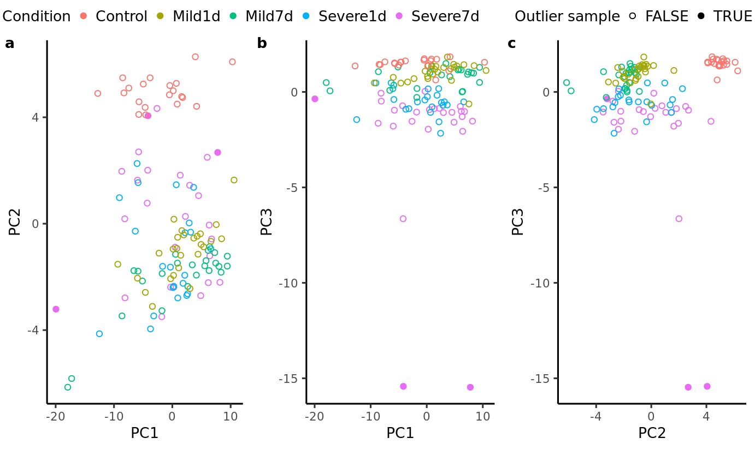

Supplementary Figure 1: Principal Component Analysis (PCA) of metabolomics data to determine the existence of systematic variation or outlier.

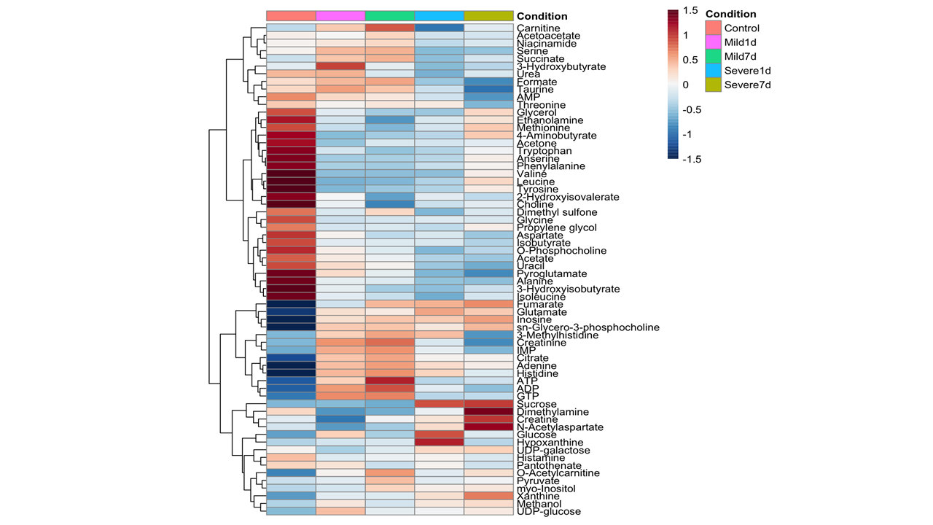
Supplementary Figure 2: Heatmap showing change in the concentration of metabolite values over time and trauma. While differentially high abundant metabolite shown in red, less abundant metabolites has shown in blue.

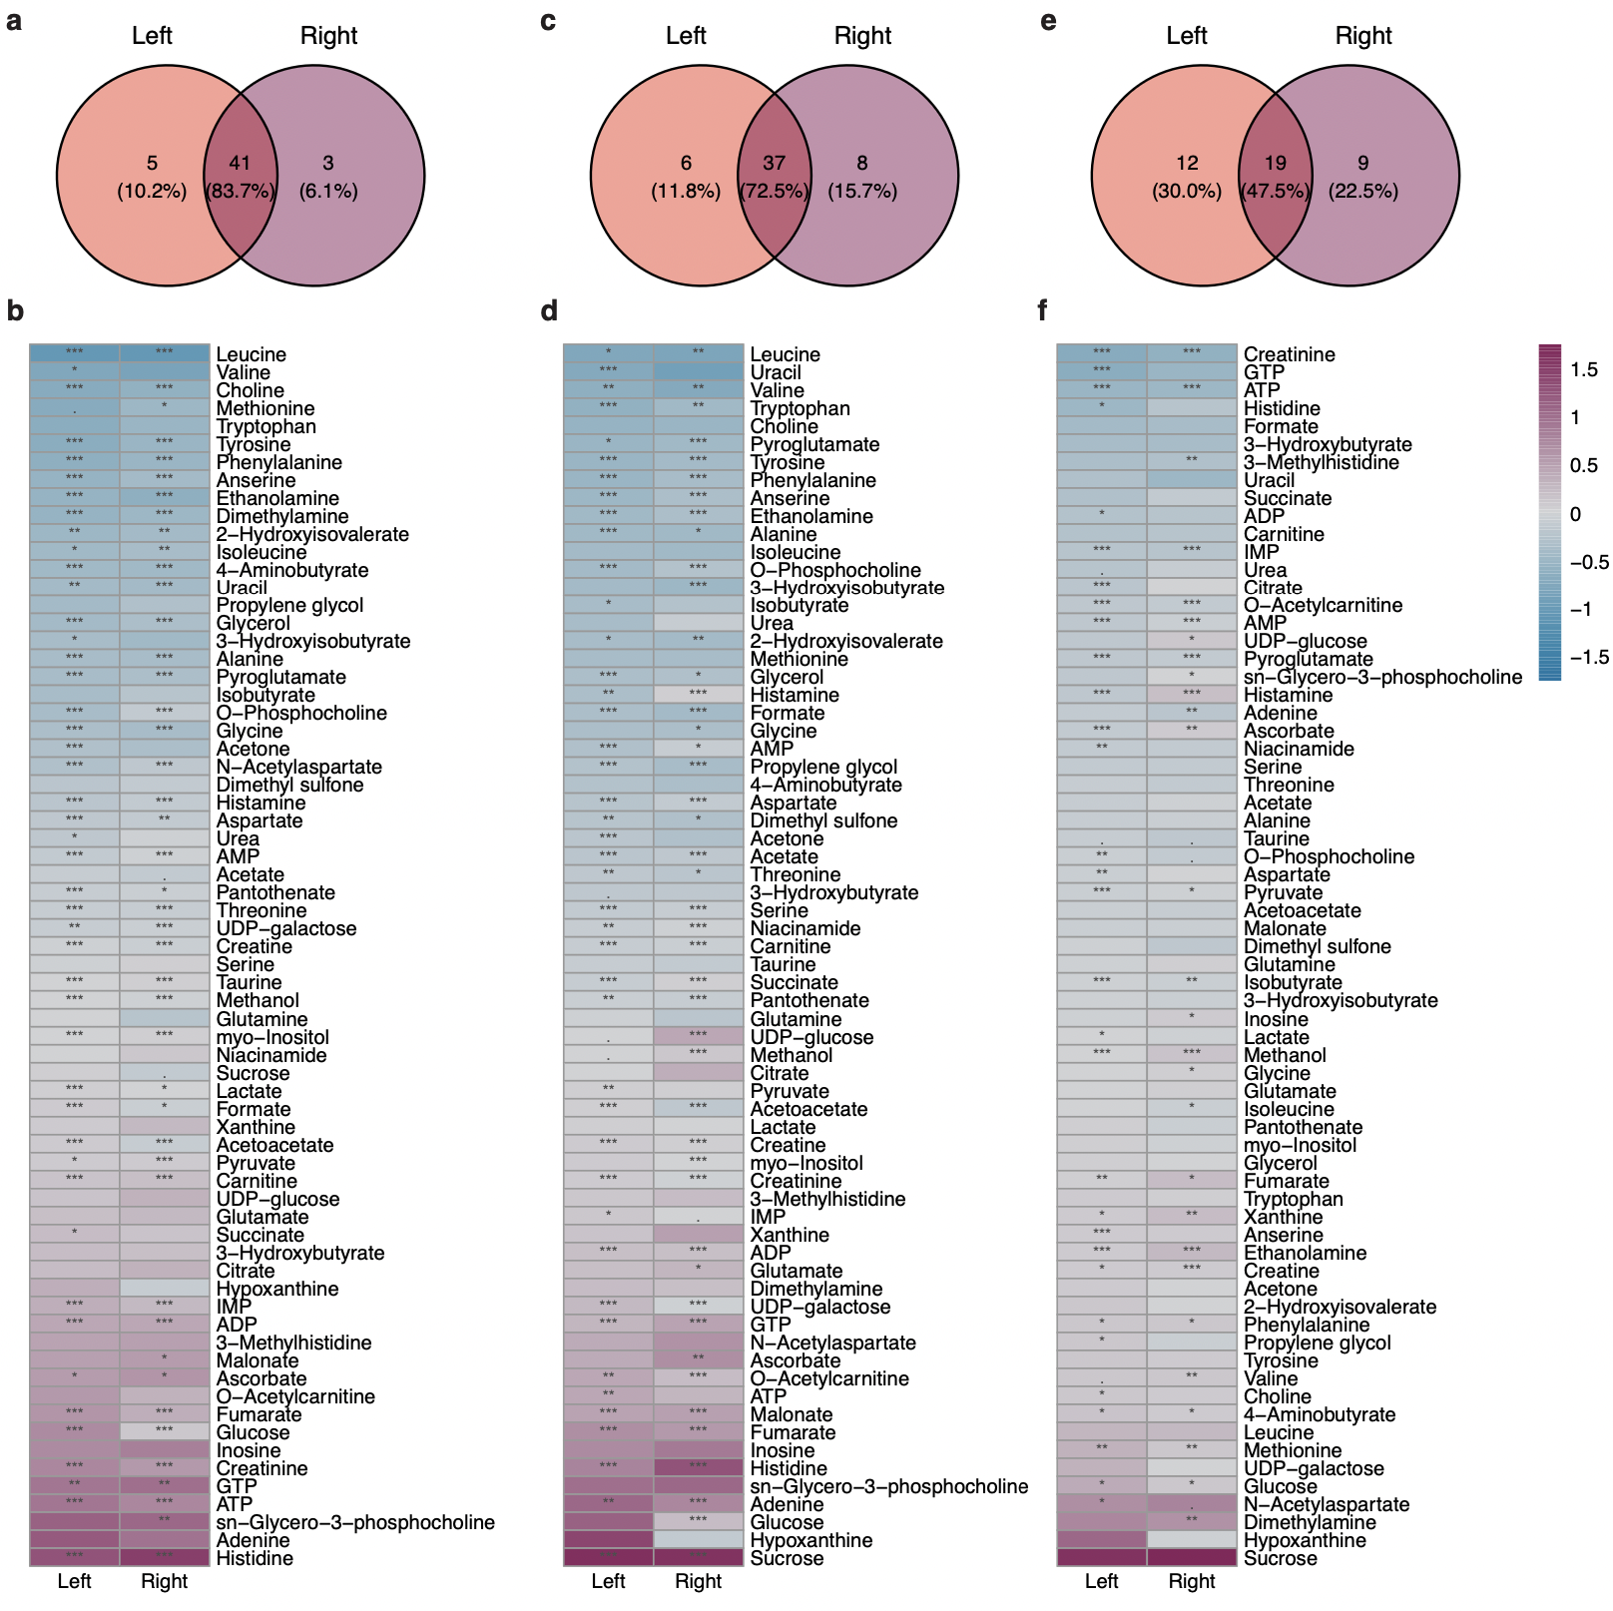
Supplementary Figure 3: Venn diagrams and heatmap indicating similarity of the metabolic profile change between left and right hemispheres of the mouse models when all severe TBI compared with healthy controls (A-B), when all mild cases compared with healthy controls (C-D), and when all severe TBI cases were compared with all mild TBI cases (E-F), respectively.

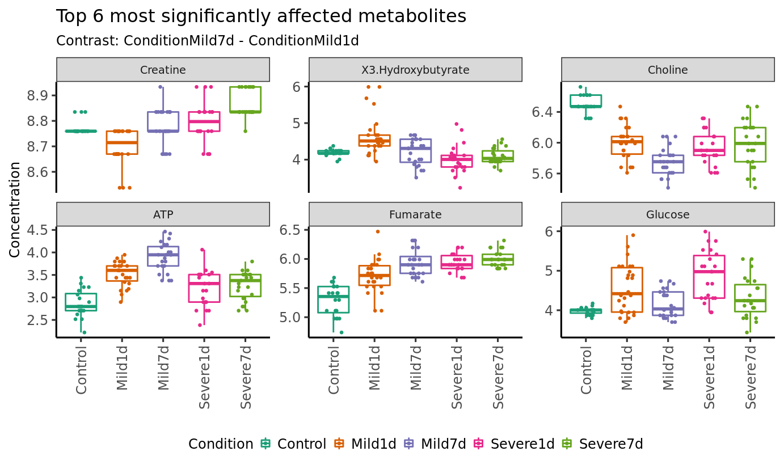
Supplementary Figure 4: Boxplots of top six most significantly affected metabolites comparing initial injury of Mild TBI (24 hours) and Mild TBI post-injury (7 days).

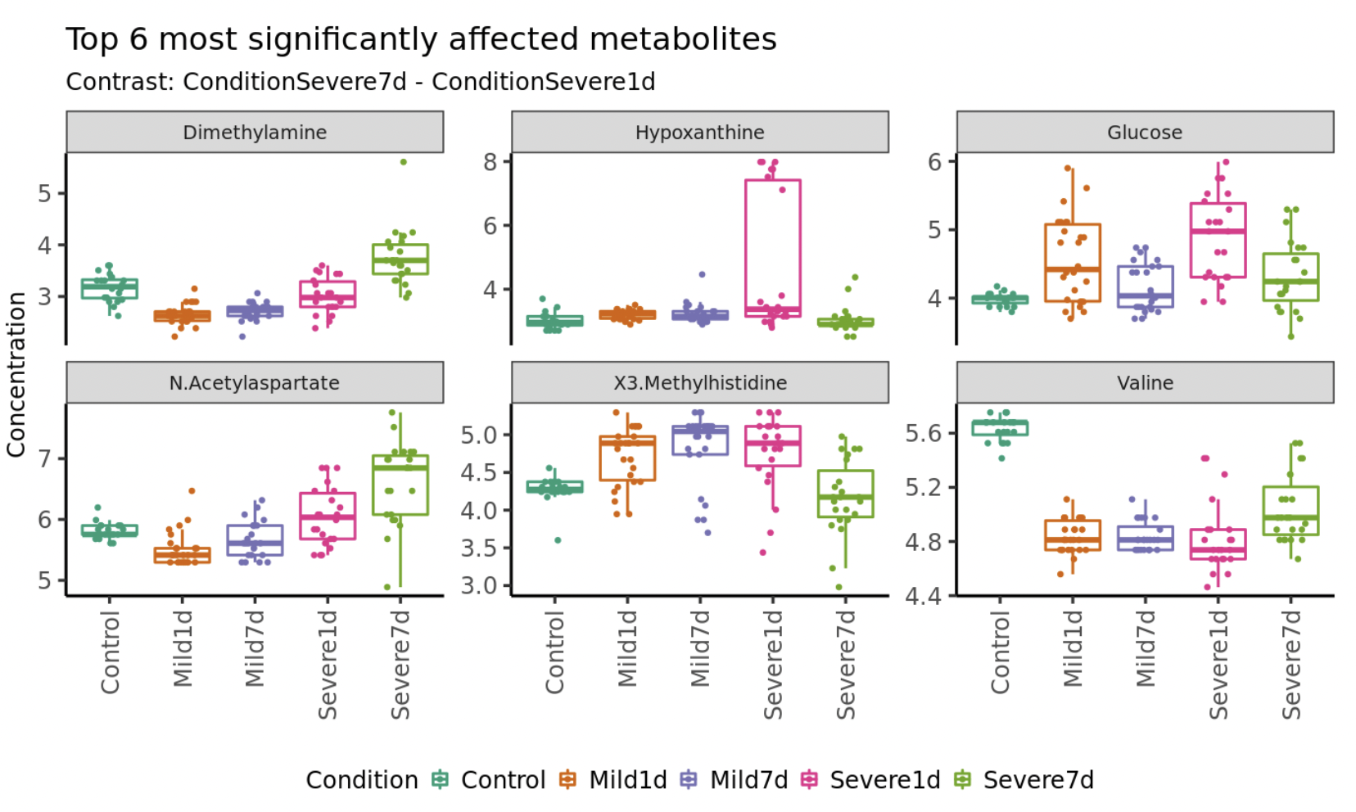
Supplementary Figure 5: Linear model indicating top six most significantly affected metabolites when the initial injury of severe TBI (24 hours) and post-injury (7days) were compared.

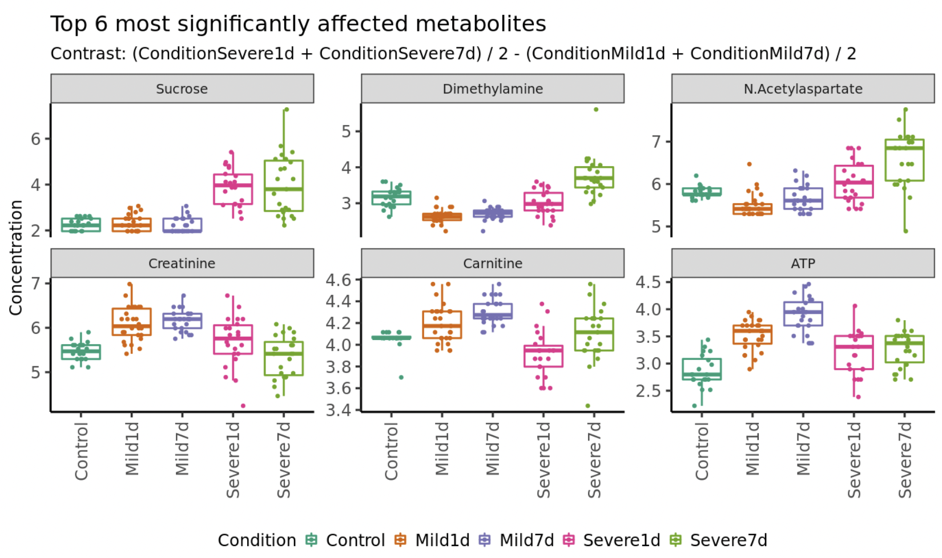
Supplementary Figure 6: Linear model indicating top six most significantly affected metabolites when all mild TBI (24 hours and 7 days) cases compared with all severe TBI (24 hours and 7 days).
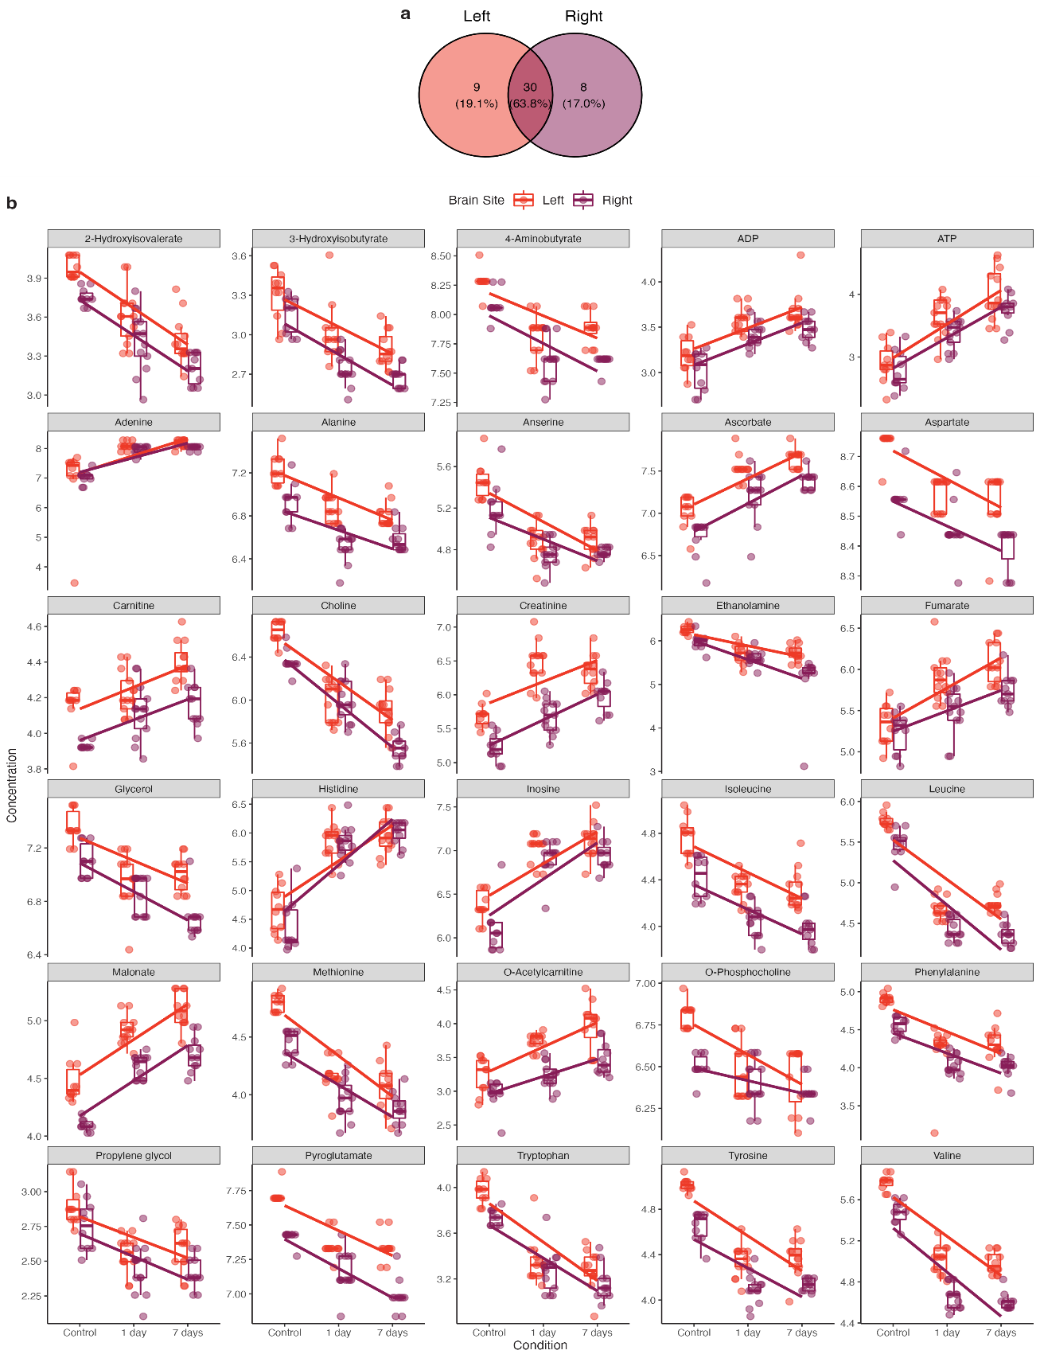

Supplementary Figure 7: (a) Venn diagram indicating similarity of the longitudinal metabolic profile change between left and right hemispheres of the mouse models of mild TBI and (b) change of the metabolites significantly affected in both hemispheres.

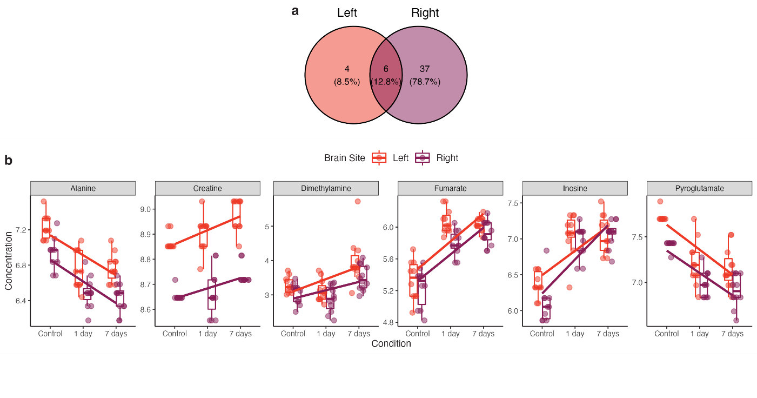Supplementary Figure 8: (a) Venn diagram indicating similarity of the longitudinal metabolic profile change between left and right hemispheres of the mouse models of severe TBI and (b) change of the metabolites significantly affected in both hemispheres.

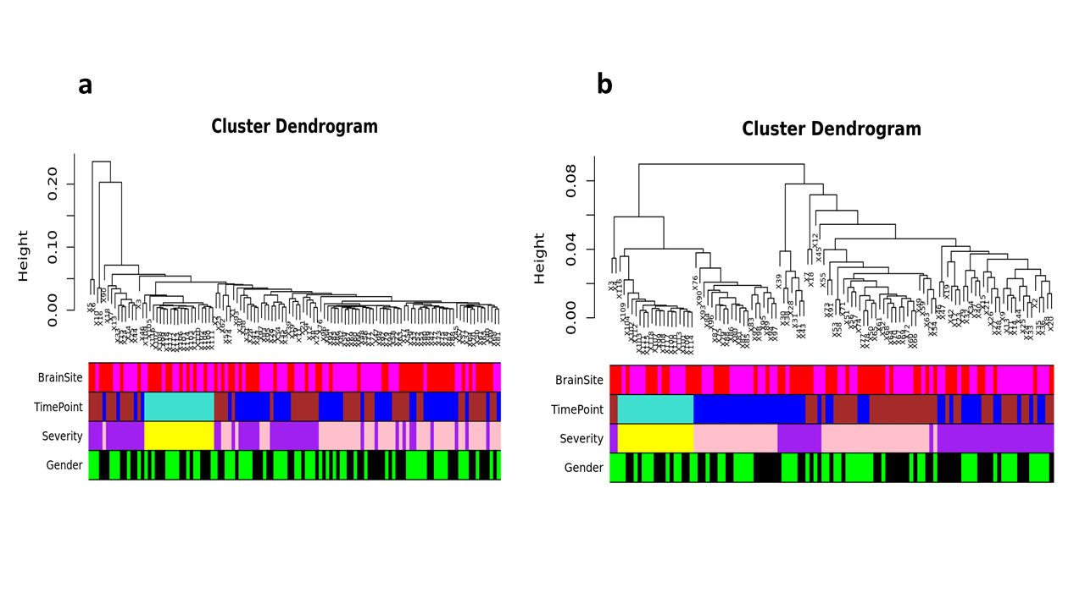
Supplementary Figure 9: Cluster analysis of data (a) before and (b) after outlier detection

