Appendix

Appropriate evaluation of rapid evolutionary responses to seasonal environmental variability in a wild Drosophila population

Takahisa Ueno¹, Akiko Takenoshita², Kaiya Hamamichi², Mitsuhiko P. Sato³ and Yuma Takahashi⁴
1. Graduate School of Science and Engineering, Chiba University, Chiba, Japan
2. Faculty of Science, Chiba University, Chiba, Japan
3. Department of Frontier Research and Development, Kazusa DNA Research Institute
4. Graduate School of Science, Chiba University, Chiba, Japan

orresponding author: Yuma Takahashi (E-mail: takahashi.yum@gmail.com)

Table S1. The number of raw reads in each isofemale line.
Isofemale line No. | Seasonal period | Reads
15 | Spring | 3338867
23 | Spring | 3733218
24 | Spring | 3424709
25 | Spring | 2896408
26 | Spring | 3516919
27 | Spring | 3857630
28 | Spring | 3707780
29 | Spring | 3133594
31 | Spring | 3203799
39 | Spring | 4135463
40 | Spring | 2984048
42 | Spring | 3454823
44 | Spring | 2845660
49 | Spring | 3348005
50 | Spring | 3829729
51 | Spring | 3108543
53 | Spring | 3285473
54 | Spring | 3767425
55 | Spring | 3776354
58 | Spring | 2915372
59 | Spring | 3130028
66 | Spring | 3503538
75 | Spring | 4049027
77 | Spring | 3335159
78 | Spring | 3005131
79 | Spring | 3461525
81 | Spring | 2981003
82 | Spring | 3722754
83 | Spring | 3584832
84 | Spring | 4486455
85 | Spring | 3231009
88 | Spring | 3132774
91 | Spring | 4174406
97 | Spring | 4706774
98 | Spring | 3585392
99 | Spring | 3915297
101 | Spring | 4021596
102 | Spring | 4724621
104 | Spring | 2744121
106 | Spring | 2660050
110 | Spring | 3038443
113 | Spring | 3507002
114 | Spring | 2545051
120 | Spring | 3193415
122 | Spring | 3115692
130 | Spring | 3303736
131 | Spring | 4074485
135 | Spring | 2640265
137 | Spring | 2714557
355 | Autumn | 3945930
384 | Autumn | 3141066
385 | Autumn | 3745097
387 | Autumn | 3974438
389 | Autumn | 2909073
500 | Autumn | 2687524
508 | Autumn | 3018026
510 | Autumn | 3434852
531 | Autumn | 3729816
533 | Autumn | 3230959
535 | Autumn | 2896025
538 | Autumn | 3278880
539 | Autumn | 4400868
541 | Autumn | 2901996
543 | Autumn | 3382202
544 | Autumn | 3372686
547 | Autumn | 3623843
551 | Autumn | 3254899
552 | Autumn | 3415532
555 | Autumn | 3373317
556 | Autumn | 3475196
581 | Autumn | 3559574
591 | Autumn | 3232658

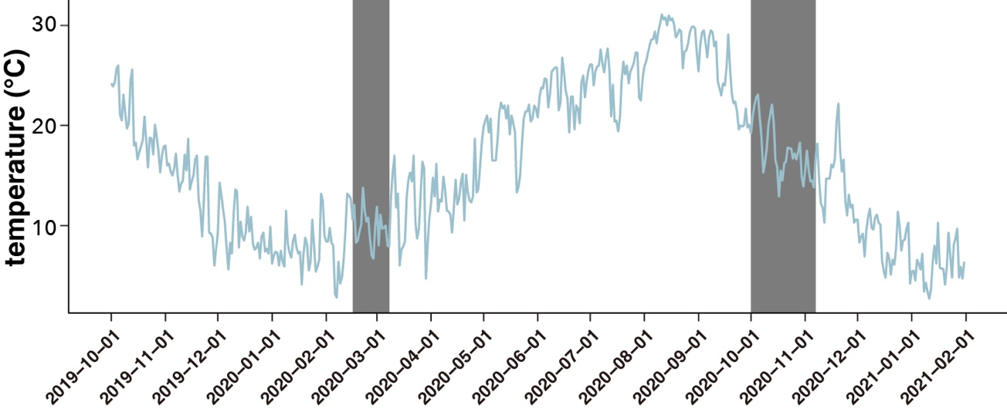
Figure S1. Average daily temperature in Chiba from 1 October 2019 to 31 January 2021. This data was published by the Japan Meteorological Agency. Grey bands indicate our collection periods.

