Supplementary Tables and Figures

Table S1. Sample size calculation assuming α = 0.05, β = 0.8, and rho = 0.5

Difference in Proportions | Aedes per treatmet cluster (m1) | Aedes Control cluster (m2) | Treatmet clusters (K1) | Control clusters (k2) | N | OR  (m1/m2) | IRR (m1/m2)
25.97% | 4 | 4 | 25 | 25 | 200 | 0.198 | 0.278
25.34% | 5 | 5 | 25 | 25 | 250 | 0.203 | 0.283
24.91% | 6 | 6 | 25 | 25 | 300 | 0.207 | 0.286
24.37% | 8 | 8 | 25 | 25 | 400 | 0.212 | 0.291
24.04% | 10 | 10 | 25 | 25 | 500 | 0.215 | 0.294

Figure S1. Examples of ovariole dissections of field-collected Ae. aegypti, indicating (A) Ovariole without dilation (10x), (B) 0 dilatations +Follicular stage 5 (F5), (C) 4 dilations + follicular stage I (FI), and (D) 5 dilations + follicular stage I (FI).

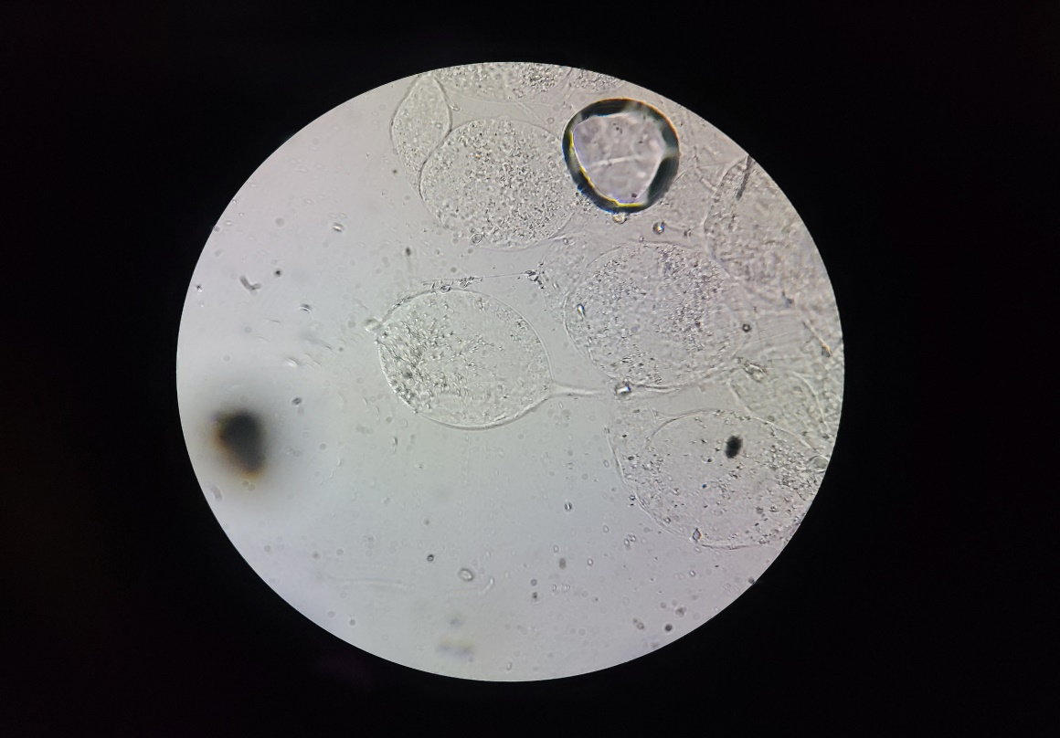
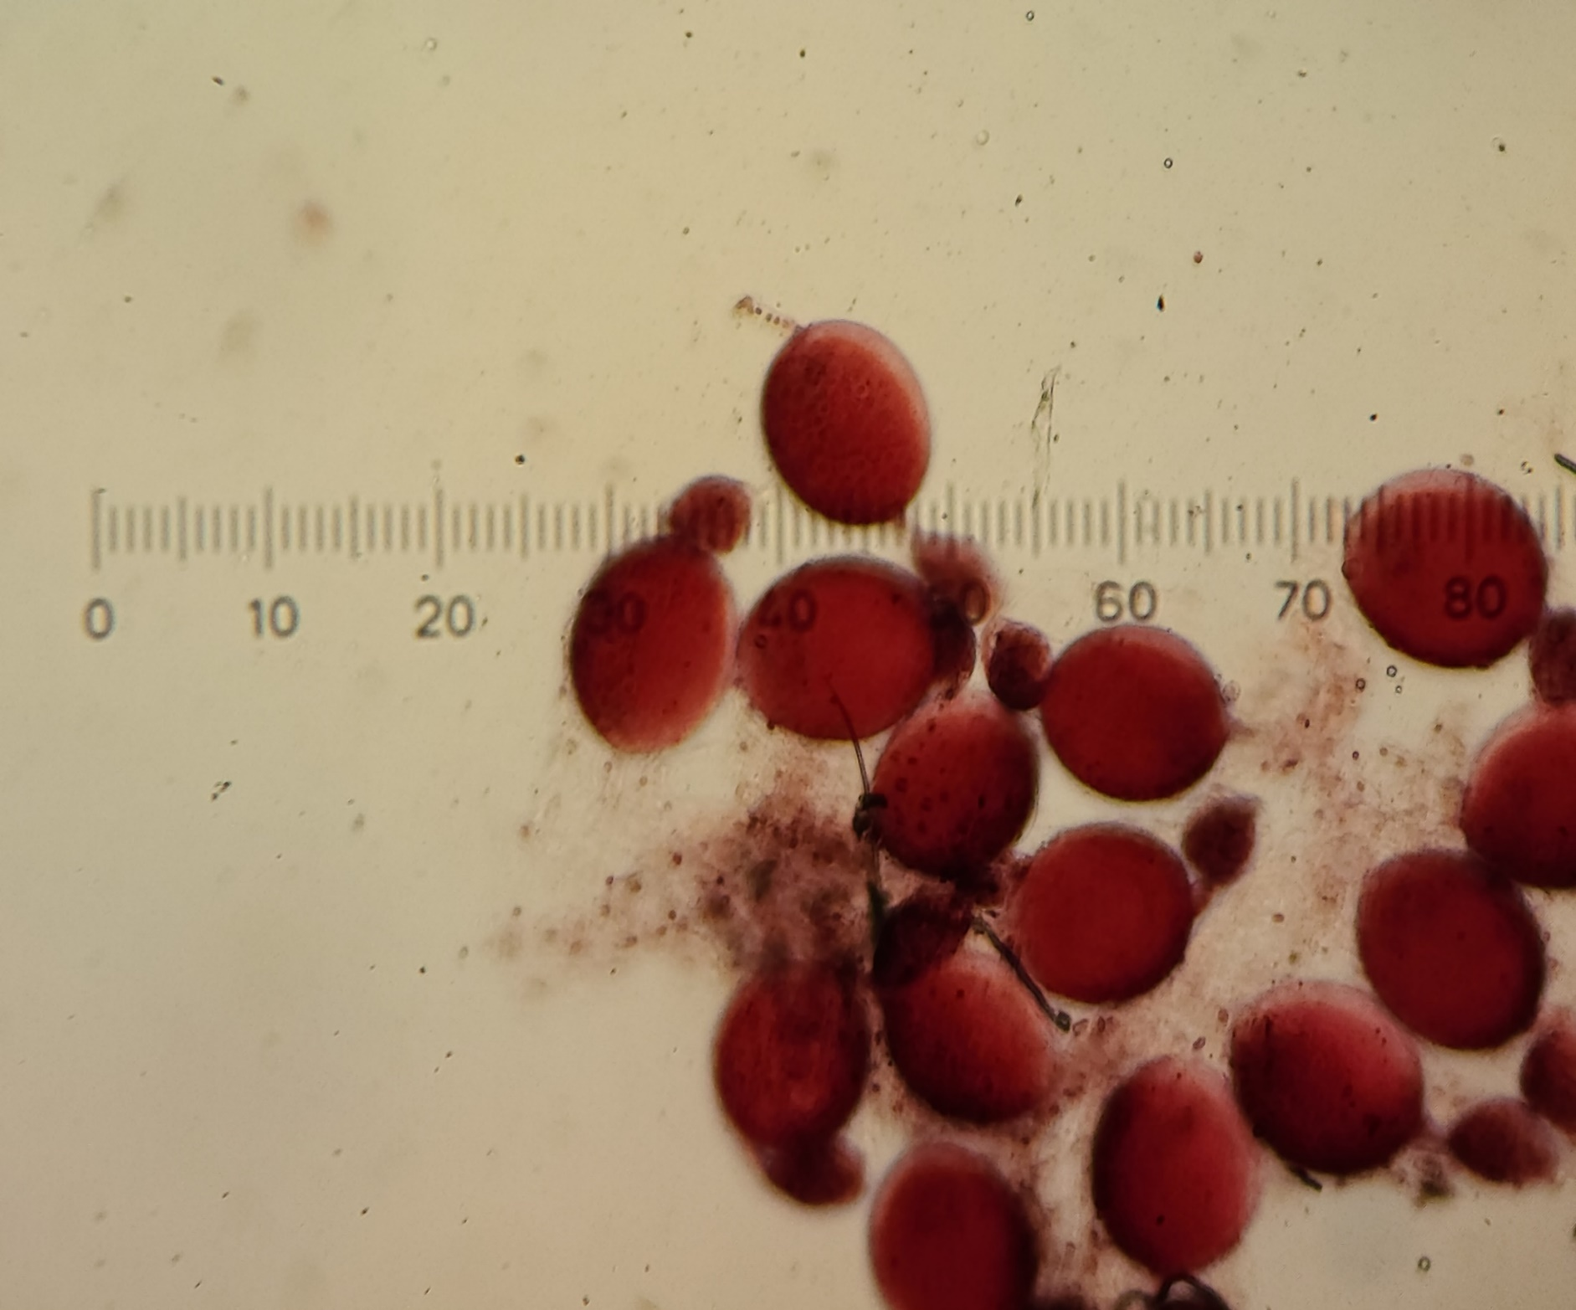
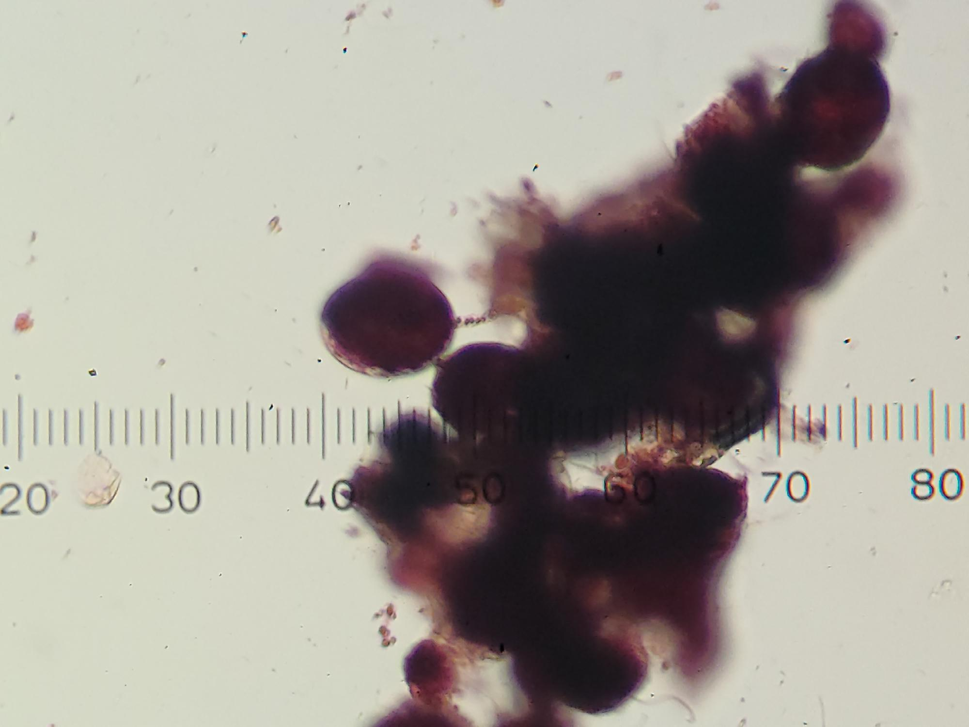
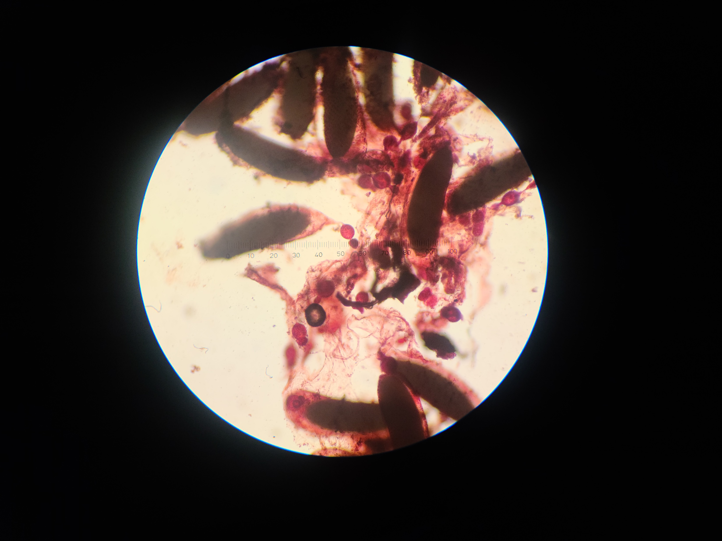

A
C
D
B

Figure S2. Results from WHO cone bioassays reporting mortality at 24h after the exposure of 100 mosquitoes for 30 min to walls treated and not treated with Actellic 300CS in Merida, Mexico.

