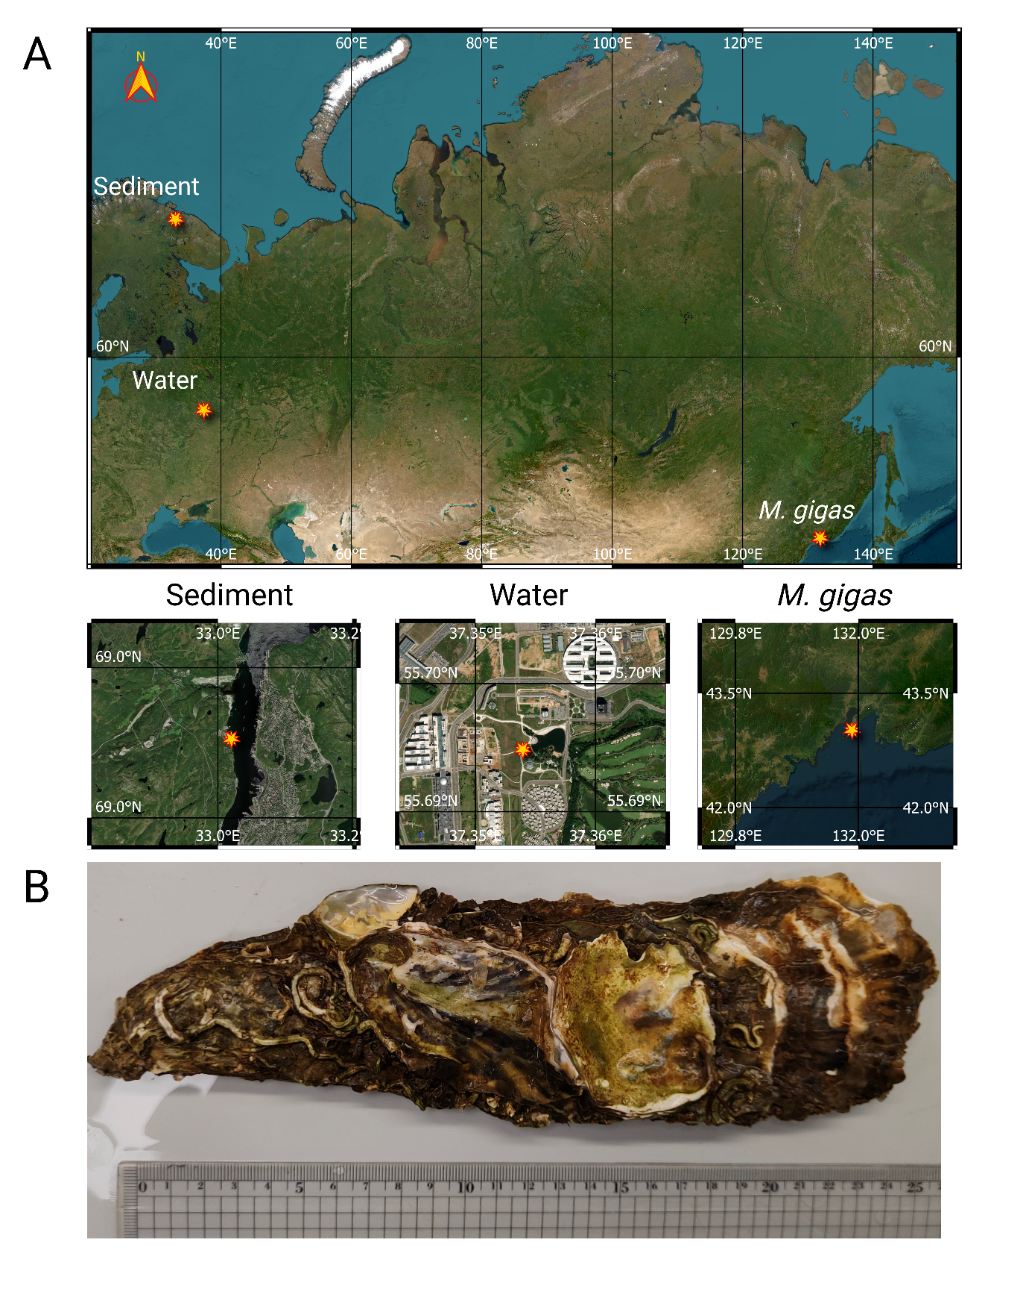

Fig. S1. A) Geographical locations for water, sea sediment, and Pacific oyster (M. gigas) collection spots. Map was prepared using Open Source Geospatial Foundation Project (http://qgis.org) B) Selected individual of Pacific oyster (M. gigas) aligned with a centimeter ruler.

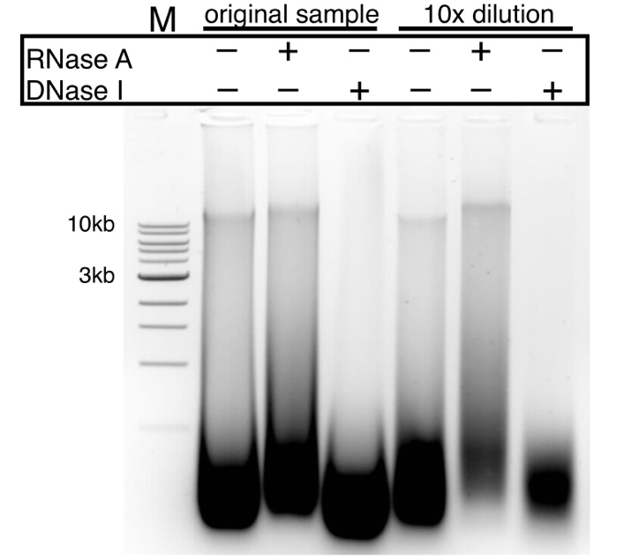
Fig. S2. DNase and RNase treatment of M.gigas DNA sample isolated with Stool kit.

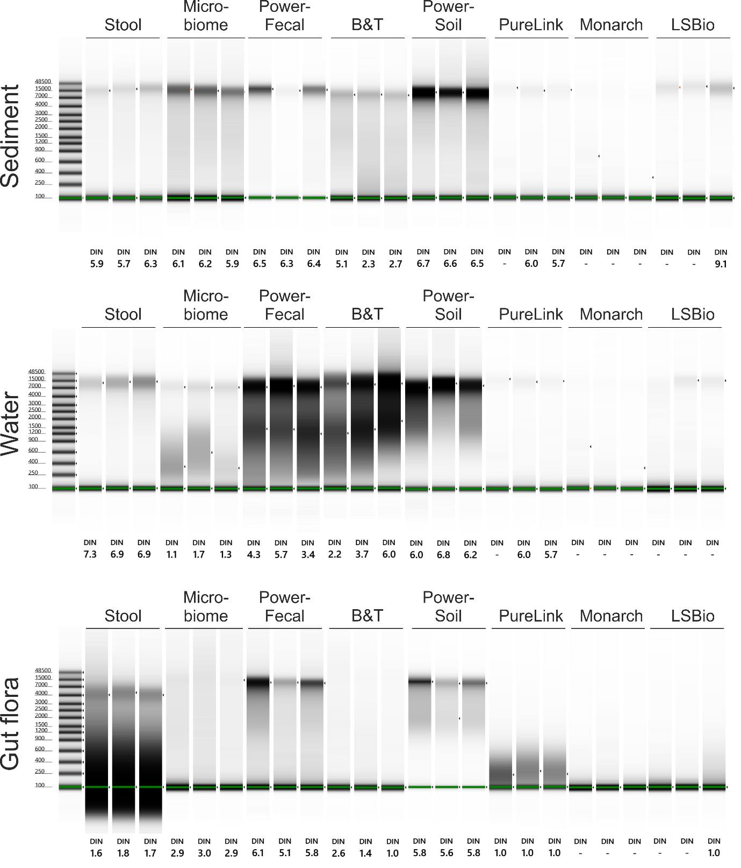
Fig. S3. Capillary electrophoresis estimation of the DIN values performed on a TapeStation 4150 (Agilent) with Genomic DNA ScreenTape System.

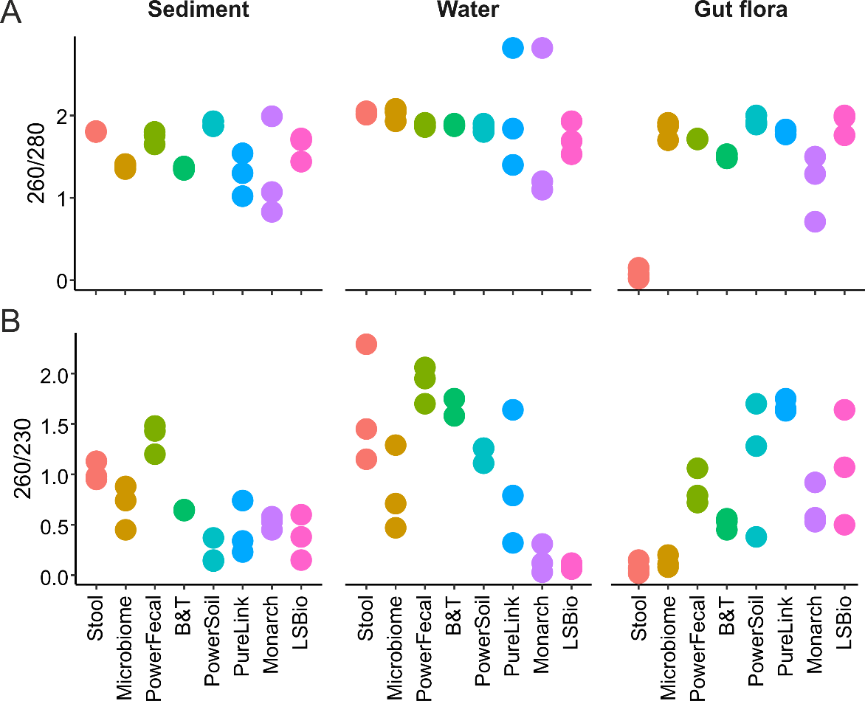
Fig. S4. DNA purity assessed by 260/280 (A) and 260/230 (B) absorption ratios. Data for three technical replicates are shown.

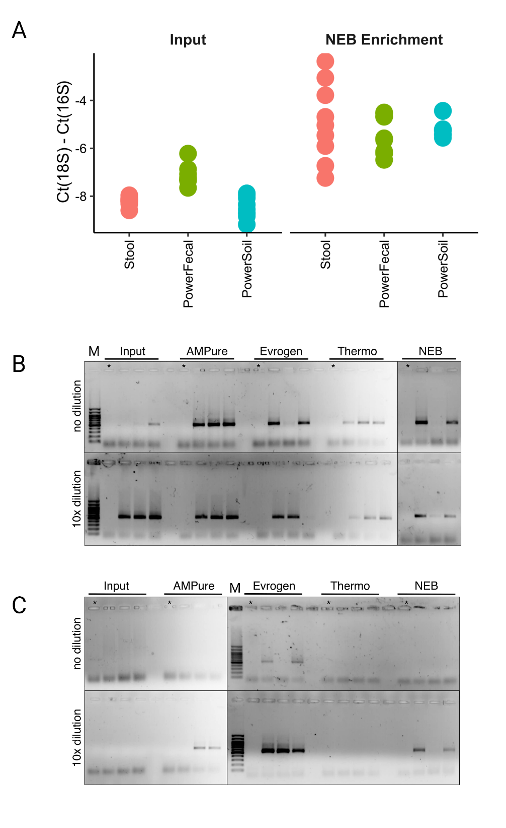

Fig. S5. (A) Retention of DNA relative to the input amount (50 ng for Stool or 150 ng for Microbiome kits) after additional re-purification procedures. (B-C) Results of the 16S rRNA gene PCR with sea sediment samples purified with Stool (B) and Microbiome (C) kits. PCR was performed with non-diluted and 10-fold diluted input DNA or DNA additionally re-purified with indicated kits (see Methods). *- no-input control that was re-purified in parallel with experimental samples to estimate potential contamination of the re-purification kit solutions with microbial DNA. M – 100 bp Plus GeneRuler DNA ladder (Thermo Scientific). Products were loaded on 3 agarose gels and run in parallel, fragments of different gels are separated by a black line. Uncropped gels can be found in Fig. S13.

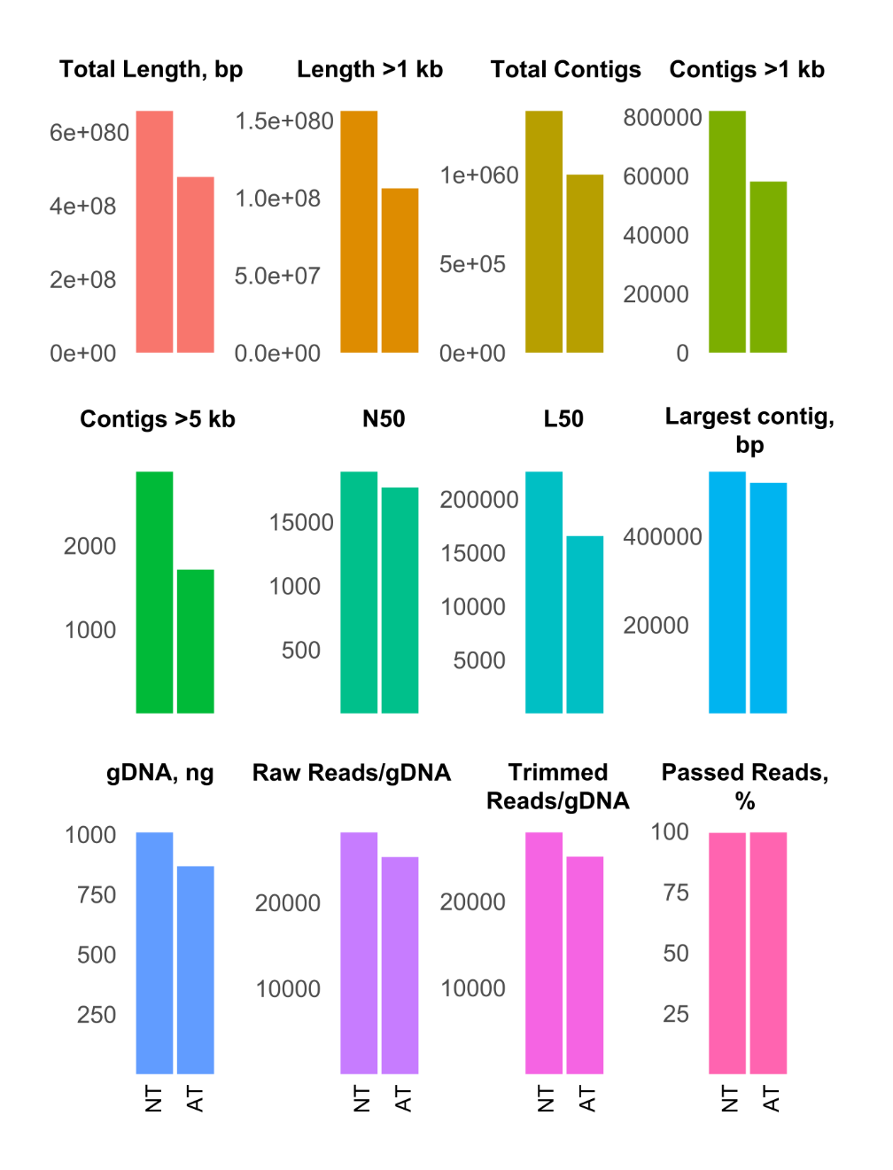
Fig. S6. Parameters of shotgun BGI libraries obtained from sediment sample purified with PowerFecal kit (NT – no treatment) and additionally re-purified with Evrogen column kit (AT - additional treatment).

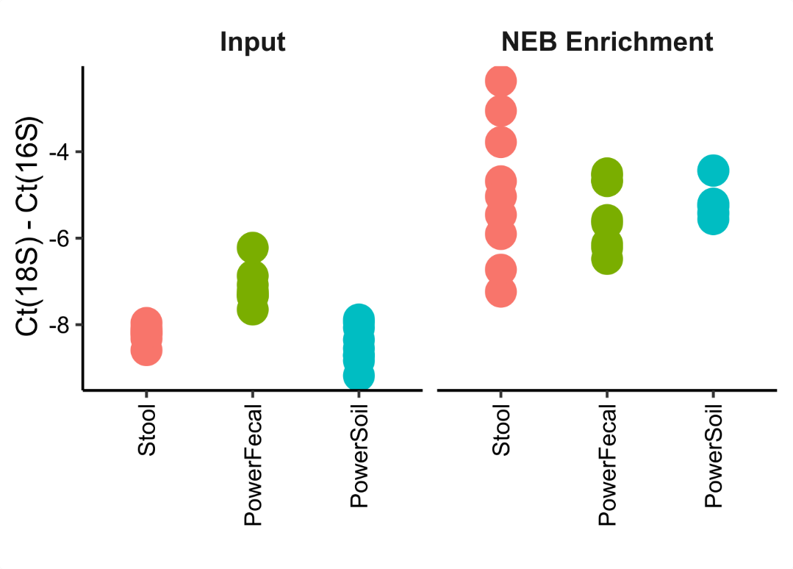
Fig. S7. qPCR Ct values obtained with 18S and 16S rRNA gene-specific primers with the input and NEB Enrichment re-purified DNA samples. Data for three technical qPCR replicates for each of the three kit purification replicates are shown.

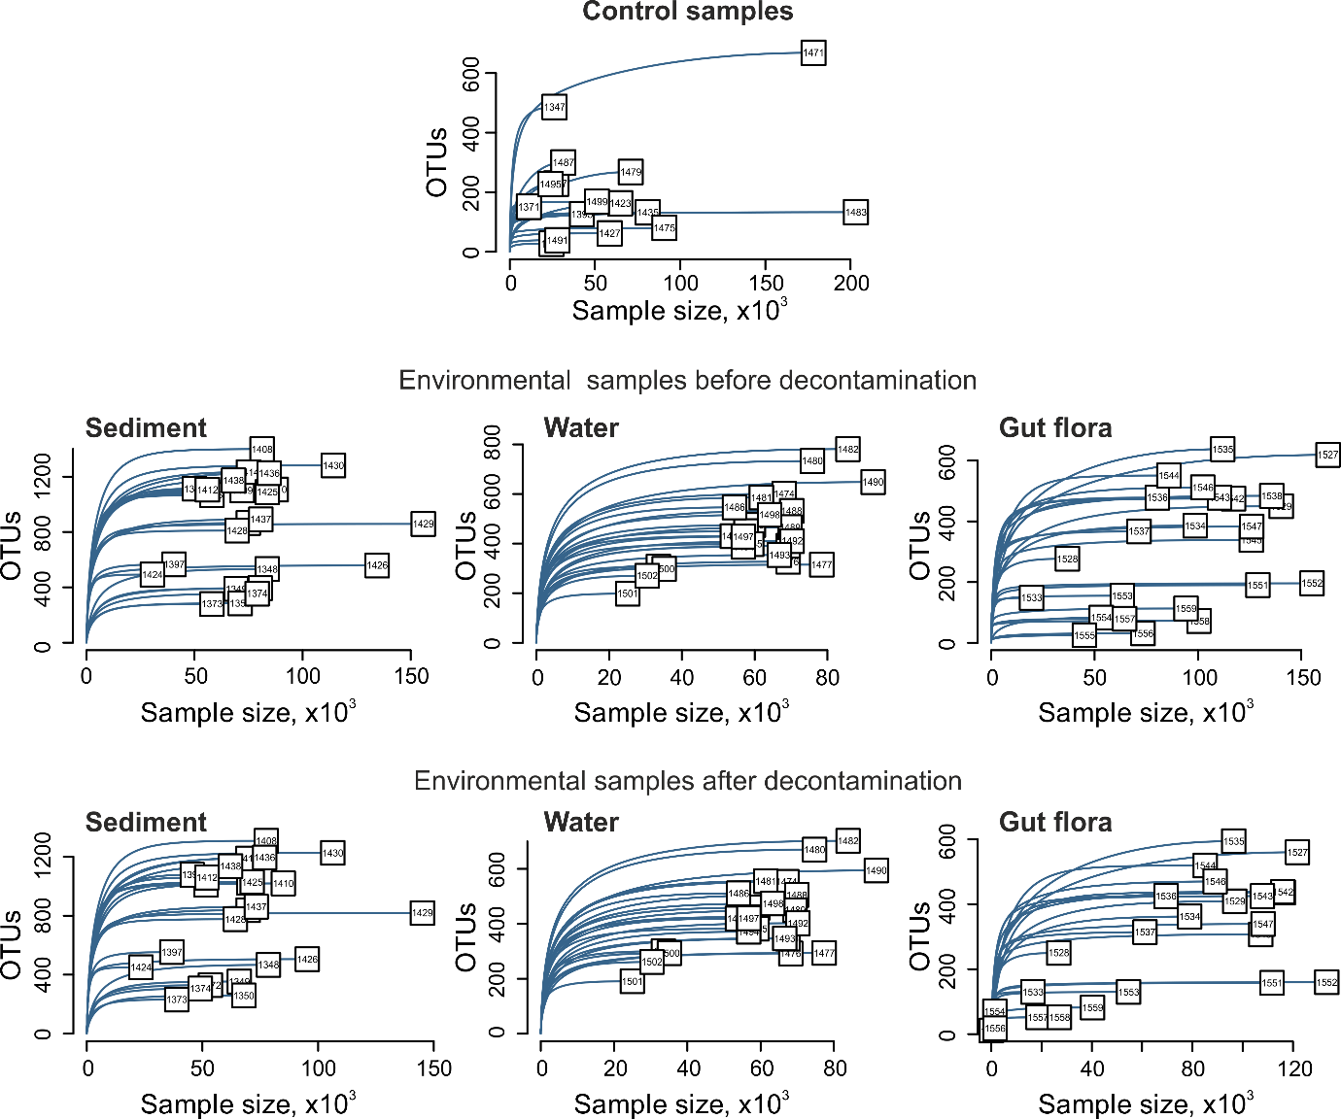

Fig. S8. Rarefaction curves for control samples (upper row), natural samples before decontamination (middle), and natural samples after decontamination (bottom row).

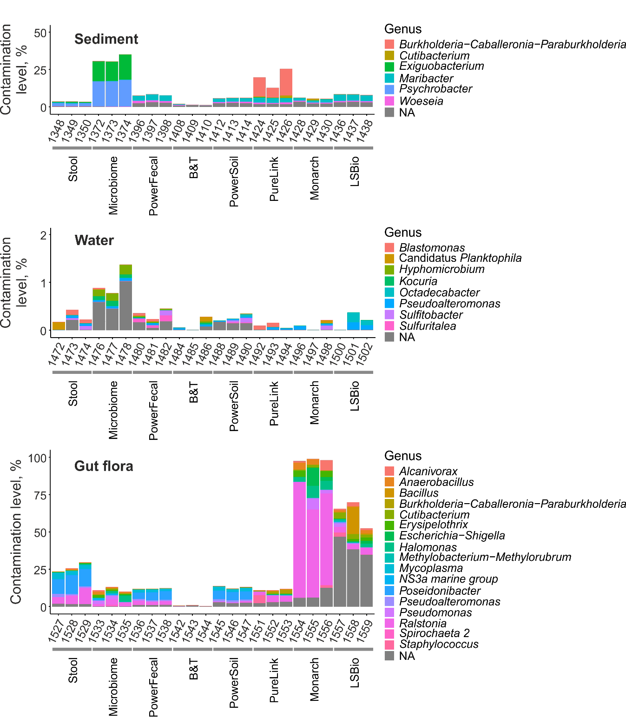
Fig. S9. Contamination levels of natural samples. Data is shown for all technical replicates independently. Genera with relative abundances >1% are shown.
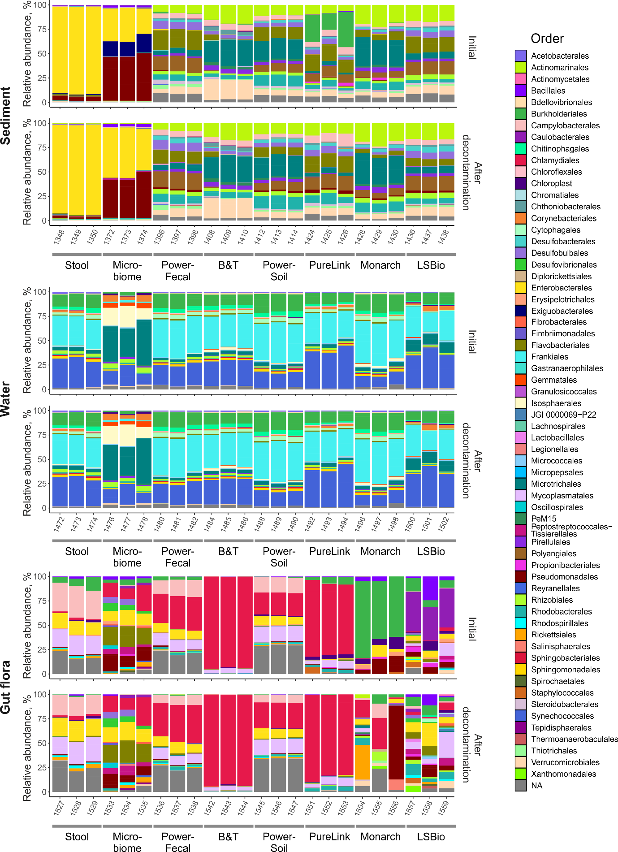
Fig. S10. Microbial communities’ composition of natural samples before decontamination (Initial) and after the decontamination on an order level. Data is shown for all technical replicates independently. Orders with relative abundances >1% are shown.
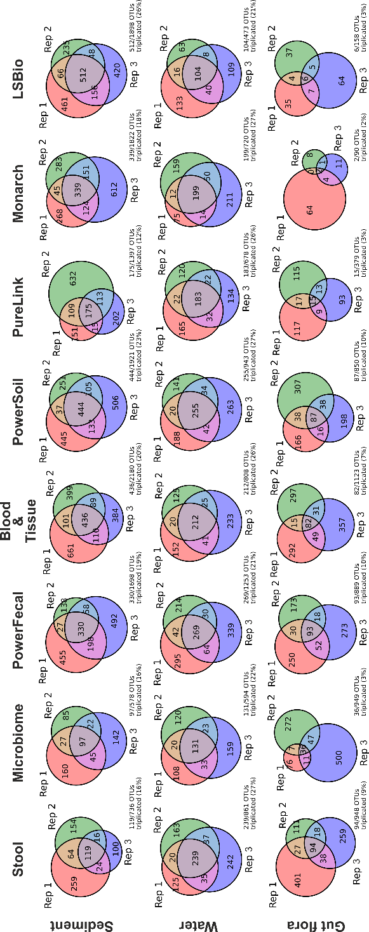

Fig. S11. Reproducibility of DNA-extraction kits. Venn diagrams representing the intersections of lists of non-zero OTUs (OTUs with a non-zero abundance) for three technical replicates obtained with specified DNA-extraction kits. Below the diagram, reproducibility level is shown (%) as a fraction of non-zero OTUs found in all three replicates from the total number of unique non-zero OTUs found in at least one replicate.

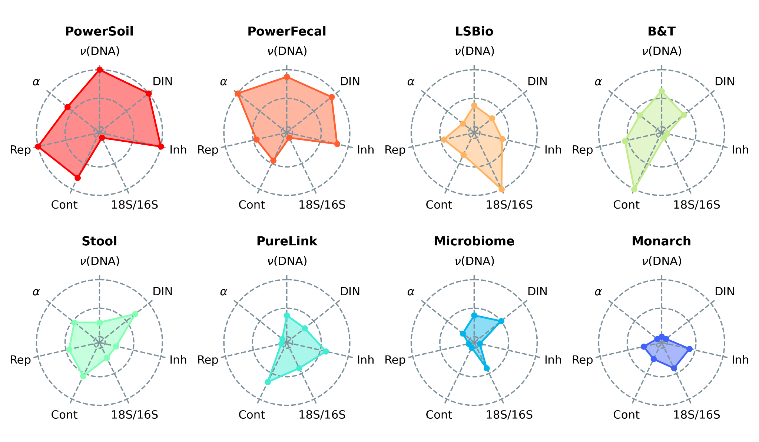
Fig. S12. Radar-plots demonstrating the average performance of DNA-extraction kits. 𝜈(DNA) - DNA yield, DIN - DNA integrity, Inh - presence of PCR inhibitors (higher rank indicates the lower level of inhibitors), 18S/16S - 18S/16S ratio (higher rank indicates the lower ratio), Cont - contamination level (higher rank indicates the lower level of contamination), Rep - reproducibility level, 𝛼 - alpha-diversity. Kits were ordered by the sum of ranks.

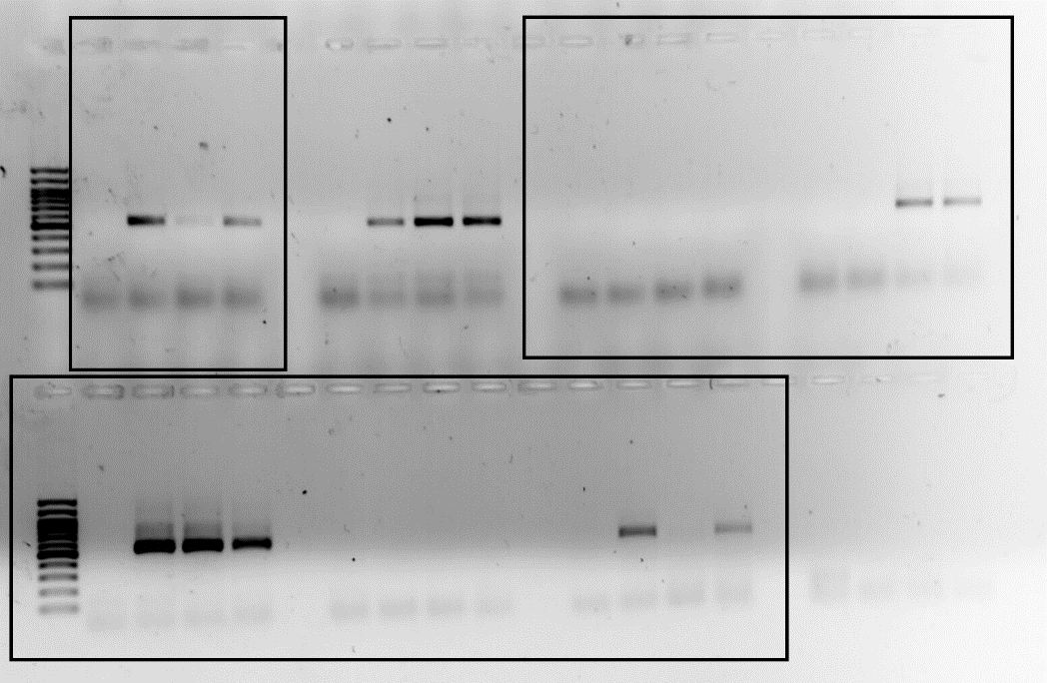

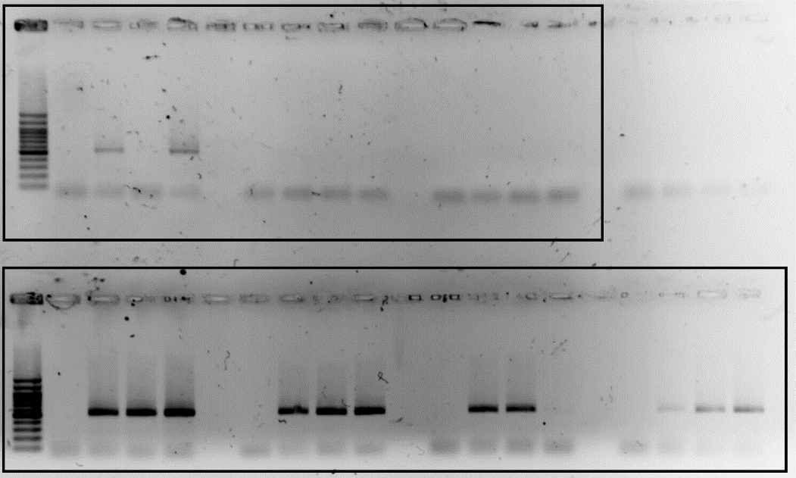

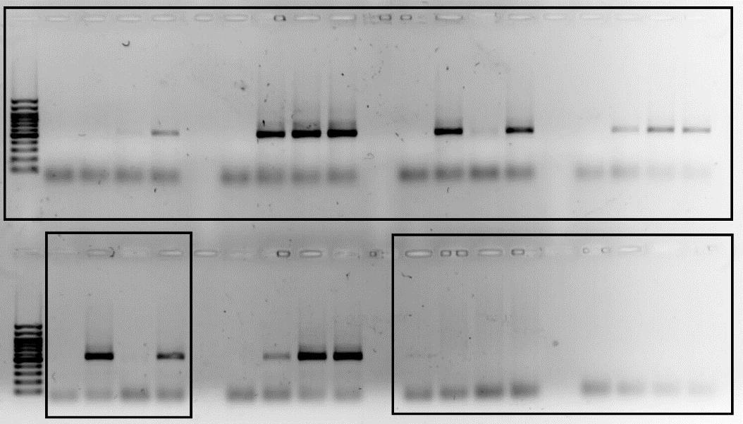

Fig. S13. Uncropped agarose gels used to generate Fig. S5B,C. Cropped fragments used to build Fig. S5B,C are shown in frames.

