Supplementary Information

Title: Multimodal Photoacoustic Microscopy, Optical Coherence Tomography, and Fluorescence Imaging of USH2A Knockout Rabbits

Authors: Van Phuc Nguyen¹, Justin Hu¹, Josh Zhe¹, Eugene Y. Chen³, Dongshan Yang^{3*}, and Yannis M. Paulus^{1,2*}

Affiliations:
¹Department of Ophthalmology and Visual Sciences, University of Michigan, Ann Arbor, MI 48105, USA
²Department of Biomedical Engineering, University of Michigan, Ann Arbor, MI 48105, USA
³Center for Advanced Models for Translational Sciences and Therapeutics, University of Michigan, Ann Arbor, MI 48109, USA

*Corresponding Authors:
Yannis M. Paulus, M.D., F.A.C.S.
Department of Ophthalmology and Visual Sciences
Department of Biomedical Engineering
University of Michigan
1000 Wall Street
Ann Arbor, MI 48105, USA
Email Address: ypaulus@med.umich.edu

Dongshan Yang, Ph.D.
Center for Advanced Models for Translational Sciences and Therapeutics Department of Internal Medicine
University of Michigan
2800 Plymouth Rd NCRC B26-355S
Ann Arbor, MI 48109-2800, USA
Email Address: doyang@med.umich.edu

SUPPLEMENTARY FIGURES
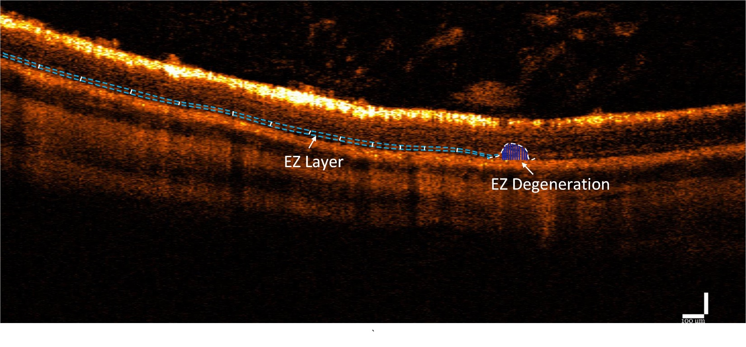
Figure S1. OCT Signal Intensity measurement. The margins of EZ degeneration areas were isolated using ImageJ (white dotted lines), while blue dotted indicate the selected region of interests (ROIs) applied to measure the non-degenerated EZ. A total of 12 different B-scan images were selected to quantify the EZ thickness and EZ signal intensity.

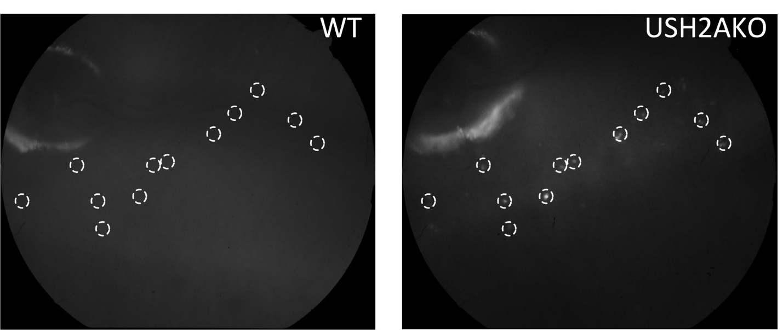
Figure S2. Fluorescent intensity measurement for WT group. White dotted circles indicate the selected region of interests (ROIs) to measure the fluorescent intensity. These areas were selected at similar location of the EZ degeneration from USH2AKO group.

