Supplementary file
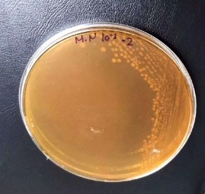 | 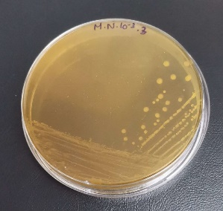 | 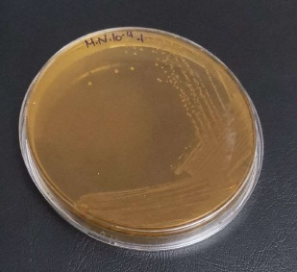
(a)
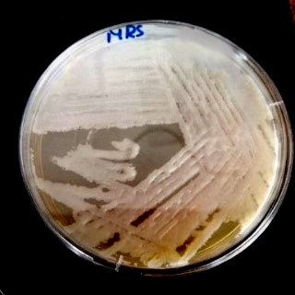 | 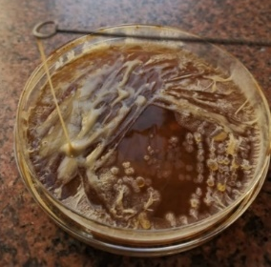 | 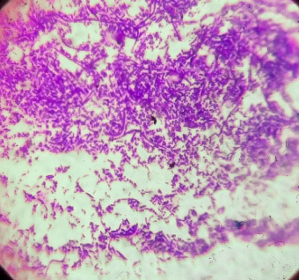
(b) | (c) | (d)
Figure S1. isolates from different samples on MRS plates (a), most potent isolate no.1 (b), showing ropiness of isolate(c) gram stain for isolates under light microscope (d).

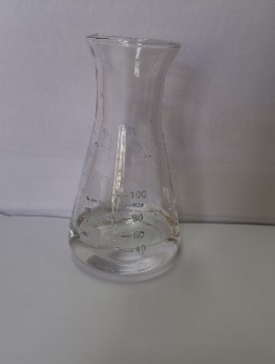  (a) | 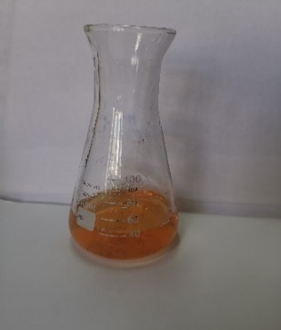  (b) | 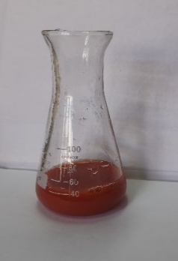  (c)
Figure S2. green synthesis production of EPS-SeNPs the color change from colorless to dark orange

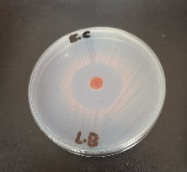 | 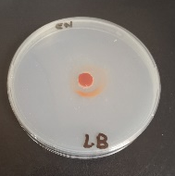 | 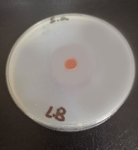 | 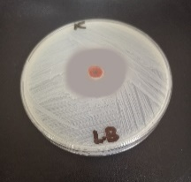 | 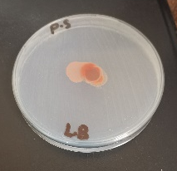 | 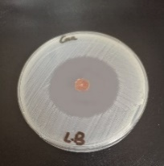
E. coli | Ent. aerogenes | Staphylococcus aureus | Klebsiella pneumoniae | P. vulgaris | Candida albicans
Figure S3.: showing antimicrobial activity of EPS-SeNPs against E. coli, Klebsiella pneumoniae, Staphylococcus aureus and Candida albicans
Table S 1: Morphological, physiological and biochemical characteristics of LAB isolates
No. | Source | Isolate Code | Colony morphology | Gram Stain | Cell shape | Biochemical parameter |  | colony color on Congo red agar
 |  |  |  |  |  | Catalase | Coagulase | colony color on Congo red agar
1 | Raw buffalo milk | Isolate no.1 | Entire, circular white to creamy color | Gram positive | Bacilli | negative | negative | black
2 | Raw buffalo milk | Isolate no.2 | Entire, circular white to creamy color | Gram positive | Bacilli | negative | negative | black
3 | Raw buffalo milk | Isolate no.3 | Entire, circular white to creamy color | Gram positive | Bacilli | negative | negative | black
4 | Raw buffalo milk | Isolate no.4 | Entire, circular white to creamy color | Gram positive | Bacilli | negative | negative | dark red
5 | Raw caw milk | Isolate no.5 | Entire, circular white to creamy color | Gram positive | Bacilli | negative | negative | black
6 | Raw caw milk | Isolate no.6 | Entire, circular white to creamy color | Gram positive | Coccobacilli | negative | negative | black
7 | Raw caw milk | Isolate no.7 | Entire, circular white to creamy color | Gram positive | Bacilli | negative | negative | black
8 | Raw caw milk | Isolate no.8 | Entire, circular white to creamy color | Gram positive | short bacilli | negative | negative | dark red
9 | Yogurt | Isolate no.9 | Entire, circular white to creamy color | Gram positive | short bacilli | negative | negative | dark red
10 | Yogurt | Isolate no.10 | Entire, circular white to creamy color | Gram positive | Coccobacilli | negative | negative | dark red
Samples coded (O), buffalo milk. (N), caw milk. (N.3-N.4) ,yogurt samples .

Table S 2: Tolerance of lactic acid bacteria isolates to different pH and bile salt concentrations
No. | LAB  Isolate Code | Growth at different pH |  |  | Growth at different  Bile salt %
No. | LAB  Isolate Code | 2 | 3 | 4 | 0.3 | 1 | 2
1 | Isolate no.1 | + | ++ | +++ | +++ | ++ | +
2 | Isolate no.2 | + | ++ | ++ | ++ | ++ | +
3 | Isolate no.3 | + | + | ++ | + | + | -
4 | Isolate no.4 | + | ++ | ++ | ++ | + | -
5 | Isolate no.5 | + | + | + | +++ | ++ | +
6 | Isolate no.6 | + | ++ | +++ | ++ | ++ | +
7 | Isolate no.7 | - | + | ++ | ++ | + | +
8 | Isolate no.8 | + | ++ | ++ | ++ | + | -
9 | Isolate no.9 | + | ++ | +++ | ++ | - | -
10 | Isolate no.10 | ++ | ++ | ++ | ++ | + | -
LAB, lactic acid bacteria. +++ high growth. ++, moderate growth. +, week growth. -, no growth.

Table S 3: Biomass, EPS response and its signal to noise ratio
 | response
Trials | Biomass  (g/L) | EPS  (g/L ) | S/N ratios of Dry weight | S/N ratios of EPS
1 | 1.03 | 17.56 | 0.26 | 24.89
2 | 1.12 | 16.24 | 0.98 | 24.21
3 | 1.26 | 14.42 | 2.01 | 23.18
4 | 1.56 | 19.44 | 3.86 | 25.77
5 | 1.38 | 16.89 | 2.80 | 24.55
6 | 2.01 | 17.53 | 6.06 | 24.88
7 | 1.52 | 20.85 | 3.64 | 26.38
8 | 1.46 | 19.65 | 3.29 | 25.87
9 | 1.64 | 19.31 | 4.30 | 25.72
10 | 3.25 | 23.45 | 10.24 | 27.40
11 | 0.16 | 17.70 | 15.9176- | 24.96
12 | 4.04 | 22.03 | 12.13 | 26.86
13 | 3.76 | 22.14 | 11.50 | 26.90
14 | 0.52 | 14.87 | -5.68 | 23.45
15 | 4.32 | 21.36 | 12.71 | 26.59
16 | 3.39 | 21.36 | 10.60 | 26.59
17 | 0.49 | 16.52 | 6.1961- | 24.36
18 | 3.96 | 21.87 | 11.95 | 26.80
19 | 1.97 | 20.87 | 5.89 | 26.39
20 | 6.32 | 26.36 | 16.01 | 28.42
21 | 3.09 | 20.52 | 9.80 | 26.24
22 | 1.32 | 20.23 | 2.41 | 26.12
23 | 6.51 | 27.12 | 16.27 | 28.67
24 | 2.88 | 20.86 | 9.19 | 26.39
25 | 1.79 | 18.36 | 5.06 | 25.28
26 | 6.33 | 25.33 | 16.03 | 28.07
27 | 3.16 | 19.01 | 9.99 | 25.58

Table S 4. Response Table for Signal to Noise Ratios and Means for variables for biomass production (Larger is better)
 | Response Table for Signal to Noise Ratios for variables |  |  |  |  |  |  |  | Response Table for variables Means
Level | Peptone | Yeast  extract | Dextrose | Sucrose | pH | Temp | Inoculum  size | Culture  volume | Peptone | Yeast  extract | Dextrose | Sucrose | pH | Temp | Inoculum  size | Culture  volume
1 | 3.025 | 4.5599 | 5.2757 | 5.8734 | 5.9399 | 10.3179 | 0.9937 | 6.3849 | 1.442 | 2.471 | 2.440 | 25.88 | 2.177 | 3.954 | 1.601 | 2.638
2 | 4.5937 | 6.5698 | 5.5834 | 6.7543 | 3.0655 | 7.5995 | 6.3576 | 5.0115 | 2.655 | 2.696 | 2.631 | 2.685 | 2.699 | 2.610 | 2.373 | 2.556
3 | 10.0725 | 6.5179 | 6.8286 | 5.0599 | 8.6822 | -0.2297 | 10.3364 | 6.2913 | 3.707 | 2.638 | 2.733 | 2.531 | 2.928 | 1.240 | 3.830 | 2.611
Delta | 7.0510 | 1.9699 | 1.5529 | 1.6944 | 5.6168 | 10.5477 | 9.3427 | 1.3734 | 2.265 | 0.224 | 0.293 | 0.154 | 0.752 | 2.714 | 2.230 | 0.82
Rank | 3 | 5 | 7 | 6 | 4 | 1 | 2 | 8 | 2 | 6 | 5 | 7 | 4 | 1 | 3 | 8

Table S 5. Response Table for Signal to Noise Ratios and Means for variables for EPS production (Larger is better)
 | Response for Signal to Noise Ratios for variables |  |  |  |  |  |  |  | Response for variables Means
Level | Peptone | Yeast  extract | Dextrose | Sucrose | pH | Temp | Inoculum  size | Culture  volume |  | Peptone | Yeast  extract | Dextrose | Sucrose | pH | Temp | Inoculum  size | Culture  volume
1 | 25.05 | 25.84 | 25.69 | 25.35 | 26.19 | 26.94 | 25.34 | 26.09 |  | 17.99 | 19.91 | 19.58 | 18.81 | 20.47 | 22.4 | 18.59 | 20.35
2 | 25.99 | 25.92 | 25.93 | 26.00 | 25.84 | 25.97 | 25.85 | 26.05 |  | 20.14 | 20.05 | 19.97 | 20.15 | 20.08 | 20.01 | 19.72 | 20.26
3 | 26.79 | 26.07 | 26.22 | 26.48 | 25.80 | 24.93 | 26.65 | 25.69 |  | 22.07 | 20.66 | 20.66 | 21.24 | 19.66 | 17.76 | 21.89 | 19.60
Delta | 1.75 | 0.23 | 0.53 | 1.13 | 0.39 | 2.01 | 1.31 | 0.40 |  | 4.09 | 0.35 | 1.08 | 2.43 | 0.82 | 4.68 | 3.30 | 0.75
Rank | 2 | 8 | 5 | 4 | 7 | 1 | 3 | 6 |  | 2 | 8 | 5 | 4 | 6 | 1 | 3 | 7

Table S 6. Analysis of Variance regression for biomass production and EPS production
 | biomass production |  |  |  |  | EPS production
Source | DF | Adj SS | Adj MS | F-Value | P-Value | DF | Adj SS | Adj MS | F-Value | P-Value
Regression | 8 | 82.389 | 10.2980 | 250.00 | 0.000 | 8 | 262.203 | 32.7754 | 205.97 | 0.000
Peptone | 1 | 23.0973 | 23.0973 | 560.73 | 0.000 | 1 | 75.113 | 75.1129 | 472.03 | 0.000
Yeast extract | 1 | 0.1250 | 0.1250 | 3.03 | 0.099 | 1 | 0.537 | 0.5373 | 3.38 | 0.083
Dextrose | 1 | 0.3872 | 0.3872 | 9.40 | 0.007 | 1 | 5.281 | 5.2813 | 33.19 | 0.000
Sucrose | 1 | 0.0145 | 0.0145 | 0.35 | 0.561 | 1 | 26.669 | 26.6693 | 167.60 | 0.000
pH | 1 | 2.5463 | 2.5463 | 61.82 | 0.000 | 1 | 3.001 | 3.0012 | 18.86 | 0.000
Temp | 1 | 33.1569 | 33.1569 | 804.95 | 0.000 | 1 | 98.514 | 98.5140 | 619.09 | 0.000
Inoculum size | 1 | 23.0535 | 23.0535 | 559.67 | 0.000 | 1 | 50.586 | 50.5856 | 317.90 | 0.000
Culture volume | 1 | 0.0032 | 0.0032 | 0.08 | 0.784 | 1 | 2.501 | 2.5013 | 15.72 | 0.001
Error | 18 | 0.7414 | 0.0412 |  |  | 18 | 2.864 | 0.1591
Total | 26 | 83.1253 |  |  |  | 26 | 265.067

