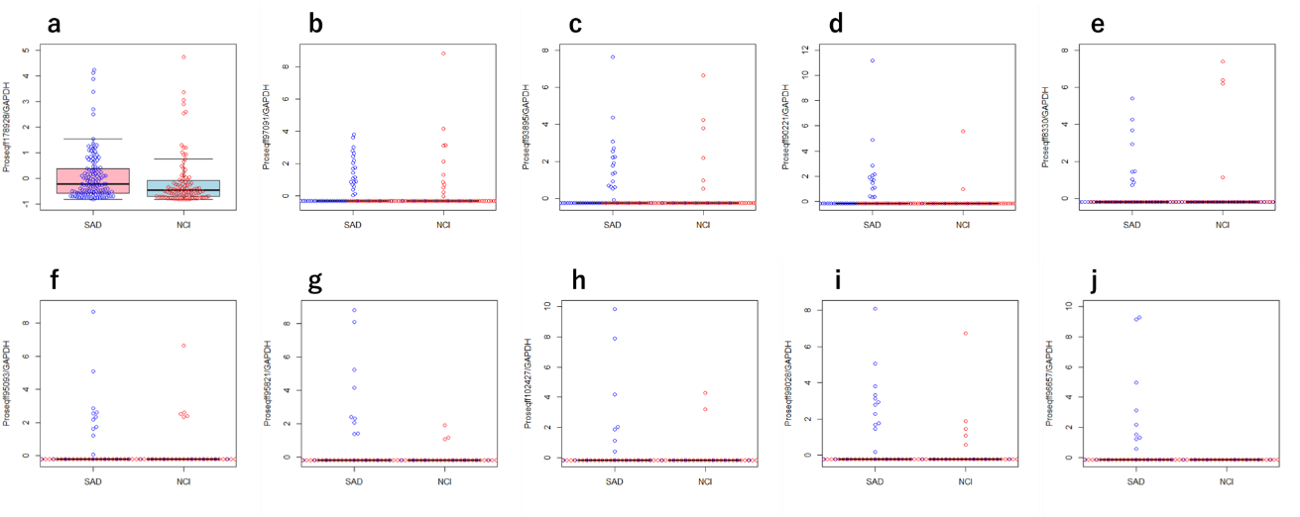
Supplementary Figure 1. Read count distribution by the probe. Read counts for the top ten probes in positive cases were plotted after dividing by GAPDH read count and Z-score normalization. a. proseqff178928, b. proseqff97091, c. Proseqff93895, d. Proseqff90221, e. Proseqff8330, f. Proseqff95093, g. Proseqff95821, h. Proseqff102427. i. Proseqff98028, j. Proseqff96657.

