Supplementary Figure 1- Blots for gel images
- RBDs
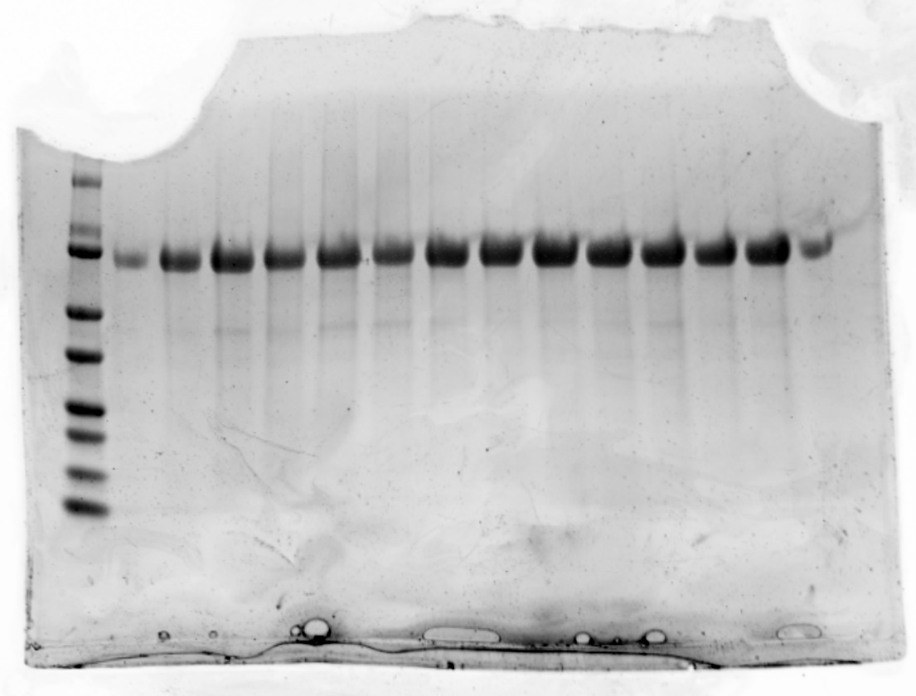
75 kda
From left:
Lane 1: Protein ladder
Lane 2: -
Lane 3: Wuhan-Hu-1 MBP RBD
Lane 4: Alpha RBD
Lane 5: Beta RBD
Lane 6: Gamma RBD
Lane 7: Delta RBD
Lane 8: Epsilon RBD
Lane 9: Kappa RBD
Lane 10: Omicron BA.1 RBD
Lane 11: Omicron BA.2 RBD
Lane 12: Omicron BA.4/5 RBD
Lane 13: XBB RBD
Lane 14: XBB 1.5 RBD
Lane 15: -
ii) ACE2-Fc
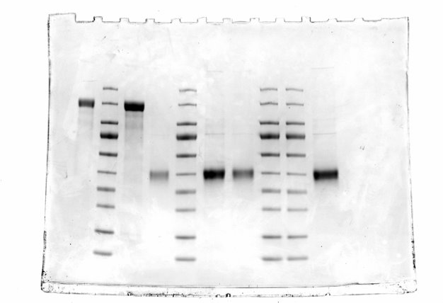

iii) Hexapro spike

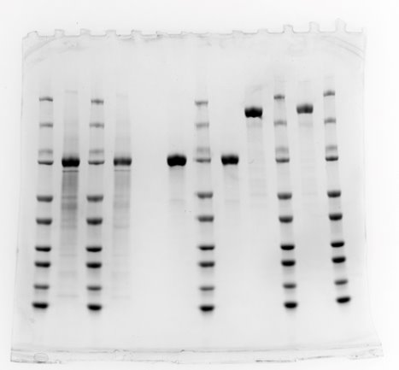

iv) Nucleocapsid
