Table S 1: Characteristics and quantities of elements in BiOI-MOF
Name | Peak BE | FWHM eV | Area (P) CPS.eV | Weight %
I3d | 619.29 | 2.55 | 690831.13 | 12.51
Bi4f | 159.35 | 1.70 | 1772170.25 | 42.31
O1s | 531.02 | 3.44 | 393125.12 | 12.28
C1s | 285.07 | 3.11 | 169423.64 | 9.61
Ti2p | 466.05 | 5.25 | 563521.87 | 22.31
N1s | 399.61 | 1.19 | 22816.83 | 0.97

Table S2: Runs of O₃-HPCP into tocilizumab removal
 | Factor 1 | Factor 2 | Factor 3 | Factor 4 | Factor 5 | Response 1
Run | A:pH | B:Dose of MOFs | C:O3 Concentration | D:Temziva Concentration | E:Reaction Time | R1
 | - | mg/l | mg/l-min | mg/l | min
1 | 4 | 0/25 | 40 | 20 | 60 | 55
2 | 8 | 0/25 | 40 | 10 | 30 | 45
3 | 2 | 0/375 | 30 | 15 | 45 | 42/5
4 | 6 | 0/375 | 30 | 15 | 45 | 75
5 | 8 | 0/5 | 40 | 10 | 60 | 81/6
6 | 4 | 0/5 | 20 | 10 | 30 | 49/9
7 | 4 | 0/25 | 20 | 20 | 60 | 40
8 | 4 | 0/5 | 20 | 20 | 60 | 56/7
9 | 6 | 0/375 | 30 | 5 | 45 | 90/8
10 | 8 | 0/25 | 40 | 20 | 60 | 54/6
11 | 4 | 0/25 | 20 | 20 | 30 | 20
12 | 6 | 0/375 | 30 | 15 | 75 | 85/9
13 | 6 | 0/375 | 30 | 15 | 15 | 42/4
14 | 8 | 0/25 | 40 | 20 | 30 | 33/6
15 | 4 | 0/5 | 40 | 20 | 30 | 52/5
16 | 8 | 0/5 | 40 | 20 | 30 | 45/3
17 | 6 | 0/375 | 30 | 15 | 45 | 75
18 | 6 | 0/375 | 30 | 25 | 45 | 56/5
19 | 6 | 0/375 | 30 | 15 | 45 | 75
20 | 4 | 0/5 | 20 | 20 | 30 | 35
21 | 6 | 0/375 | 30 | 15 | 45 | 75
22 | 8 | 0/25 | 20 | 20 | 60 | 40/4
23 | 6 | 0/375 | 10 | 15 | 45 | 45/5
24 | 4 | 0/5 | 40 | 10 | 30 | 60
25 | 8 | 0/5 | 20 | 20 | 30 | 30/1
26 | 8 | 0/25 | 20 | 20 | 30 | 19/4
27 | 6 | 0/375 | 30 | 15 | 45 | 75
28 | 8 | 0/25 | 20 | 10 | 60 | 65
29 | 8 | 0/5 | 20 | 20 | 60 | 50
30 | 8 | 0/5 | 20 | 10 | 60 | 70/3
31 | 6 | 0/375 | 30 | 15 | 45 | 77/9
32 | 6 | 0/125 | 30 | 15 | 45 | 42/3
33 | 4 | 0/5 | 40 | 20 | 60 | 75
34 | 4 | 0/5 | 20 | 10 | 60 | 75
35 | 8 | 0/5 | 40 | 20 | 60 | 70
36 | 4 | 0/25 | 40 | 10 | 30 | 50
37 | 6 | 0/375 | 30 | 15 | 45 | 75
38 | 4 | 0/5 | 40 | 10 | 60 | 85
39 | 8 | 0/5 | 40 | 10 | 30 | 60
40 | 4 | 0/25 | 20 | 10 | 60 | 59/8
41 | 8 | 0/25 | 20 | 10 | 30 | 38/3
42 | 6 | 0/375 | 50 | 15 | 45 | 72/5
43 | 8 | 0/5 | 20 | 10 | 30 | 45
44 | 4 | 0/25 | 40 | 20 | 30 | 35
45 | 10 | 0/375 | 30 | 15 | 45 | 36/1
46 | 6 | 0/625 | 30 | 15 | 45 | 66/1
47 | 6 | 0/375 | 30 | 15 | 45 | 75
48 | 4 | 0/25 | 40 | 10 | 60 | 70
49 | 4 | 0/25 | 20 | 10 | 30 | 38/8
50 | 8 | 0/25 | 40 | 10 | 60 | 70

Table S3: An overview of the model's functionality
Source | Sequential p-value | Lack of Fit p-value | Adjusted R² | Predicted R²
Linear | < 0.0001 | < 0.0001 | 0/6551 | 0/6370
2FI | 0/9991 | < 0.0001 | 0/5701 | 0/5525
Quadratic | < 0.0001 | 0/1047 | 0/9930 | 0/9859 | Suggested
Cubic | 0/5741 | 0/0585 | 0/9926 | 0/8950 | Aliased

Table S 4: ANOVA for a quadratic model in tocilizumab in O₃-HPCP

Source | Sum of Squares | df | Mean Square | F-value | p-value
Model | 15828/15 | 20 | 791/41 | 347/93 | < 0.0001 | significant
A-pH | 67/34 | 1 | 67/34 | 29/60 | < 0.0001
B-Dose of MOFs | 1614/17 | 1 | 1614/17 | 709/64 | < 0.0001
C-O3 Concentration | 1727/91 | 1 | 1727/91 | 759/64 | < 0.0001
D-Temziva Concentration | 2555/20 | 1 | 2555/20 | 1123/34 | < 0.0001
E-Reaction Time | 5006/41 | 1 | 5006/41 | 2200/96 | < 0.0001
AB | 37/20 | 1 | 37/20 | 16/35 | 0/0004
AC | 1/02 | 1 | 1/02 | 0/4464 | 0/5094
AD | 4/88 | 1 | 4/88 | 2/15 | 0/1536
AE | 3/06 | 1 | 3/06 | 1/35 | 0/2554
BC | 20/96 | 1 | 20/96 | 9/22 | 0/0050
BD | 22/28 | 1 | 22/28 | 9/79 | 0/0040
BE | 3/85 | 1 | 3/85 | 1/69 | 0/2035
CD | 77/81 | 1 | 77/81 | 34/21 | < 0.0001
CE | 0/0253 | 1 | 0/0253 | 0/0111 | 0/9167
DE | 11/16 | 1 | 11/16 | 4/91 | 0/0348
A² | 2759/13 | 1 | 2759/13 | 1212/99 | < 0.0001
B² | 989/46 | 1 | 989/46 | 434/99 | < 0.0001
C² | 608/48 | 1 | 608/48 | 267/51 | < 0.0001
D² | 15/60 | 1 | 15/60 | 6/86 | 0/0139
E² | 302/21 | 1 | 302/21 | 132/86 | < 0.0001
Residual | 65/96 | 29 | 2/27
Lack of Fit | 58/61 | 22 | 2/66 | 2/53 | 0/1047 | not significant
Pure Error | 7/36 | 7 | 1/05
Cor Total | 15894/12 | 49

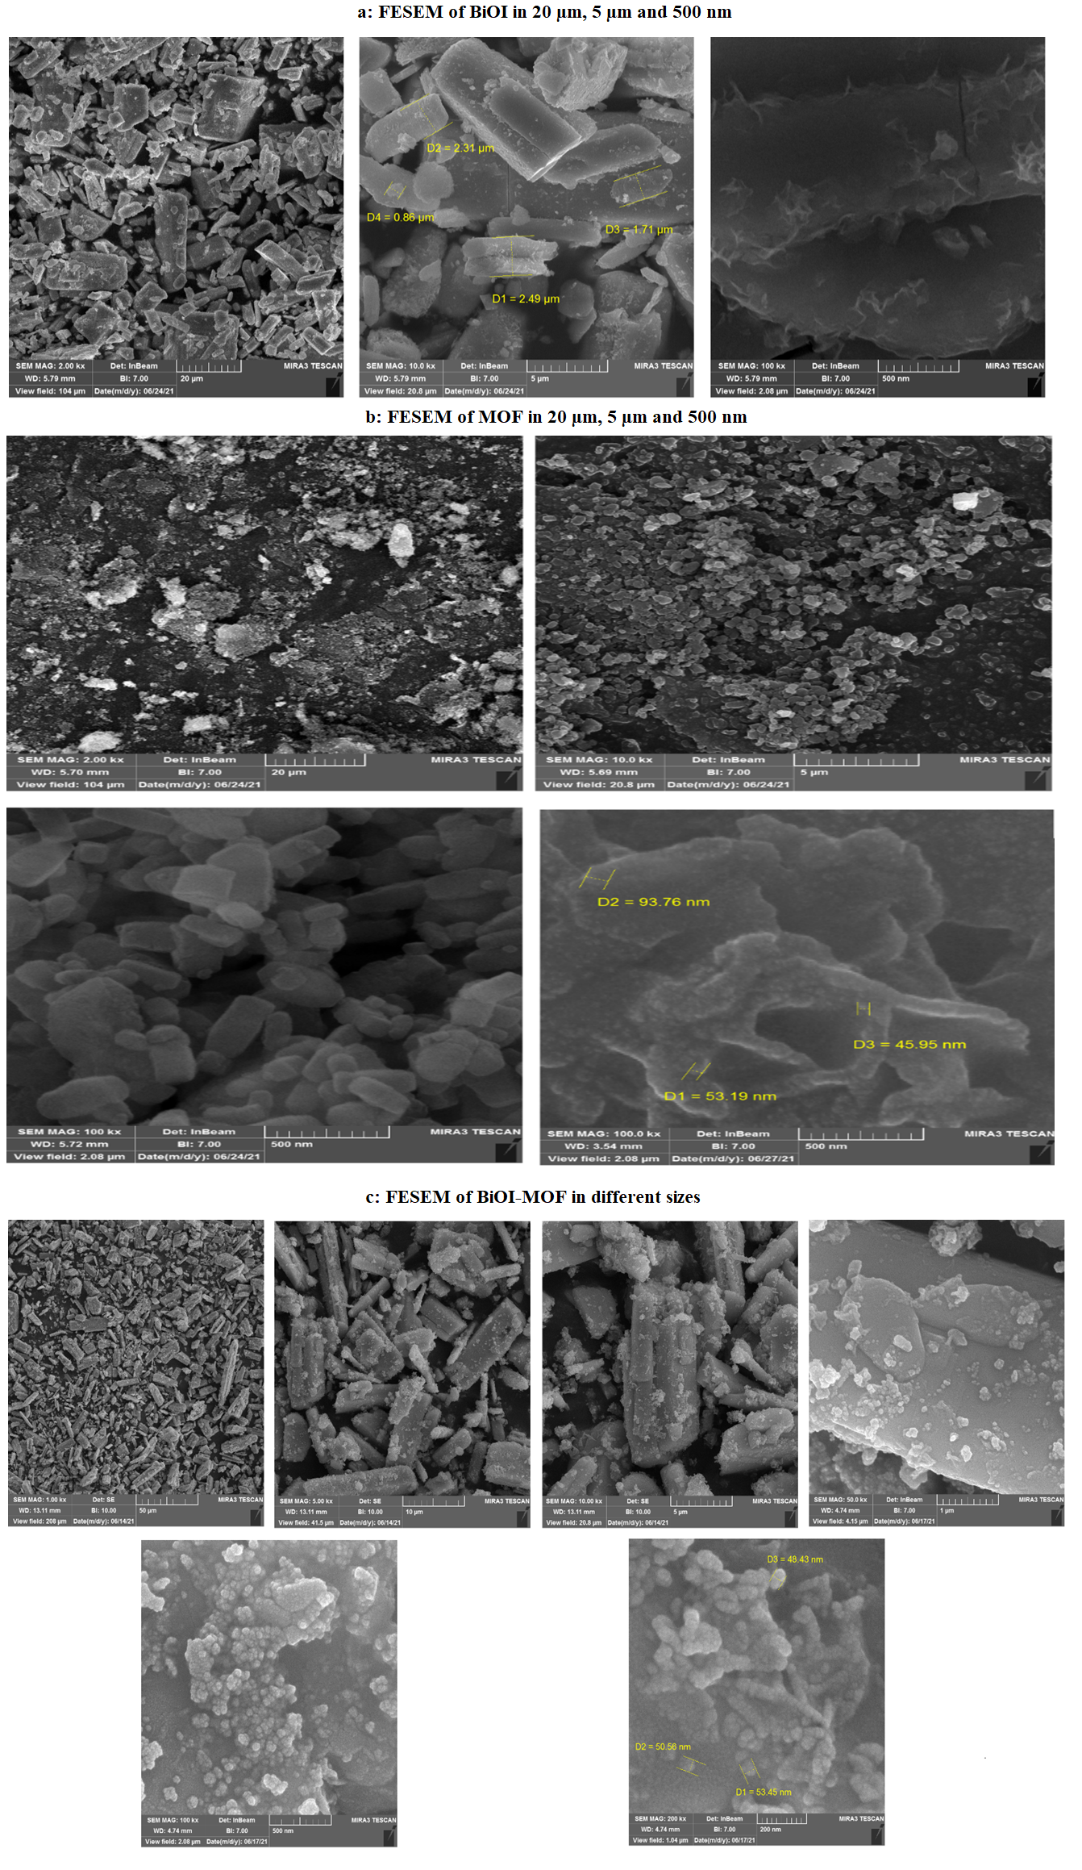
Fig. S1: FESEM morphology analysis. a) BiOI, b) MOF, c) BiOI@MOF

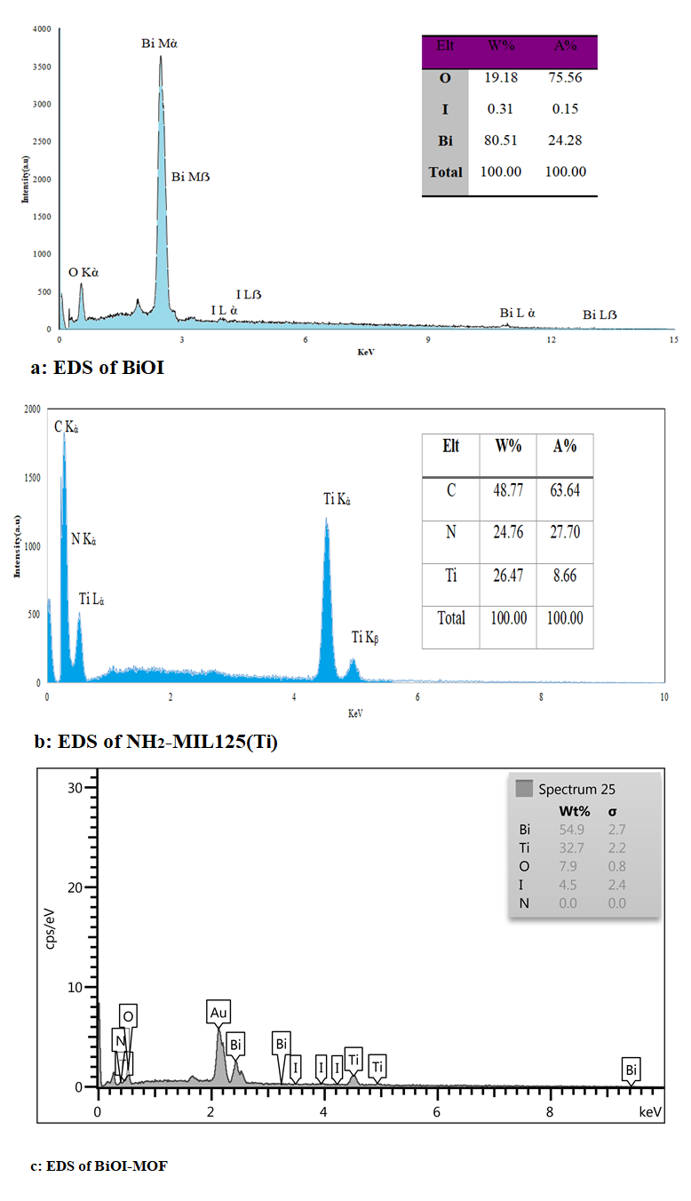
Fig. S2: EDS analysis of a) BiOI, b) NH₂-MIL125(Ti), c) BiOI-MOF
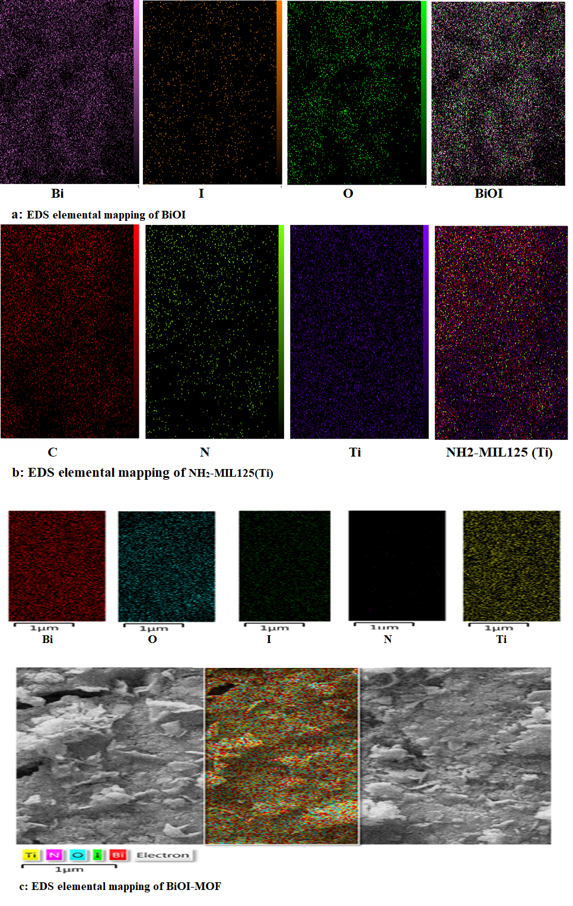
Fig. S3: EDS elemental mapping analysis of a) BiOI, b) NH₂-MIL125(Ti), c) BiOI-MOF

