Supplementary information

Progression of retinitis pigmentosa on static perimetry, optical coherence tomography, and fundus autofluorescence
Yuhei Iga, Tomoko Hasegawa, Hanako Ohashi Ikeda, Yoshimichi Hirota, Manabu Miyata, Shogo Numa, Yuki Otsuka, Akitaka Tsujikawa

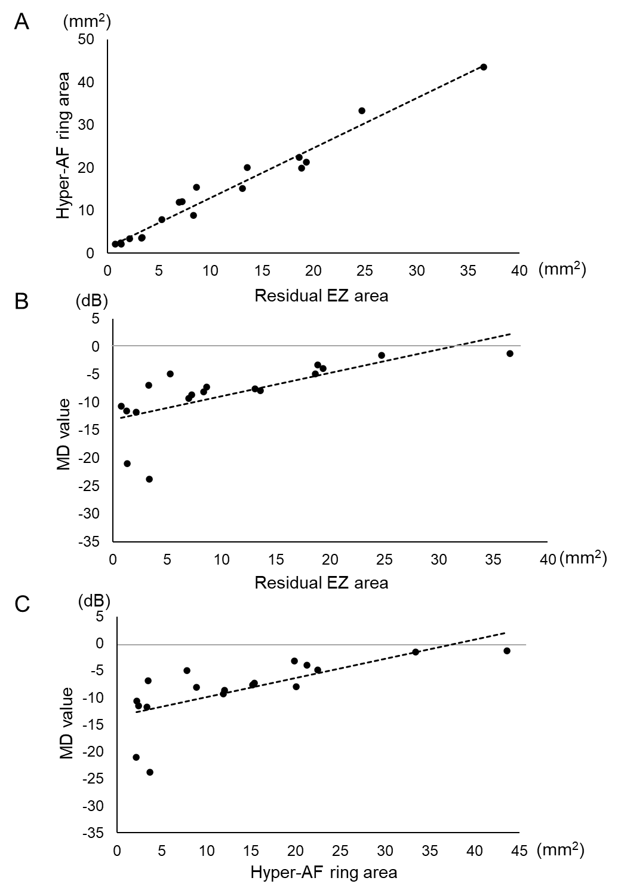
Supplementary Figure S1. Correlations between different baseline measurements in eyes with causative EYS gene. (A) Residual ellipsoid zone (EZ) area and the hyper-autofluorescent ring (hyper-AF ring) area exhibit a positive correlation (P < 0.0001, r = 0.98, Pearson's linear approximation). (B) Residual EZ area displays a positive correlation with mean deviation (MD) value (P = 0.0015, r = 0.69). (C) Hyper-AF ring area shows a positive correlation with MD value (P = 0.0013, r = 0.70). The dotted lines represent the approximate straight line using linear regression analysis with the least-squares method.
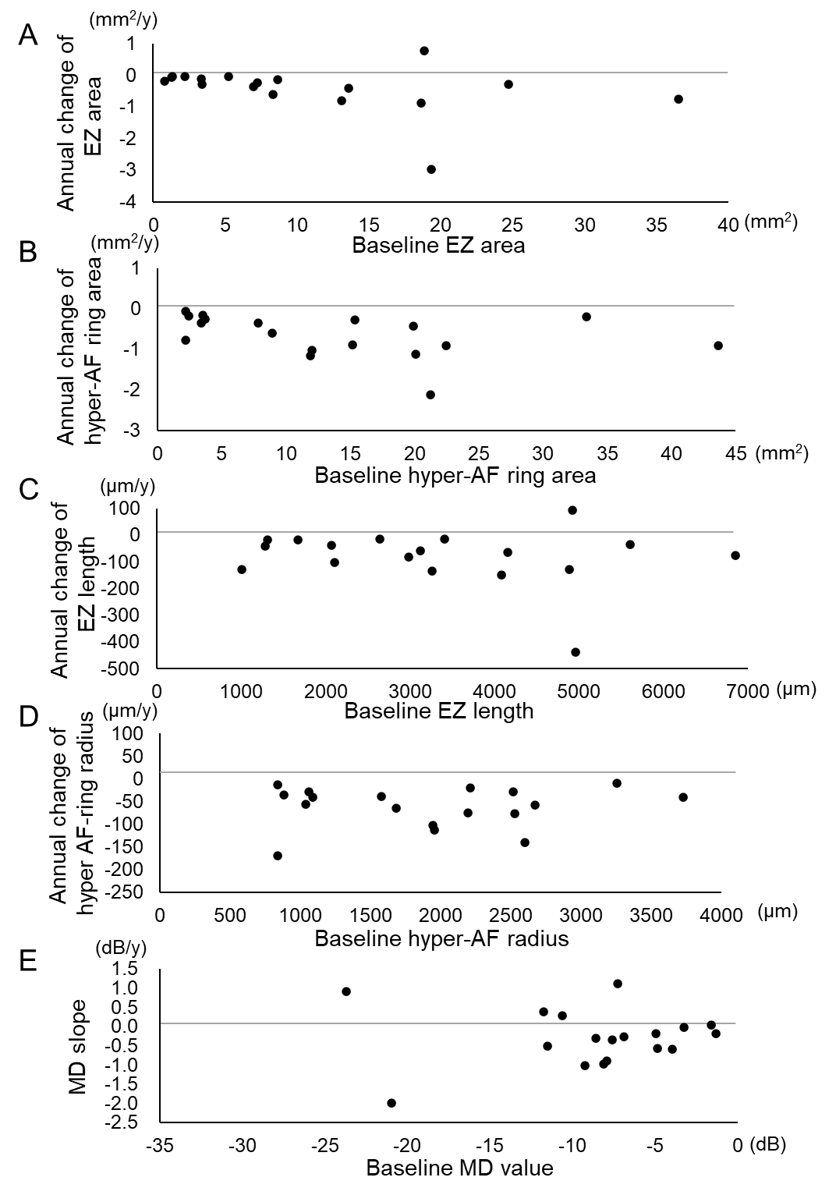
Supplementary Figure S2. Correlations between the annual change rate and baseline measurements in eyes with causative EYS gene. (A) A larger baseline residual ellipsoid zone (EZ) area showed a tendency to be correlated with a faster annual reduction of the residual EZ area (P = 0.16, r = -0.35, Pearson’s linear approximation). (B) Larger baseline hyper-autofluorescent ring (hyper-AF ring) area exhibited a tendency to be correlated with a faster annual reduction (P = 0.14, r = -0.36). (C) The baseline residual EZ length does not display a significant correlation with the annual reduction rate of EZ length (P = 0.46, r = -0.19). (D) The baseline hyper-AF ring radius does not exhibit a significant correlation with the annual reduction rate of the hyper-AF ring radius (P = 0.77, r = -0.07). (E) No significant correlation between the baseline MD and MD slope (P = 0.83, r = -0.06).
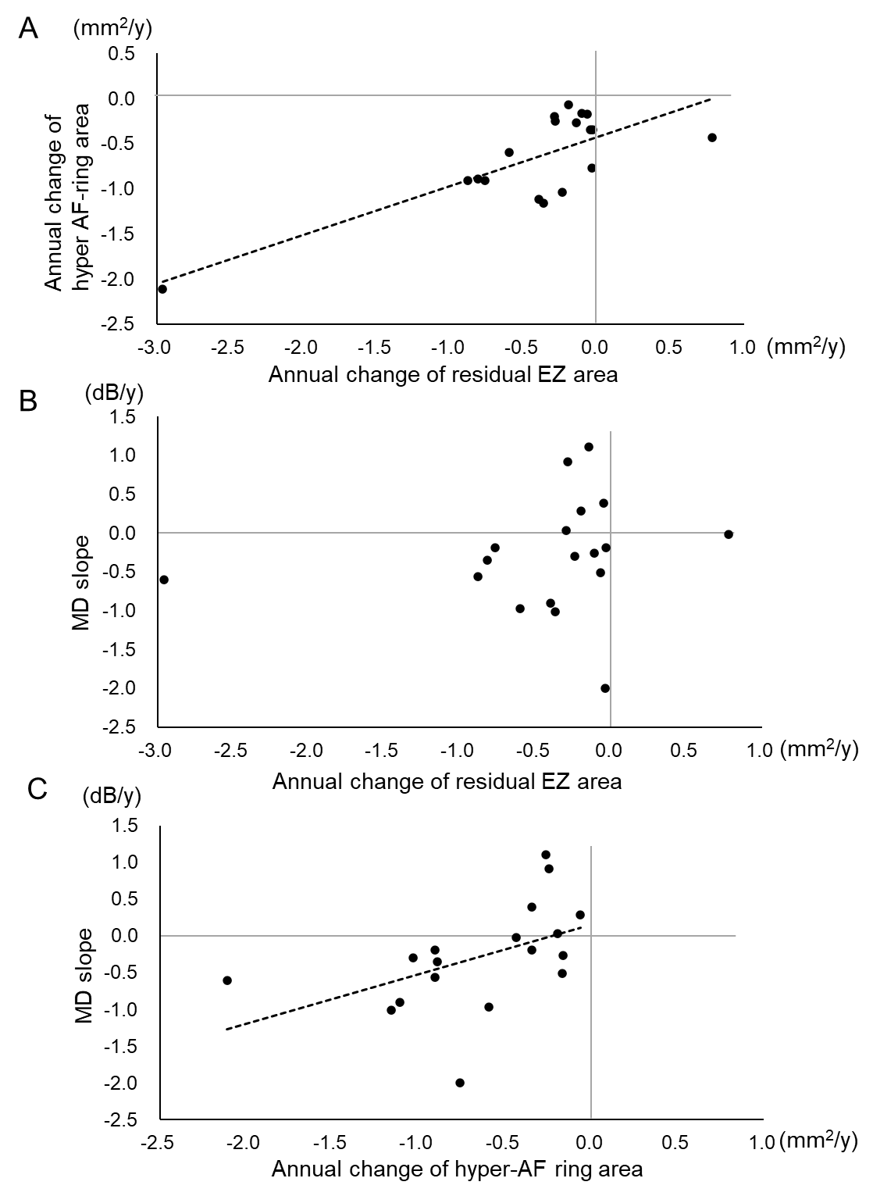
Supplementary Figure S3. Correlations between annual change rates evaluated by different parameters in eyes with the causative EYS gene. (A) The annual decrease rates of the residual EZ and hyper-AF areas are positively correlated (P = 0.0002, r = 0.78). (B) The annual change rate of the residual EZ area does not display a significant correlation with the MD slope (P = 0.49, r = 0.03). (C) Faster annual reduction rates of the hyper-AF ring area are significantly correlated with a steeper MD slope (P = 0.045, r = 0.48). The dotted lines in (A) and (C) denote the approximate straight line using linear regression analysis with the least-squares method.

