Supplemental Information for: Production and purification of ⁴³Sc and ⁴⁷Sc from enriched [⁴⁶Ti]TiO₂ and [⁵⁰Ti]TiO₂ targets
Shelbie J. Cingoranelli^{a,b}, Jennifer L. Bartels^{b}, Pavithra H. A. Kankanamalage^{c}, C. Shaun Loveless^{b}, David A. Rotsch^{c,d} Suzanne E. Lapi^{a,b*}
ªDepartment of Chemistry, University of Alabama at Birmingham
^{b}Department of Radiology, University of Alabama at Birmingham
^{c}Physics Division, Argonne National Laboratory
^{d}Radioisotope Science and Technology Division, Oak Ridge National Laboratory
* Corresponding author; E-mail: lapi@uab.edu. Telephone (205) 975-8689. Address 1924 6th Ave. S., WTI 310F, Birmingham, AL 35244.

Table of Contents
  - Relevant characteristics of ⁶⁸Ga, ¹⁷⁷Lu and ^{43,44g,47}Sc
  - Radionuclides produced from proton bombardment of ^{nat}Ti targets
  - Isotopic purity of enriched materials
  - Certificate of Analysis of enriched materials
  - Cross section measurements of ⁴⁶Ti(p,α)⁴³Sc and ⁵⁰Ti(p,α)⁴⁷Sc
  - Cross sections of proton induced reactions on ^{nat}Ti
  - Schematic of the radioscandium purification method
  - Inductively Coupled Plasma-Mass Spectrometry
  - Radiolabeling conditions and iTLC
  - Phantom dimension
  - Average radioactivity per elution of purification
  - Enriched ⁴⁶Ti and ⁵⁰Ti recovery
  - The apparent molar activity curves for [⁴³Sc]Sc-DOTA and [⁴⁷Sc]Sc-DOTA

  - Relevant characteristics of ⁶⁸Ga, ¹⁷⁷Lu and ^{43,44g,47}Sc
Table S1: Characteristics of the radioisotopes of Ga, Lu and Sc.^{1,2}
Radioisotope | Half-life | [β+/-] mean energy (keV) | Additional γ (branching ratio %)
⁶⁸Ga | 68 min | 829.5 (88.9%): [β ⁺] | 1077.3 (3.22)
⁴³Sc | 3.9 h | 476.0 (88.1%): [β ⁺] | 372.9 (22.5)
^{44g}Sc | 3.9 h | 632.0 (94.3%): [β ⁺] | 1157.0 (99.9)
¹⁷⁷Lu | 6.6 d | 133.6 (100.0%): [β ⁻] | 112.9 (6.23) & 208.4 (10.4)
⁴⁷Sc | 3.3 d | 162.0 (100.0%): [β ⁻] | 159.3 (68.3)

  - Radionuclides produced from proton bombardment of ^{nat}Ti targets
Table S2: Products from proton irradiation of ^{nat}Ti.¹⁻³
Isotope | Nuclear reaction | Half-life | Decay mode | Key gamma rays
⁴³Sc | ⁴⁶Ti(p,α)⁴³Sc | 3.9 h | β⁺ | 372 (22.5%)
^{44g}Sc | ⁴⁷Ti(p,α)^{44g}Sc | 3.9 h | β⁺ | 1157 (99.9%)
^{44m}Sc | ⁴⁷Ti(p,α)^{44m}Sc | 58.6 h | IT : 98.8%  ε: 1.2% | 271 (86.74%)
⁴⁶Sc | ⁴⁷Ti(p,2p)⁴⁶Sc  ⁴⁹Ti(p,α)⁴⁶Sc  ⁵⁰Ti(p,n+α)⁴⁶Sc | 83.7 d | β⁻ | 889 (99.98%)  1120(99.98%)
⁴⁷Sc | ⁴⁸Ti(p,2p)⁴⁷Sc  ⁵⁰Ti(p,α)⁴⁷Sc | 3.9 d | β⁻ | 159 (68.3%)
⁴⁸Sc | ⁴⁹Ti(p,2p)⁴⁸Sc | 48.6 h | β⁺ | 175 (7.48%)
 |  |  |  | 983 (100%)
 |  |  |  | 1037 (97.6%)
 |  |  |  | 1212 (2.38%)
 |  |  |  | 1312 (100%)
⁴⁸V | ⁴⁸Ti(p,n)⁴⁸V  ⁴⁹Ti(p,2n)⁴⁸V | 15.9 d | β⁺ | 944 (7.87%)  983 (98.98%)
 |  |  |  | - (98.2%)

c. Isotopic purity of enriched materials
Table S3: The isotopic enrichment of [⁴⁶Ti]TiO₂ and [⁵⁰Ti]TiO₂. All materials were provided by the National Isotope Development Center, USA.

Enrichment of ^{x}TiO₂
^{X}Ti Isotope | Isotopic Abundance in [⁴⁶Ti]TiO₂ | Isotopic Abundance in [⁵⁰Ti]TiO₂
46 | 96.84 | 1.69
47 | 0.5 | 1.29
48 | 2.33 | 12.51
49 | 0.16 | 1.41
50 | 0.16 | 83.1

- Isotopic purity of enriched materials
Table S4: The Certificates of Analysis (CoA) of [⁴⁶Ti]TiO₂ and [⁵⁰Ti]TiO₂, measured in ppm. Both the materials and the CoA were provided by the National Isotope Development Center, USA.

Element: ppm | ⁴⁶Ti | ⁵⁰Ti | Element: ppm | ⁴⁶Ti | ⁵⁰Ti | Element: ppm | ⁴⁶Ti | ⁵⁰Ti
Ag | <50 | <50 | Mg | <100T | <100T | Lanthanides and Actinides
Al | <100T | <200T | Mn | <100 | <100 | Ce | <1000 | <1000
Au | <500 | <500 | Mo | <100 | <100 | Dy | <1000 | <1000
B | <100T | <100T | Na | <=100 | 1000 | Er | <50 | <50
Ba | <100 | <100 | Nb | <500 | <500 | Eu | <50 | <50
Be | <10 | <10 | Ni | <100 | <200 | Gd | <200 | <200
Bi | <200 | <200 | Pb | <200 | <200 | Ho | <500 | <500
Ca | <100 | 100 | Pt | <500 | <500 | La | <200 | <200
Cd | <500 | <500 | Rb | <200 | <20 | Lu | <50 | <50
Co | <100 | <200 | Sb | <500 | <500 | Nd | <500 | <500
Cr | <100 | <200 | Si | 300 | <=100 | Pr | <500 | <500
Cs | <500 | <500 | Sn | <100 | <200 | Sm | <500 | <500
Cu | 200 | 200 | Sr | <100 | <100 | Tb | <500 | <500
Fe | <100 | 500 | Ta | <500 | <500 | Y | <50 | <50
Ga | <200 | <200 | Te |  | <500 | Yb | <20 | <20
Ge | <200 | <200 | Ti | M | M | Tm | <500 | <500
Hf | <500 |  | V | <100 | <200
Hg | <500 | <500 | W | <500 | 1000
In | <500 |  | Zn | <2000 | <500
K | <100 | <100 | Zr | <200T | <200
Li | BUFFER* | <50
*Was added during analysis. No values were obtained.
Where: M is major; T is trace; <= less than/equal; < is less than, nd is not detected; and elements listed without values were not detected or less than 10 ppm.

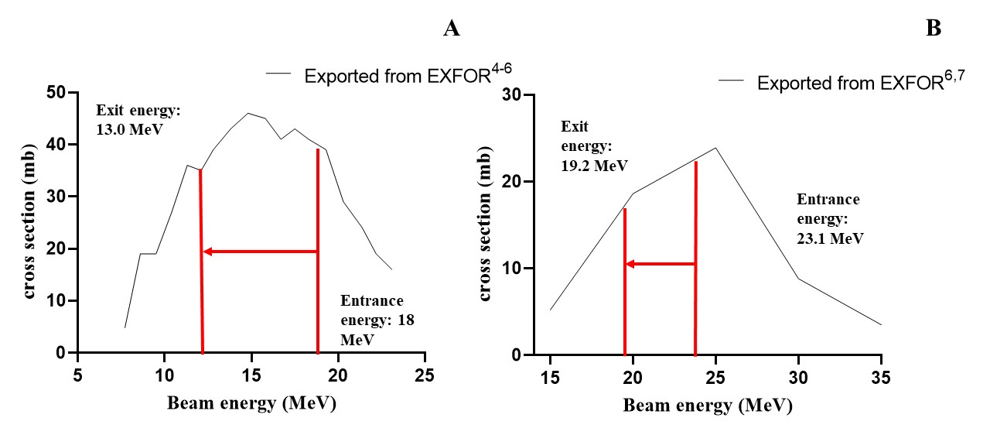
e. Cross section measurements of ⁴⁶Ti(p,α)⁴³Sc and ⁵⁰Ti(p,α)⁴⁷Sc
Figure S1: Excitation function for ⁴⁶Ti(p,α)⁴³Sc with the red lines indicating the relevant energy range during bombardment at 18 MeV (A).⁴⁻⁶. Excitation function for ⁵⁰Ti(p,α)⁴⁷Sc with the red lines indicating the relevant energy range during bombardment at 24 MeV(B).^{6,7}

f. Cross sections of nuclear reactions from proton irradiation on ^{nat}Ti.
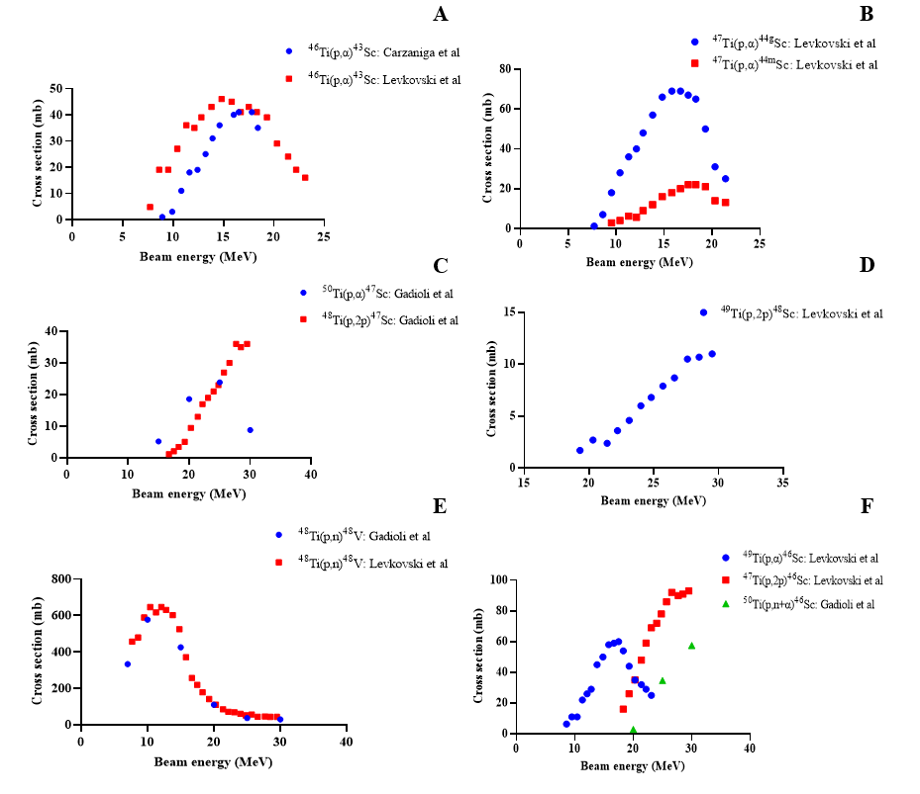
Figure S2: Representative cross sections of nuclear reactions occurring during 0-30 MeV proton irradiations on ^{nat}Ti targetes.^{4,5,7} Cross sections were imported from EXFOR and used to calculate the theoretical yields during irradiations as well as determine the optimal bombardment parameters. (A) ⁴³Sc production via ⁴⁶Ti(p,α) ⁴³Sc. (B) ^{44g/m}Sc production via ⁴⁷Ti(p,α)^{44g/m}Sc. (C) The production of ⁴⁷Sc via ⁴⁸Ti(p,2p)⁴⁷Sc and ⁵⁰Ti(p,α)⁴⁷Sc. (D) ⁴⁸Sc production via ⁴⁹Ti(p,2p)⁴⁸Sc. (E) ⁴⁸V production via ⁴⁸Ti(p,n)⁴⁸V. (F) Production of ⁴⁶Sc from ⁴⁹Ti(p,α)⁴⁶Sc, ⁴⁷Ti(p,2p)⁴⁶Sc and ⁵⁰Ti(p,n+α)⁴⁶Sc.

g. Schematic of the radioscandium purification method
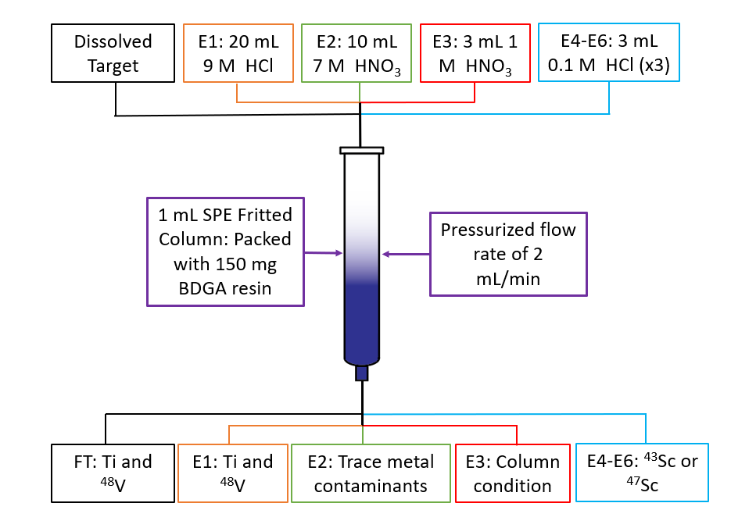
Figure S3: Optimized radioscandium purification method. Flow Through (FT) is the dissolved target solution. E1-E3 are three different washes for the removal of impurities as well as column conditioning. E4-E6 are the radioscandium elution fractions.

- Inductively Coupled Plasma – Mass Spectrometry (ICP-MS)
Table S5: The list of monitored elements for each target material used and separation performed.
Transition metals |  | Lanthanides and Actinides |  | Other
Sc | Fe | Ce | Dy | Al
Ti | Co | Pr | Ho | Ge
V | Ni | Nd | Er | Ga
Cr | Cu | Sm | Tm | Pb
Mn | Zn | Eu | Yb | Ca
Zr | W | Gd | Lu
Nb | Ta | Tb | U

- Radiolabeling conditions and iTLC
1,4,7,10-tetraazacyclododecana-1,4,7,10-tetraacetic acid (DOTA) was dissolved in 0.25 M ammonium acetate buffer, pH 4.5, to produce a 10 mg/mL concentration stock. This was further diluted in the same buffer to final volumes of 100 µL with DOTA concentrations provided in Table S6. Subsequently, either ⁴³Sc, 3.7 MBq (100 µCi) or ⁴⁷Sc, 2.3 MBq (62.5 µCi) was added to the vials, which were incubated at 95 ºC for 30 min. The resulting samples were spotted onto iTLC-SG paper (Agilent) and the paper was developed in 1 M citric acid. The iTLC strips were analyzed on an AR-2000 instrument using Winscan software (Eckert and Ziegler). In the analysis, the DOTA complex exhibited an RF of 0.65, while free ^{4x}Sc migrated with the solvent front, as illustrated in Figure S4. To determine the apparent molar activity, the EC50 value of the DOTA titration was used to calculate the µmol for total binding. The average activity used for each vial, adjusted for decay, was then divided by this value.
Table S6: The serial dilution of DOTA.
Vial | Volume buffer | Serial dilution volume | Final concentration of DOTA(nmol)
1 | 135 | 15 µL from 10 mg/mL stock | 247
2 | 100 | 50 µL from 1 | 82.4
3 | 100 | 50 µL from 2 | 27.5
4 | 100 | 50 µL from 2 | 9.16
5 | 100 | 50 µL from 4 | 3.05
6 | 100 | 50 µL from 5 | 1.02
7 | 100 | 50 µL from 6 | 0.34
8 | 100 | 50 µL from 7 | 0.11
9 | 100 | 50 µL from 8 | 0.04
10 | 100 | 50 µL from 9 | 0.01
Discard | 0 | 50 µL from 10 | 0.00

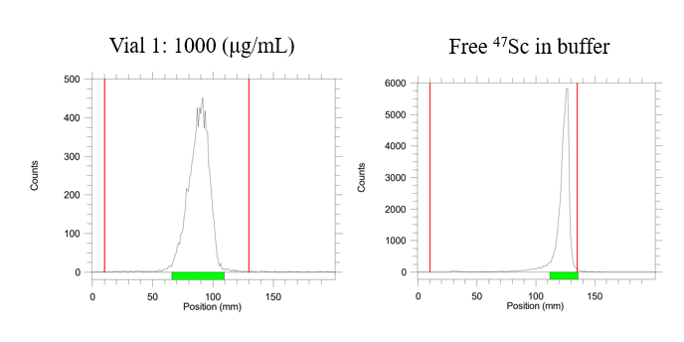
Figure S4: The radio-iTLC of [⁴⁷Sc]Sc-DOTA at 0.24 μmol DOTA concentration, R_{F} = 0.65 (A). The radio-iTLC of free [⁴⁷Sc]ScCl₃ in 0.1 M HCl, R_{F} = 1. (B) The red lines mark the origin at 10 mm and solvent front at 140 mm.

- PET phantom dimensions
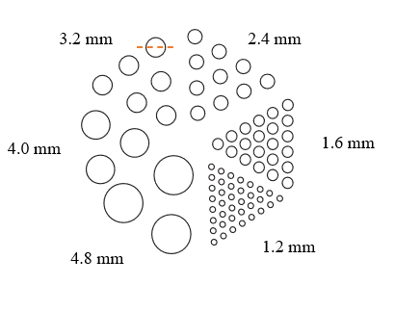
Figure S5: Schematic of the rod alignment and rod diameter of the phantom used for PET resolution comparison of three radionuclides: ¹⁸F, ⁴³Sc and ⁶⁸Ga. The dashed line represents intensity plot line that was drawn to gather the Full-width at half-maximum data.
A phantom composed of PMMA with rod diameters of 1.2, 1.6, 2.4, 3.2, 4.0 and 4.8 mm with a height of 3.4 cm, with the alignment represented in figure S5. The insert diameter was 4.4 cm, the cylinder outside diameter was 5 cm, the cylinder inside diameter was 4.5 cm, and the cylinder inside height was 6.3 cm.

- Average activity per elution of purification
Table S7: Average activity per elution for a 1.5 hour bombardment (n=3) on [⁴⁶Ti] and 4 hour bombardment (n=3) on [⁵⁰Ti], where DT stands for Dissolved Target and FT stands for Flow-through
Target | [⁴⁶Ti]TiO₂ |  |  |  | [⁵⁰Ti]TiO₂
Elutions | ⁴³Sc MBq (mCi) | SD | ⁴⁸V in MBq (μCi) | SD | ⁴⁷Sc MBq (mCi) | SD | ⁴⁸V in MBq (μCi) | SD
DT | 510 | 21.8  (0.59) | 2.51 | 0.29  (7.7) | 52.17 | 2.35  (0.06) | 8.29 | 4.29  (116)
DT | (13.8) | 21.8  (0.59) | (67.6) | 0.29  (7.7) | (1.42) | 2.35  (0.06) | (224) | 4.29  (116)
FT | 27.8 | 6.29  (0.17) | 0.93 | 0.09  (2.3) | 1.95 | 0.72  (0.02) | 5.76 | 3.48  (94.1)
FT | (0.75) | 6.29  (0.17) | (25) | 0.09  (2.3) | (0.05) | 0.72  (0.02) | (156) | 3.48  (94.1)
E1 | 4.07 | 2.59  (0.07) | 1.55 | 0.58  (15.7) | 0.18 | 0.14  (<0.01) | 1.69 | 0.132  (8.85)
E1 | (0.11) | 2.59  (0.07) | (41.9) | 0.58  (15.7) | (<0.01) | 0.14  (<0.01) | (45.5) | 0.132  (8.85)
E2 | 15.17 | 1.48  (0.4) | 1.18 | 0.22  (5.8) | 0.26 | 0.34  (0.01) | 2.04 | 0.24  (6.62)
E2 | (0.41) | 1.48  (0.4) | (32) | 0.22  (5.8) | (0.01) | 0.34  (0.01) | (55.1) | 0.24  (6.62)
E3 | 1.85 | 0.74  (0.02) | 0 | 0  0 | 0.08 | 0.02  (<0.01) | 0.04 | 0.34  (0.94)
E3 | (0.05) | 0.74  (0.02) | 0 | 0  0 | (<0.01) | 0.02  (<0.01) | (0.09) | 0.34  (0.94)
E4 | 473 | 4.44  (0.12) | 0 | 0  0 | 47.8 | 6.3  (0.11) | 0 | 0  0
E4 | (12.8) | 4.44  (0.12) | 0 | 0  0 | (1.27) | 6.3  (0.11) | 0 | 0  0
E5 | 3.7 | 2.96  (0.08) | 0 | 0  0 | 1.32 | 0.54  (0.01) | 0 | 0  0
E5 | (0.1) | 2.96  (0.08) | 0 | 0  0 | (0.04) | 0.54  (0.01) | 0 | 0  0
E6 | 4.81 | 0  0 | 0 | 0  0 | 0.19 | 0.08  (<0.01) | 0 | 0  0
E6 | (0.13) | 0  0 | 0 | 0  0 | (0.01) | 0.08  (<0.01) | 0 | 0  0

- Enriched ⁴⁶Ti and ⁵⁰Ti recovery
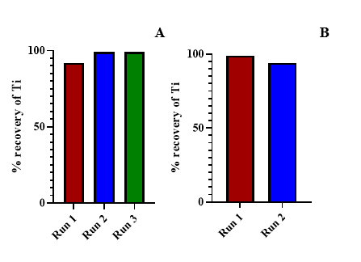
Figure S6: The percent recovery of the enriched [⁵⁰Ti]TiO₂ target for each run cycle, consisting of bombardment, processing, and recycling (A). The percent recovery for enriched [⁴⁶Ti]TiO₂ target for each run cycle, consisting of bombardment, processing, and recycling (B).

- The apparent molar activity curves for [⁴³Sc]Sc-DOTA and [⁴⁷Sc]Sc-DOTA
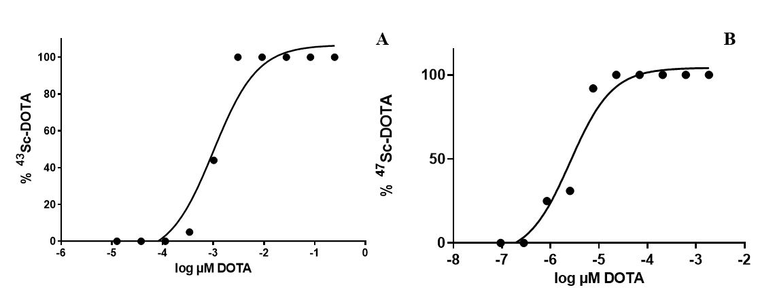
Figure S7: The apparent molar activity curve for the complexation of [⁴³Sc]Sc-DOTA, where the complexation is represented by % complex as a function of the concentration of DOTA (A). The apparent molar activity curve for the complexation of [⁴⁷Sc]Sc-DOTA, where the complexation is represented by % complex as a function of the concentration of DOTA (B).
Reference
1 NuDat 2.8. Brookhaven National Laboratory website. https://nndc.bnl.gov/nudat2/. Data extracted June 2, 2021. Accessed January 1, 2022
2 Chernysheva, M. et al. Accelerator Production of Scandium Radioisotopes: Sc-43, Sc-44, and Sc-47. Curr Radiopharm 14, 359-373, doi:10.2174/1874471014999210112205535 (2021).
3 Loveless, C. S. et al. Cyclotron Production and Separation of Scandium Radionuclides from Natural Titanium Metal and Titanium Dioxide Targets. Journal of Nuclear Medicine 62, 131-136, doi:10.2967/jnumed.120.242941 (2021).
4 Carzaniga, T. S. et al. Measurement of (43)Sc and (44)Sc production cross-section with an 18MeV medical PET cyclotron. Appl Radiat Isot 129, 96-102, doi:10.1016/j.apradiso.2017.08.013 (2017).
5 Levkovski, V. N. Cross sections of medium mass nuclide activation (A=40-100) by medium energy protons and alpha-particles (E=10-50 MeV). Atomnaya Energiya 69, 180 (1991).
6 Otuka, N. et al. Towards a More Complete and Accurate Experimental Nuclear Reaction Data Library (EXFOR): International Collaboration Between Nuclear Reaction Data Centres (NRDC). Nuclear Data Sheets 120, 272-276, doi:https://doi.org/10.1016/j.nds.2014.07.065 (2014).
7 Gadioli, E., Gadioli Erba, E., Hogan, J. J. & Burns, K. I. Emission of alpha particles in the interaction of 10–85 MeV protons with48,50Ti. Zeitschrift für Physik A Atoms and Nuclei 301, 289-300, doi:10.1007/BF01421692 (1981).

