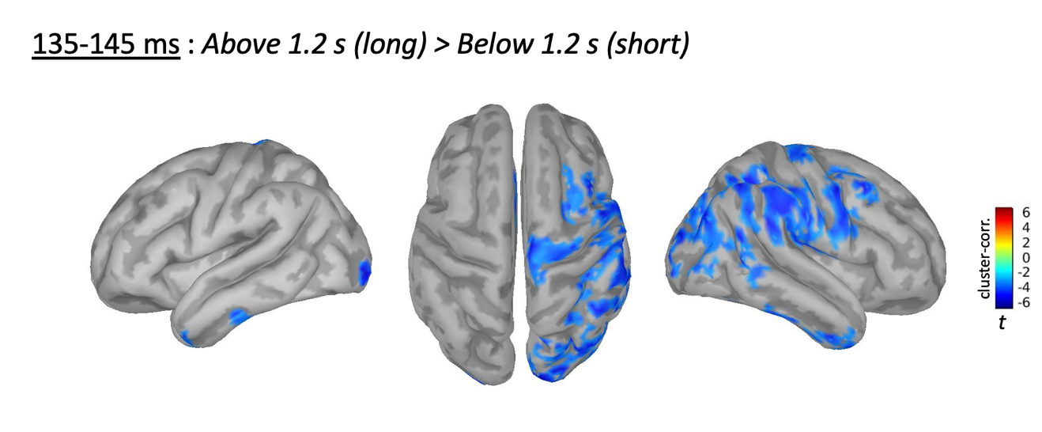

Supplementary Figure 1. Between-conditions contrast performed at the source level between below 1.2 s and above 1.2 s difference waves (delayed). p < .05 cluster-corrected, alpha = .005, k ≥ 30).

