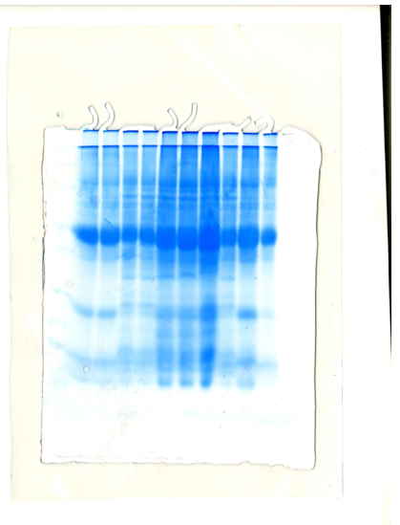
10
9
8
7
6
5
4
3
2
1
116.0
14.4
18.4
25.0
66.2
35.0
45.0
MW(KDa)
Supplementary Figure 1: Purified glycoprotein banding patterns (One dimensional gel electrophoresis) followed by ConA affinity chromatography on poly-acrylamide gel (10%) with Coomassie blue staining. Lanes 1-4 Mycobacterium tuberculosis glycoprotein patterns, Lanes 5-10 control samples (Mycobacterium tuberculosis strains H37Rv). Protein molecular weight markers are included: 116.0, 66.2, 45.0, 35.0, 25.0, 18.4, and 14.4 KDa.

