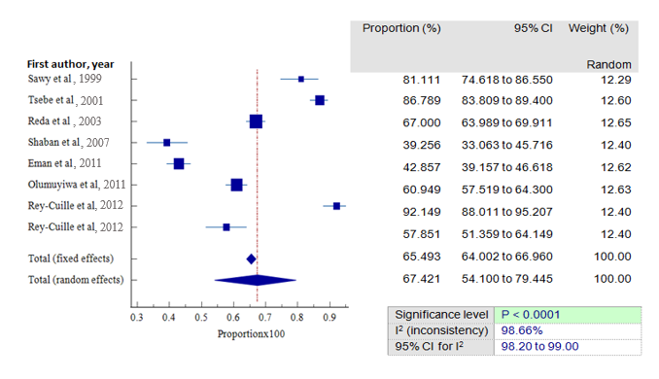
Fig. S15. Forest plot showing HBV vaccine sero-protection rate in scientific articles published from 1999 to 2012 and investigating children under 15 to years of age.

