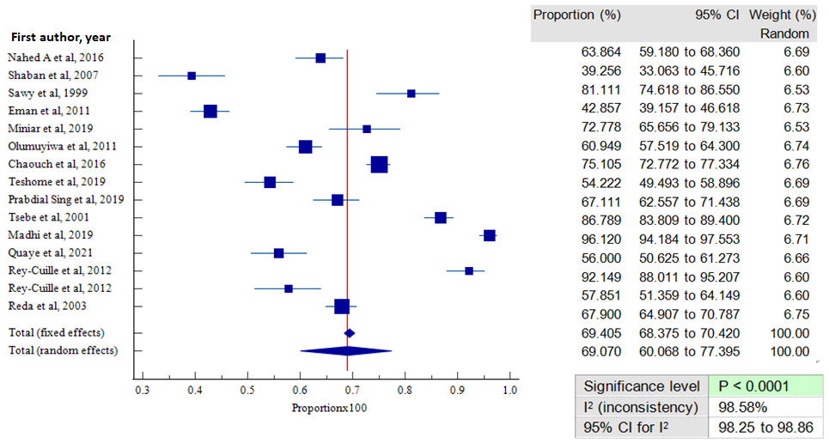

Fig. S1. Forest plot showing HBV vaccine sero-protection rate among children under 15 years of age

