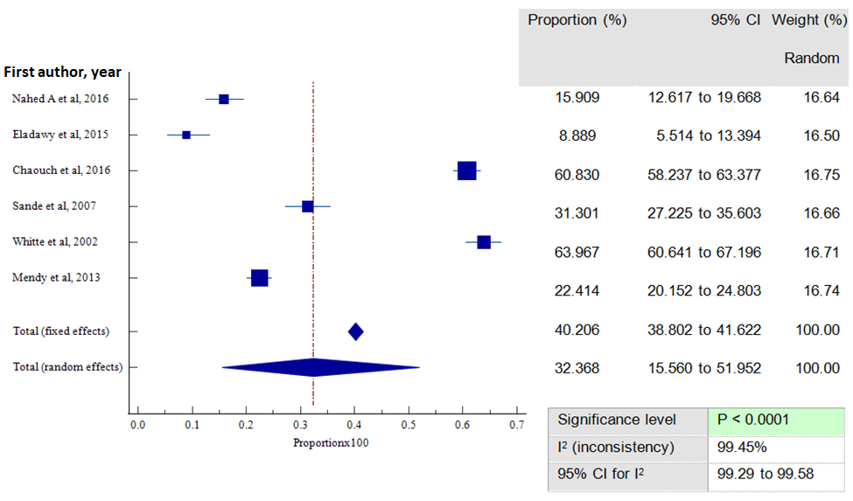

Fig. S3. Forest plot showing HBV vaccine sero-protection rate among children under 15 to 17 years of age

