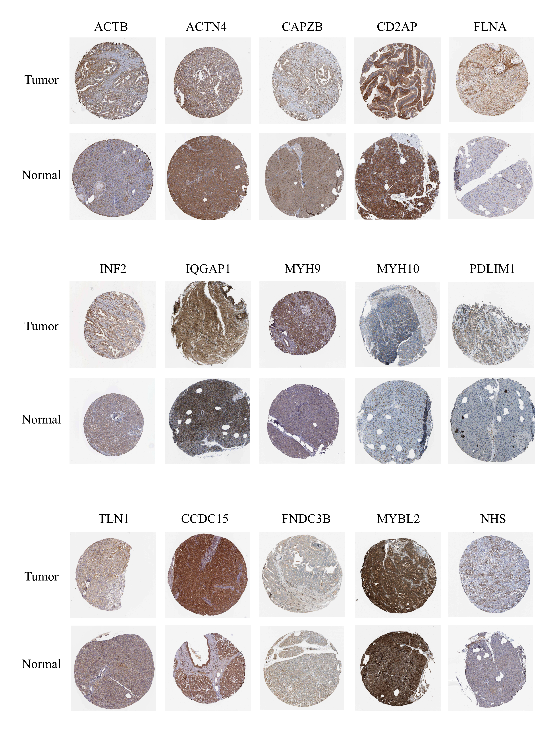
Supplementary Figure S2 Extraction of immunohistochemical profiles from the Human Protein Atlas website (SLC7A11 and UCA1 were not available from the website).

