Supplements
Table 1S: Primary and secondary antibodies used in immunofluorescence studies
Primary Antibody | Dilution in blocking serum | Manufactory
Dys2 | 1:50 | NCL-DYS2 mouse [RRID: AB_442081], Novocastra Laboratories, Newcastle on Tyne, UK
LC3 | 1:200 | LC3B rabbit [RRID: AB_2827794], ab192890, Abcam, Cambridge, UK
p62 | 1:1000 | p62 rabbit [RRID: AB_2810880], ab109012, Abcam, Cambridge, UK
LAMP1 | 1:200 | LAMP1 rabbit [RRID: AB_477157], L1418, Sigma, Saint Quentin-Fallavier, France
Secondary Antibody | Dilution in blocking serum | Manufactory
Alexa green 488 anti-rabbit | 1:1500 | Goat [RRID: AB_2313584], Jackson ImmunoResearch Laboratories, Pennsylvania, USA
Alexa red 594 anti-mouse | 1:1000 | Goat [RRID: AB_2338881], Jackson ImmunoResearch Laboratories, Pennsylvania, USA

Table S2: Mean ± SD values for qMRI results in each muscle with fat fraction (FatFr), water-T2 mapping (T2), fractional anisotropy (FA), mean diffusivity (MD), radial diffusivity (RD) and λ1 for each genotype (GT).
tp | Muscle | GT | FatFr | T2 | FA | MD | RD | λ1 | GT | FatFr | T2 | FA | MD | RD | λ1
t0 | Gastro  Soleus | Pompe | 3.34 ± 0.94 | 21.82 ± 1.19 | 0.23 ± 0.01 | 1.34 ± 0.04 | 1.17 ± 0.04 | 1.69 ± 0.05 | Wildtype | 3.33 ± 0.98 | 20.58 ± 0.48 | 0.22 ± 0.02 | 1.35 ± 0.02 | 1.18 ± 0.03 | 1.69 ± 0.03
t0 | Tibialis anterior | Pompe | 3.55 ± 1.21 | 20.67 ± 2.20 | 0.26 ± 0.01 | 1.24 ± 0.04 | 1.06 ± 0.03 | 1.62 ± 0.05 | Wildtype | 3.38 ± 0.71 | 19.09 ± 1.06 | 0.25 ± 0.01 | 1.25 ± 0.02 | 1.08 ± 0.02 | 1.61 ± 0.03
t0 | Hamstrings | Pompe | 3.47 ± 0.99 | 21.52 ± 3.49 | 0.22 ± 0.03 | 1.33 ± 0.03 | 1.16 ± 0.04 | 1.68 ± 0.06 | Wildtype | 3.02 ± 0.71 | 22.13 ± 1.83 | 0.20 ± 0.03 | 1.35 ± 0.03 | 1.20 ± 0.05 | 1.66 ± 0.03
t0 | Quadriceps | Pompe | 4.71 ± 1.89 | 21.60 ± 3.17 | 0.24 ± 0.01 | 1.31 ± 0.03 | 1.13 ± 0.04 | 1.67 ± 0.04 | Wildtype | 3.56 ± 0.42 | 21.99 ± 1.90 | 0.23 ± 0.01 | 1.35 ± 0.03 | 1.17 ± 0.02 | 1.70 ± 0.04
t1 | Gastro  Soleus | Pompe | 3.55 ± 1.09 | 22.21 ± 1.73 | 0.24 ± 0.02 | 1.31 ± 0.04 | 1.13 ± 0.05 | 1.65 ± 0.04 | Wildtype | 3.64 ± 1.34 | 20.75 ± 2.07 | 0.22 ± 0.01 | 1.40 ± 0.02 | 1.23 ± 0.02 | 1.74 ± 0.03
t1 | Tibialis anterior | Pompe | 3.14 ± 1.41 | 20.92 ± 1.51 | 0.26 ± 0.01 | 1.23 ± 0.03 | 1.05 ± 0.03 | 1.61 ± 0.03 | Wildtype | 3.08 ± 1.19 | 19.39 ± 1.55 | 0.24 ± 0.01 | 1.32 ± 0.02 | 1.14 ± 0.01 | 1.68 ± 0.03
t1 | Hamstrings | Pompe | 2.95 ± 0.58 | 22.88 ± 1.93 | 0.22 ± 0.02 | 1.27 ± 0.05 | 1.11 ± 0.04 | 1.58 ± 0.08 | Wildtype | 2.73 ± 0.57 | 22.67 ± 1.77 | 0.20 ± 0.02 | 1.39 ± 0.02 | 1.24 ± 0.03 | 1.70 ± 0.04
t1 | Quadriceps | Pompe | 4.04 ± 0.97 | 22.87 ± 2.21 | 0.25 ± 0.01 | 1.27 ± 0.05 | 1.09 ± 0.05 | 1.63 ± 0.06 | Wildtype | 3.25 ± 0.72 | 22.89 ± 1.48 | 0.21 ± 0.02 | 1.38 ± 0.01 | 1.21 ± 0.02 | 1.71 ± 0.03
t2 | Gastro  Soleus | Pompe | 4.08 ± 1.36 | 19.92 ± 1.60 | 0.25 ± 0.01 | 1.27 ± 0.02 | 1.09 ± 0.03 | 1.61 ± 0.03 | Wildtype | 3.24 ± 1.00 | 20.39 ± 0.68 | 0.22 ± 0.01 | 1.36 ± 0.02 | 1.19 ± 0.02 | 1.69 ± 0.03
t2 | Tibialis anterior | Pompe | 4.20 ± 2.24 | 18.09 ± 1.21 | 0.26 ± 0.01 | 1.19 ± 0.01 | 1.01 ± 0.01 | 1.55 ± 0.03 | Wildtype | 2.95 ± 1.15 | 18.88 ± 1.00 | 0.23 ± 0.01 | 1.29 ± 0.02 | 1.12 ± 0.01 | 1.64 ± 0.03
t2 | Hamstrings | Pompe | 3.25 ± 0.83 | 21.74 ± 1.75 | 0.24 ± 0.02 | 1.24 ± 0.04 | 1.07 ± 0.05 | 1.59 ± 0.05 | Wildtype | 2.74 ± 0.63 | 20.08 ± 2.96 | 0.20 ± 0.02 | 1.38 ± 0.02 | 1.22 ± 0.03 | 1.70 ± 0.04
t2 | Quadriceps | Pompe | 3.33 ± 0.20 | 22.35 ± 1.73 | 0.25 ± 0.02 | 1.25 ± 0.03 | 1.07 ± 0.03 | 1.60 ± 0.04 | Wildtype | 3.20 ± 0.27 | 20.41 ± 2.41 | 0.21 ± 0.01 | 1.36 ± 0.03 | 1.20 ± 0.02 | 1.68 ± 0.05
t3 | Gastro  Soleus | Pompe | 3.06 ± 1.13 | 20.77 ± 1.89 | 0.25 ± 0.01 | 1.26 ± 0.04 | 1.08 ± 0.04 | 1.61 ± 0.05 | Wildtype | 3.81 ± 1.40 | 20.01 ± 1.13 | 0.22 ± 0.01 | 1.34 ± 0.03 | 1.18 ± 0.03 | 1.67 ± 0.04
t3 | Tibialis anterior | Pompe | 2.53 ± 0.91 | 19.52 ± 1.37 | 0.27 ± 0.01 | 1.19 ± 0.04 | 1.00 ± 0.03 | 1.56 ± 0.07 | Wildtype | 3.41 ± 1.62 | 18.80 ± 1.16 | 0.23 ± 0.01 | 1.28 ± 0.02 | 1.11 ± 0.02 | 1.62 ± 0.03
t3 | Hamstrings | Pompe | 2.76 ± 0.84 | 22.49 ± 2.08 | 0.24 ± 0.03 | 1.25 ± 0.05 | 1.08 ± 0.05 | 1.59 ± 0.07 | Wildtype | 3.14 ± 0.72 | 21.68 ± 1.64 | 0.19 ± 0.01 | 1.37 ± 0.02 | 1.23 ± 0.03 | 1.66 ± 0.02
t3 | Quadriceps | Pompe | 3.66 ± 0.65 | 23.02 ± 1.39 | 0.26 ± 0.01 | 1.25 ± 0.05 | 1.06 ± 0.04 | 1.61 ± 0.07 | Wildtype | 3.83 ± 0.44 | 21.60 ± 2.06 | 0.22 ± 0.01 | 1.36 ± 0.01 | 1.19 ± 0.01 | 1.69 ± 0.02
t4 | Gastro  Soleus | Pompe | 4.00 ± 0.89 | 20.51 ± 1.96 | 0.24 ± 0.02 | 1.24 ± 0.06 | 1.07 ± 0.06 | 1.57 ± 0.06 | Wildtype | 3.29 ± 1.22 | 19.47 ± 0.75 | 0.21 ± 0.01 | 1.35 ± 0.04 | 1.19 ± 0.03 | 1.67 ± 0.05
t4 | Tibialis anterior | Pompe | 3.68 ± 1.24 | 19.13 ± 1.91 | 0.26 ± 0.01 | 1.17 ± 0.03 | 0.99 ± 0.03 | 1.52 ± 0.04 | Wildtype | 2.78 ± 1.03 | 18.09 ± 1.42 | 0.23 ± 0.01 | 1.27 ± 0.03 | 1.10 ± 0.02 | 1.60 ± 0.03
t4 | Hamstrings | Pompe | 3.27 ± 0.66 | 22.58 ± 1.47 | 0.24 ± 0.02 | 1.26 ± 0.06 | 1.08 ± 0.05 | 1.61 ± 0.10 | Wildtype | 2.78 ± 0.78 | 22.53 ± 1.73 | 0.19 ± 0.02 | 1.36 ± 0.03 | 1.21 ± 0.04 | 1.66 ± 0.04
t4 | Quadriceps | Pompe | 3.90 ± 0.18 | 23.47 ± 1.70 | 0.25 ± 0.03 | 1.26 ± 0.05 | 1.08 ± 0.06 | 1.62 ± 0.07 | Wildtype | 3.80 ± 0.81 | 22.17 ± 0.90 | 0.20 ± 0.01 | 1.36 ± 0.03 | 1.20 ± 0.03 | 1.67 ± 0.04
t5 | Gastro  Soleus | Pompe | 3.36 ± 1.17 | 20.75 ± 2.21 | 0.24 ± 0.02 | 1.26 ± 0.05 | 1.10 ± 0.06 | 1.59 ± 0.04 | Wildtype | 3.15 ± 1.04 | 19.52 ± 1.48 | 0.21 ± 0.01 | 1.36 ± 0.02 | 1.20 ± 0.02 | 1.68 ± 0.03
t5 | Tibialis anterior | Pompe | 3.34 ± 1.06 | 18.79 ± 2.97 | 0.26 ± 0.02 | 1.19 ± 0.06 | 1.01 ± 0.07 | 1.54 ± 0.05 | Wildtype | 2.93 ± 0.97 | 17.50 ± 0.76 | 0.23 ± 0.00 | 1.26 ± 0.02 | 1.10 ± 0.02 | 1.59 ± 0.03
t5 | Hamstrings | Pompe | 2.94 ± 0.69 | 22.59 ± 2.41 | 0.25 ± 0.01 | 1.24 ± 0.05 | 1.06 ± 0.04 | 1.60 ± 0.07 | Wildtype | 2.85 ± 0.68 | 22.80 ± 1.75 | 0.20 ± 0.02 | 1.35 ± 0.02 | 1.20 ± 0.02 | 1.65 ± 0.05
t5 | Quadriceps | Pompe | 3.62 ± 0.98 | 22.75 ± 1.96 | 0.24 ± 0.02 | 1.23 ± 0.03 | 1.06 ± 0.04 | 1.57 ± 0.04 | Wildtype | 3.59 ± 0.15 | 22.65 ± 1.25 | 0.20 ± 0.01 | 1.35 ± 0.03 | 1.20 ± 0.03 | 1.66 ± 0.03
t6 | Gastro  Soleus | Pompe | 3.35 ± 0.98 | 19.47 ± 1.74 | 0.25 ± 0.01 | 1.26 ± 0.03 | 1.09 ± 0.03 | 1.62 ± 0.04 | Wildtype | 4.17 ± 0.70 | 19.20 ± 1.22 | 0.21 ± 0.01 | 1.37 ± 0.03 | 1.22 ± 0.03 | 1.69 ± 0.04
t6 | Tibialis anterior | Pompe | 3.45 ± 0.78 | 18.64 ± 1.58 | 0.27 ± 0.01 | 1.16 ± 0.01 | 0.98 ± 0.01 | 1.53 ± 0.01 | Wildtype | 3.91 ± 0.95 | 17.97 ± 1.43 | 0.23 ± 0.01 | 1.30 ± 0.02 | 1.13 ± 0.01 | 1.64 ± 0.04
t6 | Hamstrings | Pompe | 3.13 ± 0.72 | 20.92 ± 2.01 | 0.26 ± 0.01 | 1.21 ± 0.02 | 1.03 ± 0.02 | 1.58 ± 0.03 | Wildtype | 3.53 ± 0.57 | 21.61 ± 1.93 | 0.20 ± 0.02 | 1.38 ± 0.03 | 1.22 ± 0.04 | 1.69 ± 0.04
t6 | Quadriceps | Pompe | 4.01 ± 0.49 | 21.51 ± 1.77 | 0.26 ± 0.02 | 1.26 ± 0.02 | 1.07 ± 0.02 | 1.63 ± 0.05 | Wildtype | 4.36 ± 0.75 | 20.50 ± 4.27 | 0.20 ± 0.02 | 1.40 ± 0.04 | 1.24 ± 0.03 | 1.71 ± 0.07
t7 | Gastro  Soleus | Pompe | 3.86 ± 1.01 | 19.80 ± 1.21 | 0.24 ± 0.01 | 1.23 ± 0.03 | 1.07 ± 0.03 | 1.55 ± 0.05 | Wildtype | 3.39 ± 1.05 | 18.51 ± 0.73 | 0.20 ± 0.01 | 1.33 ± 0.04 | 1.18 ± 0.04 | 1.63 ± 0.05
t7 | Tibialis anterior | Pompe | 3.73 ± 1.51 | 17.81 ± 0.65 | 0.27 ± 0.01 | 1.14 ± 0.03 | 0.96 ± 0.02 | 1.50 ± 0.04 | Wildtype | 3.02 ± 0.66 | 16.85 ± 1.35 | 0.23 ± 0.01 | 1.24 ± 0.04 | 1.08 ± 0.04 | 1.57 ± 0.05
t7 | Hamstrings | Pompe | 2.97 ± 0.87 | 20.95 ± 2.16 | 0.28 ± 0.02 | 1.18 ± 0.05 | 0.99 ± 0.05 | 1.56 ± 0.06 | Wildtype | 2.65 ± 0.68 | 21.64 ± 1.22 | 0.20 ± 0.02 | 1.30 ± 0.06 | 1.16 ± 0.06 | 1.60 ± 0.05
t7 | Quadriceps | Pompe | 4.01 ± 1.26 | 21.47 ± 2.20 | 0.25 ± 0.01 | 1.21 ± 0.04 | 1.04 ± 0.03 | 1.56 ± 0.06 | Wildtype | 3.56 ± 0.45 | 21.64 ± 1.22 | 0.21 ± 0.01 | 1.32 ± 0.06 | 1.16 ± 0.06 | 1.63 ± 0.08
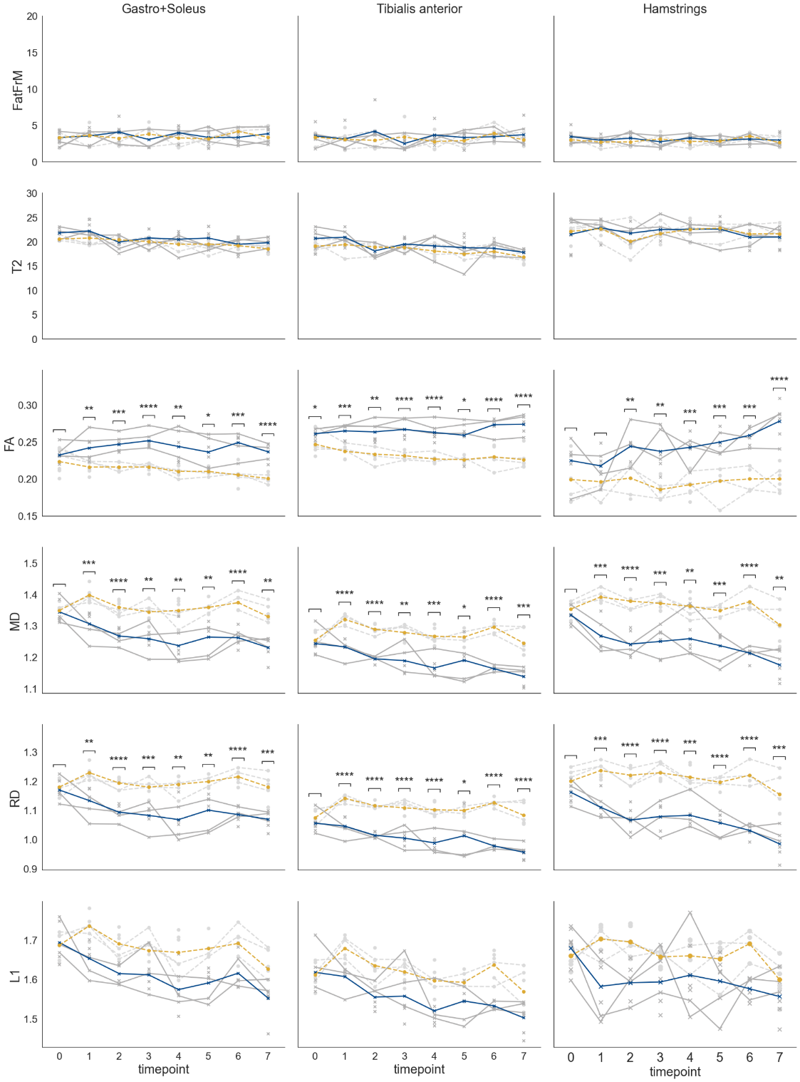
Figure S1: Upper and lower leg muscles DTI, T2-mapping and Dixon-based water fat imaging results. While fat fraction (FatFr) and T2 were not significant different comparing Pompe and wildtype mice, the diffusion parameters fractional anisotropy (FA), mean diffusivity (MD) and radial diffusivity (RD) showed significant changes. FA increased over the observed timespan, while MD and RD decreased. λ₁ showed a decreasing trend but was not significant.

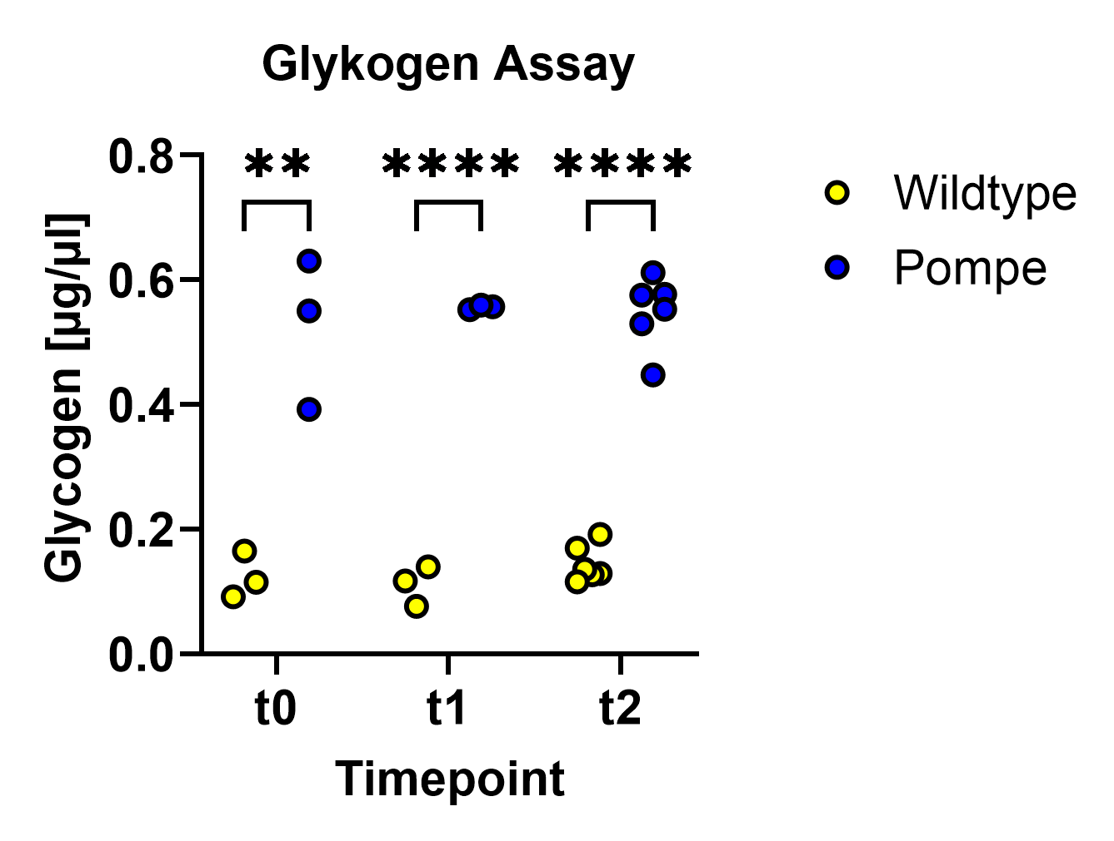
Figure S2: Glycogen content measured with glycogen assay. Pompe mice show a high concentration of glycogen over the observed timecourse

