Supplementary Table S1: Survey form administered to participants.
1. Participant’s information, participant identification #
Name:
Male □ Female □
Age:___years old
Height/weight:__cm/ __kg
Smoking: □ Yes □ No
Quarantine site during acute COVID-19 infection:
□ At home □ Therapeutic living center □ Secondary or tertiary hospital
2. About you and your COVID-19 illness
Survey completion date (DD/MM/YYYY):
What is your date of birth:
Have you been vaccinated against COVID-19? □ Yes □ No □ Not sure
If yes, how many times have you had the COVID-19 vaccine? [number]
Estimated date of the last vaccine dose received: DD/MM/20YY
Which type of COVID-19 vaccine did you receive: □ AstraZeneca □ Pfizer-BioNTech □ Janssen □ Moderna □ Other (name): ________ □ Not sure
Have you been vaccinated against influenza within last 6 months? □ Yes □ No □ Not sure
Roughly, on what day did you first experience symptoms of COVID-19? DD/MM/20YY
Were you admitted to the hospital due to COVID-19 or diagnosed with COVID-19 during a hospital admission? □ Yes □ No
• Roughly, on what day were you first admitted to the hospital? DD/MM/20YY
• Roughly, on what day were you first discharged from the hospital? DD/MM/20YY
• Have you been readmitted to hospital or health facility after your first acute COVID-19 illness?
□ Yes □ No
If yes, how many times: [number]
If ever admitted to a hospital/health facility for COVID-19, were you admitted to intensive care (ICU/ITU)? □ Yes □ No □ Not sure
• Have you been diagnosed with any new disease since having COVID-19? □ Yes □ No
• Have you had a re-infection from COVID-19? □ Yes □ No
3. About your current health
Do you feel fully recovered from COVID-19? □ Strongly disagree □ Disagree □ Neither disagree nor agree □ Agree □ Strongly Agree
4. Since having COVID-19, have you been diagnosed with any of these?
Heart attack □ Yes □ No
Stroke or mini stroke/TIA □ Yes □ No
Kidney problems □ Yes □ No
Deep vein thrombosis (DVT, “Clot in leg”) □ Yes □ No
Pulmonary embolism (PE, “Clot in lung”) □ Yes □ No
Other condition? (please specify)__________________
5. Within the last 7 days, have you had any of these symptoms? (that you did not experience before onset of your COVID-19 illness)
Fever □ Yes □ No
Chills □ Yes □ No
Muscle pain □ Yes □ No
Joint pain or swelling □ Yes □ No
Fatigue □ Yes □ No
Cough □ Yes □ No
Sore throat □ Yes □ No
Rhinorrhea □ Yes □ No
Sputum □ Yes □ No
Dyspnea □ Yes □ No
Palpitations □ Yes □ No
Arrhythmia □ Yes □ No
Chest discomfort □ Yes □ No
Headache □ Yes □ No
Dizziness □ Yes □ No
Cognitive dysfunction □ Yes □ No
Difficulty concentrating □ Yes □ No
Amnesia □ Yes □ No
Abnormal directional sensibility □ Yes □ No
Seizure □ Yes □ No
Paresthesia □ Yes □ No
Globus pharyngeus □ Yes □ No
Hallucination □ Yes □ No
Problems sleeping □ Yes □ No
Social phobia □ Yes □ No
Depression □ Yes □ No
Anxiety □ Yes □ No
Obsessive thinking □ Yes □ No
Anorexia □ Yes □ No
Diarrhea □ Yes □ No
Nausea or vomiting □ Yes □ No
Loss of smell □ Yes □ No
Loss of taste □ Yes □ No
Tinnitus □ Yes □ No
Hair loss □ Yes □ No
Skin rashes □ Yes □ No
Itchy skin □ Yes □ No
Swollen fingers or toes □ Yes □ No
6. About your health
Under each heading, please tick the ONE box that best describes your health TODAY
MOBILITY
□ I had no problems in walking about.
□ I had slight problems in walking about.
□ I had moderate problems in walking about.
□ I had severe problems in walking about.
□ I was unable to walk about.
SELF-CARE
□ I had no problems washing or dressing myself.
□ I had slight problems washing or dressing myself.
□ I had moderate problems washing or dressing myself.
□ I had severe problems washing or dressing myself.
□ I was unable to wash or dress myself.
USUAL ACTIVITIES (e.g., work, study, housework, family, or leisure activities)
□ I had no problems doing my usual activities.
□ I had slight problems doing my usual activities.
□ I had moderate problems doing my usual activities.
□ I had severe problems doing my usual activities.
□ I was unable to do my usual activities.
PAIN/DISCOMFORT
□ I had no pain or discomfort.
□ I had slight pain or discomfort.
□ I had moderate pain or discomfort.
□ I had severe pain or discomfort.
□ I had extreme pain or discomfort.
ANXIETY/DEPRESSION
□ I was not anxious or depressed.
□ I was slightly anxious or depressed.
□ I was moderately anxious or depressed.
□ I was severely anxious or depressed.
□ I was extremely anxious or depressed.
• We would like to know how good or bad your health is TODAY.
• This scale is numbered from 0 to 100.
• 100 means the best health you can imagine. 0 means the worst health you can imagine.
• Mark an X on the scale to indicate how your health is TODAY.
• Now, please write the number you marked on the scale in the box below.
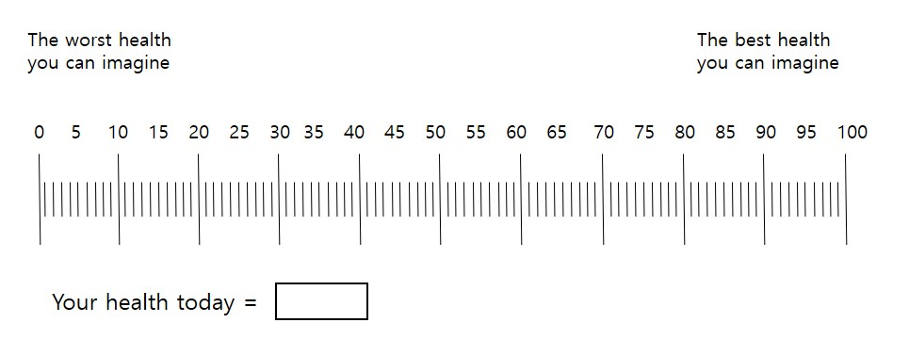
7. Breathlessness and tiredness
Please tick ONE box that best describes how breathless you feel today
Not troubled by breathlessness except on strenuous exercise □
Short of breath when hurrying or when walking up a slight hill □
Walking slower than most people of my age because of breathlessness or have to stop for breath when walking at my normal pace □
Stopping for breath after walking 100 yards (90–100 meters), or after a few minutes on level ground □
Too breathless to leave the house or breathless when dressing/undressing □
Please rate the intensity of your fatigue on average over the last 24 h on a scale from 0 to 10.
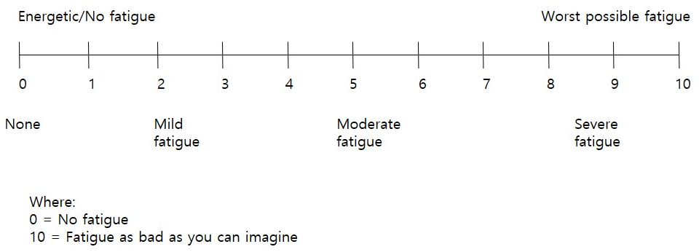
8. The next questions ask about difficulties you may have doing certain activities because of a HEALTH PROBLEM. (mark the correct answer with a tick in the box)
Do you have difficulty seeing even if wearing glasses?
□ No, no difficulty □ Yes, some difficulty □ Yes, a lot of difficulty □ Cannot do at all
Do you have difficulty hearing, even if using a hearing aid?
□ No, no difficulty □ Yes, some difficulty □ Yes, a lot of difficulty □ Cannot do at all
Do you have difficulty walking or climbing steps?
□ No, no difficulty □ Yes, some difficulty □ Yes, a lot of difficulty □ Cannot do at all
Do you have difficulty remembering or concentrating?
□ No, no difficulty □ Yes, some difficulty □ Yes, a lot of difficulty □ Cannot do at all
Do you have difficulty with self-care, such as washing all over or dressing?
□ No, no difficulty □ Yes, some difficulty □ Yes, a lot of difficulty □ Cannot do at all
Using your usual (customary) language, do you have difficulty communicating? For example, understanding or being understood?
□ No, no difficulty □ Yes, some difficulty □ Yes, a lot of difficulty □ Cannot do at all
9. Have you made lifestyle changes since your COVID-19 infection? (mark the correct answer with a tick in the box)
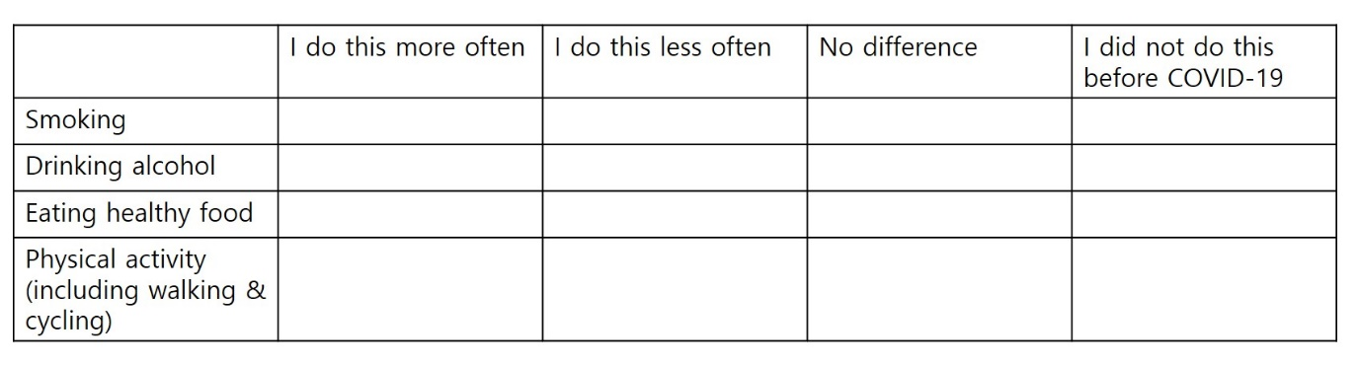
10. End of survey
Thank you for your time!

Supplementary Table S2: Baseline characteristics of 121 cohort patients.
Characteristics | No symptoms (24 months) | Symptoms  (24 months) | Total | P value
Characteristics | (N = 46) | (N = 75) | (N = 121) | P value
Oxygen treatment during acute COVID-19 infection
Yes | 3 (6.5%) | 12 (16.0%) | 15 (12.4%) | 0.211
No | 43 (93.5%) | 63 (84.0%) | 106 (87.6%)
ICU admission during acute COVID-19 infection
Yes | 0 (0.0%) | 4 (5.3%) | 4 (3.3%) | 0.285
No | 46 (100.0%) | 71 (94.7%) | 117 (96.7%)
MV use during acute COVID-19 infection
Yes | 0 (0.0%) | 3 (4.0%) | 3 (2.5%) | 0.440
No | 46 (100.0%) | 72 (96.0%) | 118 (97.5%)
Vaccinated against influenza within the last 6 months
Yes | 14 (30.4%) | 30 (40.0%) | 44 (36.4%) | 0.386
No | 32 (69.6%) | 45 (60.0%) | 77 (63.6%)
Newly diagnosed diseases since having COVID-19 infection
1. Heart disease | 0 (0.0%) | 1 (1.3%) | 1 (0.8%) | 0.566
2. Stroke or mini stroke/TIA | 0 (0.0%) | 0 (0.0%) | 0 (0.0%)
3. Kidney problems | 0 (0.0%) | 1 (1.3%) | 1 (0.8%)
4. Deep vein thrombosis | 1 (0.0%) | 0 (0.0%) | 1 (0.8%)
5. Pulmonary embolism | 0 (0.0%) | 0 (0.0%) | 0 (0.0%)
6. Other conditions | 3 (6.5%) | 6 (8.0%) | 9 (7.4%)
7. None | 42 (91.3%) | 67 (89.3%) | 109 (90.1%)
Allergic rhinitis |  |  |  | 0.301
Yes | 9 (19.6%) | 22 (29.3%) | 31 (25.6%) | 0.301
No | 37 (80.4%) | 53 (70.7%) | 90 (74.4%) | 0.301
DM |  |  |  | 1.000
Yes | 7 (15.2%) | 12 (16.0%) | 19 (15.7%) | 1.000
No | 39 (84.8%) | 63 (84.0%) | 102 (84.3%) | 1.000
HTN |  |  |  | 0.660
Yes | 11 (23.9%) | 22 (29.3%) | 33 (27.3%) | 0.660
No | 35 (76.1%) | 53 (70.7%) | 88 (72.7%) | 0.660
CKD |  |  |  | 1.000
Yes | 1 (2.2%) | 2 (2.7%) | 3 (2.5%) | 1.000
No | 45 (97.8%) | 73 (97.3%) | 118 (97.5%) | 1.000
Liver disease |  |  |  | 0.376
Yes | 2 (4.3%) | 8 (10.7%) | 10 (8.3%) | 0.376
No | 44 (95.7%) | 67 (89.3%) | 111 (91.7%) | 0.376
Solid tumor |  |  |  | 1.000
Yes | 1 (2.2%) | 2 (2.7%) | 3 (2.5%) | 1.000
No | 45 (97.8%) | 73 (97.3%) | 118 (97.5%) | 1.000
CVA |  |  |  | 0.804
Yes | 1 (2.2%) | 0 (0.0%) | 1 (0.8%) | 0.804
No | 45 (97.8%) | 75 (100.0%) | 120 (99.2%) | 0.804
COPD |  |  |  | 1.000
Yes | 0 (0.0%) | 1 (1.0%) | 1 (0.8%) | 1.000
No | 46 (100.0%) | 74 (98.7%) | 120 (99.2%) | 1.000
Heart disease |  |  |  | 0.440
Yes | 0 (0.0%) | 3 (4.0%) | 3 (2.5%) | 0.440
No | 46 (100.0%) | 72 (96.0%) | 118 (97.5%) | 0.440
COVID-19, coronavirus disease 2019; ICU, intensive care unit; MV, mechanical ventilator; TIA, transient ischemic attack; DM, diabetes mellitus; HTN, hypertension; CKD, chronic kidney disease; CVA, cerebrovascular accident; COPD, chronic obstructive pulmonary disease.
Data are presented as n (%).
Supplementary Table S3: Impact of COVID-19 vaccination stratified by number of vaccine doses.
Long COVID symptoms (24 months) | <3 vaccination doses | ≥3 vaccination doses | Total | P value
Long COVID symptoms (24 months) | (N = 44) | (N = 77) | (N = 121) | P value
Fatigue |  |  |  | 1.000
Yes | 11 (25.0%) | 20 (26.0%) | 31 (25.6%)
No | 33 (75.0%) | 57 (74.0%) | 90 (74.4%)
Amnesia |  |  |  | 1.000
Yes | 10 (22.7%) | 18 (23.4%) | 28 (23.1%)
No | 34 (77.3%) | 59 (76.6%) | 93 (76.9%)
Insomnia |  |  |  | 0.369
Yes | 6 (13.6%) | 17 (22.1%) | 23 (19.0%)
No | 38 (86.4%) | 60 (77.9%) | 98 (81.0%)
Difficulty concentrating |  |  |  | 0.584
Yes | 10 (22.7%) | 13 (16.9%) | 23 (19.0%)
No | 34 (77.3%) | 64 (83.1%) | 98 (81.0%)
Depression |  |  |  | 1.000
Yes | 7 (15.9%) | 12 (15.6%) | 19 (15.7%)
No | 37 (84.1%) | 65 (84.4%) | 102 (84.3%)
Anxiety |  |  |  | 0.832
Yes | 6 (13.6%) | 13 (16.9%) | 19 (15.7%)
No | 38 (86.4%) | 64 (83.1%) | 102 (84.3%)
Cognitive dysfunction |  |  |  | 1.000
Yes | 2 (4.5%) | 4 (5.2%) | 6 (5.0%)
No | 42 (95.5%) | 73 (94.8%) | 115 (95.0%)
Anosmia |  |  |  | 0.756
Yes | 2 (4.5%) | 6 (7.8%) | 8 (6.6%)
No | 42 (95.5%) | 71 (92.2%) | 113 (93.4%)
Ageusia |  |  |  | 1.000
Yes | 1 (2.3%) | 1 (1.3%) | 2 (1.7%)
No | 43 (97.7%) | 76 (98.7%) | 119 (98.3%)
COVID-19, coronavirus disease 2019.
Data are presented as n (%).

Supplementary Table S4: Quality of life, PHQ-9, and GAD-7 assessments 24 months following acute COVID-19 infection.
Characteristics | No symptoms (24 months)  (N = 46) | Symptoms (24 months)  (N = 75) | Total  (N = 121) | P value
You believe you have completely recovered from COVID-19 |  |  |  | < 0.001
Strongly disagree | 0 (0.0%) | 7 (9.3%) | 7 (5.8%) | < 0.001
Disagree | 0 (0.0%) | 17 (22.7%) | 17 (14.0%) | < 0.001
Neither disagree nor agree | 1 (2.2%) | 21 (28.0%) | 22 (18.2%) | < 0.001
Agree | 14 (30.4%) | 16 (21.3%) | 30 (24.8%) | < 0.001
Strongly agree | 31 (67.4%) | 14 (18.7%) | 45 (37.2%) | < 0.001
The healthiest you feel today, on a scale of 0–100; median [IQR] | 90.0  [80.0–90.0] | 80.0  [70.0–85.0] | 80.0  [70.0–90.0] | < 0.001
Intensity of fatigue on average  over the last 24 hours, on a scale from 0–10 where 0 = no fatigue and 10 = worst fatigue; median [IQR]ª | 3.0  [2.0–6.0] | 5.0  [2.0–6.0] | 4.0  [2.0–6.0] | 0.089
Extent of breathlessness you feel today (within the last 24 h) |  |  |  | 0.098
Not troubled by breathlessness, except during strenuous exercise | 28 (60.9%) | 31 (41.3%) | 59 (48.8%) | 0.098
Short of breath when rushing or walking up a gentle hill | 18 (39.1%) | 39 (52.0%) | 57 (47.1%) | 0.098
Walking slower than most people my age because of breathlessness or having to stop for breath when walking at my normal pace | 0 (0.0%) | 3 (4.0%) | 3 (2.5%) | 0.098
Stopping for breath after walking 100 yards (90–100 meters) or after walking a few minutes on level ground | 0 (0.0%) | 2 (2.7%) | 2 (1.7%) | 0.098
Too breathless to leave the house or breathless when dressing/undressing | 0 (0.0%) | 0 (0.0%) | 0 (0.0%) | 0.098
Total PHQ-9 score (depression) |  |  |  | < 0.001
0–4, None | 45 (100.0%) | 46 (61.3%) | 92 (76.0%) | < 0.001
5–9, Mild | 0 (0.0%) | 21 (28.0%) | 21 (17.4%) | < 0.001
10–19, Moderate | 0 (0.0%) | 8 (10.7%) | 8 (6.6%) | < 0.001
20–27, Severe | 0 (0.0%) | 0 (0.0%) | 0 (0.0%) | < 0.001
Total GAD-7 score (anxiety) |  |  |  | < 0.001
0–5, No-to-low risk | 46 (100.0%) | 53 (70.7%) | 99 (81.8%) | < 0.001
6–10, Mild | 0 (0.0%) | 19 (25.3%) | 19 (15.7%) | < 0.001
11–15, Moderate | 0 (0.0%) | 3 (4.0%) | 3 (2.5%) | < 0.001
≥16, Severe | 0 (0.0%) | 0 (0.0%) | 0 (0.0%) | < 0.001
IQR, interquartile range; COVID-19, coronavirus disease 2019; PHQ-9, Korean version of the Patient Health Questionnaire-9 (depression screen for individuals at risk); GAD-7, Generalized Anxiety Disorder-7.

ª Intensity of tiredness: 0, none; 2, mild fatigue; 5, moderate fatigue; 10, severe fatigue.
Data are presented as n (%).

Supplementary Table S5: Assessment of cohort patients’ difficulties in performing certain activities because of a health problem.
Characteristics | No symptom (24 moths)  (N = 46) | Symptoms (24 months)  (N = 75) | Total  (N = 121) | P value
Difficulty with vision, even when wearing glasses |  |  |  | 0.057
No, no difficulty | 40 (87.0%) | 51 (68.0%) | 91 (75.2%) | 0.057
Yes, some difficulty | 5 (10.9%) | 22 (29.3%) | 27 (22.3%) | 0.057
Yes, a lot of difficulty | 1 (2.2%) | 2 (2.7%) | 3 (2.5%) | 0.057
Cannot do it at all | 0 (0.0%) | 0 (0.0%) | 0 (0.0%) | 0.057
Difficulty in hearing, even when using a hearing aid |  |  |  | 0.072
No, no difficulty | 43 (93.5%) | 63 (84.0%) | 106 (87.6%) | 0.072
Yes, some difficulty | 2 (4.3%) | 12 (16.0%) | 14 (11.6%) | 0.072
Yes, a lot of difficulty | 1 (2.2%) | 0 (0.0%) | 1 (0.8%) | 0.072
Cannot do it at all | 0 (0.0%) | 0 (0.0%) | 0 (0.0%) | 0.072
Difficulty in walking or climbing steps |  |  |  | 0.006
No, no difficulty | 41 (89.1%) | 48 (64.0%) | 89 (73.6%) | 0.006
Yes, some difficulty | 4 (8.7%) | 26 (34.7%) | 30 (24.8%) | 0.006
Yes, a lot of difficulty | 1 (2.2%) | 1 (1.3%) | 2 (1.7%) | 0.006
Cannot do it at all | 0 (0.0%) | 0 (0.0%) | 0 (0.0%) | 0.006
Difficulty in remembering or concentrating |  |  |  | < 0.001
No, no difficulty | 40 (87.0%) | 35 (46.7%) | 75 (62.0%) | < 0.001
Yes, some difficulty | 6 (13.0%) | 38 (50.7%) | 44 (36.4%) | < 0.001
Yes, a lot of difficulty | 0 (0.0%) | 2 (2.7%) | 2 (1.7%) | < 0.001
Cannot do it at all | 0 (0.0%) | 0 (0.0%) | 0 (0.0%) | < 0.001
Difficulty with self-care like washing all over or dressing |  |  |  | 0.313
No, no difficulty | 44 (95.7%) | 71 (94.7%) | 115 (95.0%) | 0.313
Yes, some difficulty | 1 (2.2%) | 4 (5.3%) | 5 (4.1%) | 0.313
Yes, a lot of difficulty | 1 (2.2%) | 0 (0.0%) | 1 (0.8%) | 0.313
Cannot do it at all | 0 (0.0%) | 0 (0.0%) | 0 (0.0%) | 0.313
Using usual (customary) language,  having trouble communicating (for example, in understanding or being understood) |  |  |  | 0.383
No, no difficulty | 43 (93.5%) | 65 (86.7%) | 108 (89.3%) | 0.383
Yes, some difficulty | 3 (6.5%) | 10 (13.3%) | 13 (10.7%) | 0.383
Yes, a lot of difficulty | 0 (0.0%) | 0 (0.0%) | 0 (0.0%) | 0.383
Cannot do it at all | 0 (0.0%) | 0 (0.0%) | 0 (0.0%) | 0.383
COVID-19, coronavirus disease 2019.
Data are presented as n (%).

Supplementary Table S6: Assessment of lifestyle changes in cohort patients at 24 months after acute COVID-19 infection.
Characteristics | No symptoms (24 months)  (N = 46) | Symptoms (24 months)  (N = 75) | Total  (N = 121) | P value
Smoking |  |  |  | 0.008
I do this more often | 1 (2.2%) | 0 (0.0%) | 1 (0.8%) | 0.008
I do this less often | 2 (4.3%) | 1 (1.4%) | 3 (2.5%) | 0.008
No difference | 7 (15.2%) | 1 (1.4%) | 8 (6.7%) | 0.008
I did not do this before or after  COVID-19 infection | 36 (78.3%) | 72 (97.3%) | 108 (90.0%) | 0.008
Drinking alcohol |  |  |  | 0.393
I do this more often | 1 (2.2%) | 3 (4.1%) | 4 (3.3%) | 0.393
I do this less often | 8 (17.4%) | 13 (17.6%) | 21 (17.5%) | 0.393
No difference | 19 (41.3%) | 20 (27.0%) | 39 (32.5%) | 0.393
I did not do this before  COVID-19 infection | 18 (39.1%) | 38 (51.4%) | 56 (46.7%) | 0.393
Eating healthy food |  |  |  | 0.138
I do this more often | 15 (32.6%) | 36 (48.6%) | 51 (42.5%) | 0.138
I do this less often | 1 (2.2%) | 1 (1.4%) | 2 (1.7%) | 0.138
No difference | 21 (45.7%) | 19 (25.7%) | 40 (33.3%) | 0.138
I did not do this before  COVID-19 infection | 9 (19.6%) | 18 (24.3%) | 27 (22.5%) | 0.138
Physical activity  (including walking and cycling) |  |  |  | 0.440
I do this more often | 10 (21.7%) | 26 (35.1%) | 36 (30.0%) | 0.440
I do this less often | 10 (21.7%) | 11 (14.9%) | 21 (17.5%) | 0.440
No difference | 22 (47.8%) | 31 (41.9%) | 53 (44.2%) | 0.440
I did not do this before  COVID-19 infection | 4 (8.7%) | 6 (8.1%) | 10 (8.3%) | 0.440
COVID-19, coronavirus disease 2019.
Data are presented as n (%).

