Additional information.
Table S1. Short-read sequences used in E. tenella strains population study.
Supportive data Table Legends.
Table S2. Genome wide annotations of E. tenella APU2 genes-based SNPs with Pfam and GO annotations.xlsx.

Table S3. E. tenella Houghton and E. tenella APU2 Highly variable top 30 Pfam gene family with number of SNPs.xlsx

Supportive Figure Legends.
Figure S1. Workflow for the E. tenella APU2 genome sequencing, assembly, and downstream analyses.
Figure S2. A). BUSCO assessment for E. tenella APU2 sequenced genome. B). Pfam annotations with number 5 and above annotation comparison between two reference chromosomal level assembly of E. tenella strains.
Figure S3 Overview of the functional annotations Pfam (≥15 genes) and GO-teams (≥5 genes) in E. tenella APU2 classification based on Pfam annotation and GO annotation.
Figure S4 Chromosomal distribution of CpG sites between E. tenella Houghton and E. tenella APU2 genome.

Figure S5. Phylogenomic analysis of organelle genomes of Eimeria species showed the monophyletic clustering of all E. tenella sequences analyzed in this study.

Figure S6 Phylogeny analysis of important avian parasites E. mitis, E. brunetti, E. praecox, E. maxima, E. acervulina, E. tenella-APU2, E. necatrix, E. falciformis and T. gondii.

Table S1. Short-read sequences used in E. tenella strains population study.
SRA* | strain | sample name | Eimeria | center name
 | Maryland, USA | ET_S13** (APU2) | E. tenella | Animal Parasitic Disease Laboratory, ARS, USDA
ERR019311 | Houghton | ERS004356 | E. tenella | Wellcome Sanger Institute
ERR019312 | Houghton | ERS004356 | E. tenella | Wellcome Sanger Institute
ERR296541 | Nippon | Nippon Nt2 | E. tenella | Royal Veterinary College
ERR019305 | Houghton | ERS006630 | E. tenella | Wellcome Sanger Institute
ERR296879 | Wisconsin, USA |  | E. tenella | Royal Veterinary College
ERR019310 | Houghton | ERS002383 | E. tenella | Wellcome Sanger Institute
ERR019307 | Houghton | ERS006630 | E. tenella | Wellcome Sanger Institute
ERR019306 | Houghton | ERS006630 | E. tenella | Wellcome Sanger Institute
ERR019309 | Houghton | ERS002383 | E. tenella | Wellcome Sanger Institute
ERR6054480 | Houghton | Cumbria, Hawkshead | E. tenella | Royal Veterinary College
ERR6054482 | Houghton | Cumbria, Hawkshead | E. tenella | Royal Veterinary College
ERR6054483 | Houghton | Cumbria, Hawkshead | E. tenella | Royal Veterinary College
ERR6054481 | Houghton | Cumbria, Hawkshead | E. tenella | Royal Veterinary College
SRR23018153 | Houghton strain | China, Nanning | E. tenella | Guangxi University
SRR23018155 | Houghton strain | China, Naning | E. tenella | Guangxi University
ERR357127 | Houghton |  | E. acervulina | King Abdullah University of Science and Technology
ERR357128 | Weybridge |  | E. maxima | King Abdullah University of Science and Technology
ERR357129 | Houghton |  | E. necatrix | King Abdullah University of Science and Technology
ERR357130 | Houghton |  | E. brunetti | King Abdullah University of Science and Technology
ERR357191 | Houghton |  | E. mitis | King Abdullah University of Science and Technology
ERR357192 | Houghton |  | E. praecox | King Abdullah University of Science and Technology
ERR4552264 |  | OTUx | Eimeria sp. OTU-X | Royal Veterinary College
ERR4552265 |  | OTUy | Eimeria sp. OTU-Y | Royal Veterinary College
ERR4552266 |  | OTUz | Eimeria sp. OTU-Z | Royal Veterinary College

* Short-read sequences were downloaded from the Sequence Read Archive (SRA, https://www.ncbi.nlm.nih.gov/sra).** The E. tenella APU2 sequencing specimens were acquired from a local poultry form and maintained at APDL, USDA ARS Beltsville

Supportive Figures
Figure S1. Workflow for the E. tenella APU2 genome sequencing, assembly, and downstream analyses. The Sequencing Step involved sequencing of E. tenella APU2 with two different Technology, Illumina NextSeq (2nd Generation) and Oxford Nanopore MinION (3rd Generation). Followed by downstream analyses.

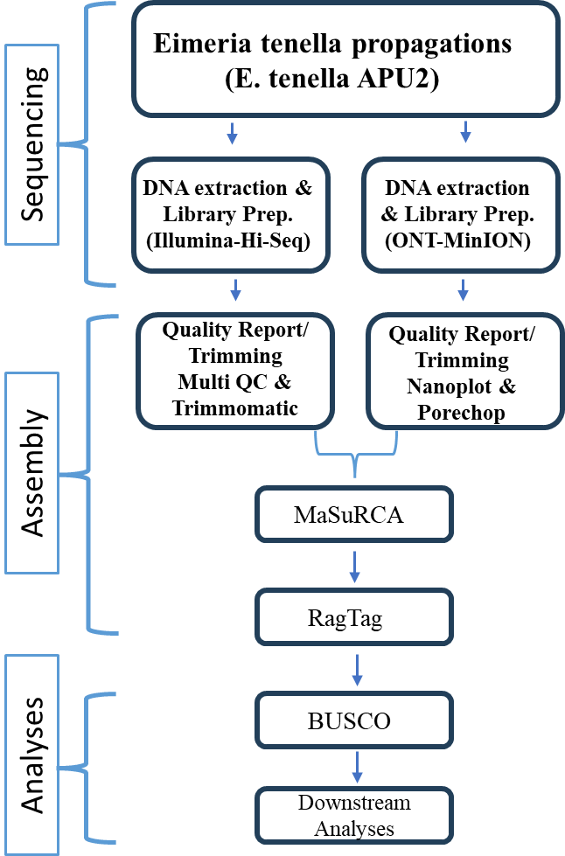

Figure S2. A). BUSCO assessment for E. tenella APU2 sequenced genome. B). Pfam annotations with number 5 and above annotation comparison between two reference chromosomal level assembly of E. tenella strains.

A). BUSCO assessment for E. tenella APU2 sequenced genome.
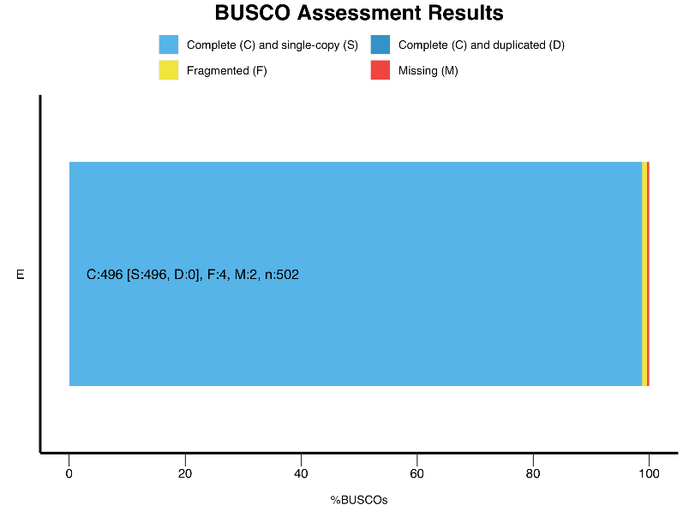
B). Pfam annotation comparison between two reference chromosomal level assembly of E. tenella strains

Figure S3 Overview of the functional annotations Pfam (≥15 genes) and GO-teams (≥5 genes) in E. tenella APU2. These proteins were classified based on Pfam annotation and GO annotation assignment to gain an overview of their biological function classification genome-wide and across the chromosomes. The GO-teams were generated based on InterPro2GO mapping. Highly variable 30 Pfam annotated variable genes between E tenella Houghton and E. tenella APU2 strains.

Figure S4 Chromosomal distribution of CpG sites between E. tenella Houghton and E. tenella APU2 genome. The Observed number of CpG patterns in a window is the number of times a 'C' is found followed immediately by a 'G' represented as per chromosomes a crossed the E. tenella strain.

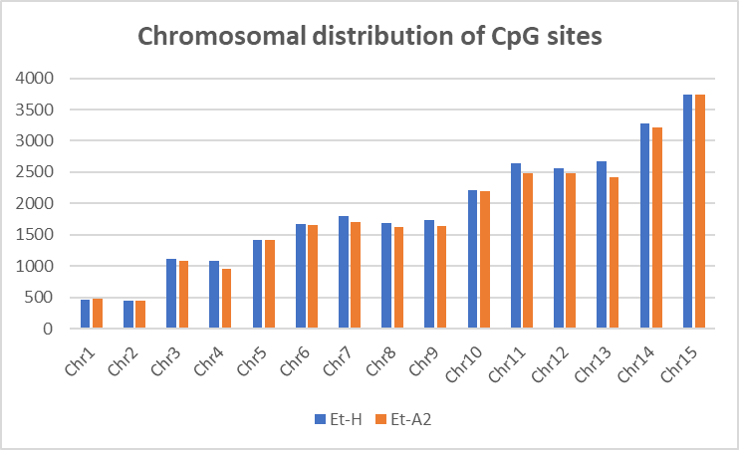
Figure S5. Phylogenomic analysis of organelle genomes of Eimeria species showed the monophyletic clustering of all E. tenella sequences analyzed in this study. Complete apicoplast (A) and mitochondria (B) genome phylogenies of Eimeria were constructed by downloading available whole genome sequences in Sequence Read Archive (https://www.ncbi.nlm.nih.gov/sra) and by comparing with the current chromosomal scaffolding of E. tenella strain APU2 (ET_S13). Apicoplast and mitochondrial reference genomes were obtained from the Assembly accession number: GCA_905310635.1(4). Single nucleotide polymorphisms were identified by reference mapping and variant calling using the GATK pipeline(46). The phylogram was obtained by an unrooted neighbor-joining tree using Mega with a 50% majority rule and 1000 bootstrap replicates (indicated at each node as percentage values). Eimeria species are placed in brackets.

Figure S6 Phylogeny analysis of avian parasites E. tenella APU2, T. gondii, E. acervuline, E. brunetti, E. maxima, E. mitis, E. nectrix, E. praecox, and E. falciformis shows E. necatrix are in one clade share close relatioship with E. tenella APU2, and E. tenella Houghton, likewise E. maxima and E. acervulina are in anther close group.
