Synthesis and in-vitro anti-proliferative with antimicrobial activity of new coumarin containing heterocycles hybrids

3 | Analysis of the GC/MS revealed MS peaks at m/z 190, 173,164  H. Ç., Hasniye, Y., & Oktay, S. (2019). Comparison of Antioxidant Activities of Mono-, Di-and Tri-substituted Coumarins. Journal of the Turkish Chemical Society Section A: Chemistry, 7(1), 87-96
6a
 | Figure S1. Mass spectra of 7-chloro-4-hydrazinylquinoline (6a). EI-MS, m ̸z (C₉H₈ClN₃) calcd, 193.04; found, 192.0 [M-1]⁺=100%, 194.0 [M+1] ⁺ .
6b
 | Figure S2. Mass spectra of N¹-(7-chloroquinolin-4-yl)ethane-1,2-diamin (6b). EI-MS, m ̸z (C₁₁H₁₂ClN₃) calcd, 221.69; found, 221.1 [M⁺] = 12.3% , 223.8 [M+2] ⁺ .
6c
 | 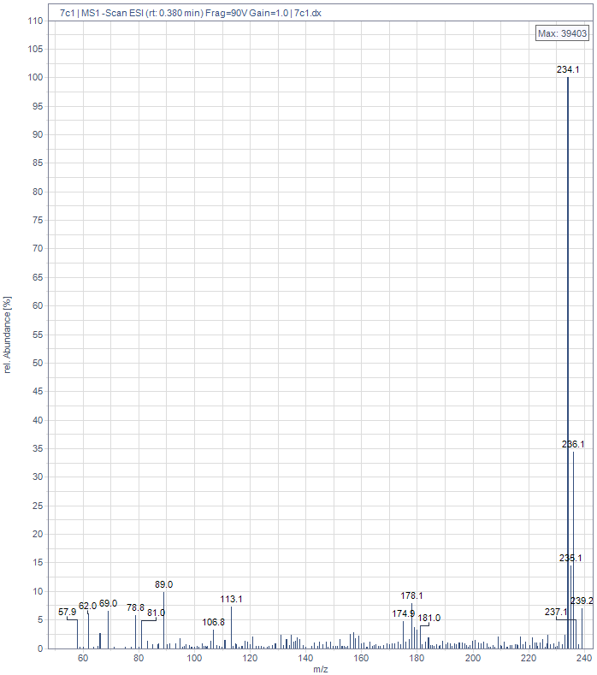
 | Figure S3. Mass spectra of N¹-(7-chloroquinolin-4-yl)propane-1,3-diamine (6c). EI-MS, m ̸z (C₁₂H₁₄ClN₃) calcd, 235.09; found, 234.1 [M-1]⁺ =100%, 236.1[M+1] ⁺ .
6d
 | 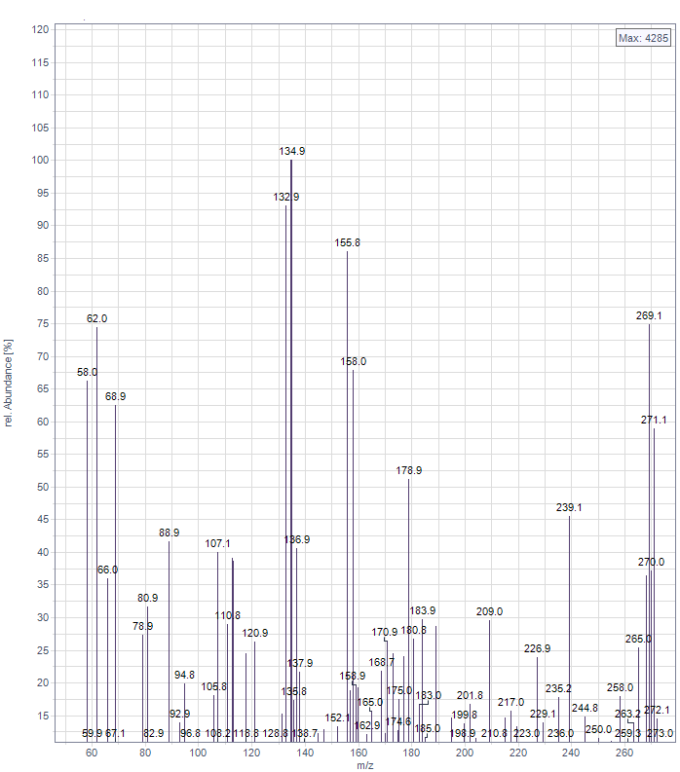
 | Figure S4. Mass spectra of N¹-(7-chloroquinolin-4-yl)benzene-1,4-diamine (6d).EI-MS, m ̸z (C₁₅H₁₂ClN₃) calcd, 269.07; found, 269.1 [M⁺] =75%, 271.1[M+2] ⁺ .
6e | 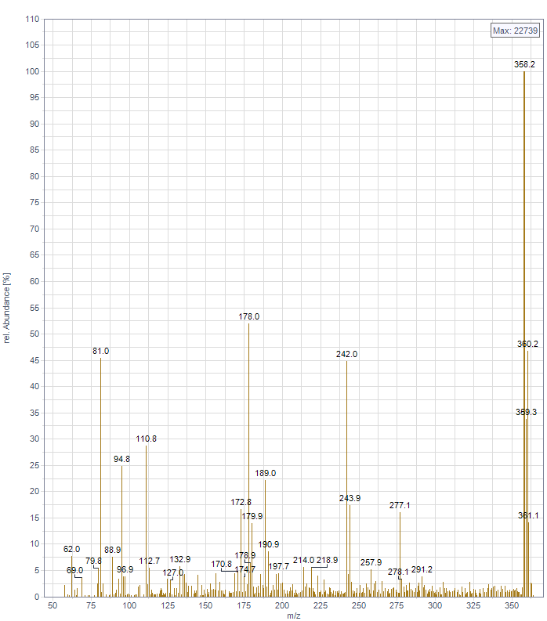  Figure S5 Mass spectra of N-(4-(4-aminobenzyl)phenyl)-7-chloroquinolin-4-amine (6e). EI-MS, m ̸z (C₂₂H₁₈ClN₃) calcd, 359.12; found, 358.2 [M-1]⁺ =100%, 360.2[M+1] ⁺ .
 | 7a
c | 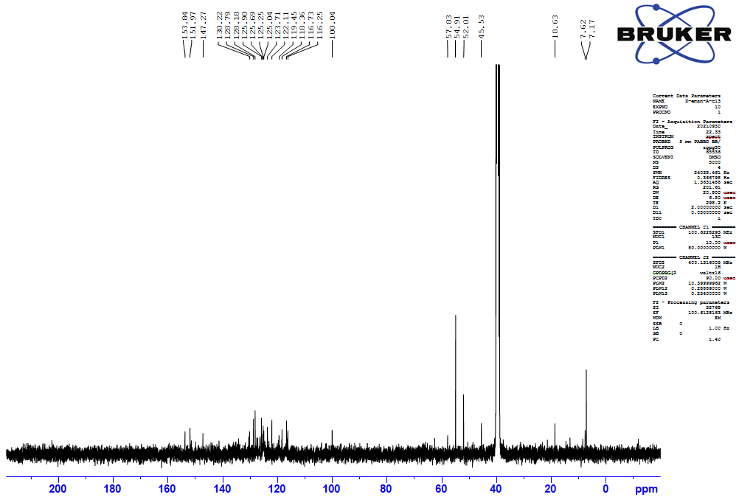
d | 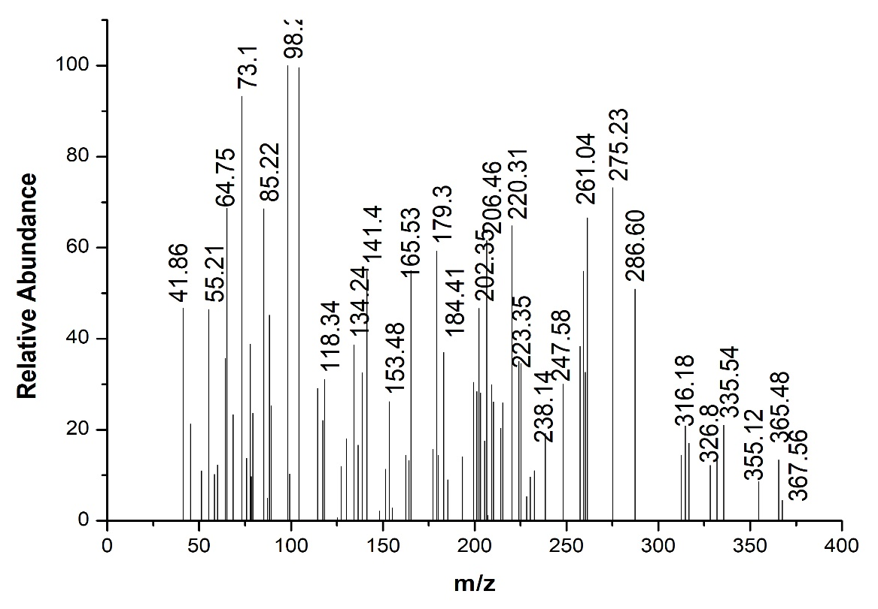
 | Figure S6. FTIR (a), ¹H-NMR (b), ¹³C-NMR (C), Mass spectra (d) of N'-(7-chloroquinolin-4-yl)-2-oxo-2H-chromene-3-carbohydrazide (7a).
7b
a | 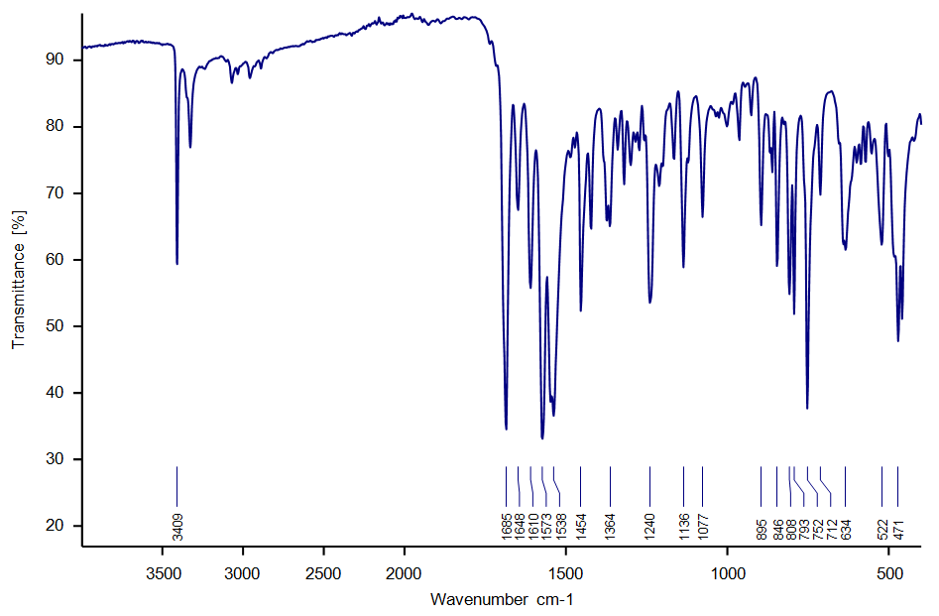
b | 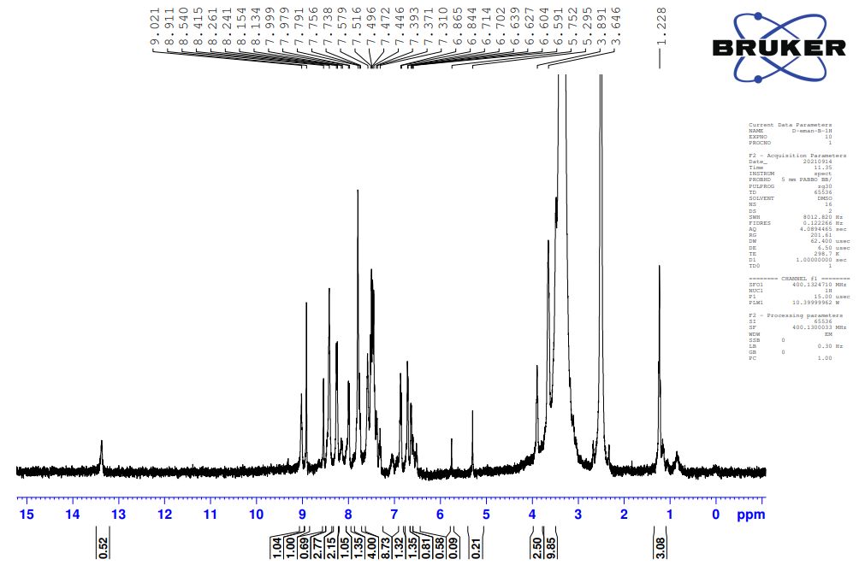
c | 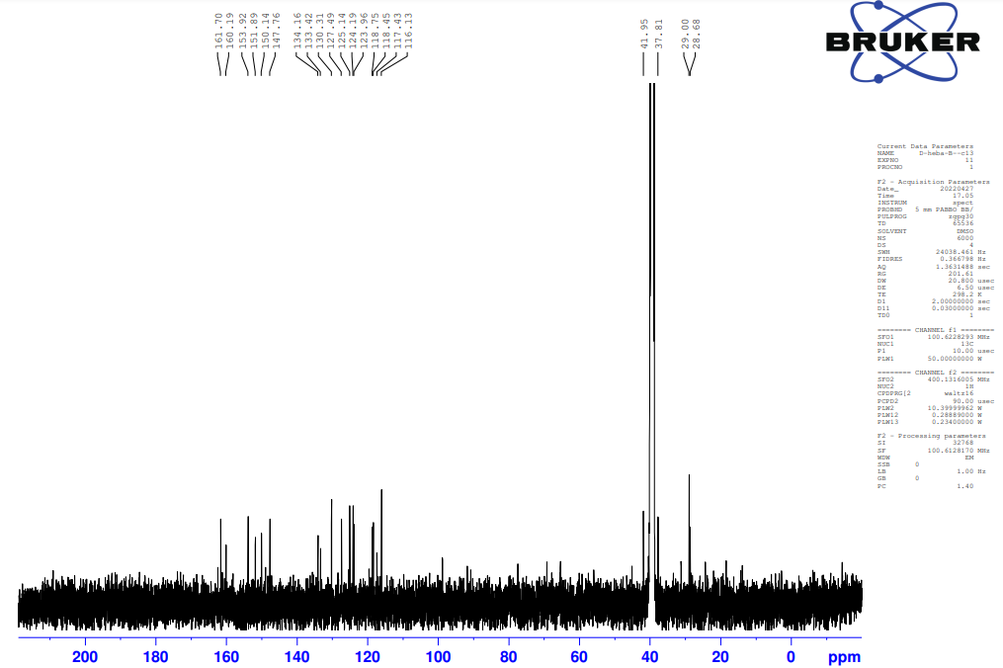
d | 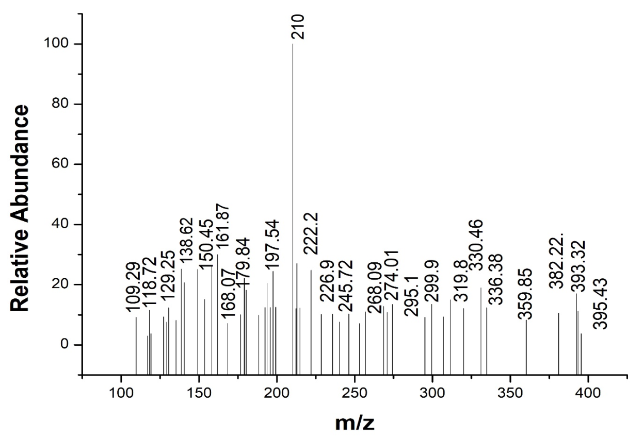
 | Figure S7. FTIR (a), ¹H-NMR (b), ¹³C-NMR (C), Mass spectra (d) of N-(2-((7-chloroquinolin-4-yl)amino)ethyl)-2-oxo-2H-chromene-3-carboxamide) (7b).
7c
a | 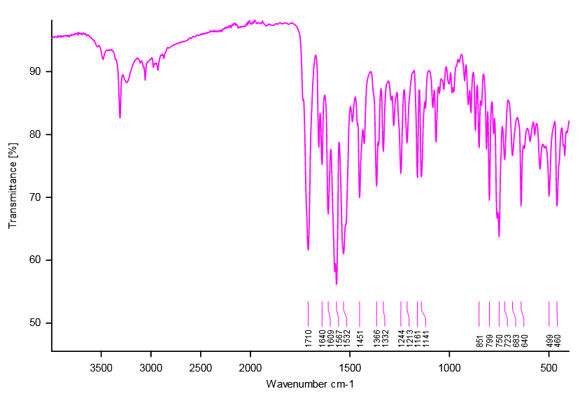
b | 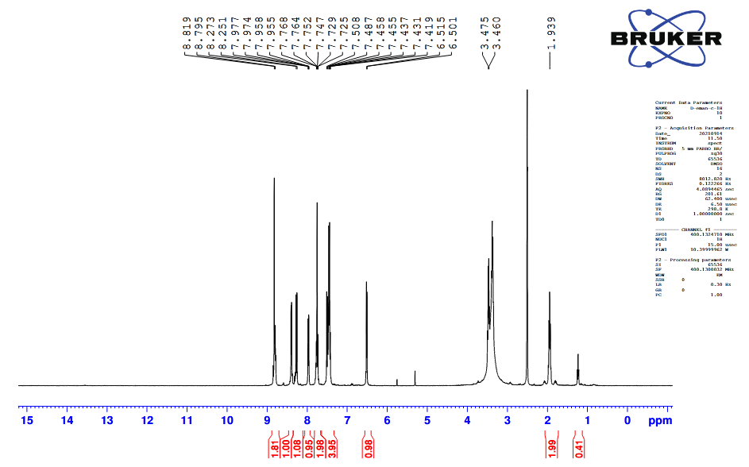
c | 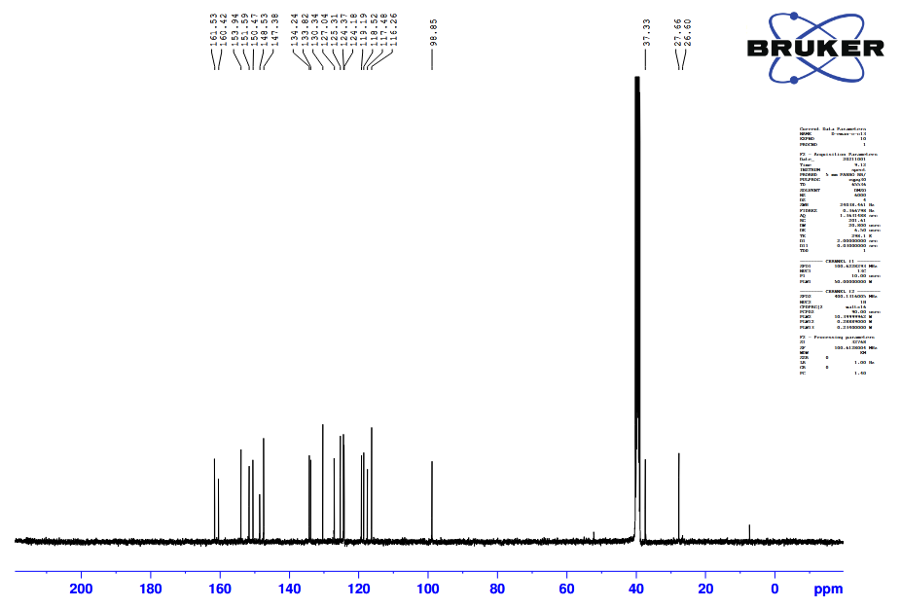
d | 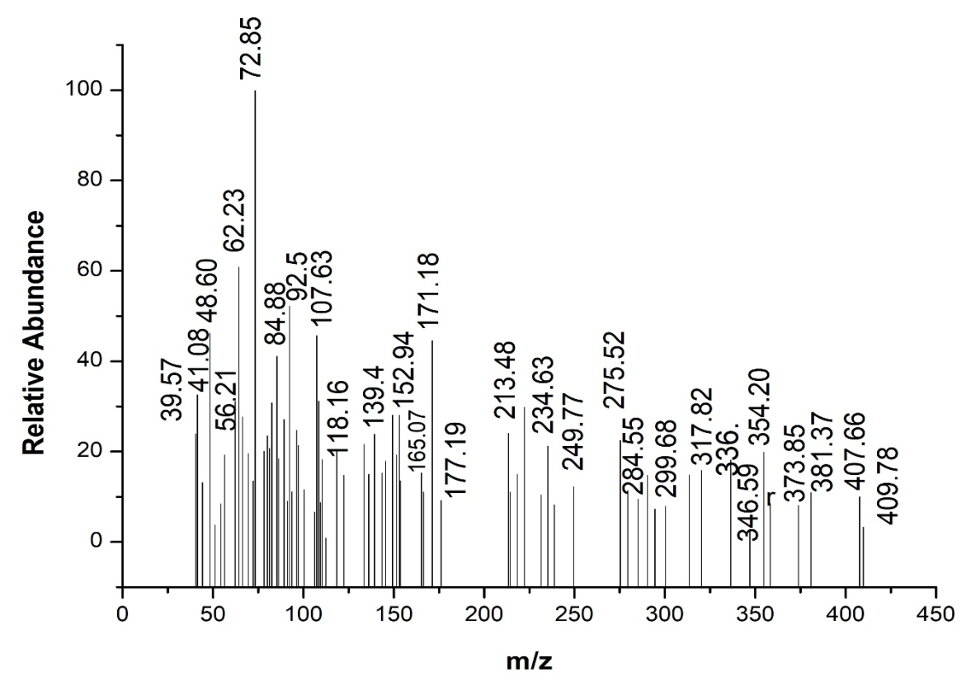
 | Figure S8. FTIR (a), ¹H-NMR (b), ¹³C-NMR (C), Mass spectra (d) of N-(3-((7-chloroquinolin-4-yl)amino)propyl)-2-oxo-2H-chromene-3-carboxamide (7c).
7d
a | 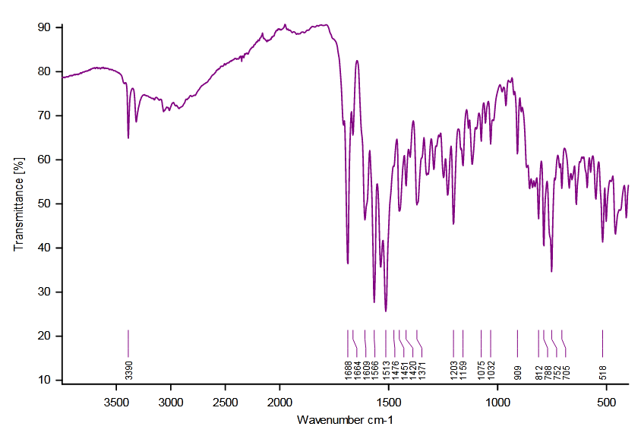
b | 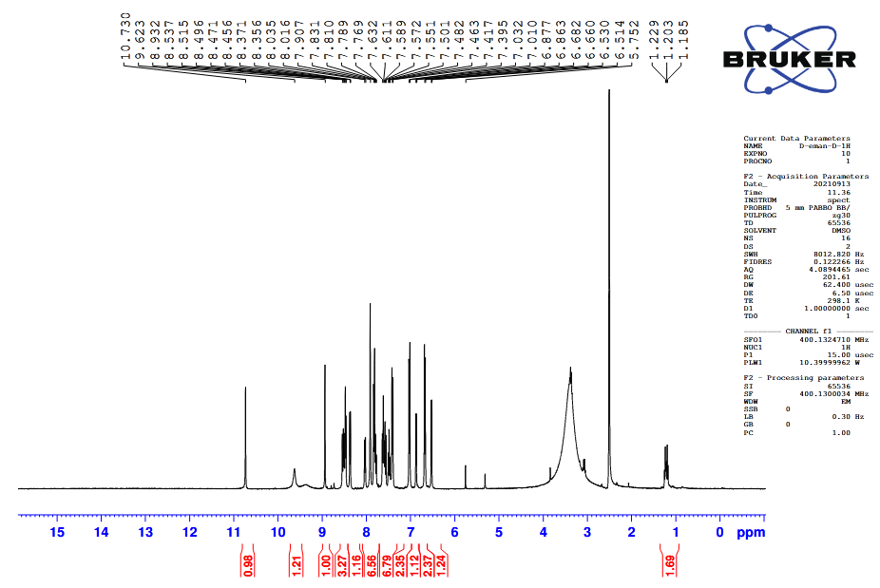
c | 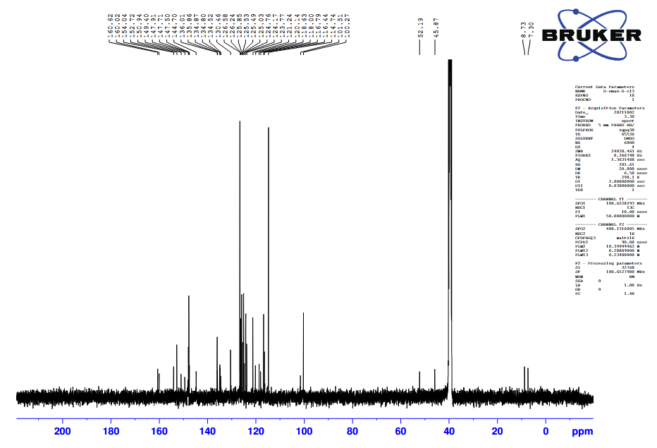
d | 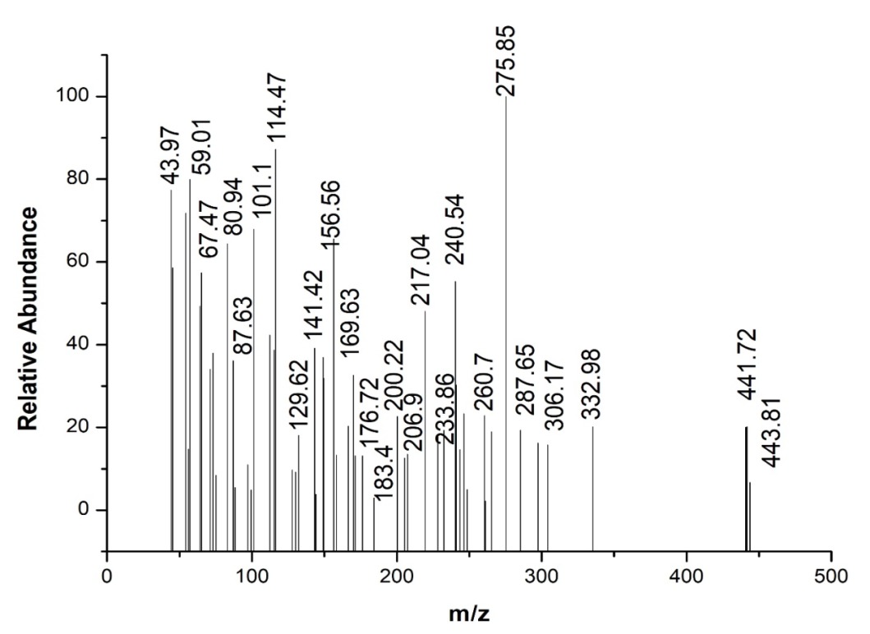
 | Figure S9. FTIR (a), ¹H-NMR (b), ¹³C-NMR (c), Mass spectra (d) of N-(4-((7-chloroquinolin-4-yl)amino)phenyl)-2-oxo-2H-chromene-3-carboxamide (7d).
7e
a | 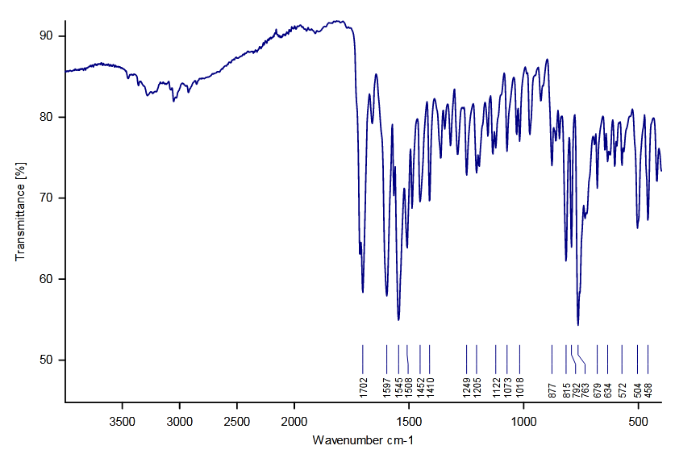
b | 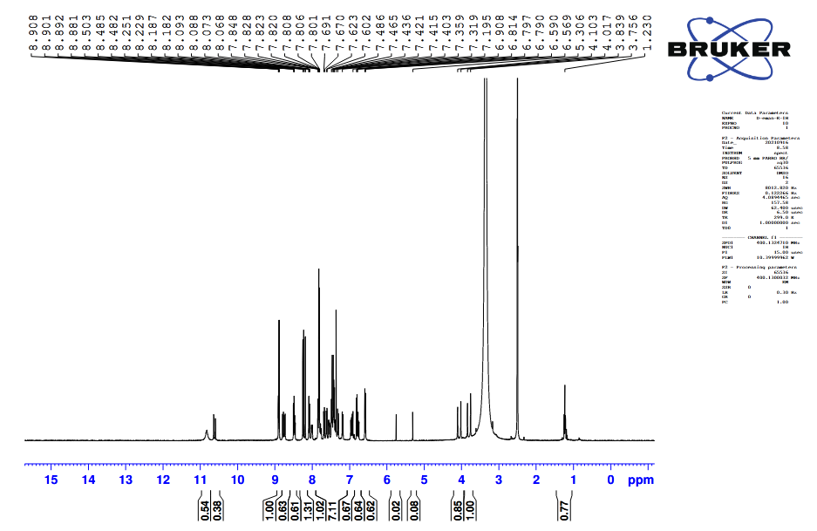
c | 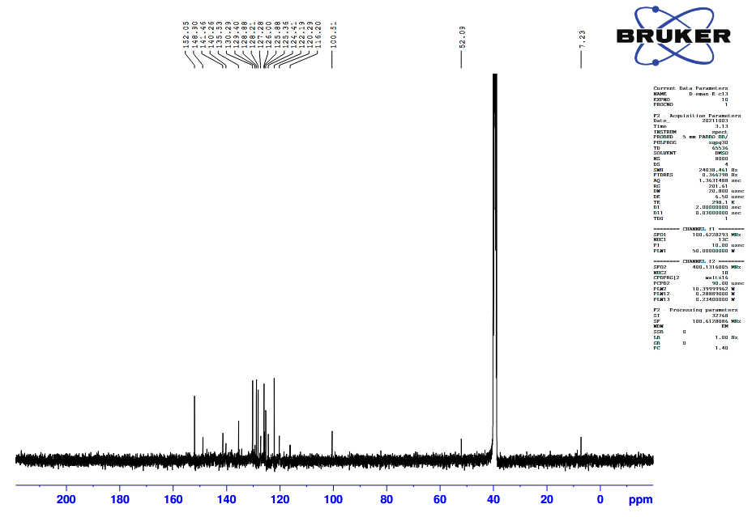
d | 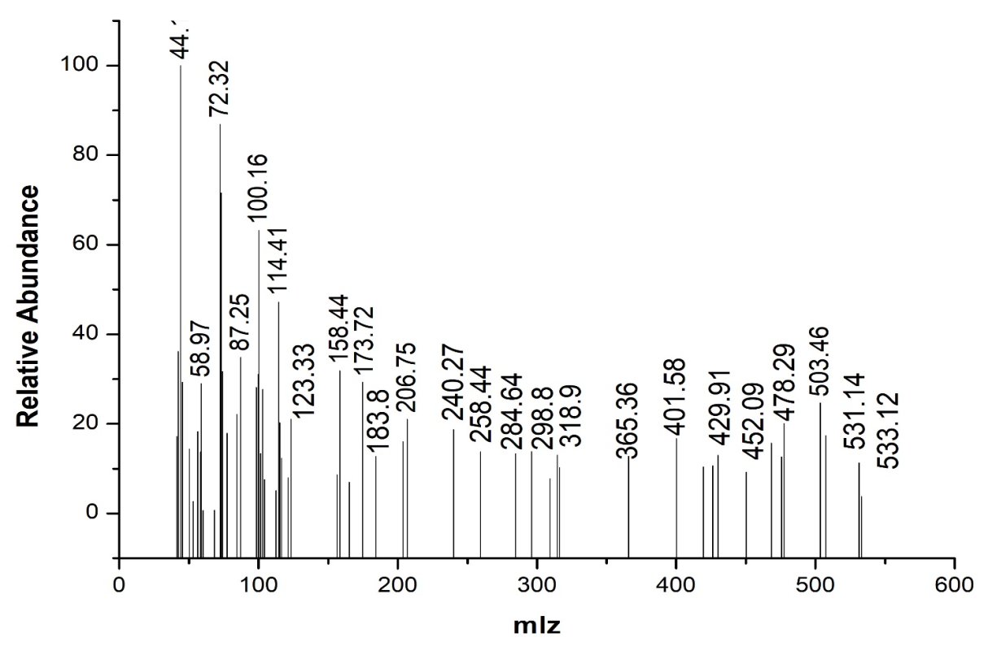
 | Figure S10. FTIR (a), ¹H-NMR (b), ¹³C-NMR (c), Mass spectra (d) of N-(4-(4-((7-chloroquinolin-4-yl)amino)benzyl)phenyl)-2-oxo-2H-chromene-3-carboxamide (7e).
10b
a | 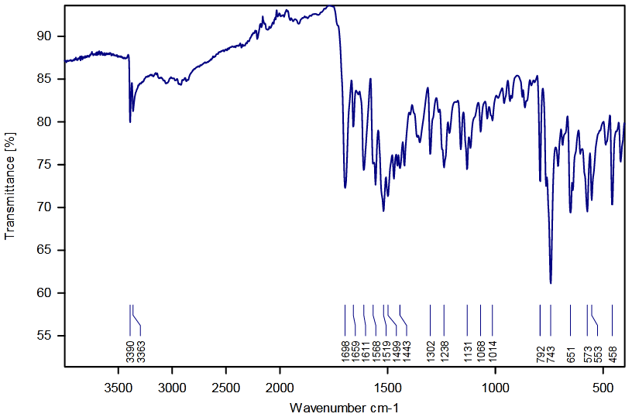
b | 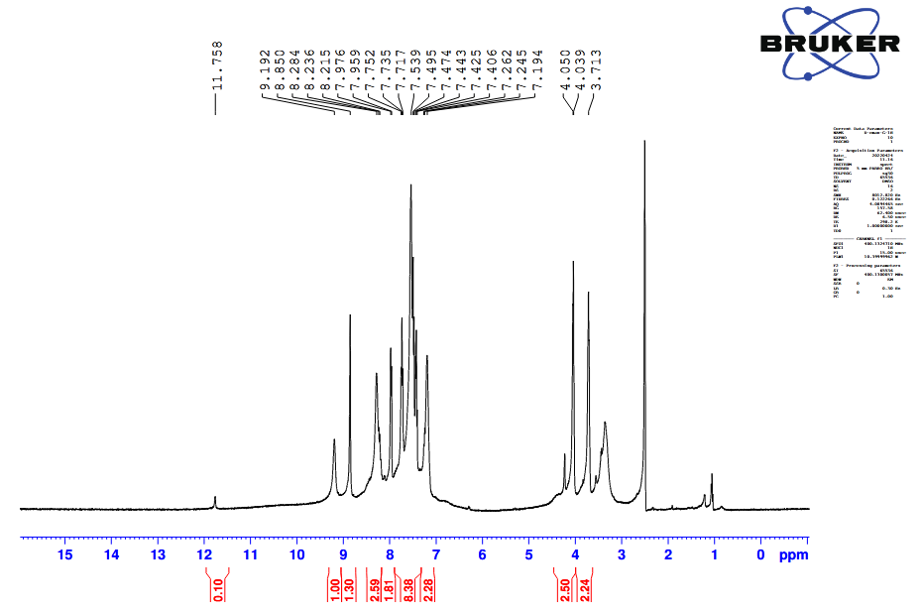
c | 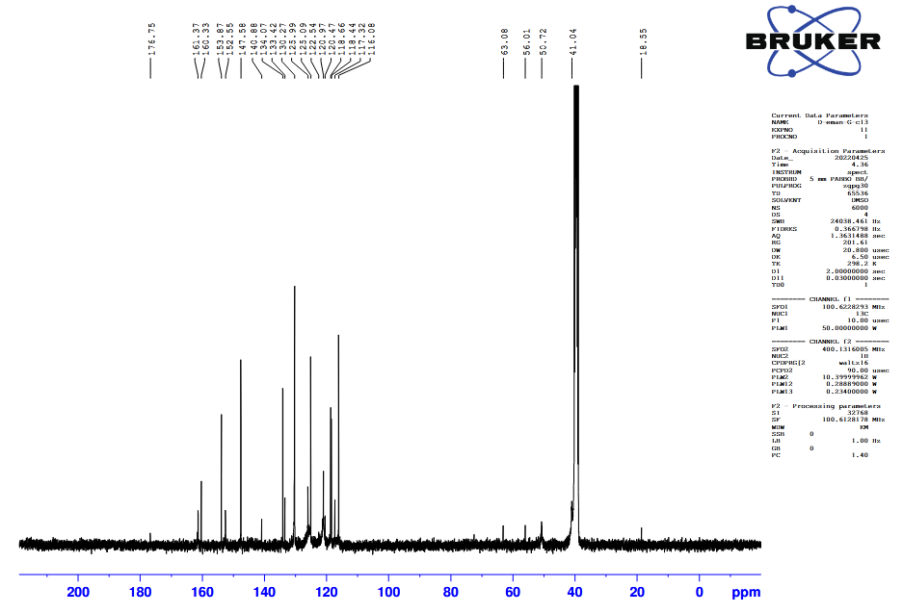
d | 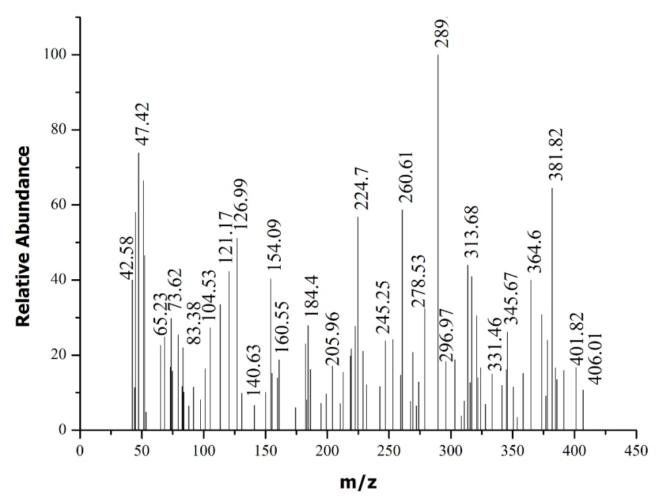
 | Figure S11. FTIR (a), ¹H-NMR (b), ¹³C-NMR (c), Mass spectra (d) of N-(2-(acridin-9-ylamino)ethyl)-2-oxo-2H-chromene-3-carboxamide (10b).
10c
a | 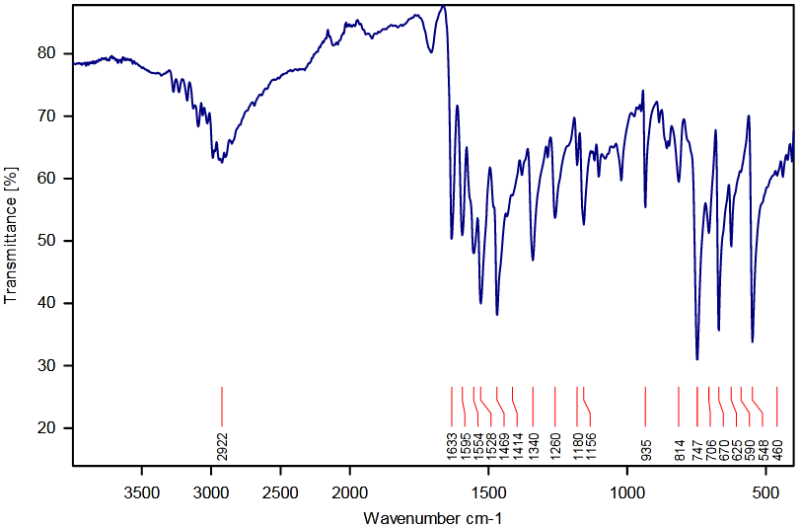
b | 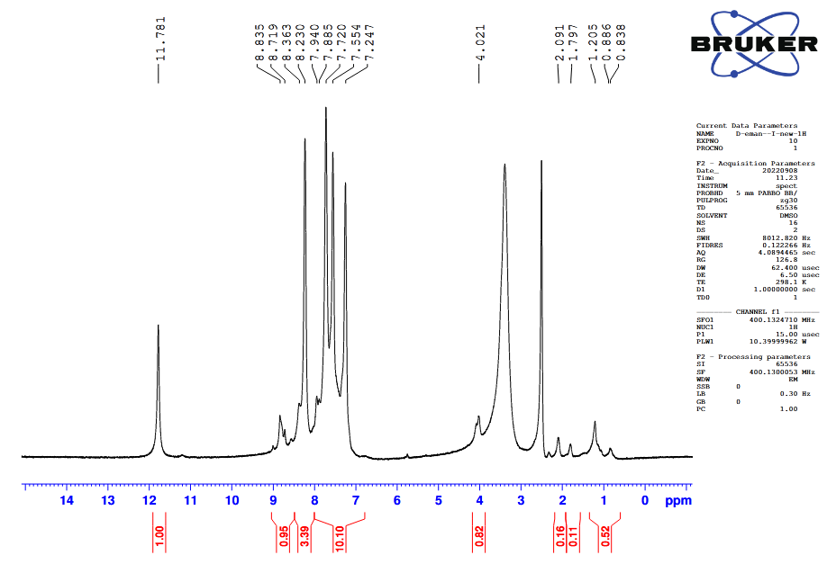
c | 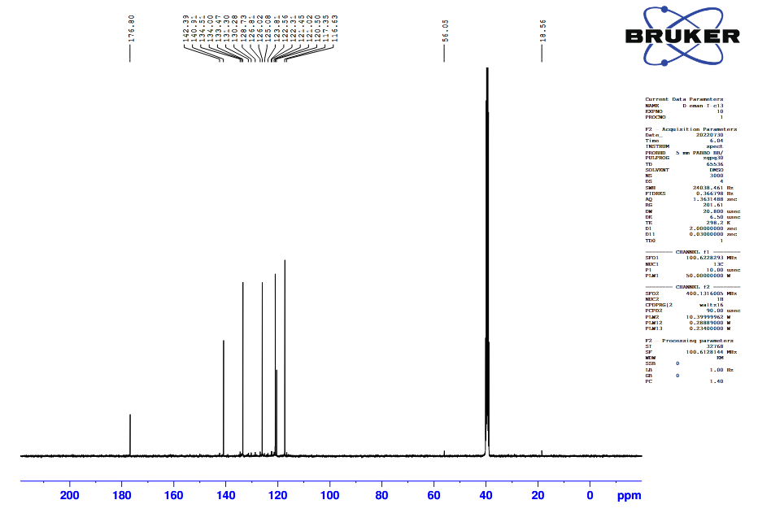
d | 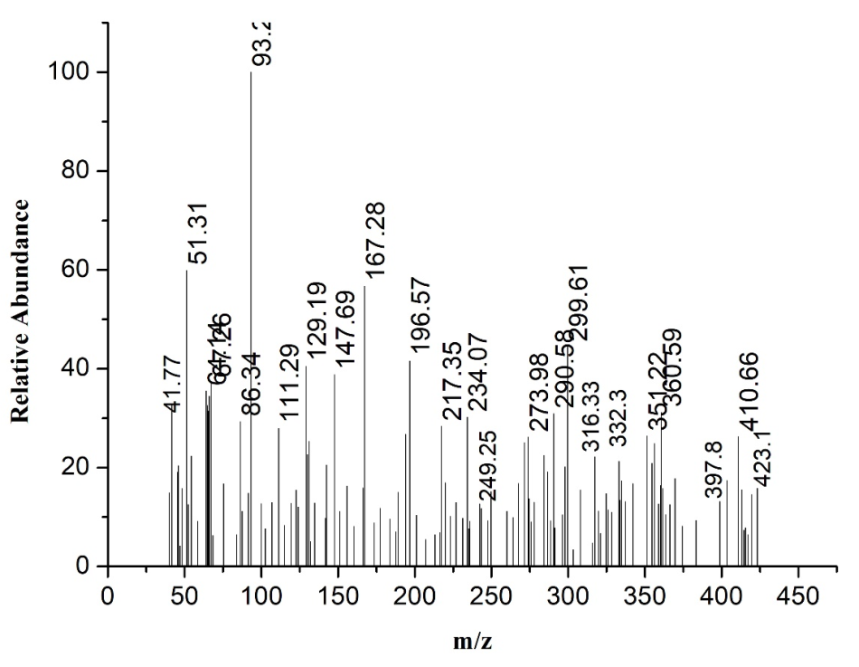
 | Figure S12. FTIR (a), ¹H NMR (b), ¹³C NMR (c), Mass spectra (d) of N-(2-(acridin-9-ylamino)propyl)-2-oxo-2H-chromene-3-carboxamide (10c).
13b
a | 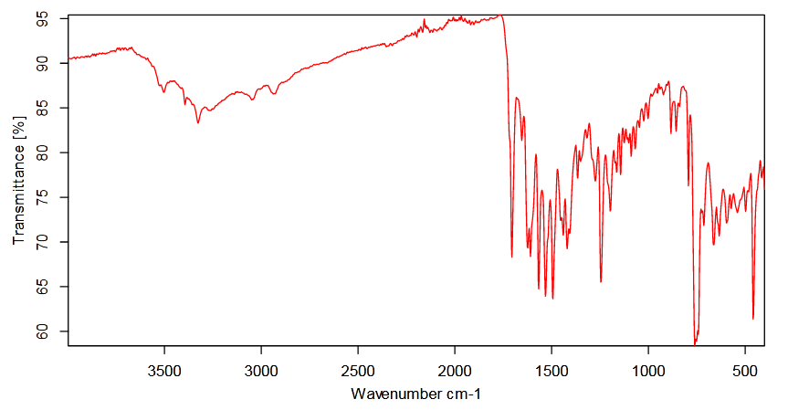
b | 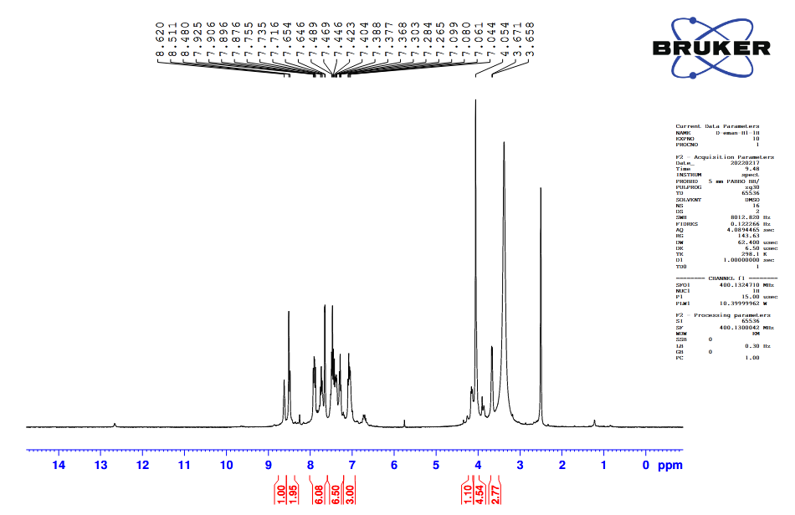
c | 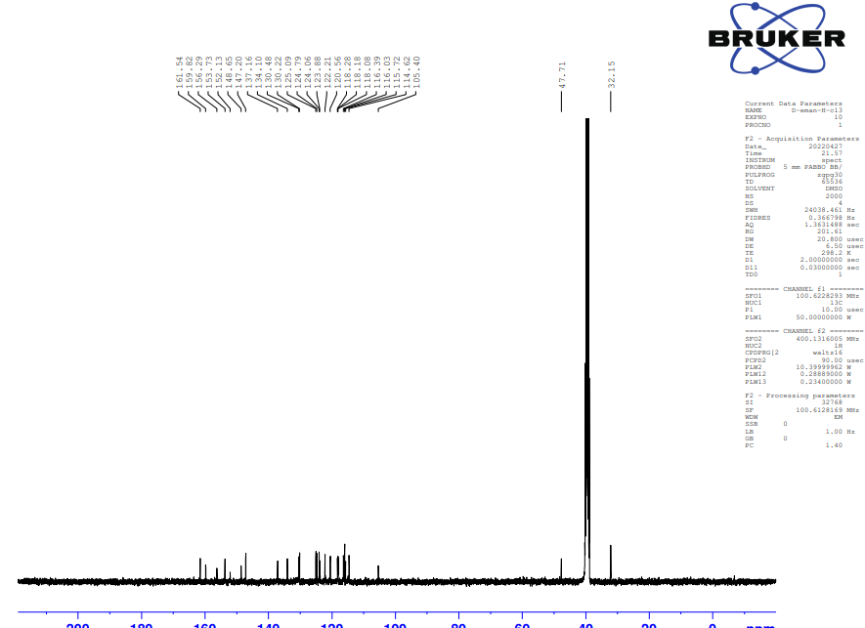
d | 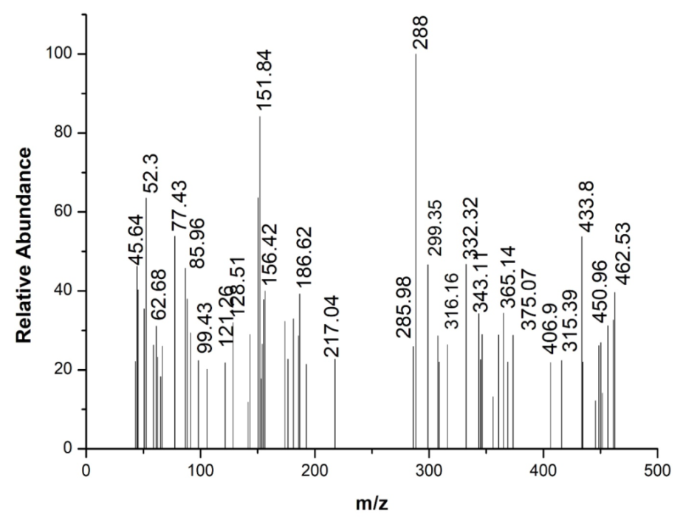
 | Figure S13. FT-IR (a), ¹H-NMR (b), ¹³C-NMR (c), Mass spectra (d) of N-(2-((5-methyl-5H-indolo[2,3-b]quinolin-11-yl)amino)ethyl)-2-oxo-2H-chromene-3-carboxamide (13b).
13c
a | 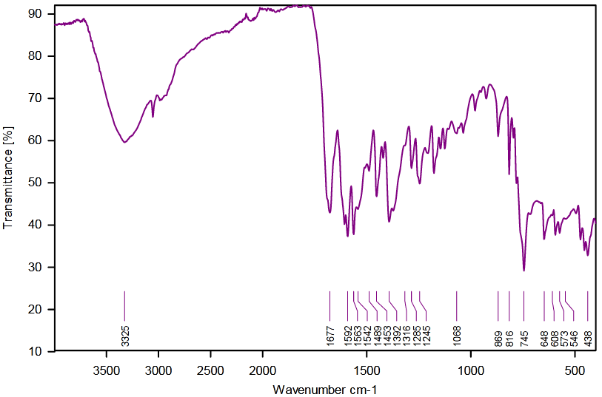
b | 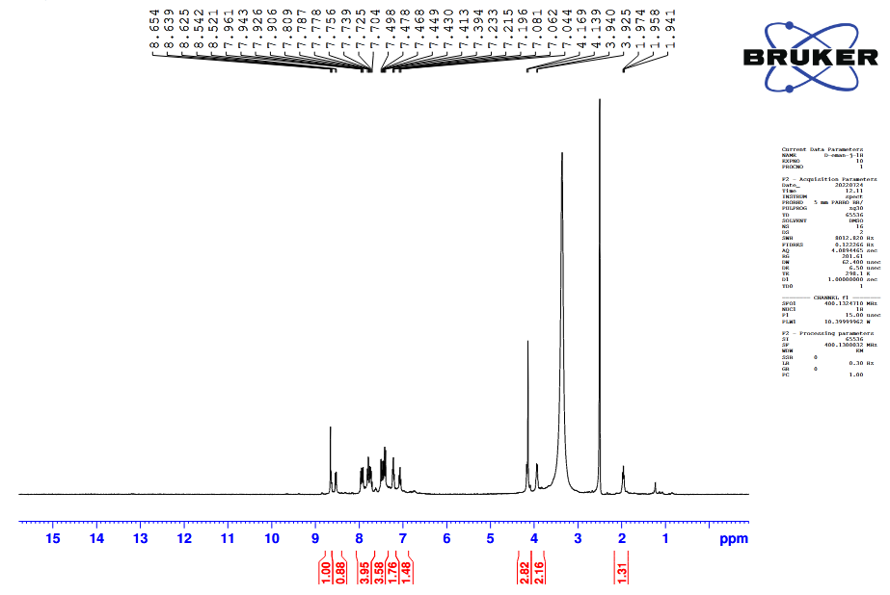
c | 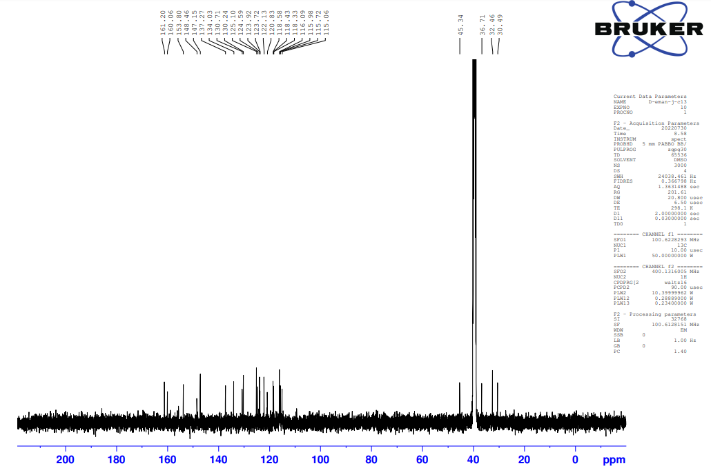
d | 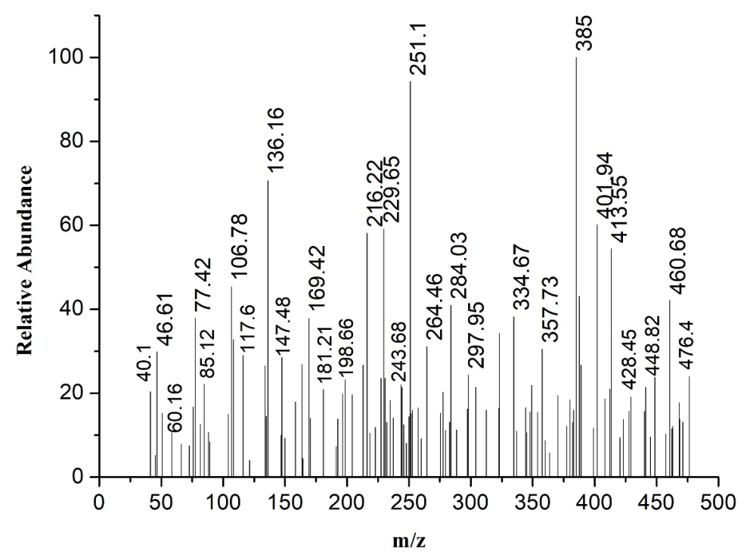
 | Figure S14. FTIR (a), ¹H NMR (b), ¹³C NMR (c), Mass spectra (d) of N-(2-((5-methyl-5H-indolo[2,3-b]quinolin-11-yl)amino)propyl)-2-oxo-2H-chromene-3-carboxamide (13c).

