Supplementary materials

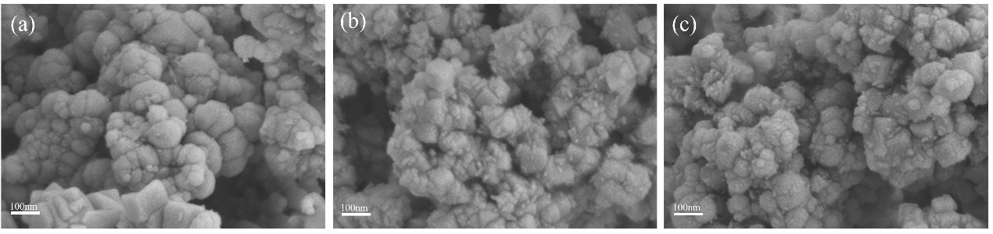
Fig.S1 (a), (b), and (c) SEM images of Fe₃O₄, Fe₃O₄@SiO_{2,} and Fe₃O₄@SiO₂-MO, respectively;

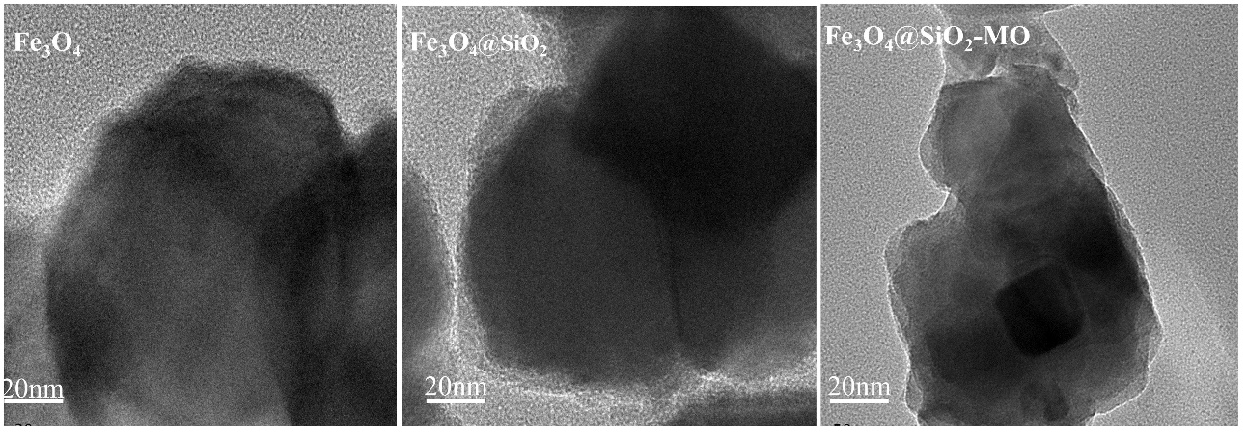
Fig.S2 TEM images of Fe₃O₄, Fe₃O₄@SiO₂ and Fe₃O₄@SiO₂-MO.

