Figure S2: Survival curves of large (purple), medium (pink) and small (green) purebred individuals, faceted by sex, along with associated table. Survival functions based on Kaplan-Meier estimates by log rank test (p-value). Variation in longevity between the three body sizes are more apparent within males. Table reports Kaplan-Meier survival estimates and cox proportional hazards regression model outputs for body size, by sex. All groupings are compared with Small-Female individuals, as these represent the longest living group. Includes the following statistics: $N_{A}$ i.e., total number of individuals still alive; $N_{D}$ i.e., total number of deaths; Median Survival i.e., median age of death; Lower 95% Confidence Interval (CI) and Upper 95% CI; Hazards Ratio (Lower 95% CI and Upper 95% CI) and p-value.

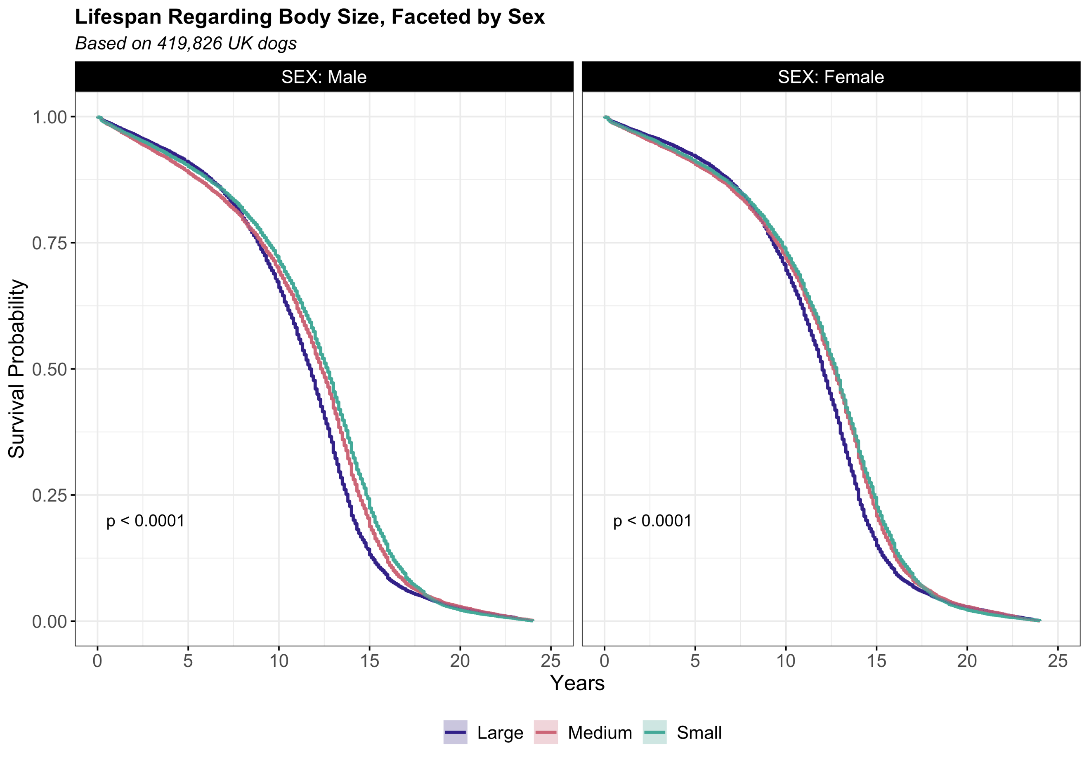

Body Size | Sex | $$N_{A}$$ | $$N_{D}$$ | Median Survival | Lower 95% CI | Upper 95% CI | HR (95% CI) | p-value
Large | Male | 63647 | 32586 | 11.8 | 11.7 | 11.8 | 1.28 (1.26, 1.29) | <0.001
Large | Female | 59531 | 29390 | 12.0 | 12.0 | 12.1 | 1.17 (1.15, 1.18) | <0.001
Medium | Male | 38618 | 19027 | 12.3 | 12.3 | 12.4 | 1.11 (1.09, 1.13) | <0.001
Medium | Female | 35290 | 16760 | 12.7 | 12.6 | 12.8 | 1.02 (1.00, 1.04) | 0.037
Small | Male | 113560 | 57487 | 12.7 | 12.6 | 12.7 | 1.03 (1.02, 1.04) | <0.001
Small | Female | 109180 | 54576 | 12.8 | 12.7 | 12.8 | NA | NA

