Supplementary: Public Health-Focused Use of COVID-19 Rapid Antigen and PCR Tests
Yonatan Woodbridge, Yair Goldberg, Sharon Amit, Naama M. Kopelman, Micha Mandel and Amit Huppert

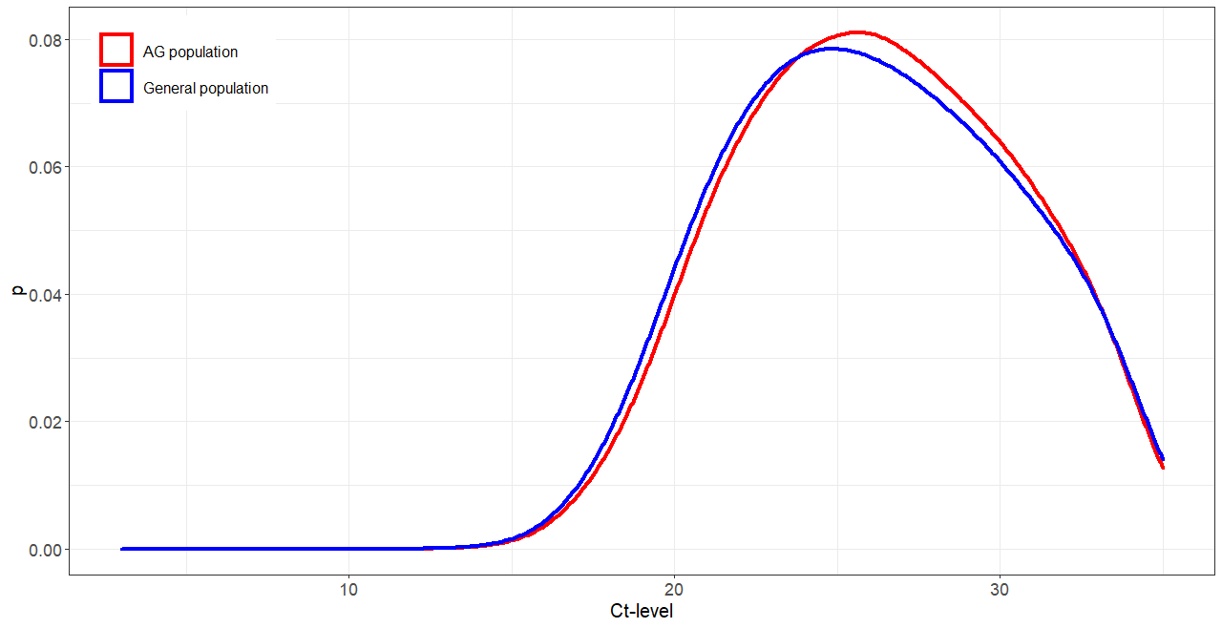
Fig. S1 Densities of Ct values in the study population (red) and overall population (blue). The two populations are described in Box A (blue curve) and Box C (red curve) of Figure 1.

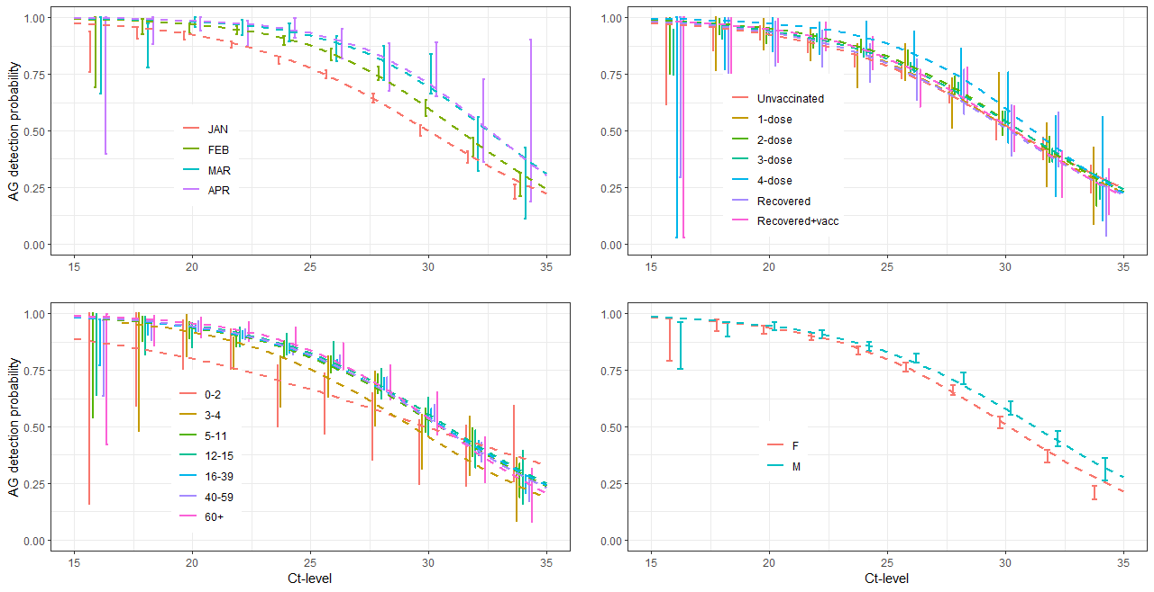
Fig. S2 The AG detection probability vs Ct-levels for gene N of 5 labs, grouped by 4 different criteria (clockwise from upper left panel): calendar time in months, vaccination status, age group, and sex. Vertical lines are proportion and 95% confidence interval calculated separately for each Ct integer value. The dashed lines are the univariate logistic regressions of Ct value on a positive AG test.

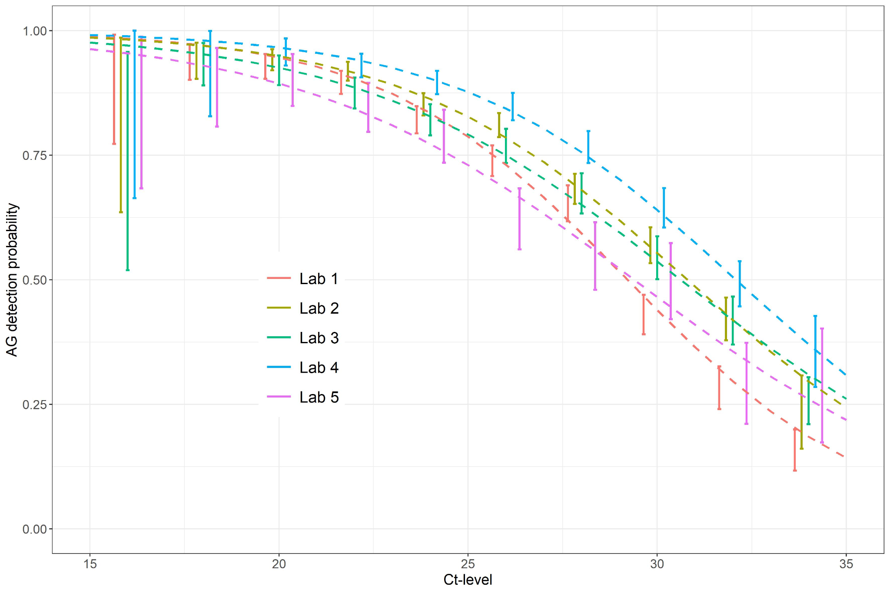
Fig. S3 The AG detection probability vs Ct-levels for gene N of 5 major labs, grouped by lab. Vertical lines are proportion and 95% confidence interval calculated separately for each Ct integer value. The dashed lines are the univariate logistic regressions of Ct value on a positive AG test.

