A facile strategy for preparation of Fe₃O₄ magnetic nanoparticles using Cordia myxa leaf extract and investigating its adsorption activity in dye removal

Elham Ghoohestaniª, Fayezeh Samari^{a,b*}, Ahmad Homaei^{c}, Saeed Yosuefinejad^{d}

ª Department of Chemistry, Faculty of Sciences, University of Hormozgan, Bandar Abbas, Iran
^{b} Nanoscience, Nanotechnology and Advanced Materials Research Center, University of Hormozgan, Bandar Abbas, Iran
^{c} Department of Marine Biology, Faculty of Marine Science and Technology, University of Hormozgan, Bandar Abbas, Iran
^{d} Research Center for Health Sciences, Institute of Health, Department of Occupational Health Engineering, School of Health, Shiraz University of Medical Sciences, Shiraz, Iran,

*Corresponding authors: Fayezeh Samari, Department of Chemistry, Faculty of Sciences, University of Hormozgan, Bandar Abbas, Iran. P.O. Box 3995, Tel.: +98 76 33711000-11; Fax: +98 76 33670716, E-mail address: fsamari@hormozgan.ac.ir (F. Samari)

Short Title:
Fe₃O₄ magnetic nanoparticles using Cordia myxa leaf extract

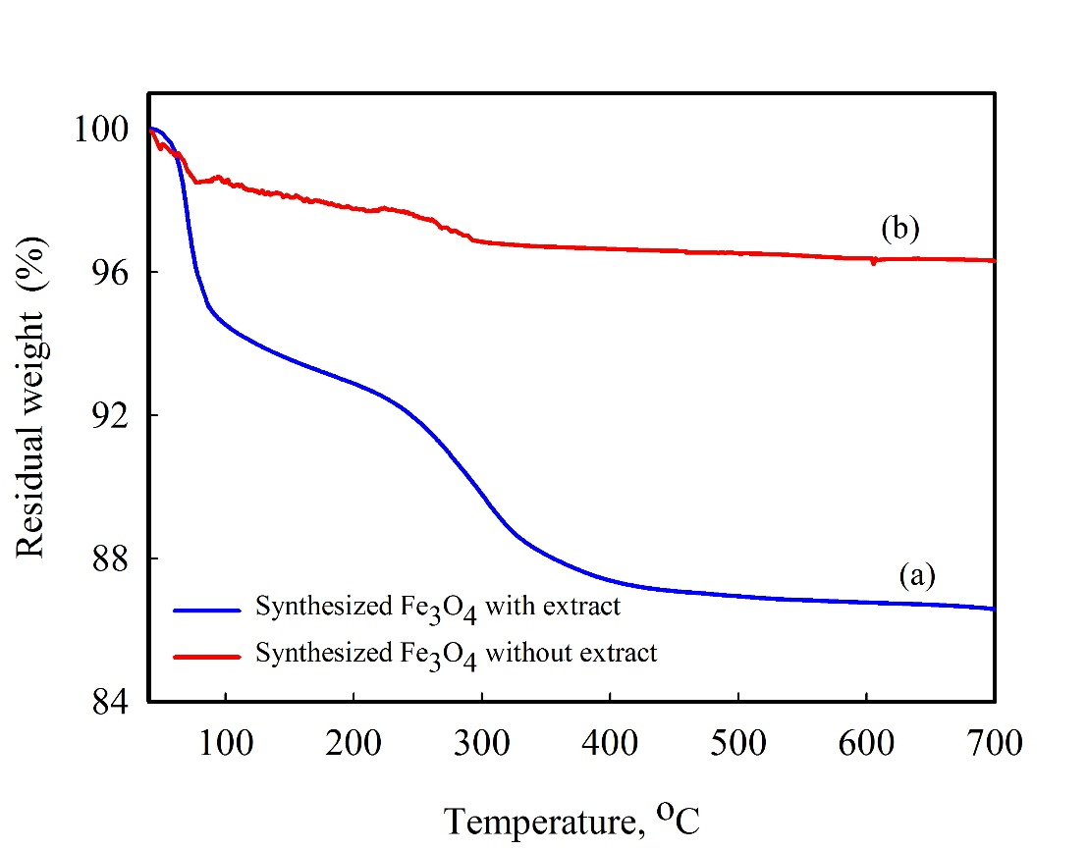
Figure S1. Thermogravimetric analysis curve of synthesized Fe₃O₄ MNPs (a) with and (b) without the extract.

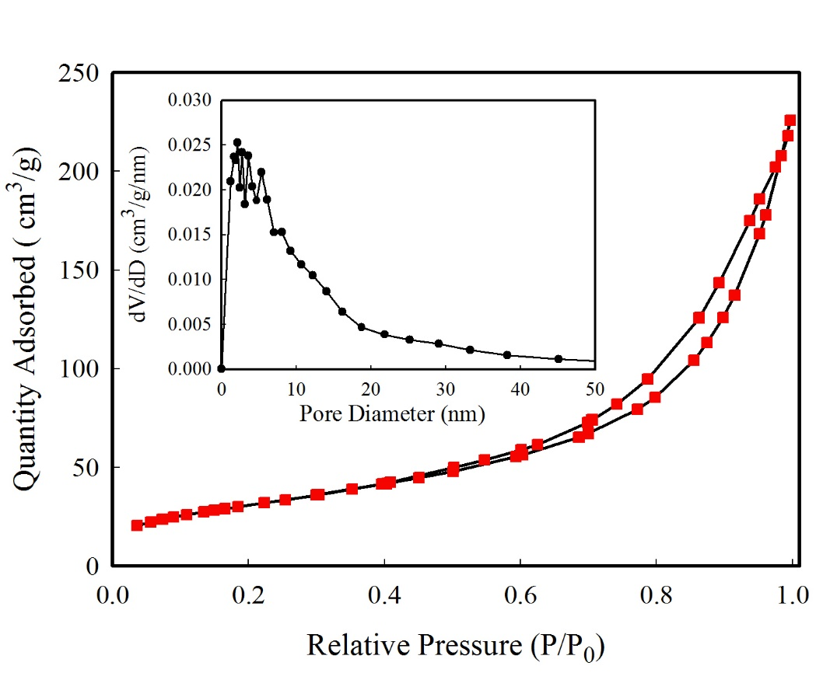
Figure S2. Nitrogen adsorption and desorption isotherms, and pore size distribution (inset) of the synthesized Fe₃O₄ MNPs.

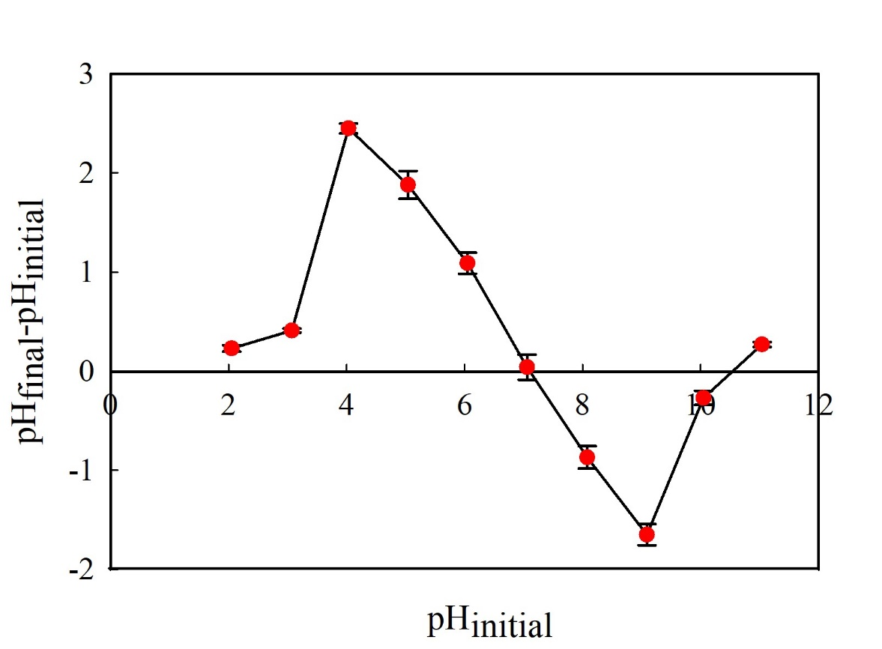

Figure S3. Determination of the pH_{PZC} of the synthesized Fe₃O₄ MNPs by the pH drift method.

